Transitions Team
Swindon Borough Council
1st Floor, Wat Tyler West
Beckhampton Street
Swindon
SN1 2JG

Friday, 20 December 2019

Dear (name)
Invitation to take part your own Planning Live event.
What is it?

If you are receiving support from the Transitions Team, then you may have the chance to take part in a Planning Live event.

This is a fun event all about YOU. It’s time to get together with people in a similar situation and the important people in your life. A chance to talk about your skills, talents and hopes for the future, and how you can be helped to achieve them.

Events can be used to discuss:
- Independent Living (including future housing and support options)
- Employment (including education and training to prepare for employment)
- Good Health (keeping healthy and well, access to Adult Health Services)
- Social Inclusion (friends, relationships, activities, hobbies etc.)
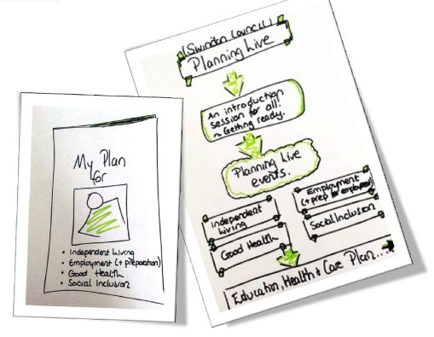
We create a space where young people set the agenda for a conversation about them, in search of what a good life might look like as they approach adulthood. Focussing on a young person’s strengths and abilities, they are empowered to think positively and creatively about their options, whilst identifying the support that they might need to achieve these ambitions.
You can invite family members and friends along with anyone else who plays an important role in your life to support you at the event.
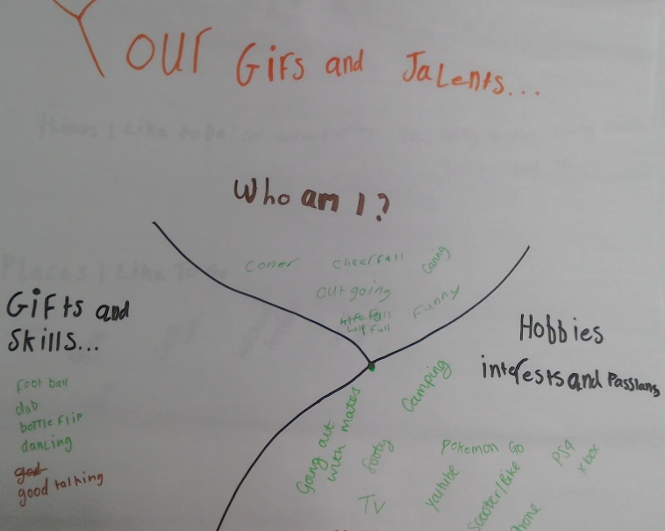
What will happen after the event?

The conversations that take place will help your support workers know exactly what you want to achieve, helping them give you the support you need.
You can be sure that when your new Care Plan, EHCP or Pathway Plan is written or updated it will include relevant and realistic goals.
You will receive a printed booklet as a record of your event that can be kept and shared with whomever you want, so that you do not have to repeat yourself over and over again. We will agree with you exactly who you are happy with us to share this with.
Some comments from young people who have taken part in Planning Live :
“I think the whole day went well – it helped my understanding”
“It helped me find out more about myself and what I can do on my own”
“These sheets will really help me in the future”
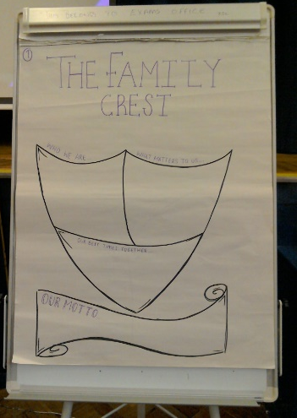
We hope that by having these conversations now, you will feel more in control of your future and more confident to take the next steps in your life.

We will be asking you and other participants to give us feedback on the event. What we learn from this event will help us to do it better in future.

If you have any questions or would like to take part in the Planning Live project, please complete and return the attached form, or speak to your support worker.
Please post or email your responses to your worker or mgumm@swindon.gov.uk. Or call the Transitions Team on 01793463333 or Matthew Gumm on 07867358760.
We look forward to hearing from you

Planning Live
Response Form
September 2019 – August 2020

Please return to Your Social Worker or Link Worker

Or Transitions Team, 1st Floor Wat Tyler West, Beckhampton Street, Swindon, SN1 2JG

Or mgumm@swindon.gov.uk

Your name

We will be running events throughout the year.
We will aim to start at 10.00am and will be finished before 13.00pm. We will provide refreshments, i.e., water, squash, tea and coffee, biscuits and fruit.
We suggest you bring between 3 – 5 people but decide what is best for you. This could be family members, friends, support workers, other professionals etc. Your child’s keyworker will be with you on the day.
Name of person | Relationship to you and/or service they are from

