Pinetrees Community Centre

The Circle, SN2 1RF

01793 466499

3 people max

The Meadow Meeting Room 6 (Main Hall)

Leigh Road, Penhill, SN2 5DE

01793 465050

5 people max

Kingsdown School

Hyde Rd, Stratton St Margaret, Swindon SN2 7SH

01793 822284

3 people max

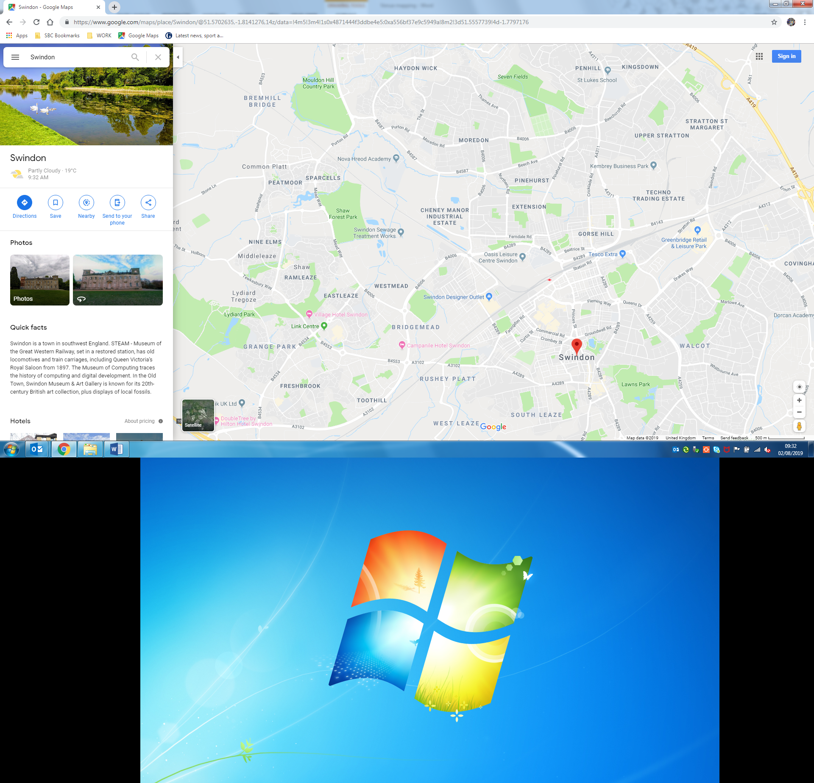

Crowdy’s Hill School

Jefferies Ave, Swindon SN2 7HJ

01793 332400

4 people max

Oaktree Annex

Oaktree Primary, Priory Rd, SN3 2HA

Contact is South Team at Reuben George

2 people max

Whitbourne House

Whitbourne Ave, SN3 2JX

01793 464640

4 people max

New College

New College Dr, Swindon SN3 1AH

01793 611470

4 people max

Swindon College

N Star Ave, Swindon SN2 1DY

01793 491591

4 people max

Commonweal School

The Mall, Swindon SN1 4JE

01793 612727

6 people max