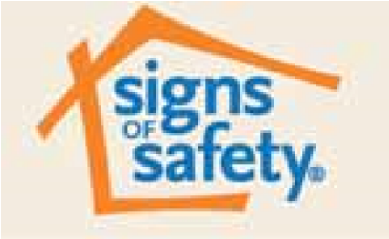
What is the Signs of Safety Approach?

In Northamptonshire, families and professionals are starting to hear about Signs of Safety. The aim of this information is to give you a better understanding of what it means for you and your child or children.

What is Signs of Safety?
Signs of Safety is a very clear way of working with children and their families.

Signs of Safety is about family members and professionals (Health Visitors, Social Workers, Teachers, Doctors, Police etc.) working together to meet children and young people’s needs in the best way possible. It puts children, young people and their parents at the heart of the work. Families play a key part in working alongside professionals when we are looking at the worries and concerns that are identified for their child (who is worried and why?) identifying the things that are going well in the child and family’s life (strengths) and agreeing what needs to be done (goals). Working together, our aim is to build on the strengths and reduce the worries.

What difference will Signs of Safety make to the way professionals work with me and my children?
Signs of Safety is a way of making sure that everyone involved in a child’s life has the same understanding of the strengths and the worries and agrees the goals that need to be reached to make sure that your child is safe. Signs of Safety helps everyone involved with a child / young person, including the child / young person themselves, to think about ways to keep safe, healthy and settled, wherever they are living.

Talking to children
Talking to children is at the heart of Signs of Safety. It is important that children, as well as adults, have an opportunity to talk about what they are worried about, what makes them happy and what they would like to see happen in their family and community to keep them safe. The Signs of Safety approach uses a range of tools, but one tool in particular, called The Three Houses, is used to talk to children and ask them their views:

How does this change your assessment?
The Signs of Safety assessment will include professionals working with your child - such as Teachers, Nurses, Doctors and Police. During an assessment the four key questions (listed below, alongside others) will be asked of you, your child, your wider family and anyone who else who helps to support you and your child:

- What are we worried about for your child?
- What is working well in your family?
- What needs to happen to make sure your child is safe and well in the future?
- How worried we all are about your child/situation on a scale of 0 to 10?
(0 meaning the child is in danger, 10 meaning the child is safe, these will become more specific as the goals are established)

This becomes a plan which looks like this:

What are you worried about? | What’s working well? | What needs to happen?
Harm - What has happened that worries us?  Complicating factors – what makes things more complicating? | Safety – when harm is present, who/what happens to make sure the children aren’t hurt/harmed?  Strengths – what are the strengths within the family/situation? | Safety Goal – what do we need to see to know the children are safe?  Next Steps – What are going to do to reach our goals?
On a scale of 0-10, where 10 means there are no real concerns about the child and family and 0 means that things are so unsafe for the child, immediate action needs to be taken, where would you scale this today?
0______________________________________________________________________10

You will be given a copy of your child’s assessment plan. This will also be given to professionals who are working with you and the children. The same plan will be used in meetings between you and your children’s Social Workers.
Your child’s Social Worker will review progress against the plan of what needs to happen, with the aim of everyone involved in their lives, family members and professionals, working together to increase the wellbeing and safety for your child.

If you have further questions about Signs of Safety that this information doesn’t answer, then please discuss these with your child’s Social Worker.

