Special Guardianship / Post Order Workspace

- Search for the child / young person in the usual way “Find.”

- On the right hand side of the Basic Demographics screen, there is an “Events” section. Underneath is the link to “Start a Post Order Contact”
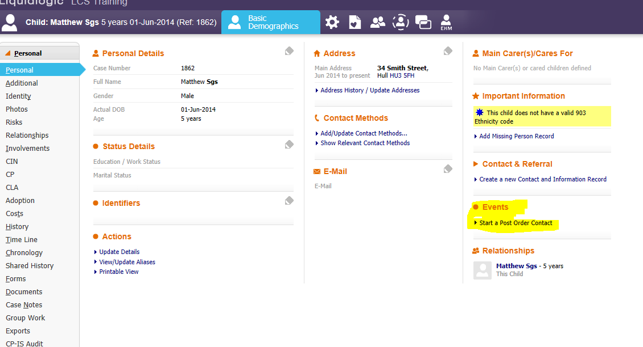

- Click to start the post Order contact, amending the start date as required. Click Start.

- The Post Order contact will go to a group tray called Special Guardianship Support Contributor. This is so that a number of people can pick it up and move the case on. If you don’t have access to this group tray then please ask your manager to log a service desk call with Liquidlogic Support – Children to be granted access.

- Pick up the form from the group tray.

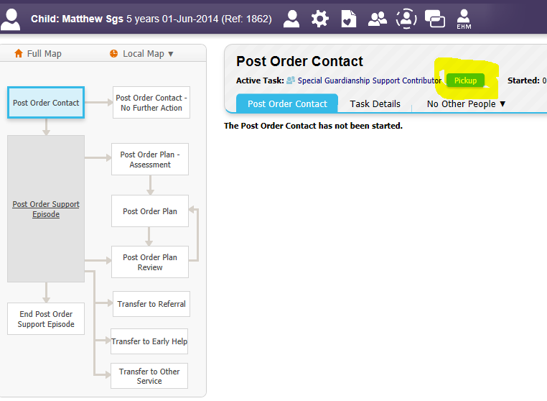

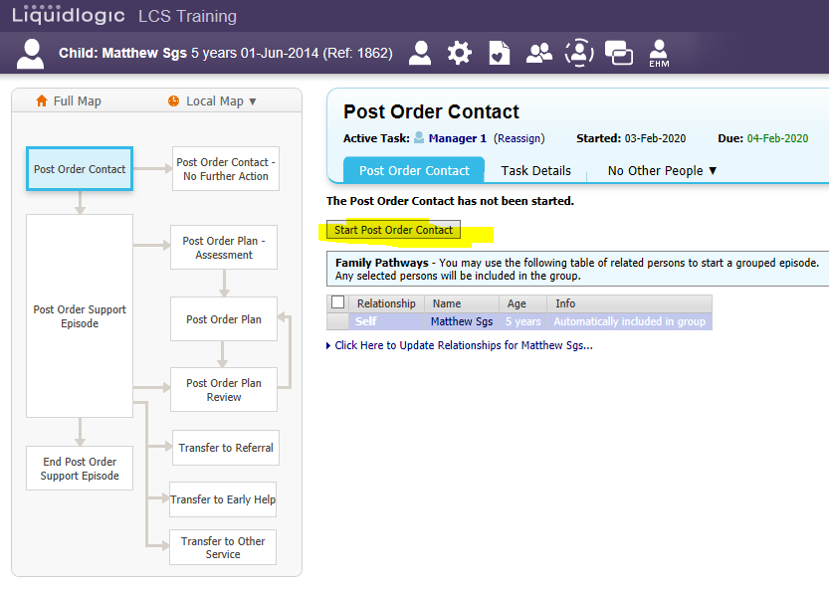
- Click to Start the Post Order Contact, ensuring it’s on all appropriate children. Tick and untick children from the table. (in this example there is only 1 child.)

- Click to Start Blank
- Complete the Post Order Contact (1 page form).
- When Start Episode is selected, and Reasons for these Selected Outcomes have been completed, there will be a blue link to choose a Lead Worker. Please speak to manager on how they wish for the worker to be allocated, e.g. you save and close the form and reassign to manager to complete that question.
- Once the new lead worker has been assigned via the form, click Finalise Request ( top right button)

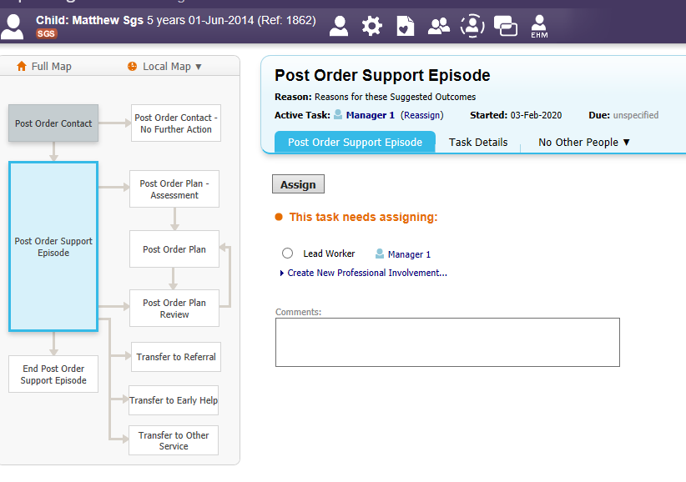
- This will then ask for the Post Order Support Episode to be assigned. You can choose the original person assigned or change if required.

- Put a mark in the circle before the Lead Workers name (in the training environment, this is Manager 1). Click the grey Assign button.

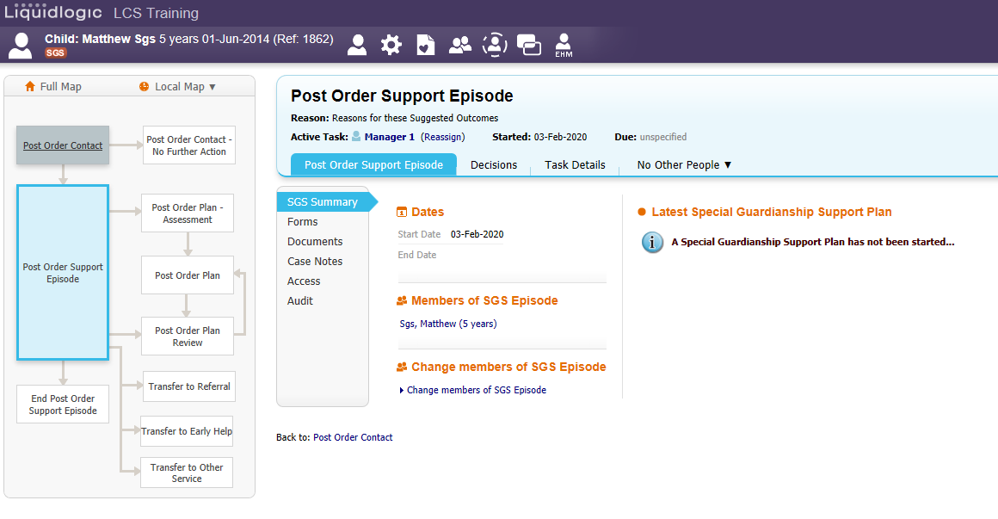
The Post Order Support Episode is the over-arching area for the episode where you can decide and progress the family through the process.

To initiate any of the boxes in the map:
- Post Order Plan – Assessment
- Post Order Plan
- Post Order Plan Review
- Transfer options ( x 3)
- End Post Order Support Episode

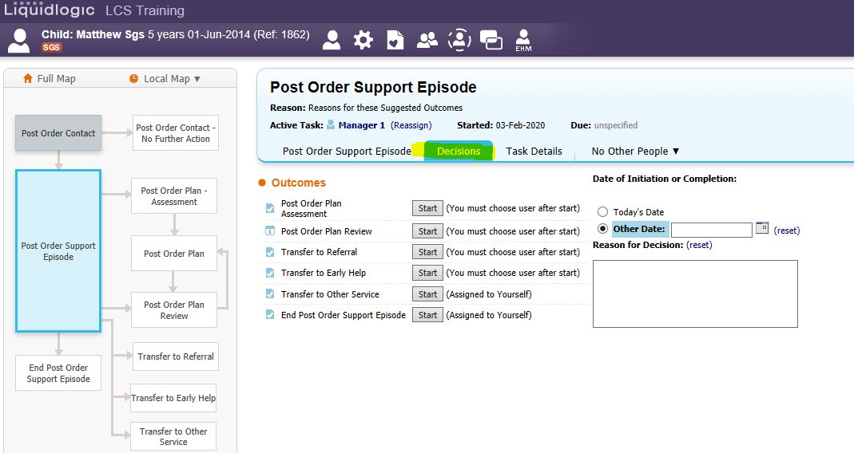
You will need to manually make a decision to the system.

Here you can now start what the family require. The map is sequenced
- Post Order Plan – Assessment
- Post Order Plan
- Post Order Plan Review
- Transfer options ( x 3)
- End Post Order Support Episode

Post Order Plan Assessment

And so this the usual route followed.

- Click Start next to Post Order Plan Assessment
- Select a date and click Confirm
- Assign to worker
- Start Post Order Plan – Assessment button
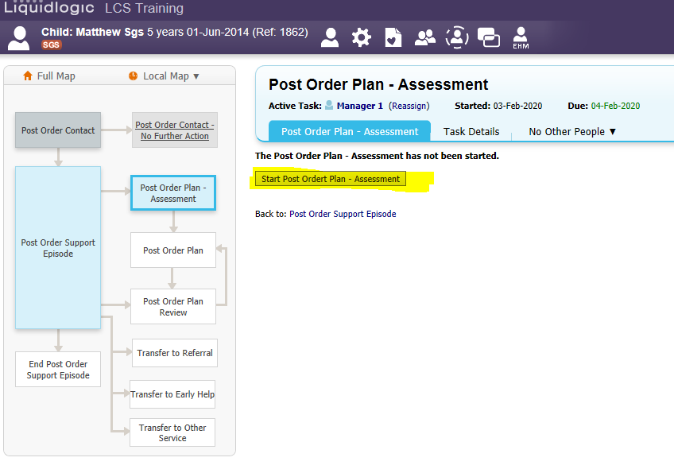
- Copy Forward Selected any documents that you think are relevant

- Complete Assessment (various sections on the left). NB you can only choose one outcome at this stage. If you choose continue with current process you WILL NOT be able to create a plan from the decisions. You would have to restart the assessment and amend the outcome, or get the service desk to un-finalise for you.

- Therefore, the outcome needs to be Update Special Guardianship Support Plan.

- Finalise Assessment

- This will then automatically be sent to manager for authorisation.

- MANAGER – checks assessment and adds Authorisation Comments to Decisions section. They then also finalise the assessment and click the Authorise button. If the manager wishes for the worker to complete more info within the assessment, then they can request further information. This will send the assessment back to the worker with comments. When the worker receives it back in their tray they can update the assessment re finalise which then send it back through to the manager to authorise again.

- Once the Post Order Plan Assessment has been authorised, with an outcome of Update Special Guardianship Support Plan, the task of Post Order Plan is to be assigned.

Post Order Plan
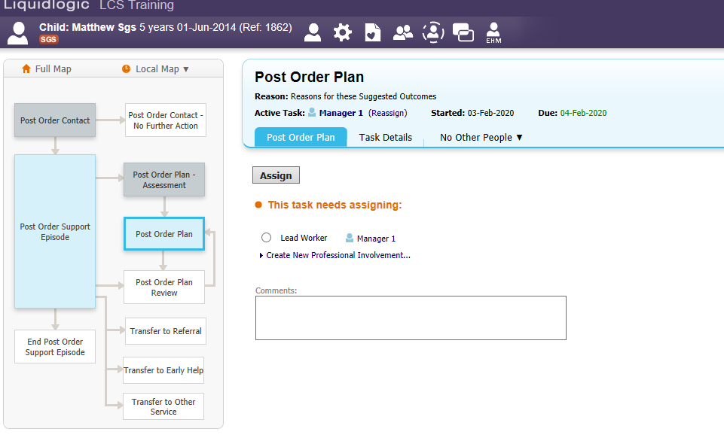
- Once assigned, the map will look like below. The grey Start Post Order Plan button will be available to begin this task.

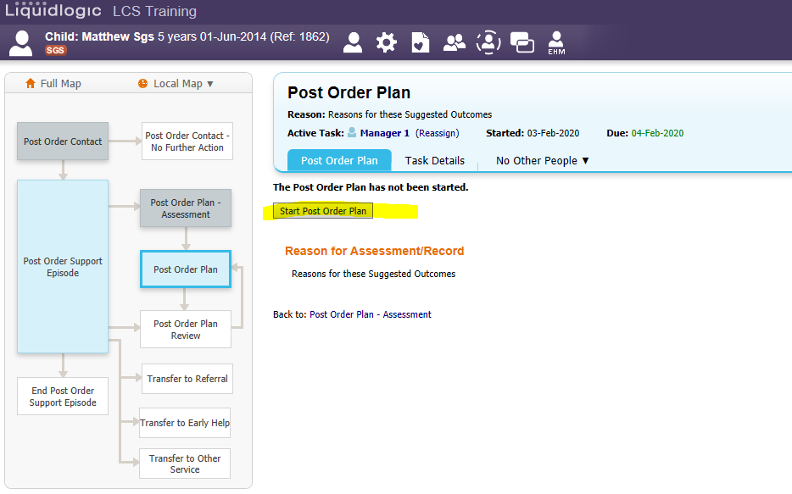
- Complete the Plan, copying forward selected where required.

- One outcome can be selected here also, however if you choose Continue with Current Process here, you can start the SGO Plan Review meeting at a later stage.

- Finalise Plan

- This will also go to managers for authorisation.

- MANAGER - checks assessment then also finalise the assessment and then click the Authorise button.

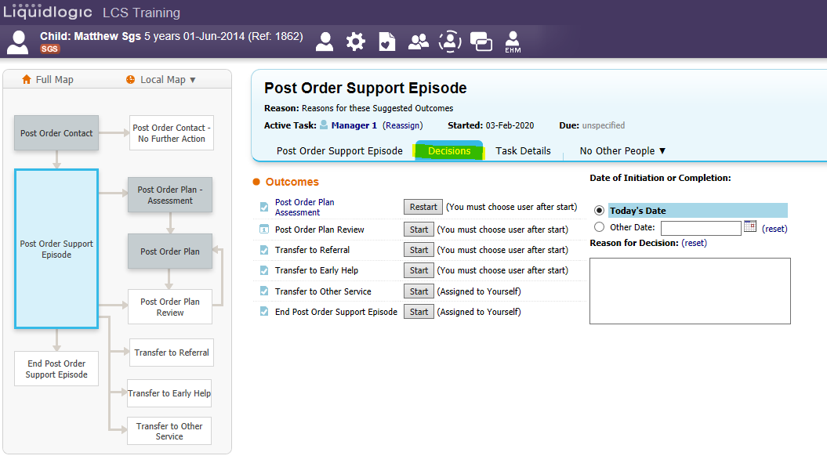
Any further Decisions, REMEMBER to click into the Post Order Support Episode box, and select the Decisions tab.

If in the future you wish to hold a Post Order Plan Review meeting, you start the task from the Decisions as directed above.
- Click start next to Post Order Plan Review
- Enter a date and click Confirm
- Assign a Lead worker ( or choose another if required)
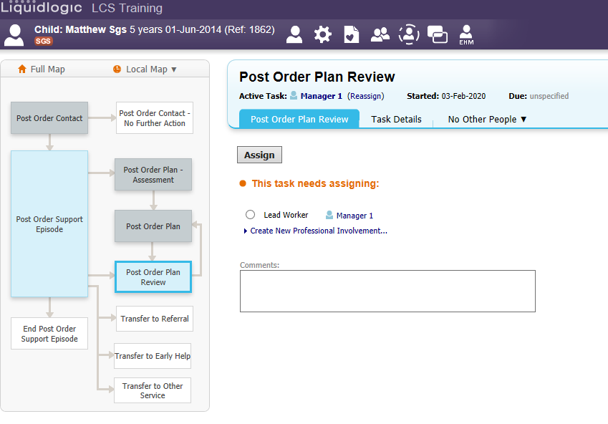

Post Order Plan Review

This is the Post Order Plan Review meeting screen. This screen can be worked on by a number of people and there is a task list to help you.

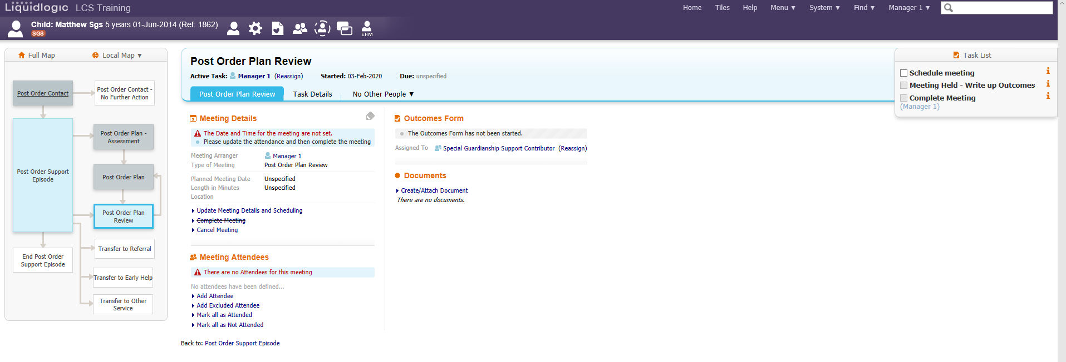

Meeting Details section

- Click link Update Meeting Details and Scheduling. Enter criteria requested, planned meeting date, Length in minutes, Location. If you wish to add a time, this needs to go in the box with the date. Click into the box after the date and enter the time in 24 hour format with the colon between the hours and the minutes - 13:00
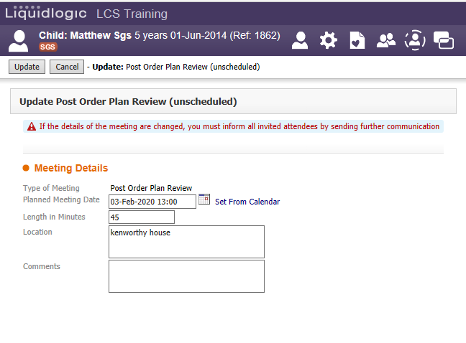

- Click Update ( top left)

Meeting Attendees

- Click Add Attendee. This will bring up a list of family and professionals already linked to the child / young person. Tick in the square before their name who you want to attend.

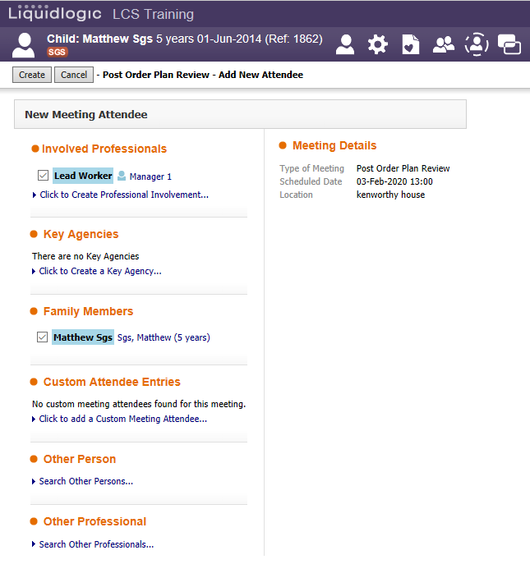

- Click Create (top left). This will populate the Meeting Attendees table.

- To add others that may not be on the LL system such as teacher aid staff or nursery nurse staff, you can add them as a Custom Attendee. To do this, click

- Add Attendee
- Under Custom Attendee Entries, choose blue link Click to add a Custom Meeting Attendee
- Type in their name and role
- Click Create
- Tick the person under the Custom Attendee entries
- Click Create again. They will also now appear in the Meeting Attendees table

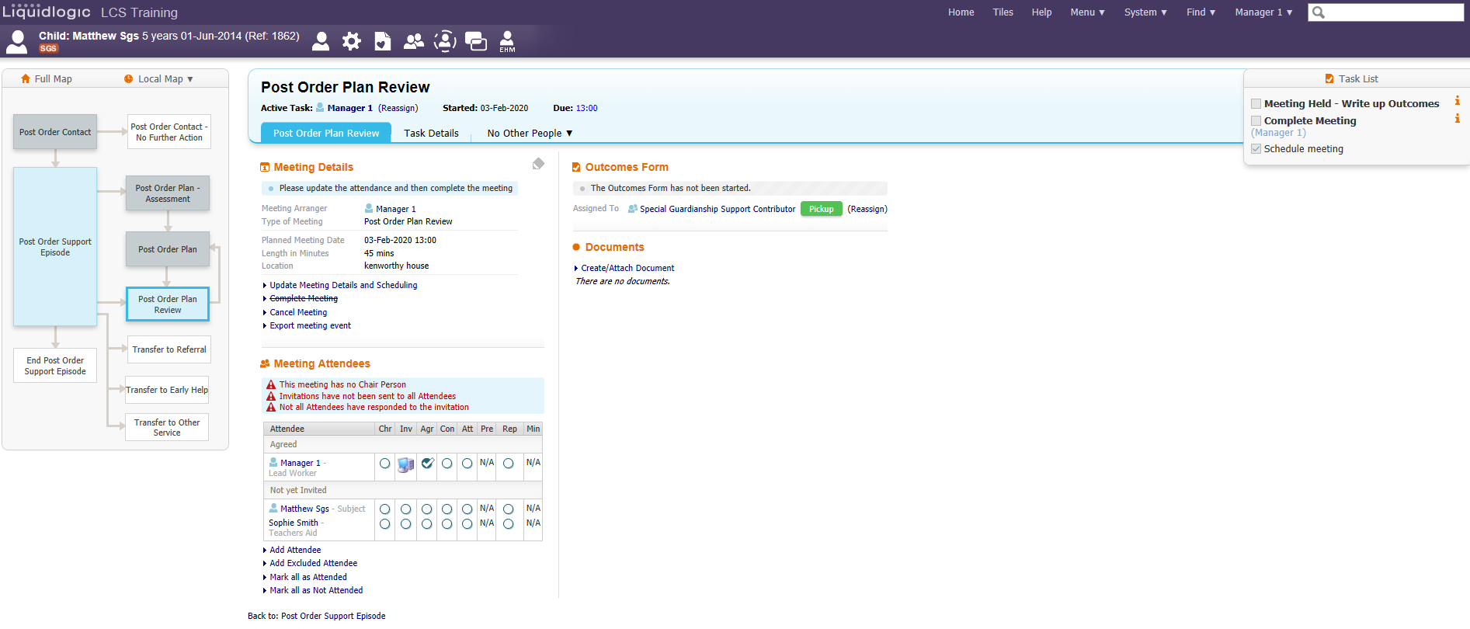
- From this table, you can mark the Chairperson by clicking in the circle
Chr

  - In the Inv column put a click in there, choose telephone or other as our letters are currently done off the LL system ( they can be scanned in and attached under the Documents section on the right of the meeting screen). Click Finish

  - Close any extra communications screens that come up so that you are back at the Meeting screen.

- The Outcomes Form (where the minutes are recorded) is sent automatically to a group tray called Special Guardianship Support Contributor. This is to allow numerous people to do minutes dependent on the team dynamics. If you haven’t got access to the group tray, your manager will need to log a service desk call with Liquidlogic Support – children’s to request access.

- Pick up the Outcomes Form task from the meeting screen area. The link will change to Meeting Held – Write up Outcomes (also in task list).

- Click this link. You are then required to record the Actual Meeting date. You can entre by hand or click the blue link Copy Planned Meeting Date. (If the meeting is delayed you can record why.)

- Click Update (top left)

- Choose to Copy Forward Selected where required.

- Complete the meeting notes form. Choosing appropriate outcome for family’s current situation.

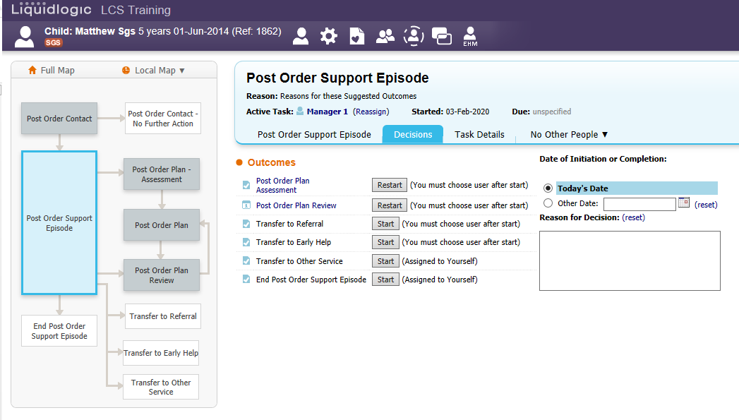
- Click Finalise Decision

Transferring the family to Referral to initiate the CIN pathway.

If the cases progresses to more than SGS, then you can complete the Transfer to Referral task. This will allow you to complete a social care referral and progress the case to CIN. CIN cases can be managed within the SGS team.

- To complete the Transfer to Referral, you need to initiate the Decision and assign a worker.

- Create the form. Copy Forward Selected as required. This will create a one page Transfer Record form

- Complete form

- Finalise Record

This will then create or re –open the green R flag relating to a social care referral. This is the same form that is used at the “front door” EHaSH.

- Click the button to start the referral
- Copy Forward Selected or Start Blank
- Complete the referral form
- Further Action, suggested outcome CSC Assessment (if wanting case to progress to CIN)
- Finalise

Allocate to managers tray if you are keeping it in house or to EHaSH depending on the case circumstances.

MANAGER – needs to complete the Managerial Oversight on Further Action section of the Referral form. Finalise the Record and Authorise.

Complete the CSC Assessment.
Transfers to Early Help

The process for this is the same as the referral, selecting the Transfer to Early Help option

Case Notes
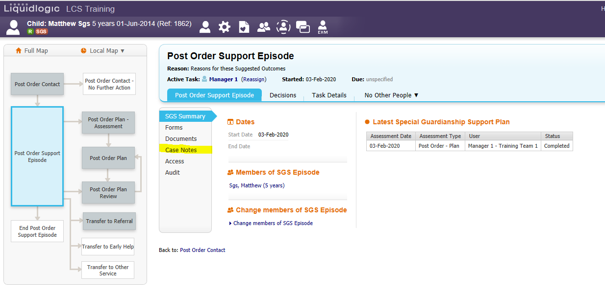
All case notes in relation to Special Guardianship need to be recorded within the SGS workspace as per below.
Getting back into the Workspace
To get back into the workspace from the demographics use the Episodes tab. Click into the table line and it will take you back into the workspace workflow.
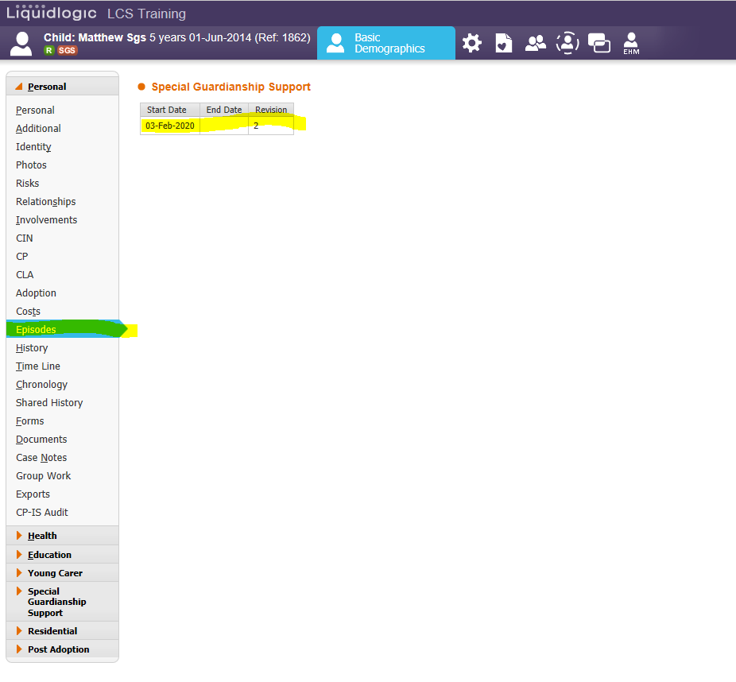

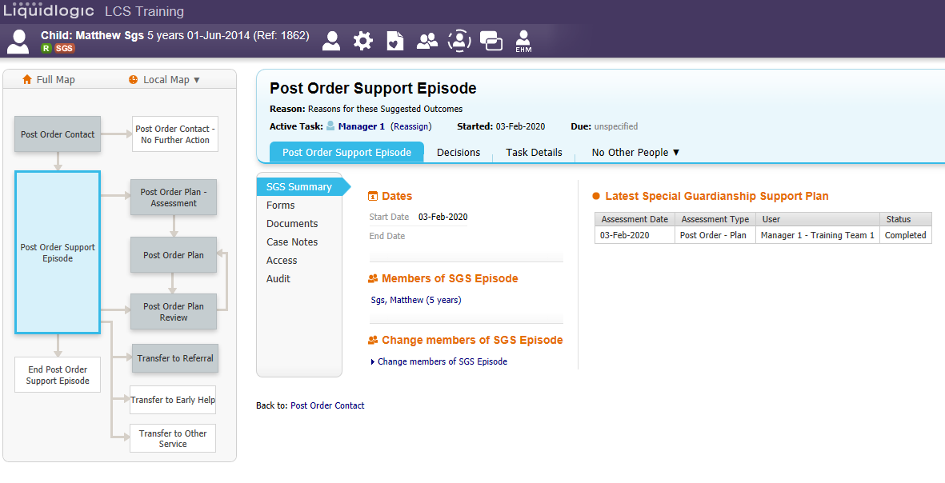
Ending the SGS workspace
To completely close the SGS workspace down, again you need to make a decision, End Post Order Support Episode.

Complete the date and click Confirm.

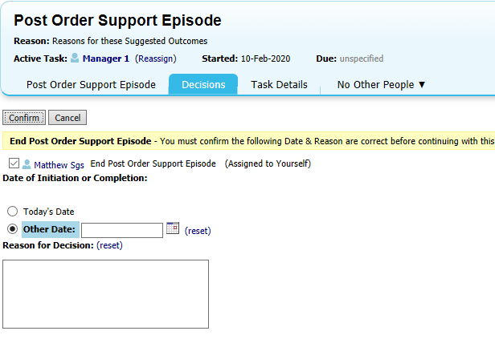

Click the grey button to Start the Post Order Support Episode Closure

Complete the form

Finalise Assessment

This will then go to manager for authorisation

MANAGER will authorise / Request further Information. If authorised, the case will close, and the SGS flag will then be crossed out.

