What is a Special Guardianship Order?
(Children Act 1989 Section 14)
Information for those considering Special Guardianship in Warrington
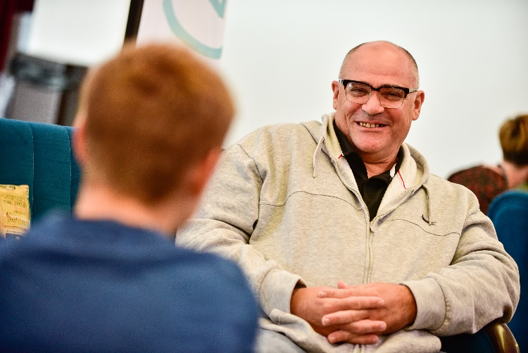
What is Special Guardianship?
Special guardianship is a legal option intended to provide permanence for children who are not being raised by a biological parent. Special Guardianship is an alternative legal status for a child that offers greater security than long-term fostering but without the absolute legal severance from their birth family which an adoption order would serve to do.

What does having Special Guardianship mean?
A Special Guardianship Order (SGO) gives the Special Guardian parental responsibility for the child. Unlike adoption, under a SGO the parents remain the child's parents and retain parental responsibility. However, Special Guardianship overrides the parental rights and responsibilities of the biological parent, whose ability to exercise their parental responsibility are extremely limited.
The intention is that the Special Guardian will have clear responsibility for all the day-to-day decisions about caring for the child or young person and for taking any other decisions about their upbringing, for example their education.
Are there other orders that can sit alongside an SGO that I need to be aware of?
Additional orders may be made alongside the Special Guardianship Order such as a ‘Contact Order’ which sets out the level of direct or indirect contact that the child has with a biological parent or other person considered significant to the child such as a sibling.

Assessment Process?
If you make the decision to apply for Special Guardianship a Court Report, Assessment and Support Plan will be completed by a Social Worker. The process will consider all aspects of your life; personal circumstances, living arrangements, employment and medical status etc. The Social Worker will also seek independent references with regard to your suitability to be a Special Guardian.

How do Warrington Borough Council support those with SGOs?
Each child who is made the subject of a Special Guardianship Order will have a Special Guardian Support Plan, tailored to meet their individual needs. Eligible prospective SGO’s are offered an opportunity to consider the support plan before the court makes an order and will be provided with the opportunity for independent legal advice. The SGO support plan will be reviewed on a 12 monthly (or before if your circumstances change).
Where a children has previously been in care of Warrington Borough Council, the department will ordinarily match the fostering allowance payment made to the Special Guardian at the time the Order is made. This will not include Christmas, Holiday and Celebration payments. Deductions will be made for child benefit and any other credits claimed for the child, such as maintenance payments / child tax credits
A request for financial support may be made where a child is previously unknown to Children’s Social Care or is at risk of coming into care. This will be considered in the Assessment & Support Plan. In these instances a means test will be undertaken by the Finance Officer in Fostering.
Please refer to: SPECIAL GUARDIANSHIP SUPPORT SERVICES – GUIDANCE 2020

Warrington currently have a support team called the Families First Team. The team offer interventions to families who require support in order to help prevent the breakdown of a child’s placement.
How do the Families First Team support Special Guardians?
- The Families First Team can be a listening ear.
Warrington developed the Families First Team, as we are aware that being a Special Guardian can often be an isolating and very difficult role. Having a listening ear to advise and guide you can make a massive difference. The team are here to support you with this.
- The Families First Team can provide assistance with mediation and contact with birth parents.
Often families need a little more assistance with mediation between Special Guardians and birth parents, particularly around contact in order for the child to maintain positive links with family. The team are here to support you with this.

- The Families First Team can provide you with additional training and services to help to meet your child’s needs.
Our children often have additional educational, emotional or behavioural needs as a result of their earlier childhood experiences. Families often require help for the child to understand their background, or require assistance to access additional services such as therapeutic work, advice and information. Special Guardians may benefit from extra professional training to develop their skills and equip them to deal with the child’s needs. The team are here to support you with this.
We also hold a monthly ‘drop in’ for Special Guardian Carers and their children.
Want to find out more?
If you would like more information about becoming a Special Guardian, the support we can provide, or have any other queries, please don’t hesitate to get in touch.
If you already have an SGO for a child you care for, we would love to hear your views on being a Special Guardian, what has helped you and your family and what support you would like to see in the future. This will help us develop the service and support you receive.
Please contact:
- Email: familiesfirstservice@warrington.gov.uk
- Tel: 01925 442725

We look forward to continuing to support you on your journey and providing support tailored to the needs of you and the child you are caring for.

