Corporate Parenting Strategy
2015-2018

Final Draft
Document Control
Name | Corporate Parenting Strategy
Version number | V0.4
Status | Working draft
Author | Stephanie Connelly- National Management Trainee (CAH)
Lead officer | Phillipa Brent-Isherwood
Approved by
Review date | April 2016

Supersedes | N/A
Target audience | Multi-agency services relating to Looked After Children; Elected members
Related to | Children & Young People’s Plan

Version history
Version | Status | Date | Dissemination/Change
V0.1 | 1st draft | 16 April 2015 | Policy & Diversity Advisor
V0.2 | 2nd draft | 17 April 2015 | Interim Corporate Policy & Community Manager
V0.3 | 3rd draft | 6th July | Children’s Improvement Board
V.04 | Final draft | 26th August | Children's Improvement Board

Approval history
Version | Status | Date | Approved by
Add final version number e.g. V0.4 | Add status of policy e.g. Final | Add date | Add name of approving body e.g. Cabinet

CONTENTS PAGES
DOCUMENT CONTROL.................................................................................................................................2
VERSION HISTORY.......................................................................................................................................2
CONTENTS................................................................................................................ ................................…3
FORWARD.............. .......................................................................................................................................4
EXECUTIVE SUMMARY..................................................................................................................... ………5
DEFINITION OF CORPORATE PARENTING................................................................................................6
PURPOSE.......................................................................................................................................................7
AIMS, OBJECTIVES AND OUTCOME...........................................................................................................7
KEY ACTIONS AND MEASURES OF PEFORMANCE..................................................................................7
HAVERING’S STRATEGIC FRAMEWORK AND GOVERNANCE.................................................................7
NATIONAL CONTEXT.....................................................................................................................................9
HAVERING CONTEXT...................................................................................................................................10
PRIORITY 1: ENSURE ALL CHILDREN AND YOUNG PEOPLE ARE SAFEGUARDED IN THEIR PLACEMENTS AND COMMUNITIES............................................................................................................13
PRIORITY 2: IMPROVE THE TIMELINESS OF CARE PROCEEDINGS, PLACEMENT STABILITY AND CHOICE IN ORDER TO ACHIEVE PERMANENCY......................................................................................20
PRIORITY 3: SUPPORTING GOOD HEALTH OUTCOMES FOR LOOKED AFTER CHILDREN…………...25
PRIORITY 4: IMPROVING EDUCATIONAL OUTCOMES FOR LOOKED AFTER CHILDREN....................28
PRIORITY 5: ENOURAGING PARTICIPATION AND POSITIVE ACTIVITIES..............................................31
TIMESCALES.................................................................................................................................................33
RELATED DOCUMENTS...............................................................................................................................33
CONSULTATION...........................................................................................................................................33
AUTHORISATION AND COMMUNICATION.................................................................................................33

Foreword
I am pleased to introduce the Corporate Parenting Strategy for the London Borough of Havering 2015-2018. This is an ambitious 3 year strategy that outlines the values, principles and key priorities to support children, young people and care leavers who are looked after by the London Borough of Havering.
The Corporate Parenting Strategy is not an end in itself; it provides an agreed direction of travel and a common commitment to action. We will work in partnership to fulfil our statutory duty as corporate parents to nurture, respect and be ambitious for our Looked After Children and young people as we would for our own children. This is with the aim of ensuring the best possible outcomes for children and their families and delivering the services they need to live safe, happy, healthy and successful adult lives.
We know that Looked After Children and young people are amongst the most vulnerable in our community, and that all too often their life chances are restricted. We have a responsibility and a commitment to changing this pattern.
Through implementation of this strategy, we will strive to ensure that our Looked After Children and young people have the best possible start in life that we can deliver and ensure we have made a measureable positive difference to their lives.

....................................................... ......................................................
Councillor Meg Davis Isobel Cattermole
Lead Member for Children's Services Interim Director for Children's Services

Executive Summary

This strategy is intended to support the whole council and relevant partners to fulfil their statutory duty as a corporate parent for Looked After Children, young people and care leavers and ensure we are making a measurable positive difference to their lives. Like any good parent, Havering Council endeavours to put the needs of our Looked After Children and young people first. We aim for each and every looked after child to achieve their full potential and become happy, independent and successful adults. We understand that Looked After Children and young people often underachieve at school and need additional support in order to achieve the same educational outcomes as their peers.

The Children Act 1989 places a duty on Local Authorities to support families to stay together where this is a safe and realistic option. Havering has a longstanding approach to preventing children becoming looked after and aims to reunite children with their families in a timely manner. Part of our commitment to improve the lives of our children and young people will involve targeting the root causes of why children become looked after, as part of our wider early help, intervention and prevention agenda.

Havering Council wants to ensure that our Looked After Children and young people are given every chance to experience a safe, healthy and happy life, receiving the right support and services at the earliest opportunity. This means being a powerful advocate for them to ensure their needs are met in the best way possible and prioritising access to our resources. Havering is committed to ensuring we have the widest range of placements available which will cater to the individual needs of each our Looked After Children and young people.

Havering’s role as a corporate parent is significant and far reaching and we will exercise our role with commitment and accountability across all areas of the Council and partnership. We will ensure high expectations for our children are shared widely and wholeheartedly. Our partner agencies will be expected to help us provide tailored services that meet the needs of our children and enable them to grow into balanced and well-rounded individuals. This will include ensuring our children and young people maintain healthy mental and physical development, attend regularly and achieve at school, are involved in extra-curricular activities and develop a sense of independence.

To ensure our vision for Looked After Children is achieved; we have set five strategic priorities:
- Priority 1: Ensure all children and young people are safeguarded in their placements and communities

- Priority 2: Improve the timeliness of care proceedings, placement stability and choice in order to achieve permanency

- Priority 3: Support good health outcomes for Looked After Children

- Priority 4: Improve educational outcomes for Looked After Children

- Priority 5: Encourage participation and positive activities

What is Corporate Parenting?

Corporate Parenting is the term used to refer to the collective responsibility of a Council (officers and elected members) to provide the best possible care and protection for children and young people in the Borough who are ‘looked after’ as set out in the Children Act 1989.

The term ‘looked after’ refers to any child or young person for whom the Local Authority has, or shares, parental responsibility, or for whom we provide care and accommodation on behalf of their parent. The term “child” can refer to any child or young person aged 0 to 18 years. The Council also has a duty and responsibility to those young people who leave their long-term care from the age of 16 years until they reach the age of 21, or 25 if they are in higher education.

A child can become looked after with the agreement of their parent (Section 20, Children Act 1989), this is known as voluntary care. Alternatively, a child can become looked after following an application by the Local Authority for a Care Order (or Interim Care Order) to the Family Proceedings Court (Sections 38 and 31 Children Act 1989). In the latter case, the Court has found that the child is suffering or is likely to suffer significant harm, unless such an Order is made. Most children are looked after by other family members, by foster carers or some may live in a residential placement.

Key responsibilities

The Cabinet Member for Children and the Director of Children, Adults and Housing in Havering has a specific role to ensure the Council is meeting its statutory responsibilities. In particular, the duty to safeguard and promote the welfare of Looked After Children and care leavers by seeking the high quality outcomes that every good parent would want for their child.

Elected members are in the unique position to promote opportunities for Looked After Children and care leavers through their political power and influence, through their connections in the community, schools, health services, local businesses and employers.

However, the Council has a collective responsibility to protect and promote the interests of Looked After Children and therefore all councillor officers, members and partner agencies will be expected to play a key role in the implementation of this strategy.

Corporate Parenting Panel responsibilities:

- To receive and consider accurate and timely management information reports on the numbers, characteristics and needs of Looked After Children and care leavers.
- Agree and oversee implementation of the Corporate Parenting Strategy to drive improved outcomes.
- To provide a forum for Looked After Children to participate and influence policy and enable Looked After Children to have opportunity to talk about issues relating to their own direct experiences of services they have received. Hence the Corporate Parenting Panel will ensure that the positive experiences and services are maintained and lessons are learnt and changes made in the areas that require improvements.
- To comment on and contribute to plans, polices and strategies for Looked After Children and make appropriate recommendations for action
- To receive and consider reports demonstrating how effectively Havering is serving it’s looked after population through the provision of services and targeted initiatives.
- To receive briefings on new national and local initiatives designed to improve children and young people’s life chances.
- To gain knowledge of services based on direct involvement and opportunities to meet and gain the views of stakeholders, especially listening to the views of children and young people looked after and members of the Children in Care Council.
- To monitor and review progress on the delivery of the Pledge to Looked After Children and Care Leavers.
- Ensure that decisive action is taken to address any shortcomings in the services provided to children and young people.

Purpose
The purpose of the Corporate Parenting Strategy is to set out a clear framework for elected members, officers of the Council and partner agencies to enable them to fulfil their Corporate Parenting responsibilities for children, young people and care leavers who are looked after by the London Borough of Havering. The five strategic priorities for Looked After Children provide a clear focus for service improvement which will enable Havering to better meet its Corporate Parenting responsibilities in the future.

Aims, objectives and outcome

The principle aim of this strategy is to put the child’s journey at its centre by building on the strengths of the existing range of interventions and services we provide, whilst also working towards continuously improving the support on offer to this key group of children, young people and their families.

Central to its development has been the child’s voice and input from current Looked After Children through the Havering Pledge co-produced by the Children in Care Council and Corporate Parenting Panel. This Pledge will form the basis of the Corporate Parenting action plan which will provide the operational guidance for the implementation of this strategy to ensure we meet out five strategic priorities. We are keen to ensure that all services across the Council are implementing the Pledge and thinking about the needs of every child and young person that is looked after.

Key actions and measures of performance

The key actions and measures of performance will be based around the Council’s Pledge to Looked After Children and the Council’s progress against the five strategic priorities within this strategy. The measure of performance will be found within the Corporate Parenting action plan which will provide key performance indicators and outcomes so that progress can clearly be assessed. The council will monitor the delivery of this strategy through the Assistant Director of Children's Services. Key actions will be built into service plan delivery, which will be monitored corporately. In addition to this, services will ensure they liaise with the Children in Care Council to confirm that the services delivered to Looked After Children are helping them achieve their full potential.

Havering’s Strategic Framework and Governance

This Corporate Parenting Strategy is not a stand-alone publication. Our Children and Young People’s plan sets out our strategic ambitions for all children and young people within the Borough, which provides the foundations for the Corporate Parenting Strategy and our Sufficiency Statement.
We have incorporated Looked After Children’s needs as part of the Council’s Corporate Plan under the ‘Safe’ priority by ensuring we will use our resources to protect people in need and give Looked After Children stability through more and better fostering and adoption opportunities. This is because, in most circumstances, permanency is the best way to achieve the best possible outcomes for Looked After Children.
The Havering Children & Young People’s Plan 2014-17 sets out our aims for every child in every part of the Borough. We want every child to:
- Get the best possible start in the early years and be ready for school
- Attend a good school and experience success in learning
- Feel safe at home, in their local area, and at school
- Develop lifelong aspirations and grow up to be a citizen who contributes positively to the lives of those around them
- Experience the best possible health outcomes

The plan outlines the Council’s three priorities: addressing family poverty, encouraging healthy weight and improving wider health, wellbeing and education outcomes for the most vulnerable children. These priorities have a direct impact on the children and young people in our care.
The Children’s Services Improvement Board (CSIB) is comprised of senior managers and officers from education, health and social care, ensuring our services work in collaboration to improve outcomes for Havering’s children and young people. This strategy will be presented to CSIB for initial approval and then progressed to the Children in Care Council, followed by our executive boards.

As we progress to implementation, we will continue to seek the views of our Looked After Children and young people, to make sure that their views and experiences remain central to our strategic planning and service delivery.

Governance

Corporate Parenting Panel | Children’s Trust | Health & Wellbeing Board
Children in Care Council

Children’s Services Improvement Board

Strategy and Policy
Children and Young People’s Plan

Corporate Parenting Strategy

Corporate Parenting Action Plan | Havering’s Pledge to Looked After Children

National context
Children and young people in care are some of the most vulnerable people in our community and face a number of challenges as they grow up, develop and then move on to independence. They may come from a background where they have suffered abuse and or neglect, may have experienced significant loss or bereavement or may have arrived in Havering from abroad as unaccompanied minors. Nationally there were 68,840 Looked After Children as at 31 March 2014, an increase of 7% compared to 31 March 2010. The number of Looked After Children has increased steadily over the past five years and it is now higher than at any point since 1985. Nationally the rate of Looked After Children per 10,000 is 60. At Local Authority level the rate varies significantly.

The age profile of children looked after has been relatively stable since 2010. The largest age group is 10 to 15 year olds, which made up 37% of Looked After Children at 31 March 2014. There has been a slight increase in the percentage of 5 to 9 year olds, from 17% in 2010, to 20% in 2014. These trends are in line with the age breakdown of all children. The majority of children looked after at 31 March 2014 (74%) are from a White British background, the same proportion as the general population of all children. The ethnic breakdown for children looked after has varied little since 2010. The Government has been clear in its drive to improve services and outcomes for Looked After Children in all types of permanence care, with revised statutory guidance that clearly sets out the need to address the problem of delays, for example, within the adoption system. It is apparent for all professionals working within children’s social care that the current court processes are contributing to the delays encountered by children and as a result the Family Justice Review has reviewed the Public Law Outline with a programme that aims to dramatically speed up care proceedings, including a time limit of 26 weeks within which all bar exceptional cases must be completed.

Nationally, there are inequalities for children in care compared to their peers. The government found that Looked After Children have the following outcomes:
- 12% of children in care obtain 5 or more A*-C GCSEs, compared to 58% of non-Looked After Children
- Children in care are twice as likely to be excluded from school and significantly more likely to be not in employment, education or training (NEETs)
- During the year ending March 2013, 6.2% of children in care aged 10-17 had been convicted or subject to a final warning, compared to 1.5% of their peers.
- 3.5% of Looked After Children aged 10-17 have a substance misuse problem compared to 0.5% of their peers.

The Government has been clear in its drive to improve services and outcomes for Looked After Children in all types of permanence care, with revised statutory guidance that clearly sets out the need to address the problem of delays for example within the adoption system. It is apparent for all professionals working within children’s social care that the current court processes are contributing to the delays encountered by children and as a result the Family Justice Review has reviewed the Public Law Outline with a programme that aims to dramatically speed up care proceedings, including a time limit of 26 weeks within which all bar exceptional cases must be completed.

Havering Context

Havering is the third largest London Borough, covering some 43 square miles. It is located on the northeast boundary of Greater London. To the north and east the Borough is bordered by the Essex countryside, to the south by a three mile River Thames frontage, and to the west by the neighbouring London Boroughs of Redbridge and Barking & Dagenham. The location of Havering in the context of all Greater London is presented below. Havering has 18 electoral wards; which can also be seen.
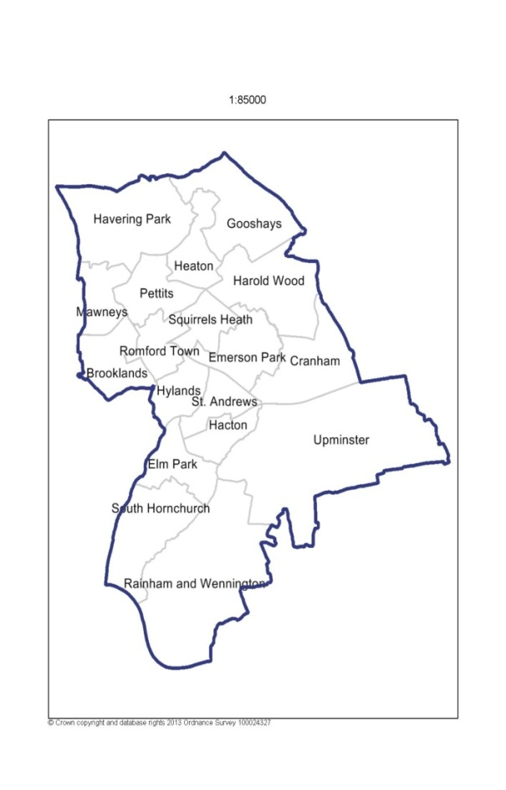

Havering is mainly characterised by suburban development, with almost half of the area dedicated to open green space, particularly to the east of the Borough where strict Green Belt restrictions are in place. On the other hand, its principal town (Romford), is densely populated, and is a major metropolitan retail and night time entertainment centre. The southern part of Havering adjacent to the Thames is within the London Riverside section of the Thames Gateway redevelopment area. This will therefore be the site of increasing development and population change.

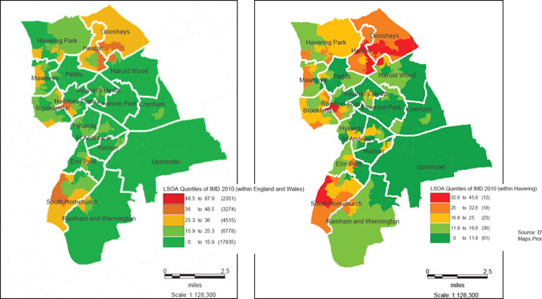
On average, people living in deprived areas, lower socio-economic groups and marginalised groups have poorer health and poorer access to health care than people resident in affluent areas and people from higher socio-economic groups.Generally Havering is ranked 177th overall out of 326 Local Authorities for deprivation (1st being most deprived, 326th being least deprived). However, there are pockets of high deprivation to the north (Gooshays and Heaton wards) and south (South Hornchurch) of the Borough. Many of our Looked After Children come from our most deprived wards and thus our focus will also be on tackling the root causes of deprivation and child poverty within Havering.

Havering LAC demographics
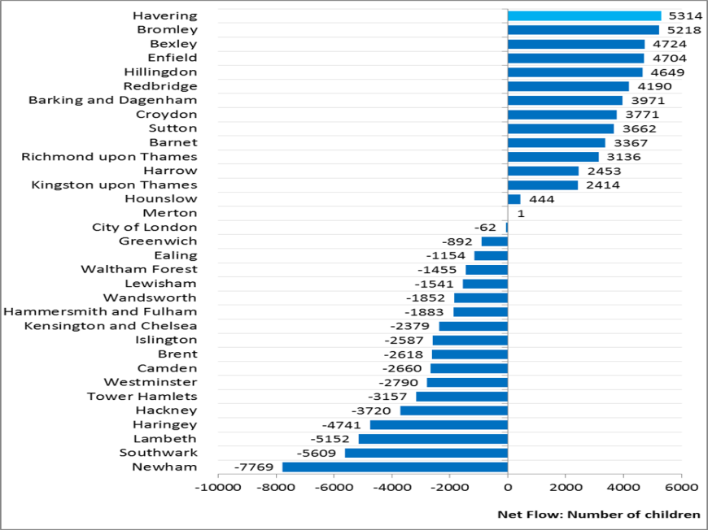
Havering has seen a recent rise in the number of children in care, with 240 children in our care at the end of 2014/2015. This has gone up from 190 in 2013/14. At the same time there has been an increase in the number of families with children moving into the Borough. Havering has experienced the largest net inflow across all London Boroughs. Across, the 5-year period (2009-2013) there was a total of 5,314 children, who have settled in the Borough from another London Borough.
The age profile of children looked after has been relatively stable since 2010. The largest age group is 11 to 15 year olds, which made up 31% of Looked After Children at 31 March 2014. There has been a slight increase in the percentage of 5 to 10 year olds, from 22% in 2013/14, to 26% in 2014/15. These trends are in line with the age breakdown of all children and the national averages. In comparison to the national averages for gender, Havering has traditionally had a higher number of male Looked After Children than female. More recently the gender gap has closed with the Havering averages aligning with national statistics.

LAC BY GENDER - PERCENTAGE | HAV-AVG 2011/12 | NAT-AVG 2011/12 | HAV-AVG 2012/13 | NAT-AVG 2012/13 | HAV-AVG 2013/14 | NAT-AVG  2013/14 | HAV-AVG  2014/15 | NAT-AVG  2014/15
PERCENTAGE - MALE | 61% | 56% | 59% | 55% | 55% | 55% | 56% | 55%
PERCENTAGE - FEMALE | 39% | 44% | 41% | 45% | 45% | 45% | 44% | 45%
The majority of Looked After Children in Havering are White British (70%), which is in line with national demographic trends. However, since 2011, Havering has seen an increase in the diversity of the children in its care, with the number of Black African children rising from 3% in 2011 to 11% in 2015. These demographics changes have meant the service has needed to adapt to best meet the needs of BME children.
There has also been an increase in number of Looked After Children from any other white background from 2% in 2011, to 5% in 2015. These demographic changes are currently being reviewed to ensure they are appropriately relflected in the services we commission.
Children and Young People’s Services
The Children and Young People’s Service is currently managed in 5 service areas. Additional management was agreed both to meet additional demand arising from an increase in statutory work with rising numbers of children on child protection plans and Looked After Children and also to deliver on improvements to work with Looked After Children. The current 5 Service areas are:
- The MASH, Assessment and Children in Need Service – is responsible for the Multi-Agency Safeguarding Hub, the Assessment Service and Children in Need and Child Protection Services for children aged under 12 and their families.

- The Looked after Children, Leaving Care and over 12’s Service –is responsible for Looked After Children including those in care proceedings (although initial court work will usually commence in Assessment and under 12’s children in need), children staying in long-term care or where the plan is for a permanent family through adoption or special guardianship. The service is responsible for all older children in need, on child protection plans or looked after. The service area also includes the Leaving Care service.

- The Early Help, Troubled Families and Youth Offending Service - is responsible for the 6 children’s centres, the Youth Offending service and targeted Early Help services including Family Group Conferencing (which is also used in statutory social work including care proceedings). The service included YOS along with targeted intervention for teenagers. It also supports mainstream services in completing EH assessments and Team around the Family meetings. Troubled Families is integral to Early Help and has assisted in making the service multi-agency.

- The Fostering, Adoption and Placements Service – Fostering is currently in 2 teams; a recruitment team which recruits and assesses foster carers and assesses family and friends carers and a team of supervising social workers who supervise existing carers. The adoption team recruits and assesses adopters and family finds for children where adoption is the plan. The team are also responsible for assessment and support of Special Guardians. The placements team is responsible for sourcing in-house and external placements and for the quality assurance of external placements.

- The Safeguarding and Service Standards Unit -has 4 main functions: chairing child protection conferences and Looked After Children reviews, managing and supporting the functions of the LSCB, the LADO function (managing allegations against staff and volunteers working with children) and overseeing case audit.

The Children and Young people’s service also works closely with the new Children and Adults with Special Educational Needs and Disability Service which sits within the Learning and Achievement Service.

- The Children and Adults with Special Educational Needs and Disability Service -will provide a streamline whole life ‘service’ for children and adults, and their families, with special educational needs and disabilities. It is intended that the new service, Children and Adults with Disabilities Team, will be responsible for providing person centred, seamless support, assessment, placement and commissioning process for all children and adults with disabilities from birth. The service currently includes professionals from education and social care working with age groups from 0-19. They will shortly be joined by health colleagues and teams working with adults who have disabilities.
Priority 1: Ensure all children and young people are safeguarded in their placements and Communities
National context:
Local Authorities have overarching responsibility for safeguarding and promoting the welfare of all children and young people in their area. They have a number of statutory functions under the 1989 and 2004 Children Acts which make this clear, and does the recently published ‘Working together to safeguard children’ guidance. This includes specific duties in relation to children in need and children suffering, or likely to suffer, significant harm, regardless of where they are found, under Sections 17 and 47 of the Children Act 1989. Whilst Local Authorities play a lead role, safeguarding children and protecting them from harm is everyone’s responsibility. Everyone who comes into contact with children and families has a role to play.
Safeguarding and promoting the welfare of children is defined as:
- protecting children from maltreatment;
- preventing impairment of children's health or development;
- ensuring that children grow up in circumstances consistent with the provision of safe and effective care; and
- taking action to enable all children to have the best outcomes.
Local agencies, including the police and health services, also have a duty under Section 11 of the Children Act 2004 to ensure that they consider the need to safeguard and promote the welfare of children when carrying out their functions. Under Section 10 of the Children Act 2004, agencies are required to cooperate with Local Authorities to promote the well-being of children in each Local Authority area. This cooperation should exist and be effective at all levels of the organisation, from strategic level through to operational delivery. Professionals working in agencies with these duties are responsible for ensuring that they fulfil their role and responsibilities in a manner consistent with the statutory duties of their employer.
Children have said that in order to be appropriately safeguarded they need:
- Vigilance: to have adults notice when things are troubling them
- Understanding and action: to understand what is happening; to be heard and understood; and to have that understanding acted upon
- Stability: to be able to develop an on-going stable relationship of trust with those helping them
- Respect: to be treated with the expectation that they are competent rather than not
- Information and engagement: to be informed about and involved in procedures, decisions, concerns and plans
- Explanation: to be informed of the outcome of assessments and decisions and reasons when their views have not met with a positive response
- Support: to be provided with support in their own right as well as a member of their family
- Advocacy: to be provided with advocacy to assist them in putting forward their views.

Havering’s track record:
Havering Council recognises that Looked After Children and care leavers are some of the most vulnerable residents in our community and our duty to safeguard and protect them remains a key priority during their time in placement and when they leave. Following a string of high profile prosecutions across the country involving Child Sexual Exploitation (CSE), most notably in Rotheram, Havering has been keen to strengthen its safeguarding policies and multi-agency working to ensure we are appropriately safeguarding all the children in the Borough, especially those in our care.
Havering Local Safeguarding Children Board (LSCB) is a statutory board that represents all organisations that work with children in order to keep children safe from harm in Havering. The LSCB committed to raising safeguarding standards and improving outcomes for all the children of Havering.
The LSCB's five priorities
- Ensuring the partnership provides an effective child protection service to all children ensuring that all statutory functions are completed to the highest standards.
- Monitoring the development and implementation of a multi-agency early offer of help to children and families living in Havering.
- Monitoring the alignment and effectiveness of the partnership when working across the child's journey between universal, targeted and specialist safeguarding.
- Coordinating an approach to domestic violence, mental health and drug and alcohol abuse across the children and adults' partnership to ensure that families affected receive the right support at the right time.
- Ensuring that Havering Safeguarding Children Board communicates effectively with partners, children, young people and their families, communities and residents.
Havering has identified that some children and young people of particular circumstance can be at a higher risk of harm and may need more targeted support. These children and young people include but are not limited to:
- Children who go missing from care and / or who are at risk of CSE.
- Children who are in part time education {less than 25 hours p/w}.
- Children who are affected by gangs or groups
- Children whose lives are affected by alcohol or drugs
- Children in placement and from adults who may pose a risk {to include professional abuse allegations & management}.
- Children who are looked after who are also parents
- Young people involved in youth offending
Safeguarding children who go missing from care and / or who are at risk of CSE
Havering’s Runaway and Missing from Home & Care (‘RMFHC’) Protocol has been written jointly by: London Borough of Havering Children’s Services; Havering Metropolitan Police; and The Children’s Society. Havering has commissioned The Children’s Society to conduct independent return home interviews for children and young people who have been missing. These provide an opportunity to uncover information that can help protect children from the risk of going missing again, from risks they may have been exposed to while missing or from risk factors in their home.

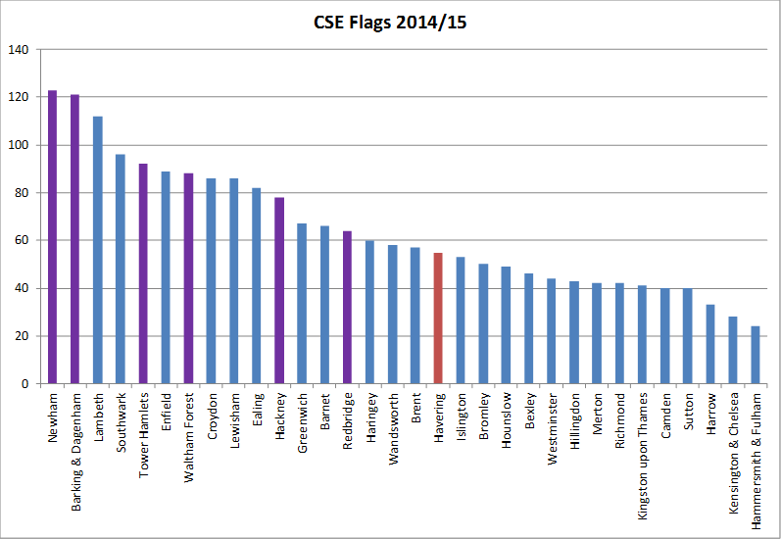
Havering LSCB has a CSE sub-group which is responsible for coordinating a local action plan to improve responses to CSE in Havering. The Multi Agency Sexual Exploitation (MASE) meetings were established as part of the Metropolitan Police Pan London CSE Protocol. Recording and identification of CSE is fairly recent in both the Local Authority and within policing. Whilst the offences of CSE are not new, understanding and ability to recognise/identify such crimes within client and crime databases is something that has only occurred in the past two years. As such, long term data on the problem locally is unavailable. The Metropolitan Police are now able to ‘flag’ crimes which are thought to be CSE, and in 2014-15 there were 55 CSE crimes recorded in Havering (with an additional 25 crime related incidents/none-crimes being recorded when concerns have been raised). Havering ranked 18th of the 32 London Borough for volume, with the average number of cases per Borough being 32. Our neighbouring Borough of Barking & Dagenham was the 2nd highest with 121, and there were offenders from this Borough which impacted on Havering.
Following a peer review conducted by the London Borough of Hillingdon, Havering introduced an action plan to help implement the recommendations it received. Part of this work has involved the creation of the multi-agency CSE steering group and a virtual CSE hub to aid information sharing across partner agencies. One of the actions involved Implementing ‘Missing’ Children Multi-agency panel (including those frequently missing from school) this has ensured that missing episodes are formally considered and risk assessed for CSE & Gangs/Groups.
Safeguarding children who are in part time education {less than 25 hours p/w}
As Corporate Parents, Havering Council requires that all Children in Care receive full-time education. However, it is understood that a Child in Care may require a temporary part-time table approach for a limited period. This plan must have the joint agreement of the child’s social worker and Virtual School Head. The DFE also expects a reduced timetable to be managed through a Pastoral Support Programme, or other appropriate robust multi-agency plan. This must have a time limit by which point the pupil is expected to attend full time or be provided with alternative provision.The Local Alternative Provision Commissioner holds an approved provider list, each whom has undergone a robust approval and quality assurance process which is linked to the work of Havering’s Community Safety team
There may be circumstances in which full-time education is not in the best interests of the child, such as where they have been suffering from a medical or psychological condition. Where this is the case, the Green Vale Campus offers teaching support, via schools, for pupils who unable to attend due to attend mainstream schools. Following an initial review, teaching will be put in place; it often occurs in the pupil’s home/ placement, it might also happen in a local library. The aim is to support pupil learning until they are able to reintegrate back into their school. For those pupils who have been out of school for long periods, or where it is deemed appropriate, pupils can attend the Green Vale Campus for a set period of time. At the campus pupils can be taught in small groups as a preparation for them returning to mainstream education.
Safeguarding children who are affected by gangs/groups or serious youth violence
Havering was selected for involvement in a Home Office programme “Ending Gangs and Youth Violence” programme that began post riots in 2011/12 and continues on an on-going basis. Involvement in this programme helped the Local Authority significantly to understand the impact and way in which gangs in this area operate and how vulnerable young people including Looked After Children and care leavers may get involved and focus on how to improve safeguarding for this vulnerable group of young men and young women.

Havering has an established Multi-Agency Safeguarding Hub and is piloting an Adult Multi-Safeguarding Hub. Within the MASH multi-agency staff are co-located, with representatives from police, children and adult social services, probation/CRC and housing. Referrals and information is received via a dedicated MASH gang researcher and brought to the Serious Group Violence panel (if unsuitable for SGV then onward referrals would be made elsewhere, i.e. Early Help Team). Any young person identified by the researcher as at-risk of gangs and serious group violence will by ‘MASHED’ to ascertain risk factors and/or drivers, with appropriate action taken as relevant. The MASH gang researcher has begun qualitative analysis and association mapping of high risk vulnerable groups with the aim of identifying those in need of early help services, and those requiring protection services. A specialist Over 12’s services works closely with Youth Offending Services to protect and divert children from gangs. All those identified as at risk of serious group violence are brought to the Serious Group Violence panel – persons can be referred via all agencies. Referrals can also be identified from the Violence Against Women Group where there are clear links with gangs identified.
As of November 2014, Havering had 83 individuals of concern, of which 25 appear on the Trident Gangs Matrix (these 25 are predominantly part of what is known as the ‘Station Crew’). The 83 figure includes individuals identified as at-risk. These individuals can be categorised as follows:
- 7 adult criminals believed to be involved in drug dealing, above street level, who according to police intelligence associate with members of the ‘Station Crew’.
- 22 persons who are believed to be part of the ‘Station Crew’.
- 13 persons who are believed to be part of gangs based outside of Havering, but residing here or retaining links to persons here.
- 17 young men/boys who are believed to associate with one or more members of the Station Crew who could be at-risk of future involvement.
- 4 local offenders who associate with the ‘Station Crew’ but we do not believe they are members. These are all burglary offenders.
- 20 females who associate with members of the ‘Station Crew’ or who have been sexually active with nominals in Havering. This includes at least 4, potentially 6, females who are members of the ‘Station Crew’.
Young people who are affected by gangs/groups or serious group violence panel are assessed and able to access a wide range of interventions. These include CAMHS assessment and support, family and parenting work, education, training and employment support and access to accommodation support. The Havering Community Safety Partnership has clear links with schools and pupil referral units. In 2012-13 Child Sexual Exploitation Awareness programmes were offered to all secondary schools in Havering (evaluation available). In 2014 Gang’s awareness training was been delivered to secondary head teachers within Havering so they are aware of risks and identification methods, and also referral procedures and how to relay concerns. Further work to raise awareness (of personal safety) for pupils begun in June 2014 with a Junior Citizenship scheme, targeted at year 6 transitional students (1,100 students).
The PRU are represented at the monthly Serious Group Violence panel and the virtual head for Looked After Children is a member of the Serious Group Violence Strategy Group. There are currently five Safer Schools Officers in Havering, with recruitment taking place to expand this provision to eight. There is insufficient resource available to ensure one officer per school/sixth form as is the case in inner Boroughs. What we are doing is reviewing this alignment through grading the education establishments into risk categories. Therefore, Gold would require a dedicated schools officer, Silver will share a schools officers and Bronze will become the responsibility of the Dedicated Ward Officer (DWO) whose ward the school is located within.
Safeguarding children whose lives are affected by alcohol or drugs
The majority of young people who seek help for substance misuse have other emotional or social problems, such as self-harming, offending, family issues. They are also less likely to be in education, employment or training (NTA, 2011). Studies have shown that young people from more than one vulnerable group are more at risk of drug or alcohol misuse (DfES:2005; The NHS Information Centre, 2011). The groups at risk are:
- Young offenders
- Looked After Children
- Care leavers
- Children affected by parental substance misuse
- Children affected by domestic violence
- Homeless young people
- Young people at risk from sexual exploitation
- Young people in gangs or at risk of gang recruitment
- Excludees and persistent truants
The Drug and Alcohol service for under 18s in Havering is called ‘Young Addaction Havering'.​​​​​​
​​ It is based at Romford Youth Zone and provides flexible weekday, weekend and evening appointments for young people. The service also provides the option for young people to have their meetings in other parts of the Borough.
The service provides:
- Support to schools in delivering drug education
- Outreach drug education to young people out-of-school and in community settings
- Prevention and early intervention work with young people excluded from or at risk of exclusion from school.
- Comprehensive assessment of substance misuse
- Advice and information to young people
- Support to young people whose parents have substance misuse problems.
Of the 121 Looked After Children/young people included in the 2014/15 cohort 5.8% (7 LAC) have been identified as having a substance misuse problem compared to 8.8% (11 LAC) the year before. Nationally, only 3.5% of Looked After Children and young people are being identified as having a substance misuse problem. In England, 34.2% of the Looked After Children identified as having a substance misuse problem refused intervention and support suggesting that the biggest challenge for our services will be engaging young people in the rehabilitation process.
Safeguarding children in placement and from adults who may pose a risk
The role of LADO in Havering was under the management of the Safeguarding Service Standards Unit. LADO activity until November 2014 was shared across the team with appropriate professionals undertaking the functions. This included duty team managers, the group manager and independent reviewing officers there is no statutory training for the post. In early 2014 it was identified that a number of issues had arisen due to an increase in the volume of LADO referrals and because there was no one person responsible for the post. Recognising the organisation required proper and adequate resources and staff, funding was successfully obtained by the Service Manager. The role is now carried out by one member of staff supported by a business support colleague. This has improved communication between key partner agencies including Ofsted, Youth Groups and nursery settings. Positive training has been provided in the late 2014 -2015 counting year for foster carers. This has resulted in two positive outcomes:
1. A greater understanding of not only the LADO process but the rationale for its existence and the support it provides for all parties concerned;
2. The reason why, when a case is referred to CPS, it takes so long or a decision to be made and the impact that has on outcomes from LADO and fostering teams.
The following data compares the raw number of allegations in 2013 /2014 and 2014 / 2015.
 | 2013 / 2014 | 2014 /2015
1st Quarter | 47 | 18
2nd Quarter | 40 | 25
3rd Quarter | 41 | 44
4th Quarter | 31 | 34
Total | 159 | 121

Although there has been a decrease in the number of referrals received in 2014/15, the referrals data since 2010 and in the last 2 quarters has shown an increasing trend. Furthermore when Havering attended the National LADO meeting in March 2015, it was a point of discussion that nationally there has been an increase in referrals. The reason for this is:
- Improved awareness of process;
- Single point of contact for LADO within the Local Authority;
- Internal and external training sessions.
Safeguarding Looked After Children who are parents
Recognising the high levels of vulnerability of Looked After Children and care leavers who become parents themselves, they are a very high priority for assessment of their needs and those of their children. A wide range of interventions are on offer. These include:

- Parenting programmes
- Mother and baby placements and parental assessments
- Health & wellbeing support
- Access to Children’s Centres

Safeguarding young people involved in youth offending
As of the 31st of March 2015, 87 Looked After Children and young people were above the age of 10years old. Of these 87, 5 have been convicted during this period (5.7%) compared to last year where it was only 2.4%. Although this is a concern, Of the 30,660 children looked after aged between 10 and 17 years nationally, 1,710 (5.6 per cent) had been convicted or subject to a final warning or reprimand during the year 14/15- showing that Havering is in line with the national average. The Early Help, Troubled Families and Youth Offending Service have been working closely with the Looked After Children Service to ensure there is early identification of children in care that might be particularly vulnerable of being drawn into crime. Furthermore, additional support and services have been put in place to ensure a robust multi-agency plans are in place for all LAC at point of discharge from custody. The percentage of young offenders engaged in suitable education, employment or training had improved to 77% in February 2015 and a reduction has been seen in the number of first time entrants to the Youth Justice System.
The Youth Offending Service were recently inspected by HM inspectorate of probation, the inspectors commented that ‘Overall, we found good assessments offending behaviour and public protection; these had improved since the last inspection. Case managers knew young people well and had engaged with them and their parents and carers, to understand what was contributing to offending. We found good support for children and young people to access education, training or employment and for substance misuse. Parents were seen as being central to the young person and were supported to help their child to stop offending. Planning was not always clear, this was recognised and a new system was being introduced. Oversight of work by managers has focused on process and it was positive to find that both the managers and staff had recognised and wanted to find a way of incorporating the quality of work and practice into supervision.’

Havering’s commitment moving forward:

- Ensure preventative interventions with young people are commissioned based on an understanding of what works.
- Ensure assessments of the risk of serious harm to others include the potential for future harmful behaviour and assessments of vulnerability consider if and how offending behaviour contributes to a child or young person’s vulnerability.
- Review cases which appear as Teenage Domestic Violence to investigate the possibility that CSE is also a factor (Boyfriend Model, Peer-on-Peer Model)
- Create Looked After Children packs which provide specific information relating to safeguarding and signpost the support and interventions available, especially for those at higher risk of harm.

Priority 2: Improve the timeliness of care proceedings, placement stability and choice in order to achieve permanency
The national context:
The best possible care involves giving children security, stability and love throughout their childhood and beyond. There are a range of permanent care options which can do this. Many children are only looked after by local authorities for a short period and then return home to the live with their families. Local authorities are under a legal duty to support families to stay together when that is a realistic prospect. Nationally three quarters of Looked After Children are in foster placements. For some this is a temporary arrangement, but for many children, particularly older children with a link to their birth parents, long-term foster care, often with family or friends, is the best permanent care option.

Providing stability relies on identifying the right placement for a child early in their care journey whilst ensuring that individual and family needs are properly assessed and support services provided in order to achieve early permanence. Remaining in care with a long term foster family or finding a new permanent family through adoption, special guardianship or residence orders are other routes to permanence. While it is evident that achieving timely permanence is desirable, nationally annual data returns show that a small but substantial number of children still experience multiple placements each year.

Special Guardianship was introduced in 2005 as a way of giving foster carers, a relative or family friend parental responsibility for a child without severing the child's ties with his or her birth family. Residence Orders were introduced in 1989 and are usually used by relatives. The Residence Orders remain in force until the child or young person’s 16th birthday whereas a Special Guardianship Order remains in force until a child or young person’s 18th birthday.

In some cases adoption is the best option particularly for younger children, but also for some older children. Adoption gives vulnerable children, including many with complex needs and a history of ill-treatment, the greatest possible stability in a permanent home with a permanent family. The Government continues to monitor the timeliness of adoption through annual returns and the adoption scorecard process. The adoption scorecard focuses on Local Authorities and the adoption process for children; this has developed to include data on timeliness for prospective adopters from 2014.

A revised Public Law Outline introduced in April 2014 set out streamlined case management procedures for dealing with Public Law children's cases. Its aim was to identify and focus on the key issues for children to making the best decisions for them within the timetable set by the Court, and avoiding the need for unnecessary evidence or hearings. Under the revised Section 32(1) (a) of the Children Act 1989 (introduced by section 14 of the Children and Families Act 2014), Care and Supervision proceedings must be completed ‘without delay, and, in any event, within twenty-six weeks beginning with the day on which the application was issued’. This places an increased emphasis on Pre-Proceedings work and the quality of assessments. The national average performance benchmark as at the end of 2013/14 is 33 weeks (National annual average 2013/14, CAFCASS).
Havering's track record:
Havering has seen a recent rise in the number of Children in Care, with 240 children in our care in March 2015. This has gone up from 190 in 2013/14 and has primarily been as a result of children and young people migrating into the Borough. This is partly due to a change in Pan London Protocol around the allocation of Unaccompanied Asylum Seeking Children across London Boroughs, Havering had 3 (UASC) in 2013/14 which rose to 17 in 2014/15. The majority of children are placed within the Borough (56%), while 44% are placed outside the Borough.

The two main changes in placements since 2012/13 has been a reduction in the percentage of in-house foster care placements (although the number of these placements has remained the same). The second change has been a 57% increase since 2012/13 in semi-independent placements because of the changes surrounding Unaccompanied Asylum Seeking Children (UASC) when Havering signed up to the Pan London Protocol for the safe care of UASC led by the London Borough of Croydon.

A summary of placements:

LAC BY PLACEMENT TYPE | Avg 2010/11 | Avg 2011/12 | Avg  2012/13 | Avg 2013/14 | Forecast average number 2014/15 | Forecast average number 2015/16 | Forecast average number 2016/17
IN-HOUSE FOSTER CARE | 77 | 71 | 75 | 70 | 81 | 88 | 92
FAMILY AND FRIENDS | 22 | 22 | 14 | 17 | 22 | 24 | 25
P&V AGENCY FOSTER CARE | 43 | 39 | 46 | 53 | 68 | 74 | 77
RESIDENTIAL UNIT | 12 | 14 | 16 | 9 | 16 | 17 | 18
CWD RESIDENTIAL | 9 | 9 | 8 | 6 | 4 | 4 | 5
PLACED WITH ADOPTERS | 5 | 3 | 9 | 8 | 7 | 8 | 8
SECURE UNIT | 0 | 0 | 2 | 3 | 0 | 0 | 0
BOARDING SCHOOL | 1 | 1 | 1 | 1 | 0 | 0 | 0
PLACED WITH PARENTS ON A CARE ORDER | 17 | 8 | 4 | 5 | 1 | 1 | 1
SEMI-INDEPENDENT/SUPPORTIVE LODGINGS PLACEMENTS | 18 | 15 | 12 | 18 | 33 | 36 | 37
NHS/HEALTH TRUSTS | 1 | 0 | 1 | 1 | 0 | 0 | 0
MISSING FROM PLACEMENT | 1 | 0 | 0 | 0 | 0 | 0 | 0
FAMILY ASSESSMENT UNIT | 0 | 0 | 0 | 0 | 5 | 5 | 6
TOTAL AVERAGE LAC | 205 | 182 | 190 | 190 | 237 | 257 | 268

In previous years, Havering had comparatively high rates of children in care moving between placements. Detailed work was undertaken in 2011/12 to understand the causes of placement stability and to inform a service improvement plan. The proportion of children moving placements three or more times has lowered since 2012 and is now closer to comparator rates. At 31st March 2015, 10.6% of our LAC had 3 or more placement moves, which was 3.5% less than the previous year’s outturn of 14.1%, and represents an overall reduction of 24.5% on period 2012/13, aligning Havering to the national average for placement moves.

Placements 1 |  | Latest data - 2014 |  | A low percentage represents high performance
Rank | LA Code | LA Name | 3 year average in 2012, 2013 and 2014(%) | 2014 Outturn
 |  | ENGLAND | 11 | 11
125 | 311 | Havering | 14 | 11
92 | 303 | Bexley | 12 | 10
16 | 887 | Medway | 9 | 7
16 | 881 | Essex | 9 | 9
61 | 351 | Bury | 11 | 11

However, placement stability does not always mean the relationship between the child and carer is happy or that the carers are satisfied. Sometimes, especially for younger children who are more likely than teenagers to have stable placements but less able to express their views, this is not the case. This data needs to be looked at in the context of children’s feedback about their happiness in their placement and is regularly reported on through the children’s social care quality assurance group and viewpoint assessment feedback.

The Council is keen to ensure that every child and young person in care is in the best placement to meet their needs. At present, the Council is aiming to improve the proportion of in-house foster carers and placements with prospective adopters. We, as Corporate Parents, must ensure that every child in care is in a long term placement in order to provide them with stability. The Council is aiming to improve the quantity and quality of semi-independent and residential care placements by working with providers and our housing department so that we have more choice within Borough.

Our year end outturn at 31st March 2014 was 79.2%, which is a significant improvement on the previous year's outturn of 63%. The year end outturn for 2014/15 was 83% which exceeded our target of 80%, and represents very good performance in relation to this KPI, and should ensure that we continue to perform significantly above the national average and those of our statistical neighbours.

The recruitment campaign for foster carers continues and although there were 12 new carers registered throughout 2014-15, the target of 15 has not been achieved. The shortfall is due to this being the first year of establishing a recruitment strategy and operational plan for both fostering and adoption. The number of foster carer enquiries has risen considerably since January, 46% of the full year total, which bodes well for the future. Furthermore, the full year total of 18 Special Guardianship Orders granted is 64% higher than 2013-14 and 38% higher than 2012-13. During this period 2014/15 we have seen 10 children cease to be looked after as a result of the granting of an adoption order, whilst we saw 15 adoption orders granted during last period 2013/14. However, Havering have seen unprecedented numbers of children/young people ceasing to be looked after during this period, 179 during 2014/15 as compared to 119 during 2013/4, which could provide an explanation for this.

The adoption scorecards were introduced as part of a new approach to address delays in the adoption system, set out in An Action Plan for Adoption: Tackling Delay. Performance thresholds for the first and second indicators in the scorecard make clear our minimum expectations for timeliness in the adoption system. The DFE will raise the performance thresholds incrementally over the next four years until they reflect the levels set out in statutory guidance. In 2014/15 we saw 10 of our Looked After Children ceasing to be looked after due to the granting of an adoption order, with an average time between entering care and moving in with their adoptive family of 595 days. Of the 7 children currently placed with their adoptive families awaiting orders, the average is 566 days between entering care and moving in with their adoptive families.

This is a significant improvement on last year's performance, however the average time between the Court decision and the child being matched with prospective adopters is 199 days which is longer than our target of 120 days. Of the 7 children currently placed with their adoptive families awaiting adoption orders, 2 were matched within less than 120 days of their placement order being granted, and 3 of these children(a sibling group)waited over 500 days between placement order and matching. The national threshold has been set at 7 months (213 days), which means that Havering is still performing well against this indicator.
During 2013/14 we redesigned our Looked After Children and permanency services to deliver permanency more quickly and accommodate the requirements of the Family Justice Review and Children and Families Act. The latest information provided by CAFCASS for the period of October to December 2014, indicates that Havering is performing well against the London average, and is only slightly above the national average.
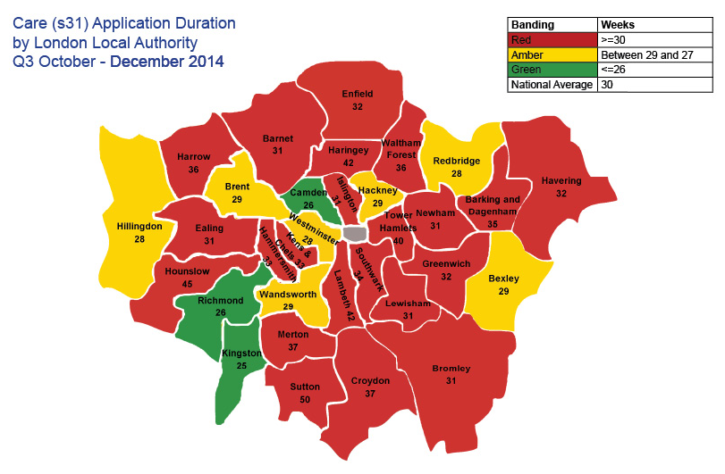
We have seen progress in the timeliness of our Court Proceedings from 63 weeks in 2011/12 to 30.5 weeks in 2014/15. It should be noted however that small cohorts of children can significantly impact performance.
Havering's commitment moving forward:
- We will continue to undertake work to understand our Looked After Children, this work will inform our commissioning activity to find suitable and sufficient placements.
- We will reduce the use of independent fostering agencies
- We will reduce the out of Borough placements which are further than 20 miles
- We will increase the number of in house foster carers for targeted groups
- We will increase our focus on the rehabilitation of children and support to individual families.
- We will continue to work closely with the North East London Adoption Group to ensure we are pooling resources and consequently securing best matches.
- We will work to ensure all assessments are initiated within one week; pre- empting challenges and thus supports the timeliness of court proceedings.
- We will shift our focus to Pre-Proceedings by developing clear processes which ensure that as much activity as possible is front loaded. This includes robust care planning, the coordination of viability assessments, expert assessments and parenting assessments.
- We will continue to review cases which go over 26 weeks to ensure that lessons are learnt and practice improved.

Priority 3: Supporting good health outcomes for Looked After Children

The national context:

Children often enter the care system with a poorer level of physical and mental health than their peers and their longer-term outcomes remain worse. Nationally two thirds of Looked After Children have at least one physical health complaint, and nearly half have a mental health disorder.

Metzer et al (2003) carried out the most authoritative study to date of the mental health needs of children in care. They found that among young people aged 5–17 years and looked after by local authorities:
- 45% were assessed as having a mental health disorder
- 37% had clinically significant conduct disorders
- 12% were assessed as having emotional disorders, and
- 7% were assessed as hyperactive.

National statistics provided by the Department for Education in December 2014:
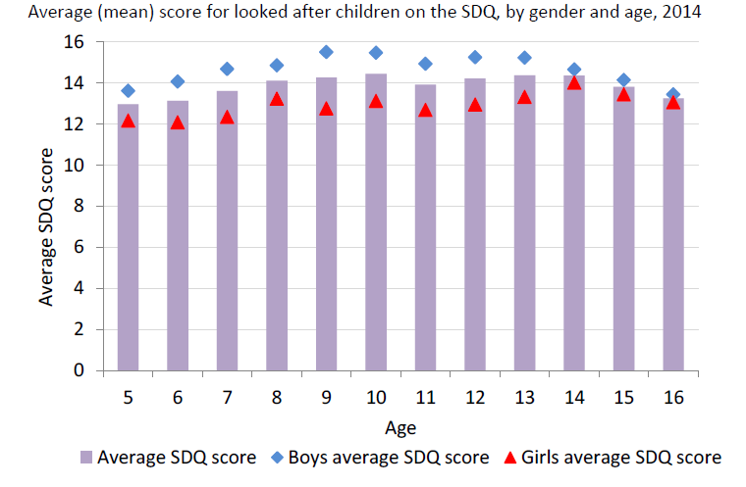

The Strengths and Difficulties Questionnaire (SDQ) is a brief behavioural screening questionnaire about 3-16 year olds and is routinely used to assess the mental well-being of children in care.

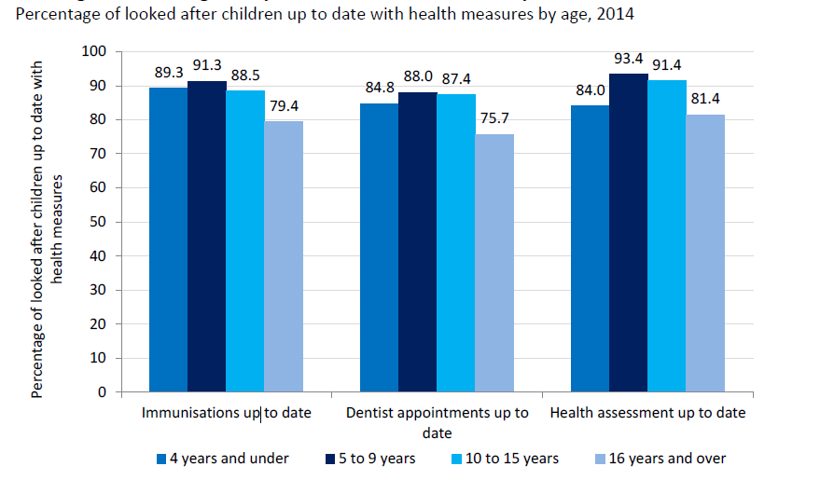

Havering's track record:
Health outcomes for Havering Looked After Children have broadly been in line with the national average. Havering has seen a vast improvement in the percentage of Looked After Children who have had their annual health assessments carried out. Of the 121 LAC/young people included in the 2014/15, 75.2% of LAC has had a health assessment, as opposed to the 60.5% in 2013/14. Ninety one per cent of Havering LAC had immunisations that were up to date during 2013/14 which was higher than the national average of 83%.
In December 2014, there were 38 children receiving a NELFT CAMHS service who are either looked after by Havering (30 children) or who have been adopted, are subject to a Special Guardianship Order or are recorded are in a 'kinship care' arrangement (this could be a private or looked after arrangement). Of those 38 children, 21 were referred in or before 2011; 8 were referred in 2012 and 8 in 2013 (the referral date for one case was unrecorded). Of the 30 children in care currently receiving a CAMHS service, 21 of these referrals came from social workers and the remainder came from health services, education or foster carers. Over half of these children (17) were referred in or before 2011.
In Havering, there are 24 children with SDQ carer-rated SDQ scores recorded from 2008/9 through to 2012/13. These children will have spent at least five years in care. Over this time, SDQ ‘total difficulties’ scores decreased for about half of the children, scores increased for around one third and scores stayed the same for 17% of this group. This suggests for around half of these children, their mental health improved over this period, and for half it stayed the same or deteriorated. It is common however for trauma experienced in early childhood to not manifest until adolescence.
Havering's commitment moving forward:
- Improve health outcomes for our Looked After Children by ensuring all children and young people have had their annual health assessments completed, engaging particularly with 16/17 year olds.
- To work with our neighbouring authorities and Health partners to create a Health Passport for Looked After Children.
- Continue to use the LAC review to ensure the Child’s health needs are being met and escalate concerns to appropriate services.
- Continue to work with partners to ensure we meet the needs of our LAC cohort when they are identified as having a substance misuse problem and improve performance in engaging young people with interventions.
- Maintain effective challenge and accountability of services through the Health & wellbeing board.
- Continue to commission an independent advocacy service for Looked After Children who encourage their participation within the case review process.
- Ensure our health partners are working together to help deliver the best possible co-ordinated services for our Looked After Children.
- We will ensure the voice of the young person in custody is heard and they are properly supported.
- We will ensure that Havering Looked After Children maintain a healthy diet and enjoy regular exercise. Where children and young people suffer from anorexia or obesity, we will ensure that they receive the appropriate help from health professionals and mental health professionals.

Priority 4: Improving the educational outcomes of Looked After Children

The national context

Local Authorities are required to discharge their statutory duty under 22(3A) of the Children
Act 1989 to promote the educational achievement of Looked After Children. That includes those children placed out-of-authority. The Children and Families Act 2014 amends Section 22 of the Children Act 1989 to require every Local Authority in England to appoint an officer employed by the authority, or another authority, to make sure that its duty to promote the educational achievement of its Looked After Children is properly discharged (Virtual School Heads). Social workers, Virtual School Heads (VSH)s and IROs, school admission officers and special educational needs departments should work together to ensure that - except in an emergency - appropriate education provision for a child is arranged at the same time as a care placement.

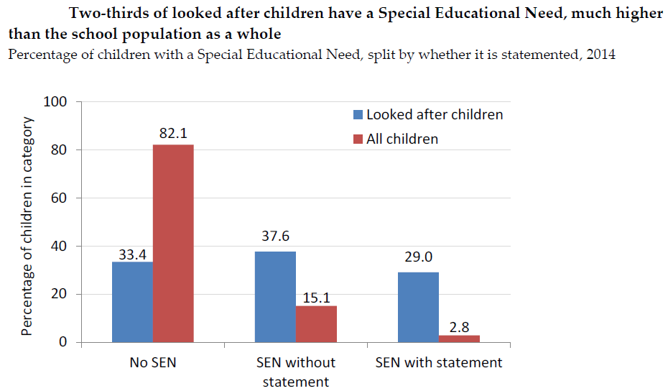
All Looked After Children should have a Personal Education Plan (PEP) which should form part of the child’s care plan or detention placement plan. All of those involved in the process of developing the PEP should use it to support the personalised learning of the child. The PEP (pre-school to age 18) is an evolving record of what needs to happen for Looked After Children to enable them to make expected progress and fulfil their potential. In 2014, there were 2,440 Looked After Children who were eligible to sit key stage 2 tests and had SEN information available. Of these, 1,600 (66 per cent) had a SEN. There were 3,940 Looked After Children who were eligible to sit key stage 4 tests and had SEN information available. Of these, 2,660 (68 per cent) had a SEN.

Havering’s track record:
Our Virtual School provides a dedicated service for Havering’s Looked After Children and Care Leavers wherever they live or are educated. The Virtual School is also supported by officers within the Education Inclusion and Support Service and by Havering School Improvement Service. They ensure that our Looked After Children all have access to high quality schooling or education and training provision. For children of statutory school age, The Virtual School closely monitors school attendance, progress and attainment. The Personal Education Plan is used to challenge and support schools and settings, social workers and carers to accelerate pupil progress and ensure good educational outcomes. The Virtual School distributes Pupil Premium funding according to the grant’s terms and conditions and contributes to the funding of interventions to meet identified needs.
The current structure of the Havering Virtual School has only been in place since October 2014. Outcomes for primary aged LAC pupils in the 2013/14 academic year were encouraging, but were very poor for KS4 aged pupils, with 0% of this cohort gaining 5 A*-C grades in GCSEs, including English and maths.
The Havering Virtual School has taken every aspect of the statutory guidance, ‘Promoting the education of Looked After Children, statutory guidance for local authorities’ and developed an action plan and RAG rating around this guidance. This action plan is a working document and updated regularly. Good progress is being made but there is more to do. Data on 2013/14 educational performance in relation to looked after pupils has been analysed and this analysis is provided with the current Learning and Achievement SEF. Key highlights are:
- Level 4 attainments of LAC pupils at KS2 is well above the national average in Maths, Reading and Writing as well as in Grammar, Punctuation and Spelling. Attainment at level 5 is also above the national average for this group in all key measures
- The percentage of LAC pupils making at least expected progress in Maths, Reading and Writing KS1-KS2 is exceptional in Reading (100%) and well above the national average in Maths and Writing.
- Level 2 attainments at KS1 are below national average for writing and maths but above national average in reading.
- Attainment and expected levels of progress for LAC pupils at KS4 is low, and will be a key focus for the work of the virtual school in 2014/15

The Virtual School is required, under the Children’s Services Ofsted Inspection Framework, to keep a log of any LAC pupils for whom there are concerns in relation to their education progress. The Virtual School has surveyed every school in the past six months and recorded concerns for 13 LAC pupils (out of a school population of 146). Each of these young people has an on-going action and support to address the concerns identified.

Of the 240 children and young people in Havering's care in 2014/15, 79 have been identified as having School Action/ School Support status or have a Statement of SEN/EHCP. None of the 39 preschool aged children have formally been identified as having SEN. 76 of the statutory school age pupils (5-19 years) have been identified as having SEN; of these 25 pupils have a Statement of SEN/EHCP.

School attendance is a key factor in relation to educational achievement and the Havering Virtual School now has a dedicated Attendance and Behaviour Officer supporting LAC pupils. Data over the past two years show that this support is beginning to make an impact on attendance:

Percentage LAC Pupil Attendance from 85% – 100%

Spring 2013 - 80.6% Spring 2014 - 85.9%
Summer 2013 – 81.4% Summer 2014 – 86.0%
Autumn 2013 – 88.2% Autumn 2014 – 86.1%

Average over 2013 – 83.3% Average over 2014 – 86%

Havering's commitment moving forward:

- We will continue to promote a culture that takes account of the child’s views according to age and understanding in identifying and meeting their educational needs, wishes and aspirations.
- We will deliver apprenticeships specifically for our Looked After Children.
- Where Looked After Children have special educational needs, the Virtual School will work closely with the Havering Children and Adults Disability Team to ensure that the child’s statement or EHC plan works in harmony with his or her care plan
- A new governance group for the Havering Virtual School will meet to provide extra scrutiny and accountability for the Borough’s work in support of Looked After Children, as well as additional advice/expertise. The group will include head teacher representation from mainstream schools as well as support from other key professionals.
- We will ensure a careers education support programme for LAC pupils so that they receive high quality careers guidance and aspire to the range of further educational opportunities available.
For example our young people will have opportunities to pursue a university education, vocational training or an apprenticeship.

Priority 5: Encourage participation and positive activities
National context:
The government is keen to ensure that Looked After Children and Care Leavers are shaping and influencing the parenting they receive, and are able to see their views reflected in our strategies and commissioning plans. The Council should facilitate Children in Care Council which encourages and supports children and young people to participate in decisions that affect their lives. Social workers and carers are expected to support Looked After Children to access and benefit from hobbies, leisure, cultural and sporting activities. Social care staff should work with other professionals to maximise LAC access to local services.
Havering's track record:
The London Borough of Havering has a strong commitment to ensuring the voice of the child is always heard and is keen to encourage and support Looked After Children to give us feedback. As part of this commitment quarterly viewpoint questionnaires are provided to not only our Looked After Children but also those who are subject to a Child Protection Plan. All our in-house foster carers are required to regularly complete the viewpoint update with the children in their care, which are fed back to social workers to take forward any concerns or actions identified.
The Viewpoint findings 2014/15:
- Most young people using viewpoint in Q4 wanted to have their review somewhere else, followed by placement then equally at school and children’s centre and they wanted to talk for themselves.

- When asked what the young people wanted sorted out at their review responses ranged from; nothing, to wanting to know what school they are going to and to have a new mum, dad and cat. The end of year data showed that most young people wanted their reviews at their placement compared to last year (2013/14) when most young people wanted their review at school.

- Young people using viewpoint have said they are mostly happy at school and get the right help. They have goals when they get older which include: I want to be a barrister, I want to teach children with additional needs and I would like to be a nurse secretary or a chef.
- Most young people said they received the right amount of help from adults – foster carers helping with homework and from social workers listening and making sure they feel safe. This was reflected in the year end data (2014/15)

- Young people were asked if they had a change of social worker, Quarter 4 data shows that 13 young people had a change of social worker, 8 young people had not. Three young people could not remember. End of Year Report (2014/15) shows of those young people completing the questionnaire 39 had a change of social worker and 33 had not, 8 young people could not remember. Compared to last year end (2013/14) when 48 young people said they had a change of social worker 33 had not. Young people’s comments about a change of social worker included: 'fine because u have to move on, ok but I’ve changed too many times'.

- Young people using viewpoint have reported they feel safe in their placement, at school and in their local area.

- Most young people said they liked using viewpoint; it was easy or very easy to use. The number of questions was about right and asked the right things. Most would use viewpoint again.
Our Independent Reviewing Officer service (IRO) is growing stronger to support and monitor how we as a Local Authority ensure that every child's views and wishes are being taken into account in relation to decisions about their care plans.
We have found it difficult in the past to obtain feedback from our Looked After Children and encourage them to participate in the shaping of our service. We have therefore sought to change the way we engage with our young people by encouraging participation in places that we know our young people are more likely to attend and enjoy. This was seen by the activity day that was run at Stubbers Adventure Centre. The day allowed staff to obtain feedback from our Looked After Children and young people in a way which was fun and informal. This insight was then used to inform the re-launch of the Children in Care Council which had previously been poorly attended. The Children in Care Council has been successfully re-launched and specialist participation officers have been hired to maintain the enthusiasm and positive response that the re-launch generated. As a result, the Children in Care Council are now taking opportunities to design the services they receive and help choose the staff that will deliver them. The Children in Care Council played an integral part in the selection process for the new Assistant Director of Children's Services. Their participation in activities such as these within the council, reiterated that Havering valued their opinion and provided them with useful experience they could use on their CVs. The Children in Care Council will provide quarterly updates on their progress and their satisfaction with our services to the Corporate Parenting Panel and Lead Member for Children's Services.
Havering are committed to ensuring that our Looked After Children are prioritised within the Council and given the best opportunities to succeed. Havering’s Housing Services have been particularly supportive of our Looked After Children and care leavers, specifically targeting them at a recent jobs and apprenticeship fair.
Havering’s commitment moving forward:
- We will continue to ensure an independent advocacy service is available for Looked After Children by the Local Authority.
- We will continue to support our IRO service to deliver robust challenge to practice.
- We will continue to encourage participation in the Children in Care council, and our young people to take on leadership roles in areas of interest.
- We will continue to resolve complaints quickly and if possible through resolution meetings before the need for formal complaints arise.
- We will continue to identify interests and hobbies through our care planning process.
- We will continue to create a range of opportunities for appropriate formal and informal ‘participation’ and engagement for our Looked After Children, including for example coffee meetings, fun activities and surveys.
- We will act on the feedback we receive from our Looked After Children, young people and care leavers- such as creating a workforce development strategy to improve staff retention, so they do not have to experience a frequent change of social worker.

Timescales
This strategy should be reviewed in 2016 and then every three years in line with the Children and Young People’s Plan.

Related documents
- Children and Young People’s Plan 2014-17
- Havering Local Safeguarding Children Board Business Plan 2012-2015
- Havering Local Safeguarding Children Board Annual Report 2013/14
- Children’s Services Service Plan 2014/15
- Havering Ofsted Action Plan 2013
- Sufficiency Statement 2013
- Havering’s Pledge to Looked After Children 2010
- Joint Needs Assessment: Children & Young People
- Children’s Services Service Plan 2015/16

Consultation
Corporate parenting requires a multi-agency approach and therefore consultation needs to be made with:
- Corporate Parenting Board and elected members
- Children in Care Council
- Children’s Safeguarding Services, LB Havering
- Children’s Commissioning, LB Havering
- Youth Offending LB Havering
- LSCB and other Safeguarding Services
- Housing Services, LB Havering
- Schools
- Clinical Commissioning Group and NELFT
- Police

Authorisation and communication
As the council and elected members have a statutory duty to be corporate parents for Looked After Children, it is essential that this strategy is a corporate strategy. It should be authorised by Cabinet/lead member.

Further information
Havering Children & Young People Plan: http://www.havering.gov.uk/Documents/Children-young-people-and-families/Havering_Children_and_young_peoples_plan.pdf
Havering Safeguarding Children’s Board: http://www.havering-lscb.org.uk/index.html
Havering Ofsted Inspections: http://reports.ofsted.gov.uk/local-authorities/havering

https://www.gov.uk/government/publications/children-in-care-research-priorities-and-questions
Working together to safeguard children- A guide to inter-agency working to safeguard and promote the welfare of children- DFE 2015
DfE School Attendance – Departmental advice for maintained schools, academies, independent schools, and Local Authorities (November 2013).

