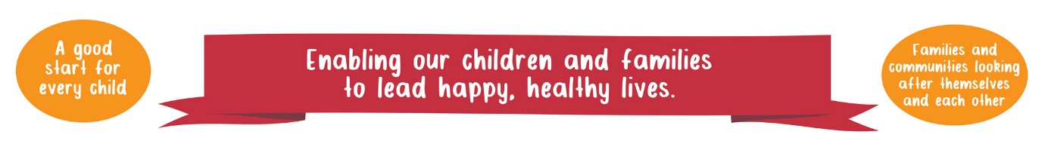
London Borough of Havering

Youth Justice Plan 2019-2020

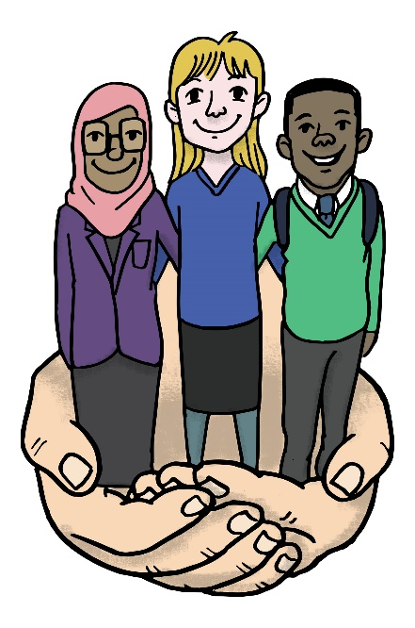
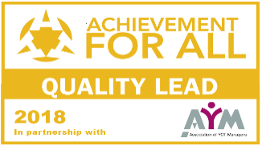

CONTENTS

CHILDREN’S SERVICES VISION | Page 3
INTRODUCTION | Page 4
STRUCTURE AND GOVERNANCE | Page 6
RESOURCES AND VALUE FOR MONEY | Page 8
PARTNERSHIP ARRANGEMENTS | Page 10
PERFORMANCE MANAGEMENT – OUTCOMES AGAINST THE 3 NATIONAL INDICATORS  - First Time Entrants  - Reducing Reoffending  - Reducing the use of custody | Page 25
RISKS TO FUTURE DELIVERY AGAINST THE YOUTH JUSTICE OUTCOME MEASURES | Page 28
STRATEGIC PRIORITIES FOR 2019/20 | Page 35
MANAGEMENT BOARD SIGNATURES | Page 44
Appendix A – Speech and Language Annual report
Appendix B – CAMHS Annual Report
Appendix C – Alternative Provision Report

Our Vision
Children and Families in Havering

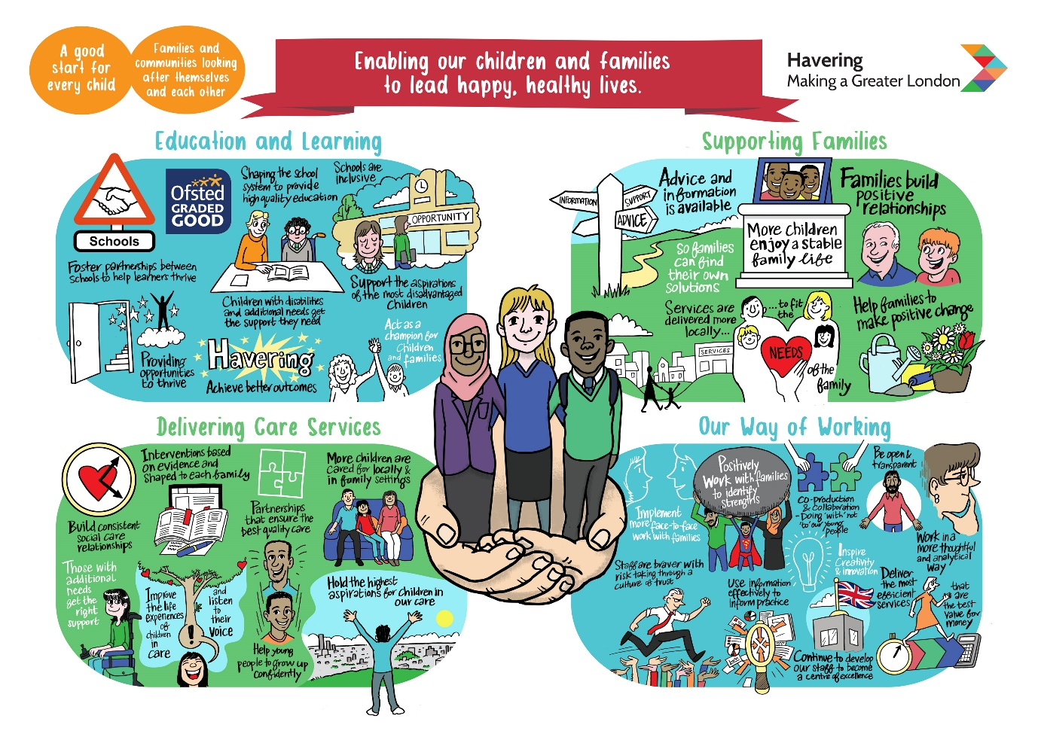

INTRODUCTION

- Welcome to the London Borough of Havering’s 2019-20 Youth Justice Strategic Plan. This plan is prepared in accordance with S.40 of the Crime and Disorder Act 1998.

- The Havering Youth Justice Plan sets out how the London Borough of Havering proposes to provide and fund youth justice services for 2019/20. It also provides information on the partnership priorities and evidences how partner agencies will work together to improve outcomes for children.

- In Havering, the YOT multi-agency partnership continues to work well together to deliver high quality and effective services to children, young people, their families and the victims of offending. Our partnership response particularly to children and young people with additional needs and disabilities was recognised via our “Achievement for ALL, Quality Lead Award” which was awarded to Havering YOT and the partnership at the 2018 Youth Justice Board Convention. We will continue to lead practice in this area so that children and young people continue to receive a quality service from the YOT partnership.

- A major challenge for Havering YOT and for the whole of London is the increase in serious youth violence and its devastating impact on the lives of some of our young people and their families. Havering YOT and the wider Council partnership has responded positively to this concern and challenge by creating an adolescent safeguarding strategy which includes all the partners who work to safeguard adolescents and extends beyond high risk and statutory services to include voluntary and community sector, universal services and local businesses. The values, aims and principles proposed in the adolescent safeguarding strategy are based in recent research into adolescent development including trauma-informed approaches.

- Six strategic priorities proposed are: prediction, leadership, prevention, intervention, disruption, and workforce development. The delivery of the strategic priorities will take place via an adolescent integrated safeguarding approach. The establishment of the adolescent integrated approach will include the Youth Offending Service, which will enhance service delivery and promote outcomes for children. As such, there will be a change in governance and leadership arrangements as the YOT Group Manager’s role will expand to oversee the Hub’s activity and there will be a new Head of Service leading these safeguarding arrangements. The change in Head of Service leadership will take effect from June 2019.

- The development of the Local Authority and YOT response to adolescent safeguarding has been informed by the Havering 2018 ILACS inspection and in part been informed by the Dorset 2018 JTAI / HMI inspection of the multi-agency response to child sexual exploitation, children associated with gangs and at risk of exploitation and children missing from home, care or education. The adolescent safeguarding approach represents a robust response to supporting children and young people who are at risk of a range of contextual harmful behaviours.

- During 2018, the Local Authority was successful in a number of MOPAC bids which increased its response to children at risk of harmful behaviours and contextual safeguarding. For example, the Local Authority and YOT are able to refer children and young people to “Rescue and Response” who support young people affected by County Lines exploitation. Rescue and Response is a third sector consortium approach lead by St. Giles Trust and incorporates Abianda to deliver a credible case working that can engage young people at a time of need including immediate safety planning for the young person and their family.

- Havering was also successful in a bid for service provision via TAITH run by Barnados, which is a specialist service for children and young people with harmful or problematic sexual behaviour. Havering YOT is able to access a new service provided by Tiger Light which is a service for children and young people (up to the age of 18) who have recently disclosed current or historical sexual abuse, assault and/or rape or where there are strong suspicions of these having occurred. The service is commissioned by the CCG and NHS so there are no cost implications for the referrer.

- The YOT partnership’s response to the thematic “out of court disposal work in youth offending teams” led to the formation of a multi-disciplinary panel in October 2018 to support young people whose offending behaviour needs to be addressed via an out of court disposal. Panel representations include: Police; Youth Service; Early Help; Systemic Family Therapist; Education, Children’s Services, substance misuse colleagues; restorative justice worker and YOT staff. The panel adopts a curious and explorative approach to offending behaviour and interventions are tailored to meet children’s needs in line with “child first; offender second” principles. The panel is chaired by the Head of Service or YOT Group Manager.

- A high level review of last year’s plan shows the number of First-Time Entrants (FTE) into the criminal justice system in Havering is continuing to fall, for example from 296 in October 2016 to September 17 to 221 in October 2017 to September 2018. The current rate of 221 per 100 000 puts us favourably at 5th place in our New YOT Family. The YOT partnership is fully committed to continue to reduce the number of FTE’s and to divert young people away from committing offences and entering the youth justice system against a backdrop of an increase in population entering the Borough and the increase in serious youth violence.

- Havering’s reoffending youth justice & local data shows an improving positive picture and declining binary rate over the last three years despite a rising cohort. The reoffending binary rate has declined from 46.2% in Jan – March 2016 to 29.3% in January 17 to March 17 and further to 16.7% at the end of February 2019. The total number of young people in our live tracker reoffending cohort is 72 which is up from 26 in March 2016 (36% increase over three years). Havering YOT remains below London and England and Wales reoffending binary rates at 42.5% and 39.9% respectively and we have the lowest reoffending rate in comparison to our YOT Family.

- For the current cohort the live tracker shows that the most common offences committed is Violence against the Person which groups offences together such as weapons related offences and assaults. Drug related offence (Possession of Cannabis) is the second most common offence.

- The YOT Management Board held in April 2019, agreed that a thematic assessment of our reoffending cohort be commissioned, in order for the partnership to further respond to and address the reoffending of the twelve young people contributing to our current binary rate.

- We have seen a cumulative increase in the number of young people sentenced to custody in the past twelve months, rising from four young people (0.17 rate per 1000) in 2017 to nine young people (rate of 0.39 per 1000) in 2018. We are seeing an increase in violent offences and robbery and a failure to comply with statutory Orders. We currently have seven young people on remand for serious offences and depending on the outcome of their trials, our custody cohort could increase further.

- The YOT Management Board held in April 2019 has agreed for a thematic assessment of our custody cohort so that the partnership can fully understand the range of issues including familial history which has led to our young people ending up in custody and on remand. The partnership will use the findings from both thematic assessments to constructively support our reoffending and custody cohort.

STRUCTURE AND GOVERNANCE

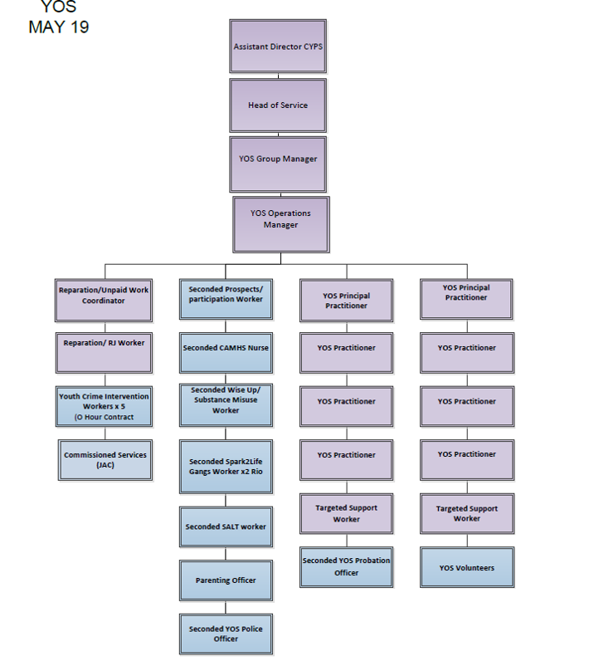
- The Youth Offending Service is very much part of Havering’s Children’s Services and sits within the service portfolio of the Head of Child Protection and Youth Offending. The leadership and service governance arrangements are going to change in June 2019 following Havering’s decision to strengthen our approach to adolescent safeguarding. The Head of the Virtual School and Youth Services will be leading the service from June 2019 and the YOT will form part of a wider adolescent approach from September 2019.

- The YOT Management Board is the strategic partnership that oversees the local delivery of responsibilities under the Crime and Disorder Act 1998 for Youth Justice Services. The YOT Management Board is responsible for the governance of the service and monitors and challenges the functions and performance of the YOS. The YOT Management Board is chaired by the Assistant Director of Children’s Services to ensure rigorous oversight of service delivery and to ensure the “child first, offender second” principle is integrated into service delivery.

- The Board convenes quarterly enabling close monitoring of YOS performance against the YOT Family and England and Wales data. The YOT performance against the YJB objectives will be covered in more detail in section D of the plan. The Board oversees the delivery of the YOS by monitoring the implementation of the annual Youth Justice Plan. The Board has been appraised of the new HMIP inspection framework and standards and has scrutinised the quality of practice in the service by means of two independent practice audits and the service training schedule. The independent audit of the YOT Service was undertaken in line with the HMIP inspection standards and a YOT improvement plan was drafted following the audit. The improvement plan is used by managers to continue to raise practice standards.

- The improvement plan has formed the basis of service improvement over the past year and the progress against the improvement plan has been scrutinised by the Board. Tim Aldridge, Director of Children’s Services commissioned an independent YOS Diagnostic Review in January 2019 to assist senior leaders in the Local Authority and partners to:
- Assess the progress that the Youth Offending Service (YOS) has made in its improvement journey
- Assess the YOS’s readiness for HMI Probation inspection
- Identify the requirements to enable the YOS to integrate as part of the proposed adolescent safeguarding arrangements
- Identify the actions based on recommendations in this report that are needed for the YOS to further improve, achieve a successful inspection outcome and to effectively contribute to Havering’s integrated approach to adolescent safeguarding.
- The recommendations from the diagnostic review will form the strategic basis for the planned integration of the YOT into the wider adolescent safeguarding arrangements and organisational culture. The review recommendations will continue to support longer term practice improvements.
- The local partnership board has been working to ensure that board membership is at an appropriate senior level with statutory partners in regular attendance. The board is pleased with the “Achievement for All Quality Lead Award” handed to Havering Partnership at the 2018 Youth Justice Convention. The Quality Lead Award recognises the excellent work which the partnership has achieved in securing better outcomes for children and young people with special educational needs in the youth justice system.

- The independent auditor who completed two audits of YOT practice in the past twelve months found there is evidence of good professional relationships with young people with a good range of interventions, joint working and communication with other agencies and partners. The integrated approach with CAMHS, Substance Misuse Worker, Speech and Language support and restorative justice is clearly evident and allows for prompt and consistent interventions. In the case of CAMHS and SALT colleagues, this includes intervention and on-going support, not just assessment. Both audits have been scrutinised by the Board.

- The board has ensured that Havering’s submission of data to the YJB is timely and accurate. The board is keen to understand more about how our young people in the secure estate can be supported to ensure that constructive resettlement is working for our young people and their families. As stated earlier, the board has agreed a thematic for reoffending and custody cohorts so that interventions can be targeted to support these cohorts.

RESOURCES AND VALUE FOR MONEY

- In 2017/18 Havering YOS Partnership received a total of £226,038 Youth Justice Grant and £47,279 for the Junior Attendance Centre bringing the total YJB contribution to £273,317. Havering YOS received a notification from the YJB in May 2018 that the total proposed grant for our Local Authority YOT Partnership for 2018/19 is £273,317. The allocation includes £47,279 for our Junior Attendance Centre.

- For 2018/19, the Local Authority contribution was £351,838 which is £69,191 (16.4%) less than the previous financial year. The Youth Justice Grant for 18/19 was £273 317 (inclusive of the JAC Grant). Funding was also received from the CCG (£70 000) for the employment of a systemic family therapist. MOPAC funding included £20 000 towards the cost of a reparation worker and £45 000 for a full time Sparks to Life Gangs worker for the mentoring program. The £45 000 MOPAC funding is held in Community Safety and does not form part of the YOT overall expenditure.

- For 2019/20, the Local Authority contribution still needs to be confirmed at the time of completing this plan. Unless advised otherwise, the financial planning for the 2019/20 period will be based on last year’s contributions from the Local Authority amounting to £351 838. The YJB has confirmed the 2019/20 grant which comes to £270 743 (inclusive of the JAC grant) totalling £ 622 581. The MOPAC funding and CCG funding for 2019/20 has been confirmed, which will be used for the systemic family therapist; the Sparks to Life worker for the mentoring project and a contribution towards the cost of a reparation worker.

- The Youth Offending Service receives ‘in kind’ funding from other services via the provision of secondments of staff and provision of services. Havering YOS is fully compliant with minimum staffing requirements set out in the Crime and Disorder Act 1998. A full breakdown of the budget/resources for 2018/19 is expected to be as follows:

Agency | Staffing Costs | Payments in kind for services | Other delegated funds | Total (£)
Local Authority |  |  | £351 838 | £351 838
Police Service |  | 1 (FTE) Police Officer seconded to the Youth Offending Service
National Probation Service |  | 1 (0.5) Probation Officer seconded to the Youth Offending Service & £5K per annum contribution | £5 000 | £5000
Health Service |  | 1 (0.5) Speech and Language Therapist seconded to the Youth Offending Service  £70K from the CCG to fund a systemic family therapist. | £70 644 | £70 644
CAMHS |  | 1 (FTE) Nurse Specialist seconded to the Youth Offending Service
YJB Practice Grant |  |  | £223 909 + £46 834 | £270 743
Restorative Justice Worker |  |  | £20 000 (MOPAC funds) | £20 000
TOTAL |  |  |  | £718225

- The remand budget is located within Children’s Services placement service and will remain so. The budget received for the 2018/19 year was £30,058. The remand allocation for 2019/20 was confirmed on the 15th May 2019 and is £84, 287.00.

- The Youth Justice Income and expenditure analysis is set out below. During the financial year of 2018/19, we accumulated a budget overspend of £78 398 which is primarily a result of agency costs and overheads. The service overspend has been absorbed by the children’s services base budget.

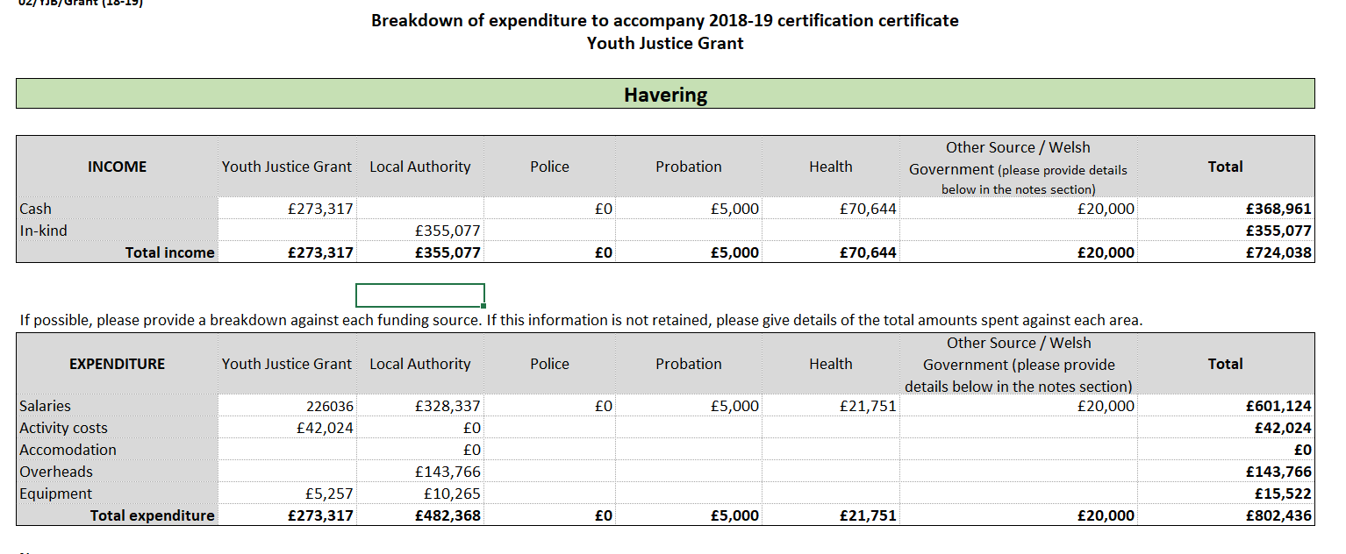

- Havering YOT continues to operate a Junior Attendance Centre for Havering, Redbridge and LBBD YOT’s. As Havering YOT receives a grant from the YJB to run the JAC, this service is available free of charge to the London Boroughs of Redbridge and Barking and Dagenham. Since October 2018, Havering has commissioned Sparks to Life to run programs for young people who attend the JAC. This provider has been commissioned to run programs out of the JAC for twelve months. The detail concerning JAC delivery is captured later in this plan.

- Havering YOT is compliant with the minimum staffing requirements as set out in the Crime and Disorder Act 1998. The YOT management structure includes social work qualified staff. The recruitment for the management posts will be taking place in June 2019 as part of the YOT’s integration into the partnership’s adolescent safeguarding approach.

PARTNERSHIP ARRANGEMENTS

- Having key agencies and services co-located at the YOT at Hedley Close ensures that young people receive the right interventions at the earliest opportunity. It allows for better sharing of information and avoids duplication of work.

- Havering YOT values the benefits achieved by effective and integrated partnership arrangements. This is evident in the embedded multi-agency working at the heart of the YOS operational and strategic delivery. The following agencies are permanently stationed at Havering YOT: Police, Probation, CAMHS practitioner, Speech and Language practitioner, Wize Up (substance misuse), Sparks to Life practitioner, systemic family therapist and a restorative justice worker. For our out of court disposal panel, we have weekly attendance from Education representatives, Early Help and Youth Service representation.

- Havering YOT shares an Early Help research team based in MASH ensuring one single ‘front door’ for all referrals to both the YOS and Early Help. This allows for greater cohesion of services provided to young people ‘at risk’ of, or already engaged within the Youth Justice system. This has led to better identification of the needs of young people and a wider strategic approach to carry out holistic whole family work across the YOS and Early Help.

- The Havering Youth Offending Service (YOS) has continued to have a part time Speech and Language Therapist (SLT), working 2 ½ days a week through CCG and NEFLT (North East London Foundation Trust – NHS). The SLT service has continued to work in partnership with Havering YOS to meet the needs of the young people with SLCN. This has been through delivering services at three waves of intervention:

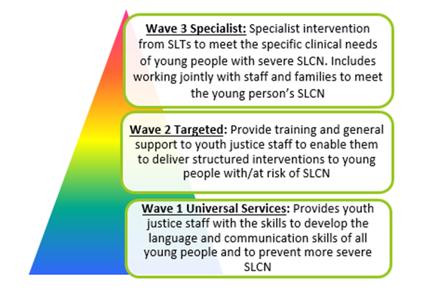
- It was initially agreed between Havering Speech and Language Therapist (SALT) team and Havering Youth Offending Service (YOS) that one of the core objectives would be that all young people on a Community Order (i.e. Referral Orders or Youth Rehabilitation Orders) who have been identified as having SLCN will be screened by the YOS SLT. From October 2018 the screens offered have been extended to include those young people with Out of Court Disposals (i.e. Police – Community Resolution, Youth Cautions or Youth Conditional Cautions).

- A SLT Screening tool was devised in January 2019, to be used by all practitioners to help them identify those young people who should be referred to SLT. Every young person’s speech, language and communication skills are routinely considered as part of the Asset Plus assessment, which is the approved assessment framework nationally for YOT’s.

- From June 2018 to April 2019, forty nine young people were booked to attend a SLT communication screen, however 21 (51%) attended. An explanation for the high non-attendance rate of 49% was that a small cohort of young people had failed to attend 2 or more communication screen appointments, for the reasons:

  - Young people were each booked for several screens and kept failing to attend their appointments, reasons being:
  - Young people going/being reported as ‘missing’
  - generally poor attendance of their YOS appointments

- Three young people were further assessed in more detail. Two SLT reports were specifically used as a contribution for a CAMHS (Child Adolescent Mental Health Service) diagnostic assessment to determine whether these young people had ASD (Autistic Spectrum Disorder).

- Of the 21 communication screens 67% of the young people have previously unidentified SLCN, and none were known to the SLT service at the time they came to YOS. Nine (3 direct 1:1; 6 in joint YOS/SLT sessions) young people gave their consent for SLT intervention. The number of young people consenting to SLT intervention this year was 43%, as opposed to 28% for last year.

- Fourteen young people who were identified as having a SLCN, none were known to SLT at the time they came to YOS.

- Three out of the 9 young people who received SLT interventions completed their block. The impact of the intervention was gathered at the beginning and at the end of the block of intervention by:

- Each young person completed a self-rating questionnaire using a scale of 1-10 (1 = very difficult; 10= no difficulties) to obtain their views of specific aspects of their intervention. A rating scale improvement of 3 steps has proved to be a noticeable and acceptable improvement within a 6 session block, for each young person completing the questionnaire.

- The young person’s outcomes indicate that for the majority they have felt there has been an improvement following their intervention. This is matched by the SLT (Practitioner) ratings which shows improvements in areas looking at the overall impact their intervention has had on them.

- The SLT offers a service as part of the custody and resettlement program for those young people with identified SLCN to support their continuity of care and transition back into the community. The aim is to continue to further develop their identified SLCN, improve their ability to access the learning being delivered, as well as supporting them to work to the best of their capability. The full SLT report can be found as Annex A to the YJB plan.

- There is a full time CAMHS specialist nurse in the YOT who works closely with the multi-disciplinary team. CAMHS continues to work jointly with SALT in the offer of The Assert Yourself Group; we have managed to complete two groups successfully this year. The CAMHS specialist nurse continues to mirror the Thrive Model (Anna Fraud Centre) available at Havering CAMHS within the Havering Youth Offending Service. We continue to work closely with and signpost to our partner agencies in the borough; such as Taith, Add up (ADHD) and Sycamore Trust. We have a close working relationship with our local Youth Centre “MyPlace”, who offer various activities and emotional wellbeing groups for Havering residents in general.

- The CAMHS specialist nurse continues to offer Individual therapeutic interventions/ assessments and/ or family work to those young people who meet the “Getting more help criteria”. This may be cognitive behavioural/ solution focused techniques, autism diagnostic observation scale assessment or ADHD screening. Autism assessment was further developed this year, with the YOS CAMHS Specialist Nurse being trained in delivering ADOS assessments. We have significantly reduced the autism assessment waiting times for young people attending Havering YOS to approximately 3-4 months.

- We have access to “Getting Risk Support” via out colleagues in Interact (CAMHS Crisis and Outreach Service) and CAMHS Home Treatment Team. CAMHS and YOS Practitioners also have access to support from Forensic CAMHS Service at The Portman clinic. The Portman Clinic were utilised on one occasion for consultation; this was provided over the phone.

- We continue to work closely with and signpost to our partner agencies in the borough; such as Taith, Add up (ADHD) and Sycamore Trust. We also have a close working relationship with our local Youth Centre “MyPlace”, who offer various activities and emotional wellbeing groups for Havering residents in general.

- All young people on a Youth Caution/ Youth Conditional Caution and Community Order are screened by the YOS CAMHS Specialist Nurse; unless the child/ YP is already known to CAMHS services. Between March 2018 to March 2019, 44 young people were referred for a Health Screen/ Assessment by the Specialist CAMHS Nurse; a further 17 referrals were carried over from the previous financial year; a total of 61 referrals. 32 young people continued to have further CAMHS specialist 1:1 Intervention and 6 young people attended to the Assert Yourself Group.

- Youth Caution (YC)/ Youth Conditional Cautions (YCC) are now all being offered an initial health screening. Thirteen young people with an YC/YCC have been screened; nine were discharged with advice and recommendations and four were offered intervention.

- For the 38 young people that were taken on for further 1:1 assessment and Intervention and Group work, similar to that of last year the biggest requirement was assessment for ADHD.

- It has been noted that there has been an increase in trauma related cases as compared to last year. This may be because of further training for YOS staff who are therefore more able to recognise trauma and perhaps also due to the new acknowledgement of Complex Trauma/ PTSD in what will be the ICD 11 (Diagnostics). With this in mind, Trauma training was held for all disciplines within YOS and also a brief presentation was given on Complex Trauma to the wider borough at the CSE Awareness Day; which included schools, police, social care and other agencies.

- Between April 2018 and March 2019 only one child disengaged from the YOS CAMHS service that was on offer and 50% of the young people successfully completed the work on offer. This therefore suggests that engagement continues to be successful. YOS CAMHS continues to meet all young people from the onset of the young person’s order/ caution, and therefore is able to sell the service that is on offer, build a therapeutic relationship and the young people buy into the work that is being completed.

- Young people have commented (via service user feedback) that if they had not come to the Youth Offending Service they would not have accessed CAMHS. The majority of young people that have had planned discharges have stated that they now feel confident to access Mental Health Services should they require this in the future. The two young people who were sentenced to custody were successfully transferred to the Health Team within the custody setting and they both engaged with this. One young person was successfully transferred to Adult Mental Health Services in another area. The full CAMHS annual report can be found at Annex B of the YJB plan.

- The YOT safeguarding partnership arrangements include working with community safety colleagues. The Serious Group Violence meetings take place every 4 weeks. Individuals are brought to the panel’s attention either by services specifically raising concerns about young people getting involved in crime related to gangs/ county lines or they are brought to the panel’s attention due to police reports which have been received. A multi-agency approach is then used to help manage the risk.

- Community Safety continues to develop the Safe Haven scheme in Romford Town Centre. There are a number of locations in the borough identified as safe haven schemes. Individuals can go in and speak to a member of staff and let them know they are being followed or in danger and the staff will arrange for them to get home safely/ call a relevant adult/ call police etc. We are looking to arrange a meeting with all partners in June 2019 presenting plans of the unit. In addition to coincide with the launch of this initiative we will be looking to update the information pack we give to other businesses in the borough joining it up with stop hate.

- The gangs unit undertake visits to all young people identified as potentially at-risk or involved in gangs and SGV to speak to them and their parent(s) about their behaviour with an offer of support to desist or face the risk of enforcement. The Gangs Unit is divided into two teams, the Enforcement/ Reactive Unit and the Prevention/ Outreach Unit. All gang members on perspective local Matrixes receive visits from the gangs unit. The gang members risk level/ current intelligence dictates the number of visits they receive from the unit.

- Those young people at high risk receive regular weekly or possibly daily visits (if risk warrants such action), whereas those who are considered low risk according to reports/ intelligence are visited much less frequently by the gangs unit. Sometimes duties may be distributed to the Police Officers in which ward the gang member lives.
Where there is information that the individual is on the periphery of gangs the gangs unit will carry out a visit (evidence led). This may have come to their attention either through police reports or because of escalating behaviour identified through the SGV panel. Wherever possible Police and Partners try to include the parent in order to help the young person desist from crime. The gangs unit also get involved in professionals meetings, emergency strategy meetings and other critical meetings.

- Support for Girls involved in gang offending, joint enterprise or county lines is available through Spark2Life Gangs Mentoring, Advance Women’s Programme (Young women from the age of 15 being caught up within the criminal justice system) advocacy and support, London Gang Exit (Support to exit gang lifestyle as a victim or perpetrator) and also Rescue and Response.

- CHANCE Scheme is established within Havering and managed through the Young Person Coordinator within the Partnership Hub and embedded with both Safer Schools and Safer Neighbourhood Teams with an agreement in place between LBH and EA BCU. Visits take place when appropriate. The Chance Programme undertake visits to all young people and their parent(s) identified as causing early stages ASB with an offer of support to desist or face the risk of escalation of enforcement. This is overseen by Sgt Hepple.

- Community Safety colleagues continue to use the dispersal powers within Romford town centre to disrupt gang-related activity and serve Community Protection Notices to those found to be causing nuisance which include specific conditions to limit the impact of their behaviour within the area.

- The Deeper Lounge has now been changed to Eds Place where they have youth groups running on a Tuesday and Wednesday evening. On a Thursday the team is out on the town centre doing outreach youth work. Youth Service have been out in the town centre with the yellow bus during the recent Easter holidays.

- Prevent is a standing agenda item on the Community MARAC. We are seeking to become an annual item for the Safeguarding Boards. Colleagues who sit on risk panels are aware of Prevent and local processes.

- Junior Citizens Scheme to continue to run in Havering primary schools to improve young people’s awareness of knives, drugs, fire safety before they transition to secondary school. The Junior Citizen scheme will be running again from the 24 June to the 5 July. Approximately 2,000 year 6 students will be attending the scheme. We are responding to local crime trends and will be including in our scenarios some of the issues we are seeing in our town centre such as knife point robbery ie what you should do if someone tries to take your phone off of you.

- The YOT problem profiles of 2015 and 2018 show an increase in 10 to 14 year olds who are becoming more vulnerable to entering the youth justice system, particularly an increase in our female cohort. Further to BHR CCG funding becoming available, the London Borough of Havering Alternative Provision was able to create bespoke packages of support and education for children and young people who are at risk or moving towards the justice system and those who are already known within it. Havering will work closely with its schools and providers to enable early identification and intervention and target resources and opportunities to addressing their difficulties and offending behaviour whilst encouraging, inspiring and moving children and young people towards better educational outcome and future goals.

- Our schools data and collaboration experience evidences that Children and Young People who are gang affiliated and who are involved in serious group violence have similarities which can be identified early and addressed using Alternative Provision (AP) and multi-disciplinary in collaboration with schools. By targeting practical and interactive approaches in collaboration with schools, providers and multi-disciplinary teams we aim to enable children and young people to make better choices and not become involved in criminal activity or support them with the process of moving away from gang affiliation and set them on a more positive life pathway.

- The aims of the project are:
- Re align children and young people’s thinking around gang affiliation and serious group violence
- Develop self-esteem and build resilience
- Support identified needs
- Inspire engagement with education
- Develop aspirations that have SMART aims and objectives
- Move children and young people away from offending
- Reduce re offending behaviour
- Increase positive engagement within the community

- We will further build on our already robust existing practices by providing head teachers with the autonomy and flexibility to recruit and train their own staff, to commission vital support services (including a stronger role in commissioning health services such as mental health and speech therapy), to further establish their approach to managing behaviour and rewarding success and, as a result create a productive and therapeutic culture which will raise attainment, improve behaviour and promote rehabilitation.

- For a full breakdown of the AP’s work to date, please find their full report attached as Annex C to the YJB plan.

- The YOS has one prospects worker (0.2FTE) who works with all 16-18 year olds who come into the service who are NEET. Prospects are developing a Pearson’s Employability Course in Construction, as this is a popular career choice amongst young people in the YOS. This course could result in the young person gaining a CSCS card, which would allow them to work on a construction site. This would be a unique project to Havering YOS. Unfortunately, the prospects resource is quite limited in the YOS currently at one day per week.

- Our Early Help Service partnership provides support to the YOS in a number of ways in order to deliver against youth justice outcomes. In terms of Restorative Justice, (RJ) training has been delivered to 12 schools across the London Borough of Havering. Out of the 12 schools that accessed the training 5 schools bought in the whole RJ package. The other 7 schools have already had the training and bought back into the service for additional training such as parent workshops or peer mentoring. Regular network meetings have been hosted throughout 2018 / 19 across primary schools to further promote the RJ approach. These network meetings are a good forum for schools that have bought into RJ approaches to share their positive outcomes from using such approaches and further promote this to other schools.

- In addition the Early Help service has delivered two intensive three day champions facilitators training to schools and services. This enables the staff for these service areas to be champions in their area of service around RJ approaches. This will also enable the staff to deliver conferences to wider networks. Twenty workshops have been delivered to parents across the London Borough of Havering, reaching 113 parents in total. This enables parents to gain a greater understanding of the RJ approaches whilst also upskilling them in the approach to manage child behaviours in a positive manner.

- A total of 60 colleagues have been trained in RJ approaches to promote that RJ is introduced across the network and partnership. Fifty four new peer mentors in schools have been trained to support and assist with low level conflict within the school environment. This is helpful particularly in relation to our rise of 10 to 14 year old cohort into the Youth Justice System. Two hundred and twenty one teaching and non-teaching staff have been trained in RJ approaches. This enables the staff to better understand the individual needs of the child, impact on children in respect of unmet needs, behaviour needs, learning needs and how the responses to behaviour that is demonstrated by children related to the above is managed positively and effectively. The above totals 448 individuals been trained within the 2018 /19 window.

- The YOT Parenting Service is based at the Youth Offending Service in Havering. The parenting offer has engaged 42 parents in the last financial year. 42 of the cases have been voluntary interventions and these have included working inclusively with mothers, fathers and carers of young people accessing the service. This is a 38% increase in parenting interventions from the 2017/18 period and demonstrates positive engagement with children and families open to the service.

- The YOS offers the Who’s in Charge Parenting Group Programme which is listed in the YJB effective practice library as an effect programme to address some of the parenting challenges that may be experienced by parents with young people that are referred to the youth offending service. In addition the service offers the Non Violent Resistance programme which looks at overcoming a child’s or young person violent, aggressive, harmful or self-destructive behaviour. A high percentage of parents engage in one to one interventions that are tailored to meet the individual family needs.

- The YOS has also offered tailored workshops to parents that cover topics such as child criminal exploitation, child sexual exploitation and substance misuse. The workshops are open to all parents to attend whether currently engaging with the parenting service or not. This has proven to be a positive step to moving parents on to one to one support where support is identified.

- The YOS has supported one parent on a Parenting Order issued via the court for this financial year. The Parenting Officer completes comprehensive parenting assessments with all parents accessing the service. In addition recommendations are made within the court report to look at how the family can best support the young person in successfully completing their order. Standalone parenting reports are completed to present the court when a Parenting Order has been identified as appropriate to engage the family in the young person’s experience and assist in reducing the young person’s reoffending.

- Sparks to Life is a commissioned service via a £45k MOPAC funding for mentoring services. Sparks to Life have been providing a mentoring service for the youth offending service for the past two years. Sparks to Life also provide a service for the JAC and this is funded via the YJB grant. From April 2018 – March 2019 Spark2Life worked with 48 young people assessed as being medium to high risk, 100% of which were known to YOS and/or Early Help. Spark2Life provide one-one high-level mentoring for all young people referred. The aim of the mentoring in the first instance is to support the young person with desistance. Of the 48 young people worked with in 2018/19 79% have not re-offended.

- Spark2Life give priority to education, training and employment as they understand that a young person’s life chances are greatly improved when they are productive and have a legitimate source of achieving and developing confidence and self-esteem. As such, 100% of our clients who have been in education at the time of mentoring have continued in full-time education. Spark2Life understand that for young people engaged in group/gang and general criminal activity to change their lifestyle intervention needs to be intensive, consistent and holistic; as such in 2018/19, Spark2Life delivered 613 one-one mentoring session to clients.

- Spark2Life interventions support our clients with making positive and informed decisions and with making lifestyle changes necessary to sustain a lifestyle free from gang and/or criminal activity. Our interventions have included the following:

- Challenging mindset
- Safety planning
- Setting strategy for progress
- Health and Fitness
- Support with engaging in education
- Preparation for employment, training and further education

- In addition to mentoring sessions Sparks to Life also support our clients with the following:

- Referring to other support agencies
- Making referrals to agencies that support with Education Training and Employment
- Making referrals to services that can support the young person as well as their family
- Supporting clients with attending meetings
- Advocacy
- Attend and contribute to multi-agency meetings
- Moral support
- Attending court with clients
- Providing reports/character references for court

- Spark2Life deliver mandatory workshops for young people whose community sentence includes reparation and attending the Junior Attendance Centre (JAC).The JAC curriculum focusses on helping the young people to develop the following:

- Increased self-awareness
- Improved communication and conflict avoidance
- Positive aspirations
- Improved relationships
- An understanding of the misconceptions surrounding gang and criminal lifestyles

- Each session within the JAC curriculum is accredited; therefore young people in attendance also have an opportunity to gain accreditation which can be added to their CV and qualification portfolio.

- The London Borough of Havering was successful in bidding for a number of MOPAC funded services alongside other Local Authorities during the 2018/19 period. As such, the YOT is able to access additional valuable provision for our most vulnerable cohort. The MOPAC funded provision includes Rescue and Response, Taith and Tiger Light. The provision is open for all statutory children’s services including the YOT.

- Rescue and Response

- Rescue and Response is a new MOPAC funded County Lines Project. All 32 London Boroughs have signed up to the project. Seventeen referrals have been made to the Rescue and Response Service to date. Eight of these referrals have had until recently YOS involvement.

Gender | Total
Male | 7
Female | 1

Age | Total
14 | 1
15 | 1
16 | 2
17 | 4

Ethnicity | Total
White British | 4
Caribbean | 2
White and Black Caribbean | 1
African | 1

- Taith is a specialist service for children and young people with harmful or problematic sexual behaviour. The service aims are to enable children and young people to control their harmful sexual behaviours, reduce their risk to others and help them develop safe and healthy relationships. The London Borough Of Havering has a full time TAITH worker who spends one day a week at the Youth Offending Service. The aim of the co-location is to raise awareness of the service and to provide a service for young people in the YOT.

- Eleven referrals have been made to TAITH to date, with one of those young people being referred from the YOT.

Male | 1
Age | 16
Ethnicity | White and Black Caribbean

- Tiger Light Service

Female | 1
Age | 16
Gender | Pakistani

- Tiger Light is a service for children and young people that has been running in North West London and has now been rolled out across North East London. This service is commissioned by the CCG and NHS so there are no cost implications to the referrer. Havering will be sharing a practitioner with Redbridge and Barking and Dagenham.

- Tiger Light is a service for children and young people (up to the age of 18) who have recently disclosed current or historical sexual abuse, assault and/or rape or where there are strong suspicions of these having occurred. The actual abuse can have happened three weeks ago or ten years ago; the timescale does not matter. The service can also be provided even if there is an ongoing Police investigation or impending trial. Tiger Light also accepts referrals in relation to siblings even if the disclosure was not made by them or in relation to them.

- Havering YOT has 1x FTE recovery co-ordinator as part of our multi-disciplinary team. Wize up is the commissioned drug and alcohol service for young people in Havering. Our recovery co-ordinator has been in post since the end of January 2019. In the period between 01/06/18 and 20/05/19 there have been 73 referrals to Wize up from the youth offending team.

Outcomes
Please see below a table outlining the outcomes of these referrals.
Intervention | Number
Declined intervention | 3
Engaged in structured | 6
Info &Guidance-Declined further intervention | 4
Info & Guidance- No treatment need | 3
Transferred to other provider | 1
Unstructured multiple intervention | 32
Unstructured single brief intervention | 16
Awaiting assessment | 8

- ‘Declined intervention’ is used when an YP has refused to meet with the Wize up worker so no intervention can take place.
- ‘Engaged in structured’ means that they have actively wanted to make changes to their substance use whether this is abstinence or reduction.
- ’ Info and guidance-declined further intervention’ is used when a YP has attended, is identified as by the assessor as needing further support but refused further sessions so IAG is given at this point.
- ‘Info and Guidance-no treatment need’ is used when an YP is assessed and has disclosed not using substances and having no indication of wanting to use. Wize up are supposed to screen all young people so do receive some referrals where there is no identified need.
- ‘Transferred to other provider’ is used when an YP moves borough whilst receiving interventions.
- ‘Unstructured multiple intervention’ means that the YP has agreed to have sessions focusing on multiple substances. This does not mean that they are actively using these substances but may encounter these during their lives.
- Unstructured single brief intervention’ is used when an YP has been assessed and one information session has been given around the substance they are using/were caught with.
- ‘Awaiting assessment’ is used before an YP has been assessed as we will not know what category they will fall into.

- Of the six people who went into structured treatment, two are still in treatment as of today, two achieved abstinent, and two reduced. The difficulty with measuring outcomes is that we do not know whether those who were given IAG have gone on to reduce and/or been deterred from using other substances.

- The Youth Offending Service has a positive relationship with the secure estate. Havering YOT has had a couple of high profile young people on remand this year and in one particular example, there was positive engagement from YJB placements and HMP Feltham regarding a young person who was making serious threats to harm himself. Havering YOT has ten young people in custody and seven on remand at the time of writing this plan.

- We believe all children living in the custodial secure estate are entitled to receive the same standards of care and protection from harm that they would receive from any reasonable parent. There are clear procedures available for workers to voice their own concerns about other staff without prejudicing their own position and prospects. We work closely with all custodial settings to keep our children safeguarded. All of our children that enter the custodial estate have a resettlement plan implemented from day one to ensure there is a clear robust plan in place for when they are released on licence, this will include the family and wider networks.

- Over the past year, the Junior Attendance Centre and Restorative Justice Coordinator has established a number of professional relationships in the community to support restorative justice work. Relationships have been established with Harold Hill Community Centre, Havering Atte Bower Allotments, South Essex Crematorium, Clockhouse School, Romford Trinity Church and Saunders School. As a result, a number of young people who are on Court Orders, have had the opportunity to pay back the community for the harm they have caused.

- The work at these sites has ranged from, gardening to painting and decorating as well as woodwork sessions. For each young person who have engaged in these sessions, they are offered the opportunity of securing an AQA accreditation. This is a huge achievement for those young people and the reparation opportunities provide them with an opportunity to build on their skill set; contribute to the community; improve peer relationships and enhances their self-esteem.

- Havering YOT was successful in a BHR CCG bid for funding for a systemic family therapist in 2018 for two years. We successfully recruited to the post and a Systemic Family Therapist commenced with Havering YOT on a full time basis in December 2018. Working with families within the context of CYPS and YOS where the organisational purpose is to bring about change so that children and young people are protected from harm and to reduce re-offending rates. Systemically informed practice helps practitioners navigate through complexity by the use of techniques that encourage questions and responses that children and families can relate to. Turning complex thinking into simple, thoughtful responses increases the potential for meaningful change.

- We believe that effective systemic practice requires an approach that is purposeful, planned and focussed. The Purposeful, Planned and Focused approach in the YOS spans across the different areas of the system as a whole thinking about families, the YOS practitioners and professionals and the service itself as a system to ensure that there is a full systemic focus across all areas of work. It is integral to ensure that a systemic focus is not just present within the work with families but also within the organization to help support this thinking and to begin to embed culture change and a shift in the way that conversations and the work that we undertake is shaped.

- Since December 2018 the first manual of the Havering model of Systemic Practice within the YOS has been written as a beginning position with the following areas as specific areas to focus on as culture change and embedding begins. Systemic consultations take place in relation to any family within the YOS and can include the multiple YOS practitioners working with a family and can also include the social worker and other colleagues from different services that are also working with a family. They follow a specific format and help the practitioners develop self-reflexivity, embed systemic ideas, provide an opportunity to reflect on the work and relationships with the families and help everyone to be clear about the work and interventions taking place with the family and the impact of them on the system.

- Family Therapy undertaken jointly with YOS practitioners. This is a focused piece of systemic family therapy and intervention between 1-12 sessions. This work will take place with any configuration of family members that feel family therapy might be helpful. This work is co-produced with the family or young person and takes place where the family or young person feels most comfortable, usually within the family home. The purpose of this is to work together with a family towards making changes around their identified goals and within the YOS context is viewed as work focusing on the offending behaviour.

- Joint work is undertaken with YOS practitioners and other specialists on their cases to support systemic thinking and the implementation of systemic ideas and techniques within sessions. These sessions are more led by the practitioner with the support of the Systemic Psychotherapist and are not family therapy sessions. In addition to supporting a more systemic way of working and thinking, similar to the function of the worker joining the family therapy sessions, these sessions focus on widening the lens of how ‘offending behaviour’ and ‘offending behaviour work’ is viewed to include more relational conversations around problems. Some of this work has focused on the use of genograms within PSR reports and interventions with families and questioning styles with a focus on circular and open questions.

- Focus on Practitioners - bite-size skills workshops and Systemic workshops Systemic techniques and skills workshops are being held in every monthly service meeting to focus on ideas like questioning styles, genograms, reframing, and other techniques. These sessions began in April 2019 and the team has reported that the session in the team meeting was helpful for them to think more about the purpose and intent behind the questions they are asking and the interventions they are making. Systemic workshops are longer more in-depth workshops around similar topics and techniques where more time is spent experientially exploring them and how it can be used in practice.

- A number of YOS practitioners and specialists are currently on the Systemic Foundation course. Support is provided for them to embed the learning from the course. This includes time set aside thinking about essays, theoretical ideas and their application to practice and systemic case discussions as they relate to the families that they are working with and writing about.

- Reflexive Group Supervision has been agreed to take place bi-weekly including all YOS practitioners, specialists and managers and started in April 2019. Similarly to the Systemic Consultations described above there is a focus on embedding systemic thinking and ideas but these conversations are used as an alternative means of supervision where actions are agreed by the Principal Practitioner or Group Manager. There is a focus on specific recommendations as a group around systemic direct work with the young person and family using collective creative problem solving together and is a space to receive support from colleagues and share risk. It also helps to create multiple points of view that aid ‘different’ thinking about the choices available to the worker, network and the family with a focus on the practicalities of what undertaking the work with the family might look like.

- At the time of writing the focus on systemic practice within the YOS is beginning and the service as a whole is keen to learn new approaches and ways of thinking and working. The below detailed approaches of practice outline how we are beginning the systemic journey through the lens of Havering’s Purposeful, Planned and Focused approach to systemic practice and we are interested to see how it grows and develops in the future. In thinking about future developments within the YOS we are interested in how we develop, focus on, understand and carry out interventions that are co-produced with the young people and families we come into contact with and the relationship between this and engagement and purposeful interventions.

- Additionally, there is an interest in the different panels that take place within the service and how they are both a starting point of thinking about and planning interventions with families and a point of review of interventions. Future development in these areas will involve direct input from the staff taking part in a variety of learning events. Ideas from future workshops and practice development will be added to this manual as they emerge.

- Statistics December 2018-April 2019
- Consultations: 103
- Number of Referrals/Consultations with direct case involvement: 32
- Workshops: 3

- PERFORMANCE MANAGEMENT – OUTCOMES AGAINST NATIONAL INDICATORS:

- HAVERING FIRST TIME ENTRANTS

- 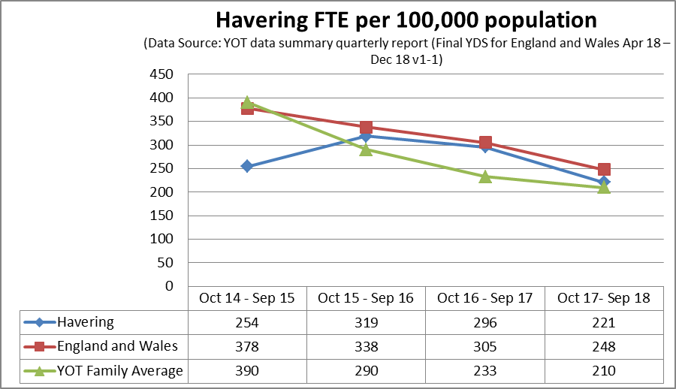

- Since October 2015 the London Borough of Havering has seen a continuous decrease in the total number of young people, aged ten to fifteen entering the youth justice system for the first time. Between October 2015 and September 2016, 319 per 100,000 individuals were entered onto the system which relates to 73 individuals; whereas when we look at our most current data October 2017 to September 2018 we are showing a decrease of 221 per 100,000, relating to 51 individuals.

- When we compare ourselves to our YOT families at the end of September 2018, we are just above the family average of 210 per 100,000. However compared to the total number of individuals, we are considerably below the average of 135 with 51.
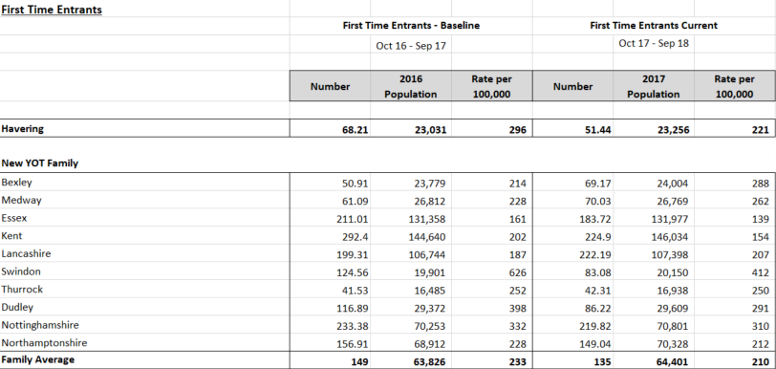
Use of Custody:
- The London Borough of Havering has seen an increase in custodial sentences since 2017 to 2018, with a rate of 0.17 per 1,000 at the end of December 2017, up to 0.39 at the end of December 2018. When we look at this In terms of actual individuals we went from 4 in 2017 up to 9 in 2018, showing an increase of 125%.

- When we compare ourselves to our YOT families at the end of December 2018 we are within the top 3 highest rates per 1,000 out of 11 boroughs. With an overall average rate of 0.24 Havering is currently sitting above this at 0.39.

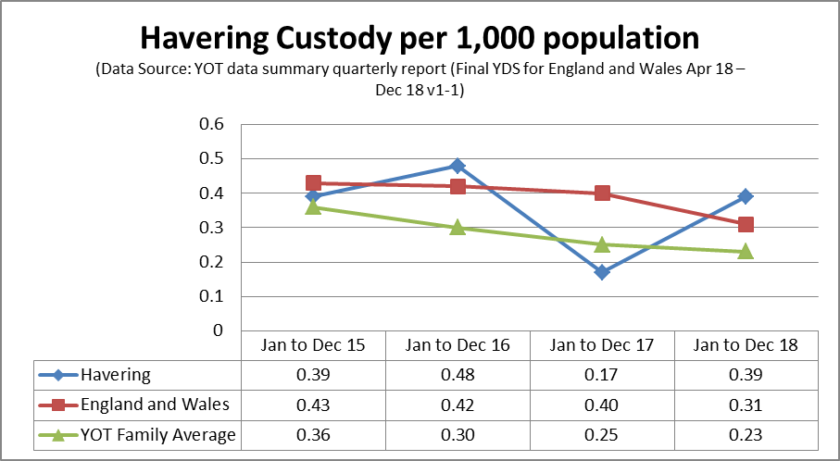
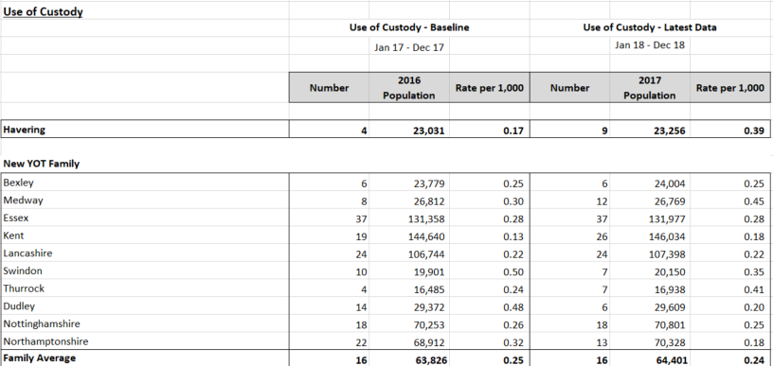

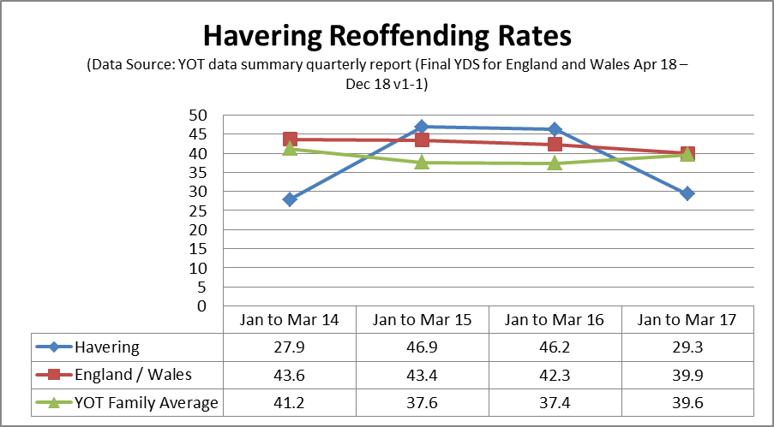

- Due to new methodology within the YDS changing from a 12 month cohort to a three month cohort we have provided data looking at three months ending March 17.

- Since 2015 Havering has seen a continuous decrease in the overall rate of reoffending from 46.9 in 2015 down to 29.3 in 2017. This is due to our cohort size fluctuating over the last 4 years, whereas our overall total number of reoffenders as remained steady. We have continued to see this trend throughout 18/19 with a binary rate of 20.8 as at the end of March 19. Havering currently has a cohort size of 72 with 15 reoffenders.

- When we compare ourselves to our YOT families at the end of March 2017, we have the lowest reoffending rate out of the eleven boroughs. With an overall average of 39.6 we are sitting considerably below this at 29.3.

- For the current cohort the reoffending live tracker shows that the most common offences committed is Violence against the Person which groups offences together such as weapons related offences and assaults. Drug related offence (Possession of Cannabis) is the second most common offence. Please note that all weapon related offences including possession of an offensive weapon and all assault related offences are incorporated under Violence against the person.

RISKS TO FUTURE DELIVERY AGAINST THE YOUTH JUSTICE OUTCOME MEASURES

- Havering YOT continues to see an improving picture in respect of First Time Entrants into the Youth Justice System. The current rate of 221 per 100 000 puts us favourably at 5th place in our New YOT Family. The YOT partnership is fully committed to continue to reduce the number of FTE’s and to divert young people away from committing offences and entering the youth justice system against a backdrop of an increasing population entering the Borough and the increase in serious youth violence.

- Over the past three years, Havering’s Face to Face program has changed the way in which we engage with children and families and the way in which we focus on relationships and engagement with children. Children’s services and the YOS have completed or are completing systemic training as our model of practice and this in turn supports families to build resilience and to improve relationships within family systems. With our focus on building resilience within families, there are fewer opportunities for family relationships to break down and for young people to be drawn into peer relationships which favour anti-social behaviours and criminality.

- We are seeing a consistent reduction of children on Child Protection Plans and Children becoming Looked After. With an increasing Early Help offer and the work offered from our Families Together Team, we are more able to offer services to families before they reach a crisis point and in doing so, we are able to reduce first time entrants into the youth justice system. Havering YOT’s out of court disposal panel is multi-disciplinary and is very much focused on understanding why young people offend and the relationship between offending and family relationships. The OOCD panel will continue to help divert young people away from becoming FTE’s into the YJ system.

- There has been a particular focus on restorative justice within schools during the 2018/19 period and the partnership will continue to strengthen this approach over 2019/20 period so that children and young people can continue to integrate restorative approaches to behaviour in schools and that they learn prosocial ways of interacting with each other. This will go in some way to reducing one of our risks to future delivery of “violence against the person”.

- Our Families Together Team is leading on edge of care innovations and supporting children and families using systemic practice as our primary model of change. By keeping families together in Havering, we are more likely to keep children from entering the youth justice system.

- Havering YOT will continue to improve our criminal justice pathways by continuing to work with NHS England to implement a Liaison and Diversion program for children in police custody. We will continue to focus on the diversion of individuals where appropriate out of youth justice systems into health and social care and support services.

- Havering’s Youth Services have a strong offer for children and young people in Havering. There are a number of projects available for young people which includes targeting young people on the edge of care; working with communities; self-esteem and wellbeing; SEND project and sexual health. Havering Youth Service have dedicated officers running a range of groups and activities for young people to divert them from criminal and anti-social behaviour.

- Havering has seen a positive reduction in our reoffending binary rate over the past four years. Our reoffending live tracker shows a binary rate of 20.8% which is below our YOT family and the England and Wales averages. Havering YOT and the partnership remain very much cognisant of the national increase in serious youth violence and our local profile showing our adolescent group engaging in reoffending behaviour and more violent crime. Victims of serious youth violence have risen from 98 in 2014 to 267 in 2018. Knife crimes with injury in Havering is increasing and we have an inward migration of gang members and offenders involved in SYV.

- The London Borough of Havering is adopting a positive partnership approach to addressing adolescent safeguarding risks and concerns in the borough. The partnership recognises that risks outside of the home and family and present in neighbourhoods, schools and peer networks require a statutory response outside of traditional child protection and criminal justice frameworks.

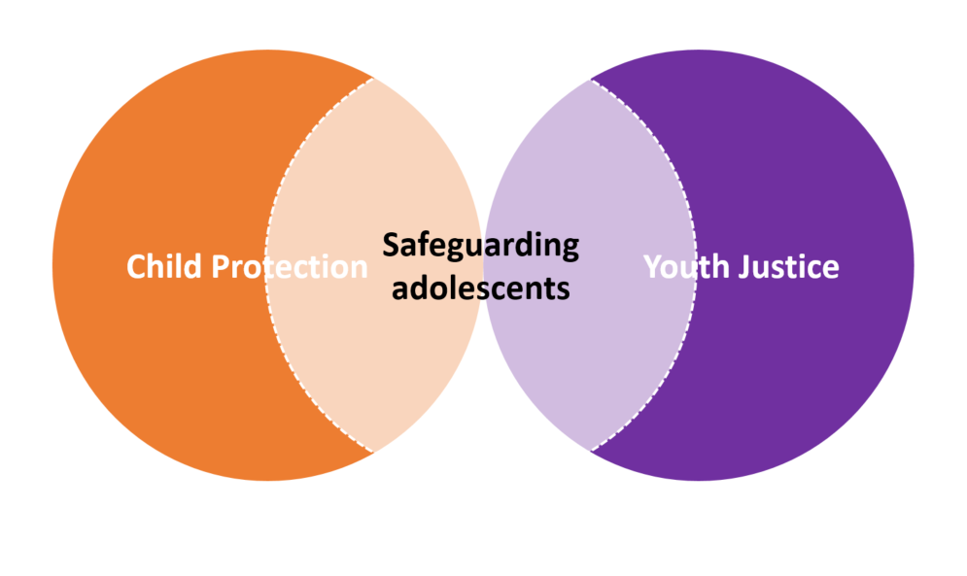
- The introduction of an adolescent safeguarding approach aims to understand adolescent contexts so services can respond to risks within peer groups and wider networks. Our approach is orientated towards maximising integrated working and ensuring that the partnership is able to assess and respond to challenges involved in reducing risk and harmful cycles of behaviour.
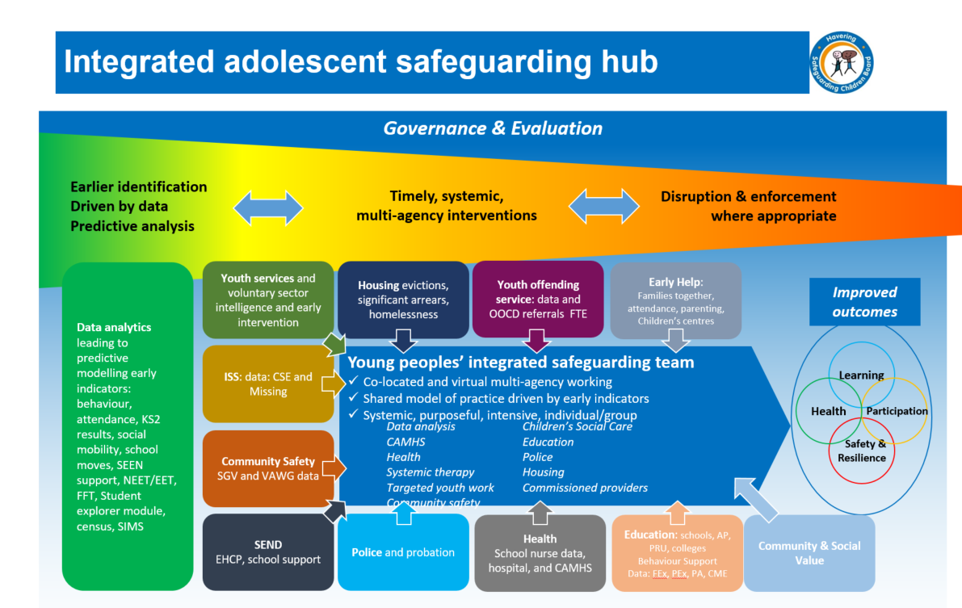
- The adolescent safeguarding strategy has been completed and funding has been approved by Cabinet for the adolescent safeguarding approach. The integration of services (as above) will commence from September 2019 and the partnership is positive that this approach will help to address the risks to future delivery against youth justice outcomes.

- Our custody cohort is rising incrementally from four to nine young people since 2017 which is a 125% increase. Our YOT Management Board agreed in April 2019 to commission an independent thematic of our reoffending (edge of custody) and custody cohort so that the partnership can fully understand the trajectory of our young people through our statutory and youth justice pathways. For example, the partnership is keen to know the familial factors; educational issues or health factors (including mental health) which resulted in a young person reoffending or ending up in custody. The partnership and the board are keen to examine how the partnership worked together with the young people and what we could have done differently to support them.

- Once the partnership and board have reviewed the thematic on reoffending and custody cohorts, the partnership intend to refine their approach to our most at risk cohorts to reduce their reoffending and risks of entering into the secure estate. The timetable for the thematic to take place is June 2019 with a report going to the board in August 2019.

- Havering YOT is completing their self-assessment so that we can understand what our strengths and growth opportunities are. We are keen to engage one of our YOT Families in a Peer Review later in the year (September 2019) so that we can learn more about what we are doing well and what we need to do in order to continue to make improvements in our service delivery for children and young people.

- In the interim, the YOT and our Families Together Team are going to be completing bespoke systemic interventions with families whose children and young people are in custody so that we can help families to improve their relationships with young people in custody and build the resilience within the family. In this way, we are hopeful that young people will have the right family support in place for when they leave custody and in doing so, we reduce the pull factors into further reoffending

- The YOT and Families Together Team will also complete systemic interventions with our most prolific reoffending cohort (15 individuals) in order to divert them away from reoffending behaviour and to help build resilience within the family systems. Our measure of success will be that we will be able to continue to reduce our reoffending binary rate over the next twelve months and reduce the number of young people entering the secure estate.

Number of proven offences committed by children by ethnicity
- Most number of proven offences occurred by children of White ethnicity, 458 out of 802 (57%) this is followed by BAME (21%), and Black (13%).

- All ethnicities display a greater likelihood than White children to commit offences where this is enough data provided to analyse. There are no instances where the Relative Rate Index (RR1) indicates the ethnicity of interest was less likely than White children to commit the particular offence.

- The offences where there was enough data to calculate the RRI were Criminal damage, Drugs, Motoring offences, Other, Robbery and Violence against the person. Offence groups listed under 'Other' include; Arson, Breach of bail, Breach of conditional discharge, Death or injury by dangerous driving, Fraud and forgery, racially aggravated offences, not known, other.

- In regards to the different ethnicities, the data shows that Black and BAME children highest demographic of offending is drugs. In both cases drugs account for around 33% of the offences resulting in a caution of conviction, in White children drugs offences on count for 12%.

- The chart above provides information on cautions and convictions given to children broken down by outcome type within each ethnicity. For all ethnicities a First Tier outcome was received. 67% of offences across all ethnicities received a First Tier outcome. The percentage of custody outcomes were low across all demographics with no ethnicity having more than 6% of offences resulting in a custodial outcome.

Number and proportion of children receiving a youth caution or court conviction by age, ethnicity and gender
- The table to the right displays the number of children who received a caution or conviction by age and ethnicity. The highest distribution of offenders was in the 16 and 17 ages. 34% of White offenders, 8% of Asian offenders and 29% of Black offenders were aged 17. Further to this 29%, 27% and 40% respectively were aged 16. In total 60% of the BAME cautions and convictions were between the two ages. The chart also highlights the low volume of offender in certain demographics. The offending data is heavily weighted towards White offenders, followed by Black. As stated the offending pattern in relation to age for both demographics follow a similar expected pathway.

- In relation to gender of offenders, the split between male and female is as to be expected. The overwhelming majority of offenders are Male. This is true for all ethnicities and is in line with previous offending patterns. 87% of White, 89% of Black and 81% of BAME children who received a caution or conviction were Male. Again the low volume of offending by certain ethnicities is to be noted.

Rate of youth cautions and court convictions given to children by outcome type and ethnicity
- The following chart displays the rate of cautions and convictions given to children broken down by outcome type and ethnicity, per 1000 children in the local 10-17 population.

- The chart below shows that BAME children receive a significantly higher rate of cautions and convictions compared to White children. The BAME figures are heavily influenced by the cautions and convictions received by Black children. In regards to First Tier outcomes for example, the rate of outcome was 11.6 for White compared to 31.9 for Black children. This pattern is continued in both Community and Custody convictions with the rate of Black children receiving both punishments being more than double to their White equivalent. The other ethnicities that contribute to BAME, Asian, Mixed and Other also display a disproportionate high rate of youth cautions and convictions, even though it should be noted that these numbers still represent low volumes.
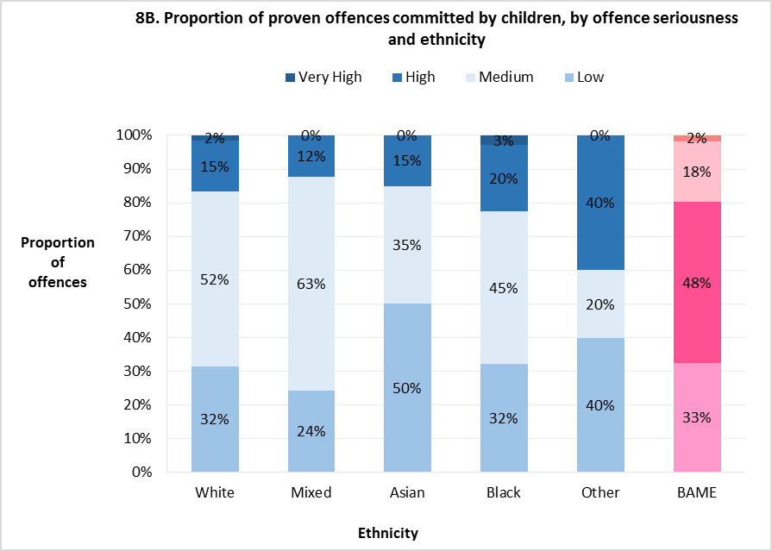
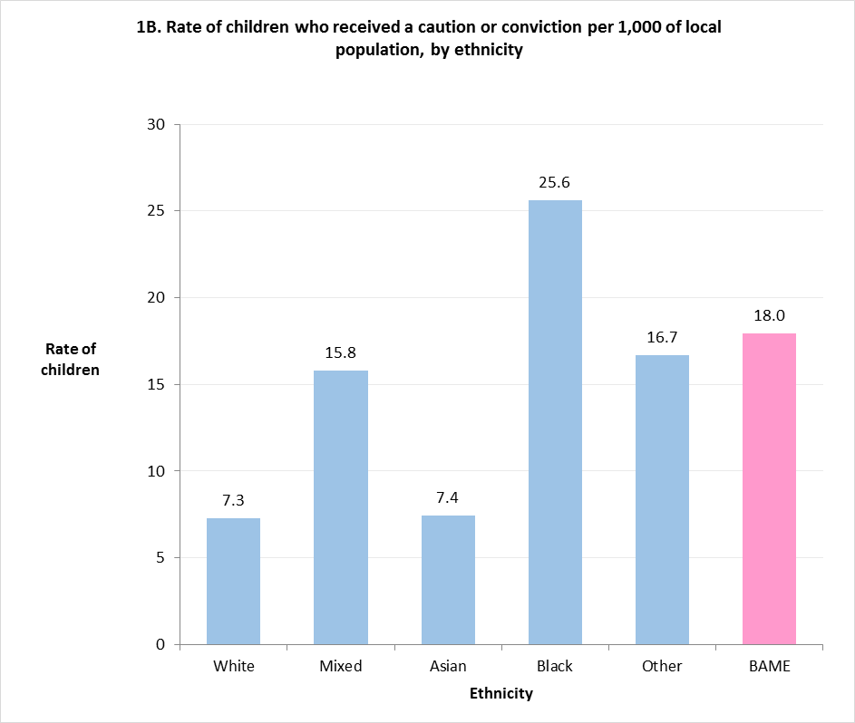
- The disparity noted is further displayed on the table below. As can be seen, the rate of children who received a caution or conviction per 1,000 is heavily biased towards Black and BAME as a total. Over 25% of Black children received a youth caution or conviction compared to just over 7% of White children. The data does skew Drugs related offending for Black children while offending of White children is more evenly spread over a number of offences.

- This however should not account for the disparity in the caution and conviction rates between the two. Also as shown below when the comparison is carried out in regards to offence seriousness White and Black children values are similar. 52% of White and 45% of Black children proven offences were considered medium gravity, 15% and 20% were considered high and 2% and 3% were considered very high. There is therefore investigation needed into why Black and BAME children are more likely to receive harsher outcomes than White children for committing a similar proportional amount of crime gravity.

YOUTH JUSTICE BOARD STRATEGIC PRIORITIES FOR HAVERING PARTNERSHIP 2019 TO 2020:

YJB Vision:

A youth justice system that sees children as children, treats them fairly and helps them to build on their strengths so they can make a constructive contribution to society. This will prevent offending and create safer communities with fewer victims.

A child first, offender second approach means that all youth justice services:

- Prioritise the best interests of children, recognising their particular needs, capacities, rights and potential. All work is child-focused and developmentally informed.

- Promote children’s individual strengths and capacities as a means of developing their pro-social identity for sustainable desistance, leading to safer communities and fewer victims. All work is constructive and future-focused, built on supportive relationships that empower children to fulfil their potential and make positive contributions to society.

- Encourage children’s active participation, engagement and wider social inclusion. All work promotes desistance through co-creation with children.

- Promote a childhood removed from the justice system, using pre-emptive prevention, diversion and minimal intervention. All work minimises criminogenic stigma from contact with the system.

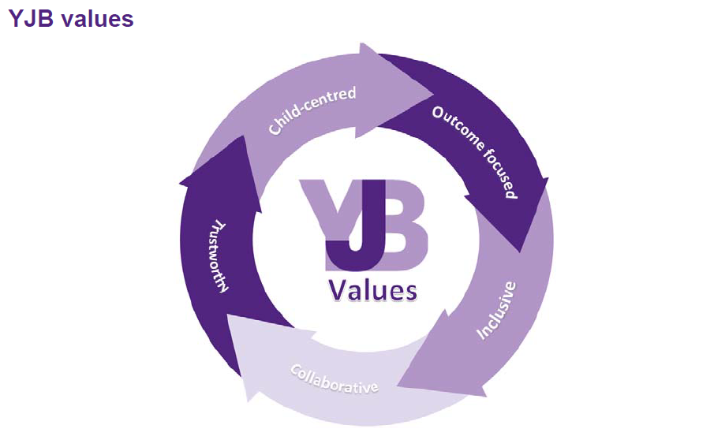

- Havering YOT and the partnership will work with enthusiasm, vigour and imagination over the next year to achieve the four strategic priorities set out below which are aligned with the vision of the Youth Justice Board:

STRATEGIC PRIORITY 1:

IMPROVE THE SAFETY AND WELLBEING OF CHILDREN IN THE YOUTH JUSTICE SYSTEM
- The YOT partnership aims to achieve improvements in relation to the safety and wellbeing of children in the youth justice system in the following ways in 2019/20:

- Adolescent Safeguarding Approach:

- An integrated adolescent safeguarding approach which delivers a multidisciplinary offer that responds to adolescent risk and need (see diagram on p. 29).
- Implementation of contextual safeguarding approaches outside of the family and home that improve outcomes for vulnerable adolescents.

- MASE & CSE / Missing Operational panel

- Enduring support to children and adolescents who have been exploited, ensuring that what is offered is appropriate for each individual child or adolescent based on their gender, age, ethnicity, disability, and the nature of the exploitation that they have experienced.
- Children receive specialist services from the range of MOPAC funded services for children at risk of sexual and criminal exploitation and county lines activity.

- Serious Group Violence & Gangs

- The multi-agency Serious Group Violence Panel will continue to oversee the risk management of medium to high risk nominals.
- Sparks to Life mentoring and outreach is available for young people who are vulnerable to becoming involved in gang activity or who are entrenched in gang activity.
- Community Safety will continue to use dispersal powers within Romford Town Centre to disrupt gang-related activity and service Community Protection Notices to those found causing a nuisance.

- Chance Scheme:

- Will continue to support young people identified as causing early stages of anti-social behaviour and ensure that they are able to learn more pro-social behaviours.

- YOT Risk Management Processes:

- Children and Young People who ordinarily meet the criteria for risk management panels will in future attend bespoke multi-agency safeguarding planning meetings chaired by the YOT Advanced Practitioners or YOT Operations Manager. The meetings will include the family and the young person to identify risk and need and agree a plan which is co-produced and promotes engagement of young people in safety planning.

- Safe Haven Schemes

- Young people will be able to access a number of key sites around the borough where young people at risk of harm can go to for immediate refuge and assisted to get home safely.

- Children’s Services statutory response:

- Where children and young people are identified to be in need or at risk of significant harm, they will be referred into children’s services for a statutory assessment and intervention. Children open to children’s services and the YOT will benefit from a joined up approach which privileges collaboration and co-production as the drivers for change.

- Prevent:

- Havering has a dedicated Prevent Lead Officer who works closely with all services to identify young people and adults who are at risk of radicalisation and extremism to ensure that they get the help which they require.
- YOT staff have received WRAP 3 training and are alert to signs of young people who are at risk of radicalisation and extremism.

- MAPPA

- The MAPPA chair is a member of the YOT Management Board. All partner agencies will continue to manage the risks posed by violent and sexual offenders living in the community in order to protect the public.
STRATEGIC PRIORITY 2
REDUCE THE NUMBER OF CHILDREN IN THE YOUTH JUSTICE SYSTEM (REDUCTION IN FTE’s)
- Havering partnership has demonstrated a continuous reduction in the number of First Time Entrants into the Youth Justice System over the past five years. For example, a reduction in the rate per 100 000 of 306 (April 13/14) to 221 (September 2018). The partnership has been able to keep the rate per 100 000 relatively stable over time without significant increases between reporting periods to the YJB.

- Over the next year, the YOT Management Board will work to support and challenge the partnerships response to ensure that we continue to reduce the number of FTE’s into the YJS.

- Early Help

- The Local Authority has a robust Early Help offer for children and families which aims to support families and help them to tackle problems earlier and to build resilience within families. Examples of interventions include services available via universal plus; a solid interface with schools and a range of programs for children and families to access at a number of children’s centres and in the community.

- The YOT has a full time parenting officer who provides a range of parenting support to children and families open to the YOT. Junior citizen’s scheme continues to run in Havering primary schools to improve young people’s awareness of knives, drugs and fire safety before they transition to secondary school. This is particularly helpful considering our 10 to 14 cohort identified in our problem profile as requiring early services to avoid becoming FTE’s.

- Pupils who are statutory school age 5-16 who are involved in ASB, or who are at risk of CSE or risk exclusion from school will be referred to the Alternative Provision Service (APS). The APS will work closely with the pupil’s school to support and divert the young person from offending behaviour. They will assess and provide alternative education and / or support them to engage and enable the pupils to make better choices to gain better educational outcomes and set future goals.

- There is a robust Early Help Restorative Justice offer for Havering’s schools and young people. In terms of Restorative Justice, (RJ) training has been delivered to 12 schools across the London Borough of Havering. Out of the 12 schools that accessed the training 5 schools bought in the whole RJ package.

- A total of 60 colleagues have been trained in RJ approaches to promote that RJ is introduced across the network and partnership. Fifty four new peer mentors in schools have been trained to support and assist with low level conflict within the school environment. This is helpful particularly in relation to our rise of 10 to 14 year old cohort into the Youth Justice System.

- Two hundred and twenty one teaching and non-teaching staff have been trained in RJ approaches. This enables the staff to better understand the individual needs of the child, impact on children in respect of unmet needs, behaviour needs, learning needs and how the responses to behaviour that is demonstrated by children related to the above is managed positively and effectively.

- Liaison and Diversion:

- Havering YOT will continue to improve our criminal justice pathways by continuing to work with NHS England to implement a Liaison and Diversion program for children in police custody. We will continue to focus on the diversion of individuals where appropriate out of youth justice systems into health and social care and support services.

- Families Together – Edge of Care

- Our Families Together Team is leading the way on edge of care innovations and supporting children and families using systemic practice as our primary model of change. By keeping families together in Havering, we are more likely to keep children from entering the youth justice system and becoming First Time Entrants.

- The FTT is a highly effective systemically trained team who have a strong success record in engaging families successfully and working with them to build resilience and positive relationships.

- Out of Court Disposal Panel

- Havering YOT operates a highly effective multi-disciplinary Out of Court Disposal Panel who are fair, proportionate and balanced when thinking about support and disposal options for young people. Panel members are interested in understanding the familial stories linked to offending behaviour and how young people can be truly supported to have their needs met while addressing risk, need and concern.

- The panel agrees on an appropriate disposal option for the young person in line with the offending matrix scores ensuring that all disposals are proportionate and do not unnecessarily criminalise young people. The panel will continue its positive work into the 2019/20 period working from strengths based platform to reduce First Time Entrants into the youth justice system.

- Systemic Practice (model of change)

- In thinking about future developments within the YOS we are interested in how we develop, focus on, understand and carry out interventions that are co-produced with the young people and families we come into contact with and the relationship between this and engagement and purposeful interventions. Additionally, there is an interest in the different panels that take place within the service and how they are both a starting point of thinking about and planning interventions with families and a point of review of interventions.

- The YOT systemic family therapist will continue to offer direct interventions, consultations and group work to staff and to clients in the service. All of the YOT staff will soon be completing their systemic training and as such, will be able to work even more effectively with children and their families in the YOT.

- Children’s Services

- Children’s services has successfully implemented Havering’s Face to Face vision which incorporates a range of DFE innovation funded approaches in working with children and families. In offering services to families which privileges relationships and helps families to build resilience, it is less likely that children will be drawn into anti-social and criminal behaviour which results in them becoming FTE’s.

- Children’s Services will continue to offer proportionate statutory responses for children who have high levels of risk and need and we will work closely with schools to tackle problems early on.

- Police

- The YOS partnership has a good working relationship with the police via BCU arrangements. Over the next twelve months, we will continue to work with police to ensure that only where necessary, children enter the youth justice system for offending behaviour.

- NEET / EET

- Havering partners recognise the strong link between children’s non-attendance at schools and the link to offending and FTE’s. Havering partnership is looking to increase its capacity to target young people aged 15-18 who are NEET and to help them to reintegrate into informal or formal educational opportunities.

- Serious Youth Violence / County Lines / Sexual and Criminal Exploitation

- As noted earlier in the YJB plan, Havering partnership has completed research drawn from national research which clearly highlights the need for the whole partnership to work together and to do so as early as possible for children at risk of SYV or exploitation. The Local Authority’s adolescent safeguarding approach will be a source of support and protection for young people who are actively being exploited; who are involved with SYV or who are vulnerable to being drawn into either of these harmful practices. Our CSE and Missing Co-Ordinator is also central to safeguarding young people at risk.

- Alongside the adolescent safeguarding approach, Havering partnership has access to a range of MOPAC funded services for young people who are victims of exploitation. By supporting these young people with robust assessment and planning processes and ensuring that services are timely and effective, we are more likely to be successful in helping young people not to become First Time Entrants into the youth justice system. Our partnership work with schools is inevitably key in diverting young people from becoming FTE’s.
STRATEGIC PRIORITY 3 – REDUCE REOFFENDING BY CHILDREN IN THE YOUTH JUSTICE SYSTEM
- Havering partnership is committed to reducing the overall number of young people reoffending. Since 2015 Havering has seen a continuous decrease in the overall rate of reoffending from 46.9 in 2015 down to 29.3 in 2017. We have continued to see this trend throughout 18/19 with a binary rate of 20.8 as at the end of March 19. Havering currently has a cohort size of 72 with 15 reoffenders.

- Thematic Review of our Reoffending Cohort

- The YOT Management Board agreed in April 2019 for a thematic review of our most prolific reoffending cohort to be undertaken. This will enable the partnership to fully understand the reasons why young people continue to reoffend and what interventions can be specifically targeted to reduce young people reoffending.

- Following the conclusion of the thematic review in August 2019, the management board and the partnership will agree on a specific range of interventions to test with the reoffending cohort and to measure the impact on reducing reoffending. If the particular measures are successful, then this will be rolled out further to other young people in YOT who are at risk of reoffending while on their Orders.

- Families Together Team & the YOT

- The Families Together Team, the YOT staff and the YOT Systemic Family Therapist are going to undertake a bespoke piece of family work with some of the young people who are in the most prolific reoffending cohort. The focus of the work will be looking at engagement and relational based family work to help the families concerned to help the young people to reduce their reoffending.

- JAC / Reparation / Victim Work

- Havering YOT will continue to support young people across the BHR footprint (LBH / LBR / LBBD) who are on statutory Orders and are suitable for JAC attendance to be part of their rehabilitation. Sparks to Life will continue to deliver programs for young people referred to the JAC in order to reduce their reoffending.

- Havering YOT will continue to offer reparation to victims and community reparation projects. We have recruited to the reparation worker role and they are due to start soon. A reparation program is being developed which will take place during school holiday periods which supports young people learning new accredited skills and using their time constructively which reduces the risk of reoffending.

- Havering YOT has made links with a number of local business where our young people benefit from learning opportunities at community reparation work projects. A quarterly JAC and Reparation report will be submitted to the YOT Management Board for scrutiny and challenge.

- SEND QUALITY LEAD AWARD

- Havering Partnership was awarded the Achievement for All Quality Lead Award at the Youth Justice Convention in 2018. The award recognises the partnerships excellent working relationships and our approach with young people who have additional needs. Considering that a quarter of our young people open to YOT have some form of additional needs, the partnership will continue to work together effectively to ensure that all young children’s needs are met in order to reduce reoffending.

- NELFT SERVICES FOR YOUNG PEOPLE

- Havering YOT has a full time speech and language therapist and a CAMHS Specialist Nurse who work closely together. We have already set out the range of specialist services which NELFT provide for our young people in the YOT.

- Young people open to YOT will continue to receive speech and language and mental health screens to identify which services are most useful to support them.

- WISE UP

- Havering YOT has a full time substance misuse practitioner who offers a range of interventions for young people with substance misuse problems. This service will continue into the 2019/20 period and will support risk reduction with our young people particularly young people who have mental health needs and substance misuse problems.

- Mentoring Support via Sparks to Life

- Sparks to Life offer a mentoring service to our young people who are at risk of being drawn into gangs or are entrenched in gang membership.

- Sparks to Life will continue to offer mentoring support to our young people who are engaged in a range of anti-social behaviours which increase their risk of reoffending.

- Workforce Development:

- Havering YOT staff are committed to keeping their knowledge and skills up to date via research in practice forums and training opportunities as well as the Local Authority’s systemic training offer.

- The service will continue to use the YOT service improvement plan and the auditing framework to benchmark progress against HMIP practice standards over the next twelve months.

- The addition of a qualified social work management role to the team will add value to supporting more complex case work and leading on whole family working within the service.

- Havering YOT will continue to reach out to other YOT’s who have been inspected as GOOD or Outstanding in order to support our own learning around excellent practice.

- YOT Managers will continue to support and develop YOT practitioners in terms of the quality of their asset plus assessments and young people’s plans, to ensure that both are achieving a “GOOD” standard at the time of an HMIP inspection.

- Referral Order Panels:

- Young people subject to Referral Orders will continue to attend Youth Referral Order Panels to set and review their goals. Havering YOT is committed to conducting Referral Order panels in a way in which they enable children to recognise the consequences of their offending and to be accountable for their actions.

- Our approach will ensure that meetings are conducted in accordance with restorative principles and practice.

- During the 2019/20 period, independent referral order panel training will be available for the panel members to ensure that they have the most up to date knowledge and skills to administer the panels fairly and proportionately.

- Young people’s feedback will be sourced via mind of my own regarding their lived experience of the Referral Order Panels and how this helped them to reduce reoffending.
STRATEGIC PRIORITY 4:
IMPROVE OUTCOMES FOR CHILDREN IN THE YOUTH JUSTICE SYSTEM
- Young People in the Secure Estate

- The YOT Management Board agreed in April 2019 that a thematic review of young people in custody will be commissioned independently and the partnership will review and respond to the recommendations. The aim of the thematic is for the partnership to be able to respond earlier to the “edge of custody” cohort in order to divert them from entering the secure estate.

- YOT practitioners will be supported to produce quality pre-sentence reports with a clear analysis of BAME disproportionality and include proportionate and credible community sentence recommendations.

- Havering YOT will review national research around ethnic disproportionality of those young people receiving custodial outcomes to identify best practice. We will use the research to inform our practice so that our service delivery supports our BAME cohort and challenges our thinking; our unconscious bias and our decision making.

- We will continue to develop and closely monitor our alternatives to custody, such as Bail or YROs with Intensive Supervision and Surveillance (ISS) requirements, so that Courts can be confident in these sentencing proposals.

- For young people open to the secure estate, we will ensure that Independent Reviewing Officers will scrutinise the quality of care afforded to our young people in custody to ensure that their needs are being adequately met.

- Upon entering the secure estate, all young people’s asset plus assessments and plans will be updated to ensure that their needs are met and risks are managed.

- Havering YOT will actively work with the secure estate to develop young people’s pro-social identity for sustainable desistance, leading to safer communities and fewer victims. Havering YOT and the partnership will work with young people’s families to ensure that they have the best opportunities for reunification and support on their release from custody.

- MOPAC Funded Services:

- Havering partnership has access to a number of MOPAC funded services for children and young people who are at risk of criminal or sexual exploitation or other needs arising from adverse childhood experiences.

- Havering YOT and the partnership are committed to making use of services which include: Rescue and Response, Tiger Light, Abianda and TAITH in order to provide the services which they need in order to improve the outcomes for young people in the youth justice system.

- Probation Service

- Havering YOT has a 0.5 FTE probation officer in the YOT. Havering YOT and the probation service will continue to work closely together to ensure that all young people have a careful and considered transition between services which ensures that their needs are met and the risk to the public is managed.

- Voice of the Child / Engagement with young people

- In order to improve outcomes for young people, Havering YOT partnership believe that young people need to be very much involved in understanding intra-familial and adolescent risks and helping them to find solutions to their circumstances by co-producing their plans.

- We are providing a commitment to reviewing our existing risk management processes to enable us to move forward to a position where young people and their families are very much involved in assessment and care planning processes. In doing so, our approach is more likely to support positive desistance and strengths-based outcomes which encourage children’s active engagement in decisions which affect their lives.

Signed:

Robert South
Assistant Director, Children’s Services
Chair of YOT Management Board

