To be reviewed by May 2020 – Participation Consultation is currently in process and will further inform the Participation Strategy.
London Borough of Havering
Participation Strategy

Contents
Introduction

Our Vision

Who is the strategy for?

Key messages

Establishing a shared understanding of Participation and the Benefits

What is Participation?

Participation for Children in Care and Care Leavers

Inclusion and Equality

Where and how do young people have an opportunity to share their views?

Creating an environment

Participation work undertaken

Children in Care Council

Youth Parliament, Youth Council and London Youth Assembly

Introduction
Participation is the process of involving children and young people in decision making opportunities that can influence the strategy, delivery and evaluation of the service provided.
The aim of this strategy is to:
- set out our vision for participation
- clarify what participation is
- outline the benefits of participation
- identify good practice to date
- outline areas for improvement
Involvement in decisions that affect their lives is a fundamental right for all children and young people. The United Nations Convention on the Rights of the Child or UNCRC says that children and young people “have a right to say what you think should happen when adults are making decisions that affect you and to have your opinions taken into account” (Article 12 of the UNCRC)
The following Legislation has helped form this strategy:
Keep on Caring (July 2016)
Leaving Care Act 2000
Children and Young Person’s Act 2008
Children’s and Families Act 2014 (Staying Put)

Our Vision
Havering is committed to ensuring that partner agencies, children, parents and carers have the opportunity to influence decision-making and the development of the service.
Over the next year the aim is to embed a culture of participation which will give children and young people a voice. Our work centres on promoting improved outcomes for children and young people, by working with children and young people (co-production) and by young people identifying some of the outcomes themselves.
To achieve this, participation activities should encompass a range of initiatives- including building opportunities for children and young people to talk about and explore their experiences. The following shared values are at the heart of our partnership’s commitment. We are committed to embedding the values across the council and its partners to enable strategies, leadership and commitment to children and young people’s involvement.

Who is the strategy for?

This strategy is for all the people involved in the Children and Family Partnership including young people in care and care leavers and other vulnerable groups (including Child Protection, Early Help, Missing/CSE (Child Sexual Exploitation), UASC (Unaccompanied Asylum Seeking Children) and Children with Disabilities. We want to embed a culture of participation across Havering, by positively engaging children and young people and ensuring that they understand how they can be involved in the decisions that affect their lives and future.
We want to develop positive opportunities and initiatives which will engage young people in decision making. This will include listening to their opinions, concerns and views in the design and delivery of our service to ensure that it meets their needs and improve the way we work.

Key messages:

- Develop a culture - the ethos of an organisation, shared by all staff and service users, which demonstrates a commitment to participation
- Develop a structure - the planning, development and resourcing of participation evident in an organisation’s infrastructures
- Develop effective practice - the ways of working, methods for involvement, skills and knowledge which enable children and young people to become involved
- Develop effective review systems - the monitoring and evaluation systems which enable an organisation to evidence change affected by children and young people’s participation

Establishing a shared understanding of Participation and the Benefits

To create a culture of meaningful participation managers, practitioners, children and young people need to have a shared understanding of participation and what this means. To achieve this, they need to have a clear understanding about what participation means to them and the potential impact it could have. As Treseder (1997) states: ‘Many attempts to involve children and young people end in frustration precisely because the implications of empowerment are not properly considered from the start’.

The table below sets out the benefits of participation for both young people and the organisation.

Benefits for young people | Benefits for Organisation
- Learn new skills for employment  - Develop self confidence  - Opportunity to influence decisions that affect their lives  - Opportunity to influence develop social networks  - Feel valued and empowered  - Opportunity to develop better understanding of how organisations operate and make decisions  - Buid resilience and a greater understanding of effective communication. | - Services become more responsive to the needs of children and young people  - Can begin to challenge presumptions about the needs of children and young people  - Become more accessible to children and young people  - Become more efficient as they are providing a more effective service for children and young people  - Creating a greater understanding of the needs of children and young people from the view point of children and young people.

Source: The participation of children and young people in developing social care. This guide was compiled for SCIE by a team from Barnardo’s Policy and Research Unit, which was led by Polly Wright. The authors of the guide are Polly Wright with Claire Turner, Daniel Clay and Helen Mills.

What is Participation?
Participation can mean many things…. Contribution, input, partaking, involvement, connection, relationship and belonging. It is also the process by which individuals can proactively influence decision-making and bring about change. This may mean individuals influencing decisions about their own lives and also the lives and outcomes of others.
Consultation is the process by which children, young people and their families are asked their opinions. This includes asking their opinions on various suggested options, e.g. satisfaction surveys and evaluation feedback. Consultation may support participation but does not replace it.

Participation for Children in Care and Care Leavers

This Participation Strategy will:
- Set out how the voices of children in care and care leavers are heard within Havering and the impact this will have on the service
- Set out the current level of participation for children and young people in care and to plan priorities for future development
- Listen to children and young people and feed back to them – the feedback loop.
This will be overseen by Havering’s Corporate Parenting Board and Strategy, also included in the Quality Assurance Framework.
Forums for young people are:
- Children in Care Council – Phoenix (aged 10yrs to 16yrs)
- Youth Management Team – (17yrs – 25yrs)

Inclusion and Equality
Havering is committed to promoting equality of access and inclusion and will seek the views of all young people and offer them the opportunity to influence service delivery. This includes:
- Children and young people with a disability
- Children and young people with Special Educational Needs
- Those with communication and language needs/barriers
- Looked after children
- Children and young people subject to child protection procedures
- Children on Child in Need plans
- Young Carers
- Teenage Parents
- Lesbian, gay, bisexual or transgender
- Black minority ethnic
- Faith communities
- UASC (Unaccompanied Asylum Seeking Children)
- Young People who are supported by YOS (Youth Offending Service)

Where do young people have an opportunity to share their views?

- Through their social workers i.e. during visits, phone calls, text messages
- Through Family Practitioners doing direct work with children
- Meeting with Independent Reviewing officer/ Conference Chair
- Through attending their conference/ review/meetings
- Through family meetings held with the Early Help Team
- Through an advocate and independent visitors
- Interviews with parents and children/young people (where they are present at the CP Conference)
- Service user feedback from children/ young people through the case file audit tool and Practise Week.
- Focus groups
- Group work with Care Leavers
- Children in Care meeting/group meeting(CiCC)
- Activities with the Virtual school
- Questionnaires – Care Leavers and children in care.
- Mind Of My Own completed by Looked after Children and children subject to a Child Protection Plan, CIN Plan or in Early Help
- Some schools are supporting with partnership working and direct work with children
- Youth Council/Youth Parliament meetings/consultations
- Complaints – Mind of My own Complaints or Problem Statements
- Participation visits with Young People Advisor Pathway Coordinator and Social Workers to young people
- Corporate Parenting Panel

Universal
- Schools consultation
- School councils
- Youth centre consultations
- Make Your Mark (UK wide),
Other Youth Forums
- CAHMS
- Young Carer’s
- Young Disabled Forum
- Youth Clubs

Creating an environment
There will be some young people that will need to be able to develop trusting relationships with staff/adults before sharing information. Young people themselves identified the following:
Treat young people as individuals

Respect young people’s right to confidentiality

Respect young people and their views

Act on what young people say

Make yourself available to listen to young people when they want to speak.

Do not judge young people on their appearance

Provide consistent members of staff so that young people have the opportunity to develop trusting relationships over time

Provide young people with enough time to voice their opinions and become involved

Source: The participation of children and young people in developing social care. This guide was compiled for SCIE by a team from Barnardo’s Policy and Research Unit, which was led by Polly Wright. The authors of the guide are Polly Wright with Claire Turner, Daniel Clay and Helen Mills.

Some Havering Young People took part in a workshop with their Social Worker about feedback, which also included what is a ‘good’ and ‘bad’ social worker

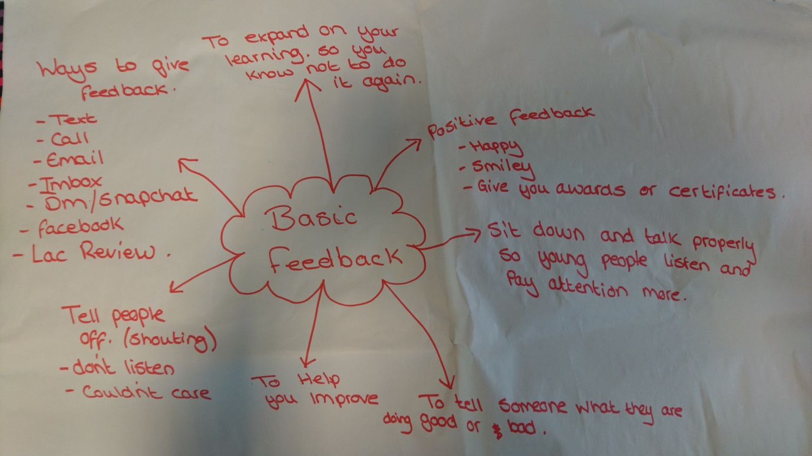

Feedback from Workshop

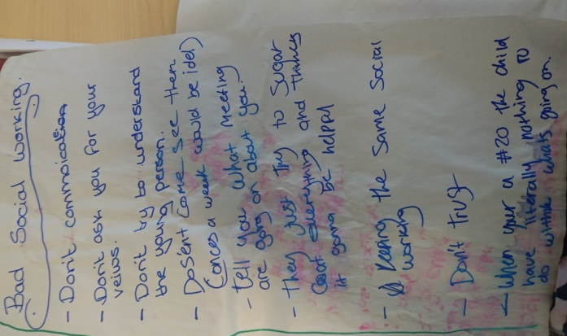
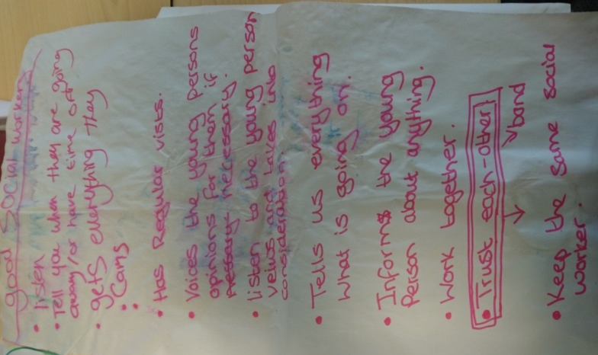

How will young people know how they can share their views?

- Information Pack when young people come into care.
- Children in Care Pack
- Information leaflet when young people are in the child protection process.
- Via their worker, IRO or Young Person’s Advisor
- Advocate

How will young people know they have been listened to?

- From their meetings, reviews and workers
- From attending Corporate Parenting Board Meetings
- From Newsletters, social media and 1 -2-1 feedback

Children in Care Council (10-16 years): Havering Children in Care Council was re-launched in March 2019. Children in Care Council members state that “The Children in Care Council is a group of young people who are all cared for by Havering. It gives the young people an opportunity to meet other young people with the same sort of background. It also gives a chance to shape and influence the parenting that they receive at every level. As well as gaining a greater understanding on their rights and entitlements. Attendees will be able to voice their opinion and suggest ways to improve Havering and the services they receive. The aim is to make their life better and others around them, helping to shape the overall strategy for cared for children and young people in Havering.”
The Children in Care Council have been consulted and involved in a variety of projects:
- Including their Rights and Mind of my Own Entitlements, What is Participation? Your Thoughts on Advocacy, Thoughts on their LAC Reviews and re-writing their Pledge (Local Authorities promises, to name a few).
- creating the information displayed on the ‘Foster Guide for Children’ and designing the content for a foster care advert.
Youth Management Team (17-26 years): meet monthly with staff and with decision makers regarding making changes to improve the service. They have recently worked with Havering with case recording and created the Caswe Recording Pledge

Youth Parliament: There are two members of the Youth Parliament who are democratically voted to represent Havering. Elections were in February 2018 and the two members with the most votes took up post on the 1st March 2018 for a two year term. Those members will shortly be stepping after elections in Feb 2020.
The Members of Youth Parliament attend events and meetings both in and out of Borough and represent the views of young people locally, regionally and nationally.
Youth Council: There is an open membership (no voting) and presently there are 20 young people attending regularly (the expansion and diversity of this group is on-going). Young people are from different schools, cultures, sexuality and backgrounds, including vulnerable young people accessing different services.
The role of the Youth Council is to support the Members of Youth Parliament and be part of campaigns and consultations to represent the voice of young people in Havering in order to promote change locally and regionally
London Youth Assembly: this is relatively new and is a forum for all London Borough to meet to tackle issues for young people across London. There is a Member for 1 year, Deputy Member for 2 years who stops up after a year. Meetings are at City Hall 4 times a year and in regions 4 times a year.

Examples of Participation

Taking part in interviews
Attending Corporate Parenting Board
Being a member of Safer Neighbourhood Board
Co-producing events such as Achievement Awards Evening, events at the Cocoon.

