How to access a CVP hearing
The court has started doing some hearings using a new system called CVP (Court Video Platform). If a hearing is being conducted in this way you will receive an email from the court telling you how to join but due to our IT we have to access it in a slightly different way which I have set out below. If you have any queries please let me know.
The email from the court will tell you to click on a link to open in your web browser and then enter a conference ID. However, instead you should be able to join the conference directly from Lync (or Skype if you are on Windows 10) – by copying the conference ID and pasting it into the box where you would search for someone – the conference ID will look something like hmcts407@meet.video.justice.gov.uk. You then call that ID as you would make a normal call.

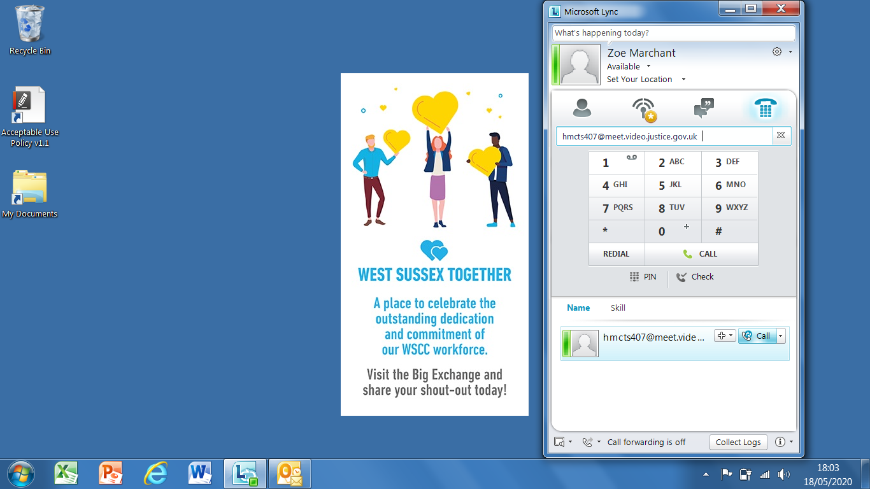

This should then dial you in to the conference and it will ask for your pin which you can enter through the dial pad – the pin will be in the email sent from the court.

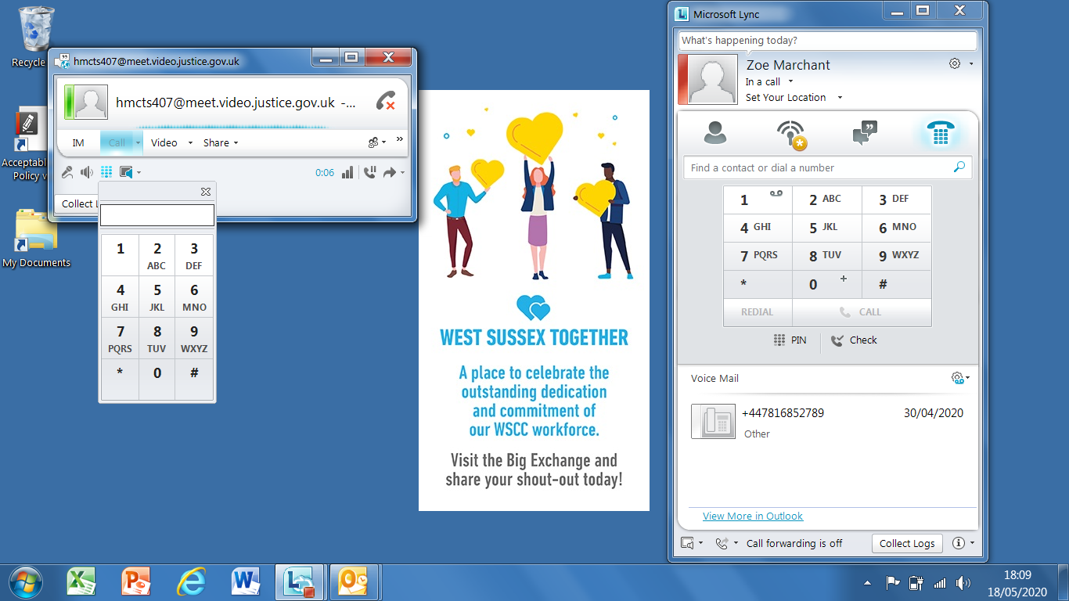

Once you are in the hearing you then turn your video on.

