**Neglect Tool Kit Tick List Guidance**

This form is used to record that a worker has completed the mandatory tools where neglect has been identified as a concern.

To open the form:

* Person Summary page > *Documents*

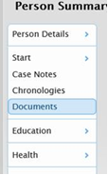

This takes you to the Documents page.

* Click > *Create* (n.b. you may need to scroll down to see this)

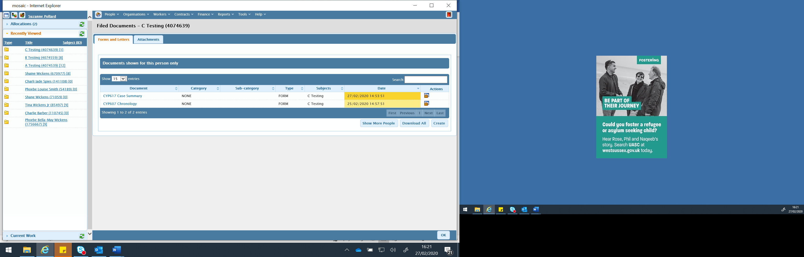



* Click > *CYP752 Neglect tools checklist*

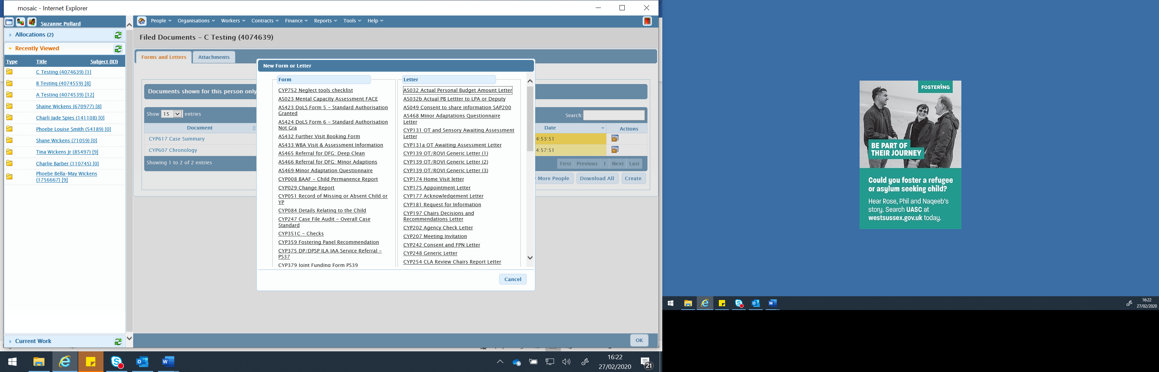



This opens up the tick list:

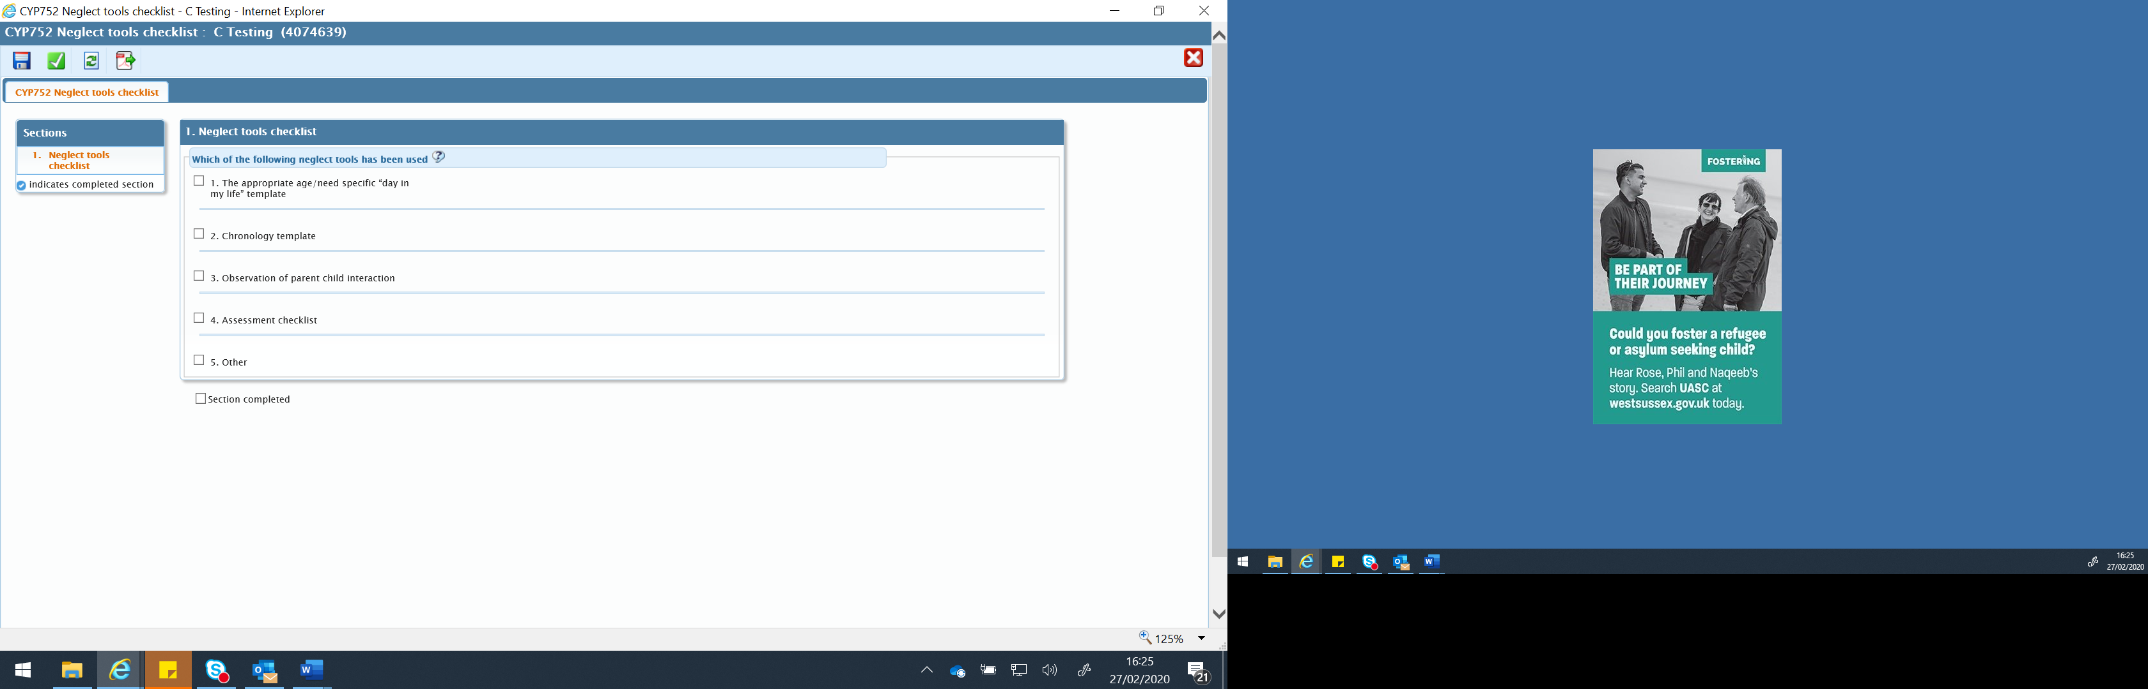



There are 5 boxes

Tick the box on the left when you have used the tool. A free text box and a date field will open:

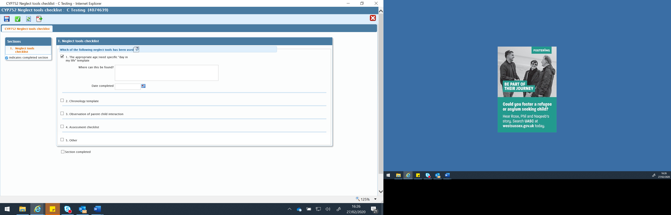

The box asks *where can this be found?* If you have uploaded a scanned copy of the document, state its name so it can be found easily by another worker at a later date. If you have recorded the information as part of, for example the pen picture in a child and family assessment, please indicate this here.

Once you have ticked as many boxes as apply, entered the date and included information about how to find a copy of your work, the form can be finished by clicking on the green tick button at the top of the page.

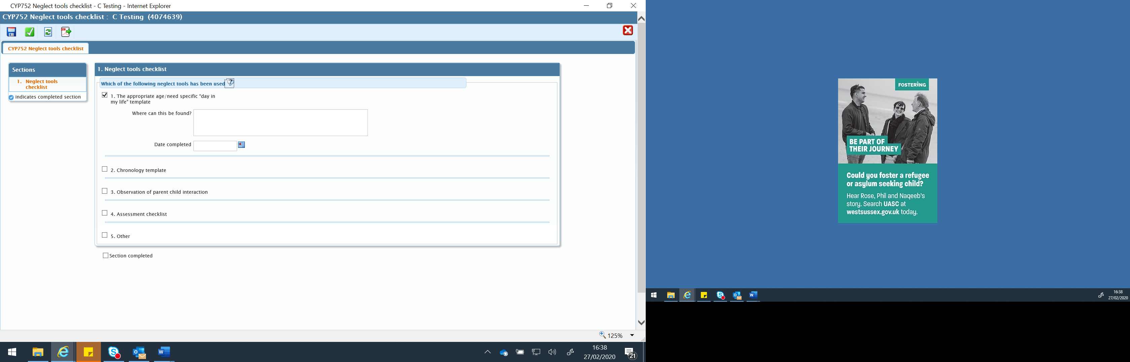



If you have entered some information about the tools you have used so far (for example you have only checked the ‘Day in the life’ box) and wish to add additional material at a later date (to record that an  observation has taken place) Click the *Save* icon, located on the top menu bar: 

This will save the form in the *Documents* file

To re-enter the form in order to add further information, you need to click on the pencil icon located on the right of the screen:  

DO NOT click the document name. If you click on the document name you will enter a READ ONLY state.

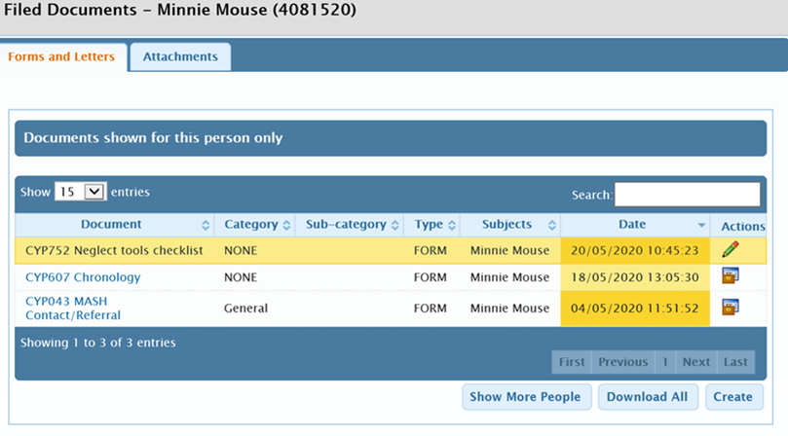

The form can remain saved for as long as is appropriate for the type of work you are completing.