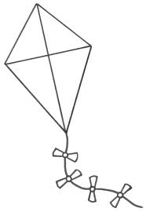
The Voice of the Child
Write your name inside the kite!
You can colour it in if you want to.

- Draw a circle around the faces that show how you felt before you met your support worker.
Sad |  | Scared |  | Confused /worried |  | Angry | Happy
- Draw a circle around the faces that show how you feel now that your family have had some help from your support worker.
Sad |  | Scared |  | Confused/worried |  | Angry | Happy

- What kind of things did your support worker do?
1 | 2 |  | 3 | 4 | 5
Played  games |  | Helped your mum /dad or carer | Did drawing with you | Made sure people listened to you | Helped mum / dad or carer set up rules
6 | 7 |  | 8 | 9 | 10
Helped you feel happier at home |  | Helped you get a good morning routine | Helped you get a good bedtime routine | Helped with your eating or diet | Helped you go to school more
11 |  | 12 | 13 | 14 | 15
Helped you get along better with your family |  | Listened to your worries | Helped your mum / dad or carer with fun activities | Helped you talk more about your feelings | Didn’t help me at all
16 |  | 17 | 18 | 19 | 20
Helped your family understand you better |  | Helped you to control your temper better | Didn’t listen to you | Did something new
5. What was your favourite activity?

Name:
Date:

Last updated July 2016

