Installation Guidance for GENEPRO Software

- Installing the software
To install this software, please follow these steps:

- Click on your windows icon, which as you look at your screen, is situated in the bottom left hand corner.
- This will present the following menu screen and you will need to select software centre. This is located under Hoople ICT Services, on the bottom right of the menu screen.

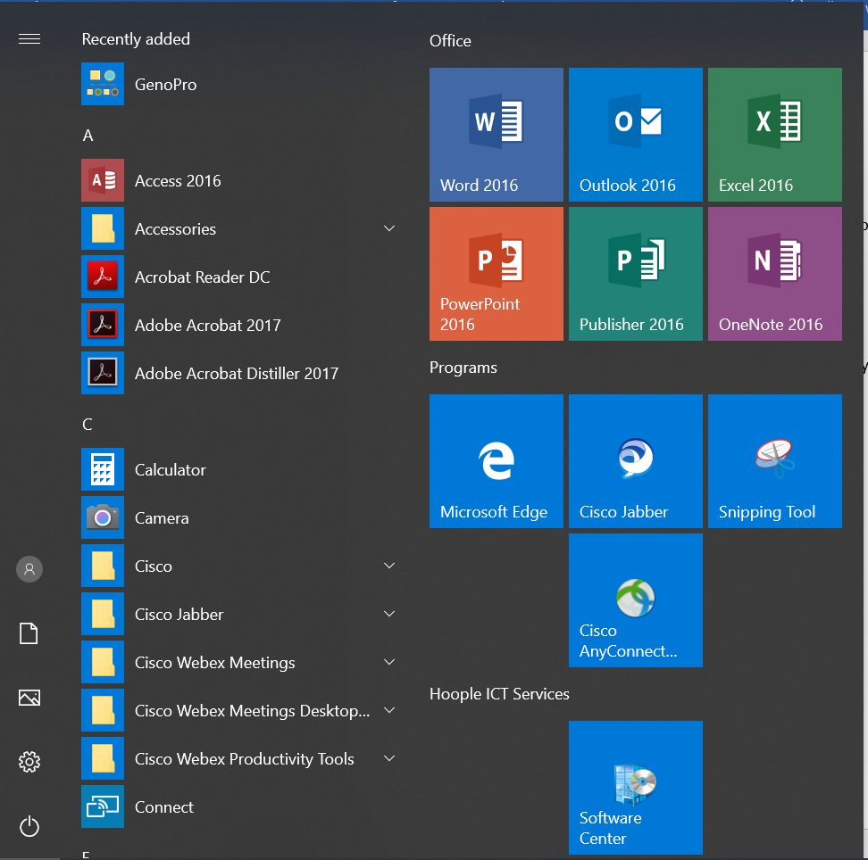

- If the software centre is not showing as an icon, you can search for it in the search bar located next to the windows icon, in the bottom left of the screen.
- If the search bar is not visible you must right click on the upward arrow on tool bar where your date and time is presented. This tool bar is in the bottom right of the screen. Once selected a menu will open, which looks like this;
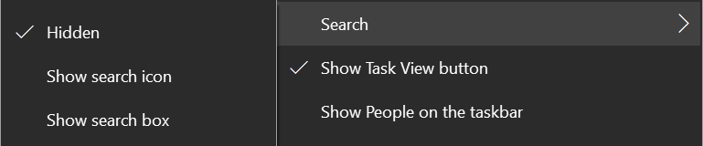

- You must click on search and then click on show search box. This will change the search box from hidden to visible.

- When you open the software centre, the following option screen will be presented;

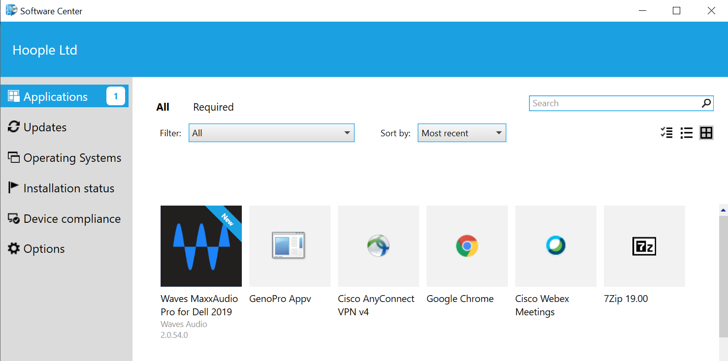

- Highlighted in blue in the image above, you will need to select applications and look for an image entitled, GenoPro Appv. Alternatively, you can search for it in the search bar located in the top right of the software centre. In this image, the GenoPro software is the second icon from the left.
- Once found, you will need to select the software and when given the option, press install. This will begin the process. Once installation has completed, it will automatically be located on your desktop. It will be this icon

- To open the application, simply select it as you would for any of your other applications.

Now that installation is complete, the following pages of guidance will give you a basic understanding of how to use the GenoPro software.

Any issues found with installing the software will need to be directed through IT Service Desk, who will be able to assist.

GENOPRO Guidance

GENOPRO is a software system that allows the user to create detailed genograms and cultural genograms.

As a first time user or when opening a new document, you will be met with this screen;
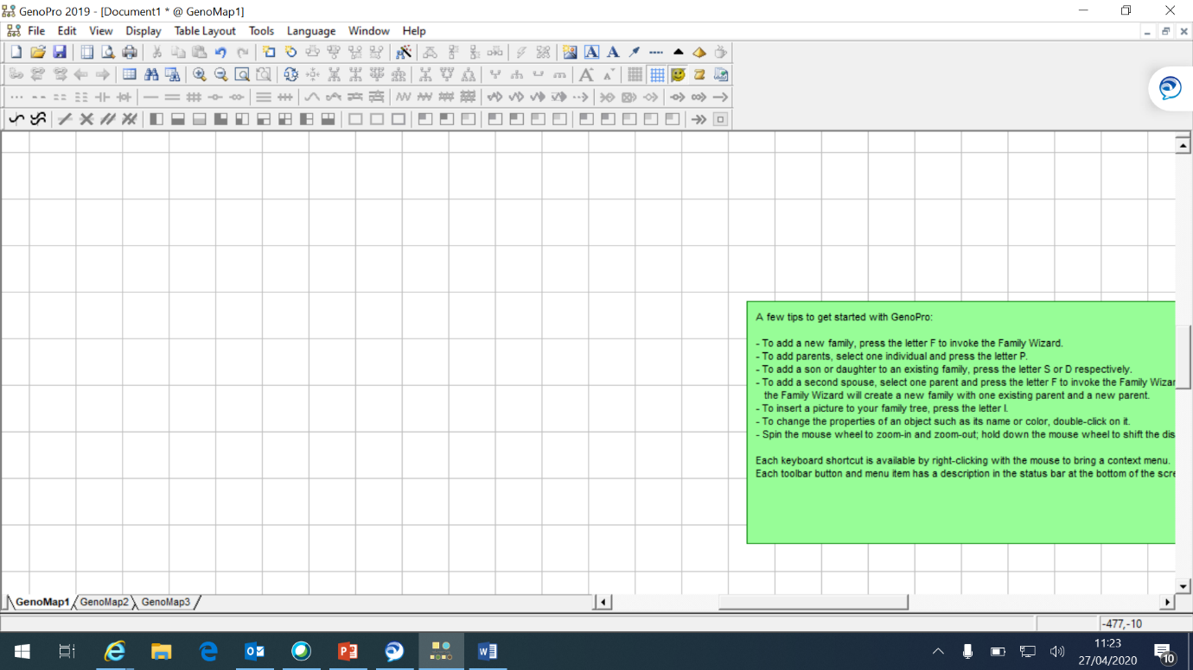

GENOPRO has a very detailed key list, which will be explained throughout this guidance. The initial toolbar will allow you to open, save and create a new document, as with most office applications. This tool bar also includes icons that will allow you to insert genealogy related features, such as family, parents, sons and daughters. A genogram created on this software can be as basic in detail or as in depth as needed.

- Create a simple Family Tree
To create a basic family tree conduct the following:
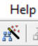
- Click on the icon, located underneath help, which is for family wizard. A shortcut for this icon can also be completed by pressing F. Both will transfer you to the following;

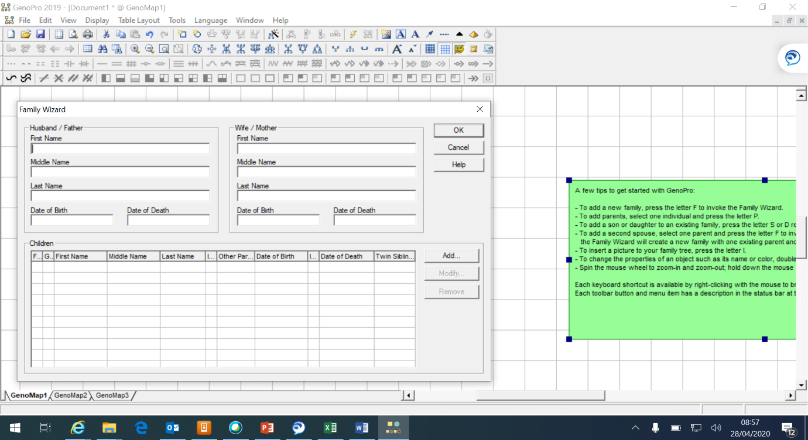

- In the relevant fields, enter the data for the Father and Mother of the family tree you want to create.
- If the parents have a child, click the add button. You will be presented with a similar image to the one above. As with the parents’ information, enter the data for the child and press okay. This will begin creating a basic family tree. The add button is located here.
- Once the data has been added for the child, press OK and this will return you to the original image above. You can add as many children as you like in this section. Once all fields are complete for both parents and children, press OK again. The data recorded will transfer into an image similar to;

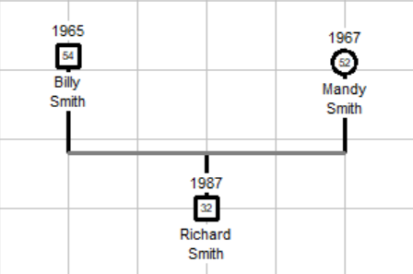

- The Family Tree has been created, showing names, ages and year of birth. Males are identified as squares and Females as Circles. Here, Mandy and Billy are Husband and Wife, known on the software as Mates and have one child named Richard.
- The following shortcut keys will assist in adding members to any family tree. When adding a son or daughter to a family tree, you must select the parent

Shortcut Key | Family Member
W | Male
E | Female
M | Mate
P | Parent
S | Son
D | Daughter

- Creating properties for family members
To add properties and build a database for an individual, conduct the following:

- Using the left hand side of your mouse or touch pad, double click the family member and the following image will appear;

- In this box, you can enter all types of data that are pertinent to the individual selected. Ranging from DOB, DOD, education, contact details and occupation.
- Once complete and all data has been added, press okay to close the box. To view or amend the data, double click the individual again. Certain criteria added here, will show on the family tree. For example, if an individual is deceased, it will be represented by a cross through their gender shape. If an individual is childless, it will be represented by a small black square, located outside of their gender shape.
- You can left click on any relationship or person and drag to a different position on the genogram.

- Family Tree Links
To make more advanced changes and alterations to a family tree, complete the following steps;

- When a separation between parents occurs, a new family tree can be created from the existing one. It will also keep existing links for children born in a previous marriage. A solid black line between parents shows a marriage bond, however, by right clicking on the adjoining line, a drop down menu will appear. Select relation and the following list will appear;
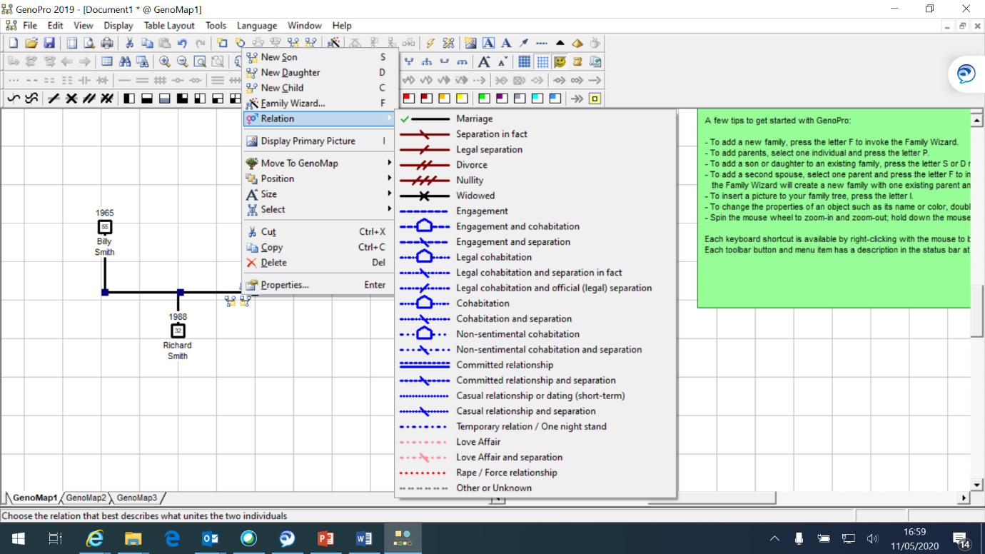

- The green tick identifies the current relation. From the list presented you can choose a multitude of different relations, ranging from widowed to cohabitation. Once selected, the adjoining line will mirror the one in the list.
- As well as creating relation links, there is also the option to create emotional links. To do this, right click on the person it is for and select new emotional relationship. This will present the following menu and you can again select a variety of different options;
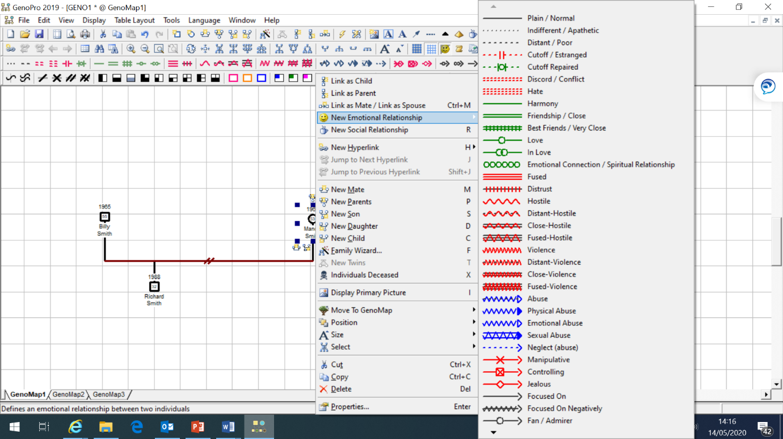

- When selecting, different options and links will allow family trees to grow. They can be as detailed or as simplistic as needed, in order to suit the information known. Below is an example of two family trees, with differing relation and emotional links.
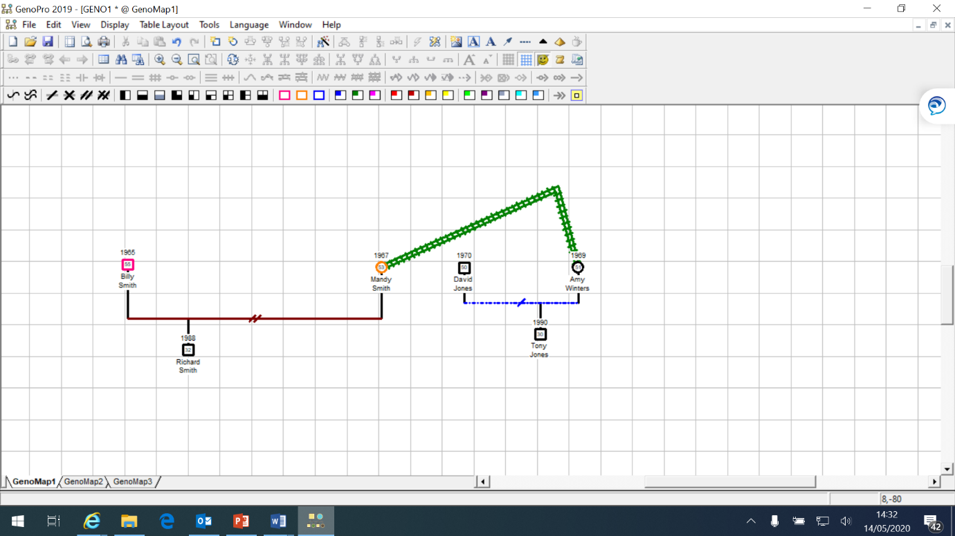

- This shows that Billy and Mandy are divorced, with one child. Although not directly related, the genogram identifies that Mandy has a close friendship with Amy, who legally cohabits with David but are divorced, with one child.
- To see what any link means, you can hover your cursor over it and it will be identified.
- When a member of the family has a particular issue or ailment, use the tool bar highlighted by the arrow. These sections identify, immigration status, addictions, medical issues and recovery states. Use your cursor to select a person and then choose the tab. Billy is outlined as pink, which means he has a gambling addiction. Mandy, outlined in orange, is a drug abuser.
- If a family member enters into a new relationship, you can also create a “new mate” link. To do this, follow the previous step and right click on the individual involved

- Copying Genograms To Other Documents
Once a Genogram has been designed, it can be transferred to another document by the copy and paste function. To do this, follow these steps;

- To initially copy the genogram, left click in an area around the desired image. Then drag the cursor across the genogram to cover it. A blue box will be created as you do this. However, the blue box will disappear but a series of smaller blue boxes around each member of the genogram, will confirm the area has been highlighted successfully.
- Once highlighted, it is imperative that you right click on a part of the genogram and not any of the blank space within your highlighted area. This will present you with the following image;

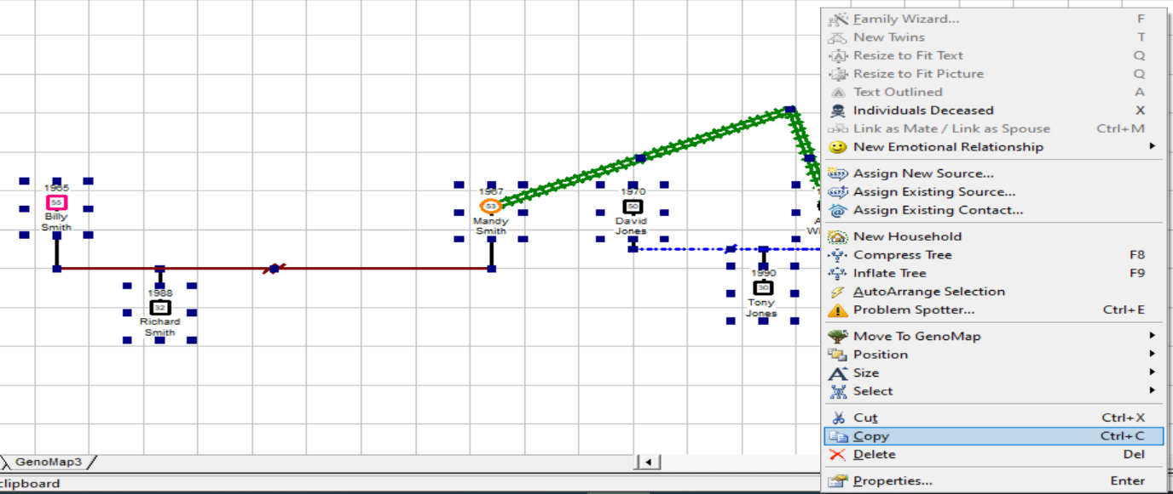

- In the drop down menu that appears, select copy, as highlighted blue in the image.
- Open the application you wish to copy the image to, for example Microsoft Word. Once open, right click in any blank space and select paste. This will transfer an image of the genogram to the document. However, it must be noted that it is only an image and the genogram cannot be changed or altered in any software application other than GenoPro.
- You are now in a position to format the image (eg size), in order to meet the need of the document you are creating.

The guidance as detailed above is a simplistic breakdown of functions, which will allow you to get started as a GENOPRO software user. This programme also has online guidance, should you require further and more complex direction. This can be found at the hyperlink listed below;

Getting Started Building My Family Tree - GenoPro Help

