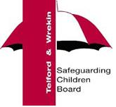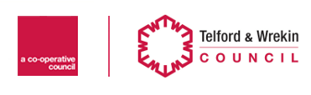

Family Connect Referral Form for members of the public
Telford & Wrekin Council

If you have concerns about a child's safety and wellbeing, including a child in your family, you can use this form to tell Family Connect. One of our advisors will read it within 24 hours and decide what action needs to be taken.

You can contact Family Connect anonymously if you do not want to tell us who you are. However, it's really helpful to have your name and contact details, as we may need to contact you for more information in order to protect the child or children that you are concerned about.

If you are unsure or concerned about completing this form, please call Family Connect on 01952 385385 option 1.

If a child is in immediate danger - always dial 999

- Details of the person making this request for service:
Your name:
Your address, including postcode:
Your contact number: | Your email address:
Your DOB: | Gender:
Ethnicity: | Do you wish to remain anonymous?
What is your relationship to the child/family or situation?

- Details of Child / Children
Child’s first name: | Child’s surname:
Child’s address:
Known contact number: | Child’s DOB or age:
Child’s gender:

- Details of each family member or significant people
(e.g. parents, siblings, other household members i.e. a lodger)
Name | Date of Birth | Relationship to child: | Address (if different from above)

Please tell us as much as you can about the situation. Tell us the facts that you know, as well as any concerns you have about that child.

- Once completed, your form can be emailed or posted to:

Email | familyconnect@telford.gov.uk
Post | Family Connect, Telford and Wrekin Council, Darby House, 5th Floor, Lawn Central, Telford, TF3 4JA

T&W Council Statement
I understand that:

- Telford and Wrekin Council (T&WC) collect personal information on me/my family to enable T&WC to provide support services which will benefit me as an individual and/or my family
- That my/my family’s personal information will only be shared internally between Council services to enable these services to be provided to me/my family
- T&WC may also share my/my family’s personal information with government departments or other public bodies as required by relevant legislation

For further information please visit www.telford.gov.uk/terms

