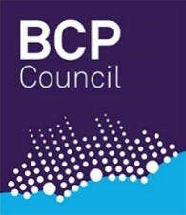
Housing Resource Panel
Please send completed referral forms to Laura Sinclair (laura.sinclair@bcpcouncil.gov.uk) - Business Support Officer to
Penny Lodwick

Panel Date:
Young Person’s Name:
Date of Birth: Age:
MOSAIC No:
Current Address:
Postcode:

Current placement:
( ) Staying Put
( ) Own flat / home / shared
( ) Supported Lodgings
( ) Friends / family
( ) Others - please specify:
Please ensure that a Housing Options meeting has taken place prior to referring to the Housing Resource Panel.

Date of Housing Options interview:

How long has the Young Person been in placement?

Reason for referral

Service Engagement
What is the young person like? How have they engaged with our service? Outside activities?

Employment and/or Training
What is their history and current ability to sustain this?

Budgeting / Tenancy Management
Can the Young Person manage a tenancy long term? E.g. budgeting, can they keep safe, are there support / risk issues? Can they claim benefits if they are out of work?
Additional Relevant Information

Documentation: ( ) Pathway Plan Date:

Referred by:
Personal Advisor:
Social Worker:
Date Referral Sent:

