My One Page Profile

**Name**



What makes me happy?

PHOTO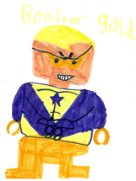

Things people like

about me ......

I need a little help with ………….

I might feel sad when………….

**PHOTO**