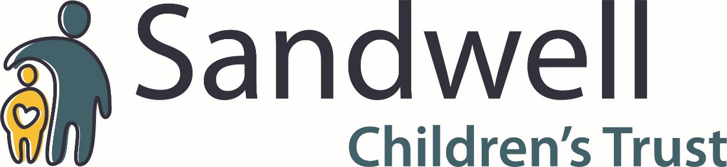
Life Work
Understanding
And Telling Guidance

Understanding and Telling

Understanding and Telling

Pre-verbal Stage
Children at this stage:
- Begin to understand language before speech develops;
- Begin to process information;
- Need to hear and become familiar with the word “adoption”, leading to emotional acceptance of adoption and greater receptiveness to more complex information later on.

2 - 6 Years
Most pre-school age children do not understand much about adoption even though told they are adopted. They may use the word in referring to themselves, but they often confuse being born with being adopted.
Children at this stage:
- Are egocentric and can’t see another’s point of view;
- Can’t handle too many bits of information all at once;
- Think they are responsible for everything that happens (magical thinking);
- Have a different concept of time to adults;
- Don’t understand relationships;
- Find greater significance in where they live and who cares for them;
- Don’t distinguish between the parental (caring) role and the parental (birth) relationship.
Children may respond to a simple story from their point of view, which concentrates on the here and now.

6 - 8 Years
Children at this stage:
- Understand the difference between adoption and birth as alternative ways of entering a family;
- Accept adoption as permanent, but don’t understand why;
- This acceptance relies on “blind faith” (e.g. because Mummy says so”).
Children are likely to accept their story without question and accept the basic explanations provided.

8 - 10 Years
Children at this stage:
- Develop a more sophisticated understanding of adoption;
- Can see things from other people’s point of view;
- Can see other sides to a story and consider alternatives;
- Can distinguish between perception and reality;
- May begin to recognise the loss of their birth family and grieve;
- May begin to question the permanence of adoption, thinking birth parents may re-claim or adoptive parents give them up;
- May regress to an earlier stage of development as they struggle to deal with more complex thoughts and the fear that this may not be permanent;
- Children’s understanding of adoption increases, resulting in more questions, which need more detailed answers and may become more challenging. Children need reassurance from their adoptive parents that they are here to stay.

10 - 13 Years
Children at this stage:
- Begin to grasp the concept that there was a legal process involved with their adoption;
- Are still unsure about why this has made their adoption permanent.

13 Years +
Children appreciate that adoption involves the legal transfer of parental responsibility, with all the rights and responsibilities this entails, from their birth parents to their adoptive parents.

