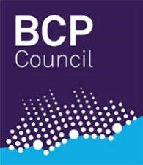
Adult and Children’s Directorate
Children, Young People & Families Services (CYPFS)
Review Permanence Planning
Meeting (PPM)

Date and Time:
Venue and Location:
Present:
Minute Taker:

Child’s Name:
Date of Birth: |  |  |  | Age:
Electronic Record ID: |  | Legal Status:
Ethnicity:
Disability:
Placement Provider Details:
Name: Address:
Allocated Social Worker:
Practice Manager:
Team Manager:
 | Page 1/4

Review of Actions / Outcomes
Current Legal Context
Current Assessments in Progress with Probable Outcome
Child(ren)’s Health
Child(ren)’s Education / Geographical Needs
Child(ren)’s Wishes and Feelings
Views of Parents and Other Significant Adults
Page 2/4
Views of the IRO
Name of IRO: |  |  | Date of Next LAC Review:
Discussions of Relevant Options / Likely Outcomes
ACTION
Details of Actions |  |  |  | Who will do this | By When
Review Date
 |  | Page 3/4

Chair’s Comments
Chair’s Signature: |  | Date:
Service Manager Comments
Service Manager Signature: |  | Date:

Page 4/4

