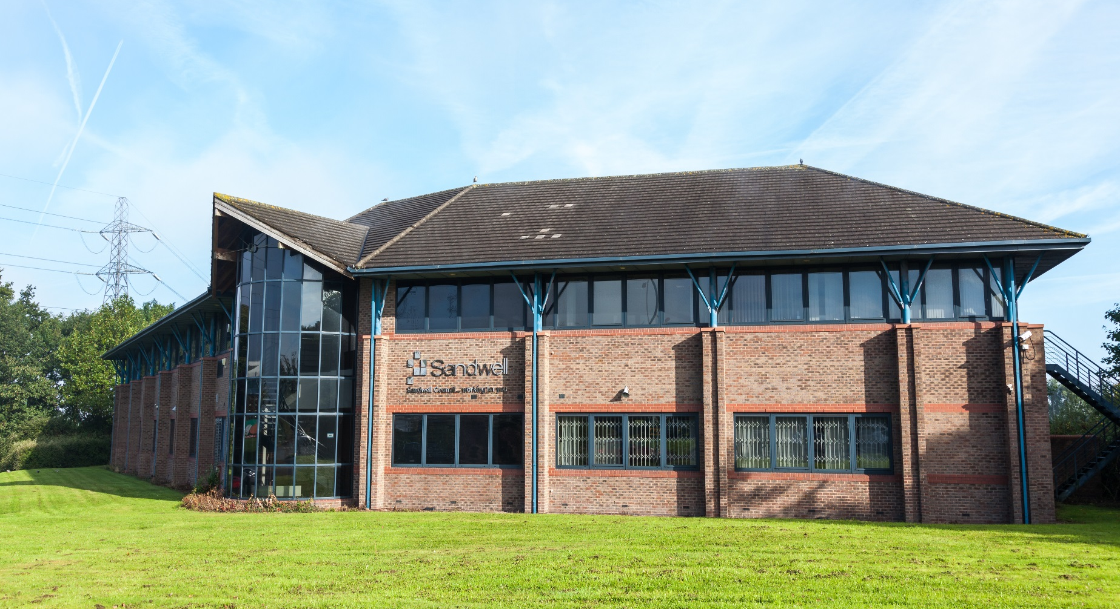

The Wellman Building

Welcome pack:

Supporting agile working

Version 1

Date: January 2018

Contents

Foreword 4
The building 5
Post 5
Car parking 6
Disabled parking 6
Opening hours and access to the building 7
Reception 7
Building security 7
Entering and leaving the building 7
Heating, lighting and ventilation 7
Management of the building 8
Your work area 9
About agile working 9
Work styles 9
Team zones 10
At your workstation 10
Pan drawers and lockers 11
ICT problems 12
Stationery 12
Shared facilities 13
Resources 13
Resource/Click and Collect Room 13
Employee breakout area 13
Ability to purchase food 13
Hygiene 14
Touchdown areas 14
Employee notice boards and artwork displays 14
Meeting rooms and booking meetings 16
Meeting rooms 16
Small meeting rooms 16
Larger meeting rooms 16
Family friendly room 16
Smaller meeting areas 16
Using employee breakout area for meetings 17
Booking rooms 17
Health and safety 18
Cleaning 18
Fire alarm test 18
Fire evacuation 18
First aiders 19

Workstation assessments 19
Laptops 19
Panic alarm 18
Paperwork 20

Guide to booking meeting rooms using Outlook 21
Floor plans 25
Ground floor 25
First floor 26
Useful contacts 28

Foreword
Welcome to The Wellman Building.

You will be working in one of the newly refurbished buildings in Sandwell which has a number of unique features that support the move towards more flexible ways of working.

Within the building there are ‘zones’. These are shown on the floor plans at the back of the booklet. You can sit at any free desk within your team’s zone or in other zones. This makes the best use of our office facilities as well as going towards meeting our environmental commitments.

There are other office bases where employees can work at whichever of these is most convenient so reducing the need for unnecessary travel across the borough and improving efficiency.

I hope you enjoy working in this building. This welcome pack gives you guidance on the facilities in the building.

Please enjoy the facilities and I hope you will embrace the opportunities for new ways of working. If you have any queries, this handbook also contains a table of Useful Contacts at the back.

Sign off *

The building

The Wellman Building is near the centre of Oldbury and is close to Sandwell Council House and a variety of shops, cafés and pubs.

There is access to public transport, with regular buses to many local destinations. Sandwell and Dudley railway station is within walking distance, with trains to Wolverhampton, Birmingham and elsewhere.

The building has a number of unique features that support the agile working philosophy, providing a flexibility of where and when work can be carried out. This will ensure that we make the best use of our existing office facilities. There is more information about agile working throughout this pack, and on the intranet.

Post
All post will be received and distributed by Sandwell Council House Post Room via the below. For any issues with post contact Postal Services on 569 3086.

Postal address:
The Wellman Building
Dudley Road
Oldbury
West Midlands B69 3DL

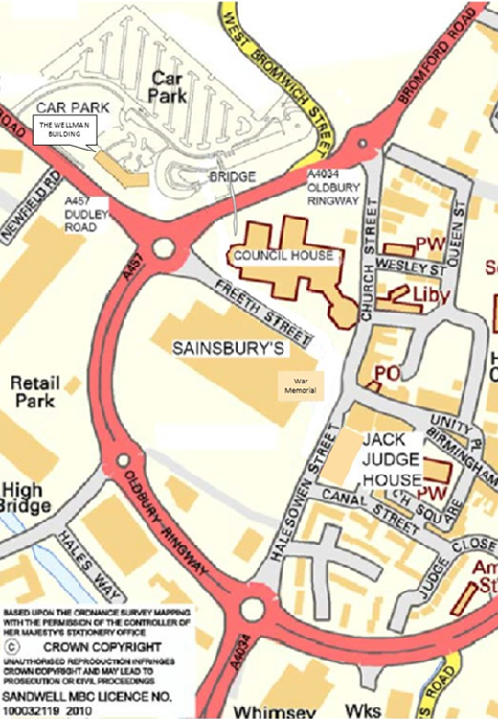
Car parking

Employees and visitors
There is a public, pay and display car park available. This is on a first-come first-served basis.

Access to the car park is via the A457, Dudley Road and B4166, West Bromwich Street.

The car park has CCTV and lighting throughout.

Cars are parked at owner’s risk.

Permanent staff can purchase
Annual Season tickets via the
Salary sacrifice scheme using the
HR41.1 Application Form.

Agency/temporary staff can
purchase Monthly/Annual Season tickets. The application form is available from your Business Support Team.

Disabled parking
There are four designated disabled spaces available at the entrance to the building. These are for Blue Badge holders and are on a first-come, first-served basis. Please note that any parking space can be utilised for disabled parking when a valid Blue Badge is displayed. Parking is free for Blue Badge holders.

Opening hours and access to the building
Curators will deactivate security at 07:00. Employees will be able to enter the building from this time using their ID access control card. The building and the barrier to the public car park will be locked at 20:00.

Reception

Reception is staffed by Business Support from 09:00 – 17:30 (17:00 on Friday’s).

For the safety of employees on reception, there is a panic alarm button behind the reception desk. The alarm will sound in the reception area and Brunswick Wing (rear of reception). This will be tested every Monday morning at 10:00. More information about the panic alarm procedure is available on the intranet.

Building security
You will have a pass card that will allow you into the building. If you lose your card you must report it immediately to Facilities Manager 569 3939 or 3934. A new card will be issued but you will be charged for this. If you forget your card you will need to contact Facilities Management who will provide you a temporary pass for the day.

Please do not allow others to follow you into the building.

Entering and leaving the building

Visitors
Staff on reception will need to let people in and contact someone in the building who will collect the visitor from the Ground Floor.

Heating, lighting and ventilation
The Wellman Building has a centrally controlled system. Heat cannot be adjusted to individual needs, so you should dress appropriately – be prepared to wear a jacket or cardigan if you need to.

Secondary sources of heating, such as individual electric fires, are not permitted.

Ventilation
Ventilation is centrally controlled and regulated. During the summer months you can open the windows if necessary.

Lighting
Lighting is managed throughout the building by movement sensors. There are no light switches.
Contact information
There is a list of useful contacts on page *.

Management of the building
Facilities Management manage the operation and maintenance of the building. The FM Helpdesk are to be contacted on 0121 569 3939 with any building related issues – Monday to Thursday 08:00-17:30 and 08:00-17:00 Friday. Email fm_helpdesk@sandwell.gov.uk. You will not normally need to contact the team as day-to-day issues will be dealt with by the people listed in the contents list on page *.

Your work area

The layout of the furniture has been designed to make the most of the office space available, make best use of natural light and provide space for the employee breakout and meeting areas.

The way that you use your work area and the building as a whole, is part of the concept of agile working. Agile working means working more flexibly and involves being considerate of others to make best use of the office facilities.

Please note that there are a number of ‘rise and fall’ desks situated in each wing as follows:

Ground Floor left – Dartmouth – 2 desks
Ground Floor right – Brunswick – 6 desks
First Floor right – Britannia – 6 desks

Height adjustable desks are only allocated to staff when they have received an assessment by Occupational Health. A diary system showing availability is in place for these desks to be used by at all times when the dedicated member of staff is on leave, at meetings etc.

About agile working
Agile working is the name given to range of more flexible work styles which are being used to improve customer service delivery and assist employees in managing their work-life balance. It is important that staff utilise desks in their designated zones in the first instance. However, there will always be alternative desks to work at in other zones, touchdown areas etc. Wi-fi is available throughout the building and you are encouraged to make full use of the facilities available.

There is a flexible working policy on the intranet along with other more detailed information about agile working. There are HR policies and guidance on the intranet including home working, flexible working and lone working. If you have any questions you can contact the HR Service Centre on 569 3300.

Work styles
Your work style will have been identified as:
- fixed worker;
- flexible worker;
- mobile worker;

Fixed worker – you will be allocated a workstation within your teams zone but you may not necessarily be sitting at the same desk every day. You can expect to have a desk, Z3 and VOIP phone. You will have access to pan drawers and lockers for storage.

Flexible worker – you will use any currently unoccupied workstation initially within your team zone, or the next available desk space, whilst in the office. When you arrive you will use your laptop. You will type your telephone number into the phone to activate it. You will collect your work from your designated pan drawer or team filing area.

Mobile worker – you should only need to use the office space for a limited amount of time per day. You will be able to use any available workstation in your team zone or make use of the touchdown areas.

Team zones
Teams are allocated a number of permanent workstations in a specific area so they can sit together. These are called zones. The floor plans on page * show the team zones.

When a zone is full (all workstations are occupied), you can move into adjoining zones that have spare workstation space.

Please remember the whole building is operating in an agile working, flexible way and you are encouraged to make full use of the facilities available.

At your workstation
When you get to your chosen workstation, you should follow the instructions below to make sure that you and the people around you are comfortable.

- Adjust your chair to suit your needs. If the chair has a sign on it saying “do not adjust” please look for an alternative chair. These chairs have been set aside for specific individuals through a formal assessment. Please refer to the health and safety section on page * for information about workstation assessments.
- If you are using a laptop install it and arrange your electronic equipment on the desk to suit.
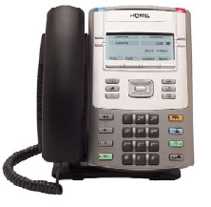
- Log onto the telephone to assign your telephone number to the workstation. This will let the call system know you are at work and available to take calls. Your telephone number and calls will then follow you to wherever you sit. Business Support will show you how to use the phone system if you are unsure.
- Check that your mobile phone is on silent.
- Make yourself aware of your surroundings and your nearest fire escape route in case of emergency.
- If you decide to personalise your workstation you must clear everything away at the end of your work session. You must not stick or pin anything to the screen that divides the workstations, or on the walls.

Considerate working
You are sharing your working environment, so please be considerate of others at all times.

  - You can have hot or cold drinks at your workstation but you should eat your lunch and hot food in the employee breakout area.
  - Try to avoid having meetings at your workstation, as this may be disruptive to others. Please use the various rooms/ areas available specifically for this purpose. See the section on meeting rooms and booking meetings on page *.
  - If you are going to be away from your desk for more than one hour you must clear your workstation. This is part of the ‘clear desk policy’ that applies to everyone at the building. Your work session ends when you clear your desk, and you must also log off your telephone, as someone else may need to use it.
  - A clear workstation should only have a phone, monitor, keyboard, mouse/or desk top on it (Z3). You must store your personal items and work files in a pan drawer or locker.
  - Some workstations will have specialist software (e.g. Performance) which can only be used by specific individuals. These will be clearly marked and cannot be used by anyone else.
  - Equipment such as specialist chairs will be clearly marked and should not be altered in any way.

If you feel people are being inconsiderate, please speak to your line manager.

Pan drawers and lockers
Most of your work should be stored electronically on the network. However you will have a limited amount of storage space for paper documents and personal items.

Flexible or mobile workers will have access to a flat, wide, shallow, lockable ‘pan’ drawer. These are drawers in a filing cabinet and will be located at the end of your team zone. You fetch the items you need from the drawer as and when you need them. You must return them at the end of your work session. Pan drawers are big enough to share between two members of staff if required.

There will be lockers available and if you choose to utilise a locker, you will be responsible for the safety of the key.

If you lose the key to a pan drawer or locker, please inform your Business Support Team immediately. Individual teams will have to pay for replacement keys.

Any valuables that are left in pan drawers or lockers are done so at your own risk.

ICT problems
You should report all ICT or phone issues and concerns to ICT by logging a call on Landesk (accessed through the intranet) or phoning ICT Service Desk on 569 3399.

Stationery
All general stationery is centralised in the Resource/Click and Collect Room. All employees have access to this area and have a responsibility to keep it tidy. There is a limited stationery budget to provide standard items only. Stock levels are monitored daily and stock levels replenished by the Business Support team.
Health and safety

Please read and familiarise yourself with the health and safety information on page *.

Shared facilities

Resource pods
There are pods on the Ground and First floor where photocopiers/printers are located. There are 5 photocopiers in total across the building.

You will do all your printing, scanning, faxing and photocopying on multi- functional devices (MFDs) located in the resource pods. After you have sent something from your computer to print, go to the nearest MFD and type in your ID number. Your printing is only processed after you have done this, while you are there. This helps maintain confidentiality.

Please think before you print. Is a hard copy absolutely necessary? Could the document be stored and shared electronically?

If you get to a MFD and the toner or paper needs replenishing, please follow the instructions on the device. Faults are reported automatically and a service engineer visits on a daily basis.

There are facilities for disposal of confidential waste and paper recycling. There will be a supply of stationery in the Resource/Click and Collect Room on the Ground Floor behind Reception.

Wipes for disinfecting IT keyboards and telephones are available from Business Support.

Resource/Click and Collect Room

This room accommodates all resources required for use by the whole building. This includes car seats, training resources, direct work bags and a centralised stationery store.

Staff are required to ‘sign out’ items when they are required and sign them back in when they are finished with.

Employee breakout area
These are where you can go to take a break, eat your lunch and make drinks. There is one breakout area on the First Floor. There are small kitchen areas in each of the four wings of the building where you can make drinks etc.

During the lunch period, from 12:30 – 14:30, breakout areas are for employee breaks only. At other times you can use them for informal meetings. If someone is using the area for a meeting, you can still go in and make drinks and have a conversation with your colleagues.

The kitchen areas have drink making facilities, a fridge, microwave and some storage for cutlery and crockery. You can only use the kitchen electrical equipment supplied. Toasters are not allowed, as they may set off the sprinkler system. You will be expected to bring your own cutlery and crockery, which can be kept in the kitchen.

There is a comfortable seating area where you can have your lunch break and chat with colleagues, or watch or listen to the news on the SMART TV.

A Sandwich Van visits on a daily basis at approximately 10:30 and will be available in reception for approximately 10-15 minutes.

Hygiene
You have to share this area with other employees, so please be considerate
- clean up after yourself and practise good hygiene. Please wipe up spillages and wash up cups, cutlery, containers, plates and so on promptly. Dirty cups, plates etc will be thrown away after 48 hours if not cleaned.

Please remove any out of date or unused food and drink regularly from the fridge and wipe the microwave clean after you have used it.

If bins become full during the day, please empty them and replace the bin liner. Leave full bags by the bin for the cleaner to dispose of at the end of the day.

Touchdown areas
On the Ground and First floors, there are ‘touchdown areas’. These are drop-in work areas set out like a breakfast bar with raised tables and chairs. They have data and power points so employees operating as flexible and mobile workers can access the network via their laptop. They are not suitable for prolonged work and use there should be limited to a maximum of two hours. No booking is necessary.

Employee notice boards and artwork displays
***

Meeting rooms and booking meetings

Meeting rooms
The building has 15 meeting rooms. They have all been given names according to the wing in which they are situated:
Ground Floor left – Dartmouth
Ground Floor right – Brunswick
First Floor left – Lightwoods
First Floor right - Britannia

Meeting rooms
- Brunswick – Ground Floor right:
3 one to one rooms

- Britannia – First Floor right:
1 meeting room - 6 people
3 one to one rooms

- Lightwoods – First Floor left:
2 meeting rooms - 6 people
1 Family Friendly room - 8 people
4 small meeting rooms - 4 people

- First Floor between Britannia and Lightwoods
Board room - 12 people

All large meeting rooms have a telephone, data points and presentation facilities. You must bring a laptop if you need one for your meeting.

All rooms must be left tidy ready for the next occupants. You must remove any presentation materials and meeting papers, and clear away cups and other items.

If the fire alarm goes off, the chair of the meeting is responsible for the safe evacuation of any visitors.

Family Friendly meeting room
There is a large meeting room that is a ‘Child Friendly’ room. This can be utilised when children are on-site. Please note that children should be supervised at all times whilst in the building.

Smaller meeting areas
There are small meeting areas on the Ground and First floor where you can go to have small meetings that do not require any privacy. These will take up to three people. These meeting areas do not have to be booked.

These should not be used if you require privacy, for example for supervision of employees or back to work interviews.

Using employee breakout areas for meetings
You can use the breakout area on the Ground Floor for informal meetings except between 12:30 – 14:30, when they are to be used only as a lunch and break area. You need to be aware that the breakout areas are not quiet zones – people will be using them to make drinks in throughout the day.

Booking rooms
You can book rooms through Outlook directly from your PC. You will be given training in how to do this.

To make the most of the rooms available, and be fair to everyone, teams should only book for a specific time and not allow meetings to overrun.

Please remember to cancel bookings promptly if you no longer require the room.

A step by step instruction guide on how to electronically book a room is on page *.

If you have a problem booking a room using Outlook, please speak to a member of Business Support in the first instance. You can also log a call on Landesk, or contact ICT Servicedesk on 569 3399.

Health and safety

Cleaning

Cleaning staff clean inside the building every day. You must not leave anything on your desk when you have finished for the day. This is part of the clear desk policy that operates in the building. The cleaner will wipe over each desk every day.

Screen and phone wipes will be available in the Resource Pods.

Fridges will be cleaned out on the last Friday of every month. You must remove all your items from the fridge prior to this, as everything that is still in the fridge will be thrown out.

You are expected to wipe inside the microwave after you have used it.

Contact 569 3939 if you have any concerns or issues about cleaning.

Fire alarm test
The fire alarm is tested at 12 noon every Friday.

Fire evacuation
The fire alarm is a continuous bell. If the fire alarm goes off you must leave the building immediately using the nearest fire exit.

Do not stop to collect clothing or personal belongings. Do not use lifts in an emergency evacuation situation.

The assembly point is the public car park on West Bromwich Street.

Do not re-enter the building until instructed to do so.

Please familiarise yourself with your nearest escape route. Your line manager will provide you with an electronic copy of the emergency procedures on request.

In the event of a chlorine or phosphine gas alert, you will be given a verbal instruction to go to the First Floor.

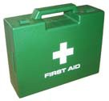
First aiders
Details of first aiders are available from reception. There is a First Aid room located on the First Floor in the Britannia wing. This room can also be used as a Quiet Room but the physical health and wellbeing of others must take precedence over spiritual wellbeing. Please ask Business Support for a copy of the Quiet Room guidelines

Workstation assessments
You will need to complete a workstation assessment for your workstation shortly after you first use it. This is to make sure that your manager can comply with the requirements of the Health and Safety (Display Screen Equipment) Regulations 1992 to carry out an appropriate risk assessment.

All computer workstation risk assessments should now be started using the online training and assessment package - Workrite. You can access this on the intranet using the link above or via the People Portal.

When you have completed the training and test, adjust your chair and workstation layout in line with the training and advice you have received. Next complete the assessment questionnaire to start the display screen equipment risk assessment process.

Once you have finished the questionnaire, your manager or workplace assessor will contact you about any outstanding issues to help you resolve them. If your local assessor cannot resolve all of the issues, please contact the Health and Safety Unit on 0121 569 3807.

As most of the work areas are similar, you will not need to complete a workstation assessment if you change workstations unless there are significant differences.

Guidance for home workers is available in the Homeworking Scheme on the intranet.
Laptops
If you are using a laptop, please follow the health and safety general guidance and the implications and best practice guidance on the intranet.

If you use a laptop you must lock it securely away at the end of each day in your pan drawer or locker if you are not taking it home with you.

If you take your laptop out of the office you must keep it safe, e.g. out of sight in a locked car boot or in a safe place upstairs in your home. Laptops should not be left in vehicles overnight.

Paperwork
Please follow the Data Protection guidance on the intranet.

You must make sure that when you take any work related paperwork out of the office you keep it safe and secure at all times.

Guide to booking meeting rooms using Outlook

This guide covers the basics of using Outlook to book the meeting rooms at The Wellman Building.

How do I book a room?

Booking a meeting room in Outlook is very similar to inviting a person to a meeting. Open your own Calendar, select the date and time for your meeting, right click and select New Meeting Request.

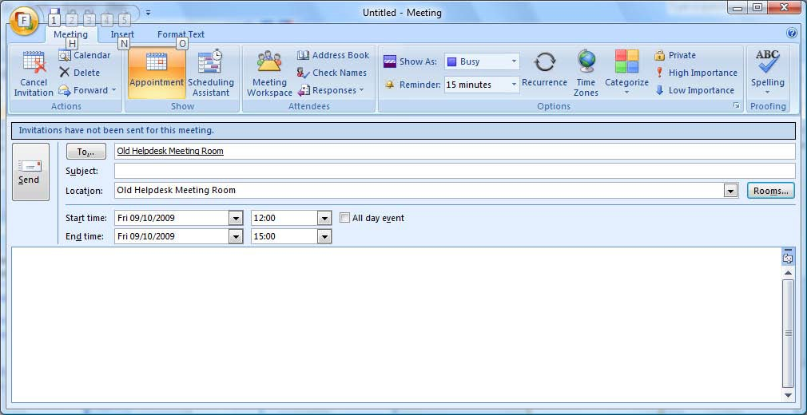
Click on the Rooms button to see a list of available meeting rooms.

In this example Old Helpdesk Meeting Room has been selected. It appears as both the location and in the ‘To’ field as an attendee.

Information about the capacity and the location of the meeting room can also be seen here.

How do I view a room’s availability?

To check to see if a particular meeting room is available when you require it the Scheduling Assistant can be used.
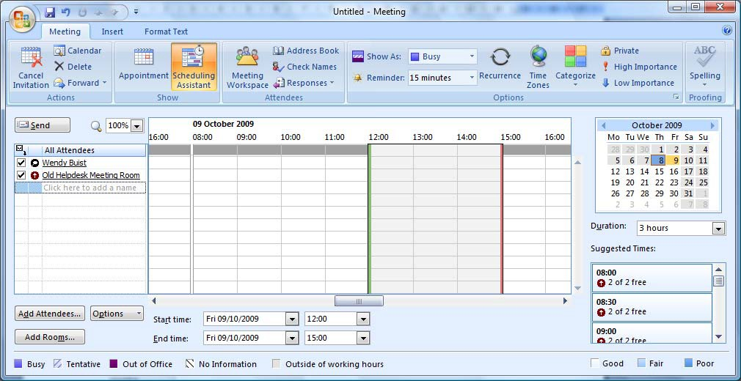

Once the room has been added free/busy information can be seen as though the room was a normal user.

How can I search for a meeting room in a building?

All the meeting rooms will be listed by wing name first, followed by the number of the meeting room, followed by the room’s capacity.
The list of bookable meeting rooms are as follows:

Ground Floor right
Brunswick 1 (capacity 2)
Brunswick 2 (capacity 2)
Brunswick 3 (capacity 2)

First Floor right
Britannia 1 (capacity 2)
Britannia 2 (capacity 2)
Britannia 3 (capacity 2)
Britannia 4 (capacity 6)

First Floor left
Lightwoods 1 (capacity 4)
Lightwoods 2 (capacity 4)
Lightwoods 3 (capacity 4)
Lightwoods 4 (capacity 4)
Lightwoods 5 (capacity 8) (family friendly room)
Lightwoods 6 (capacity 6)
Lightwoods 7 (capacity 6)

First Floor
Boardroom (capacity 12)

How do I change the time/date of my booking?

The organiser of the meeting can alter the time or date of a meeting by opening the meeting and selecting a new Start Time and End Time. Click on Send Update to send the new date/time. The original meeting will be removed and a new meeting will appear at the new Date and Time.

If the meeting is one you have been invited to, you can right click on the meeting and select Propose New Time.
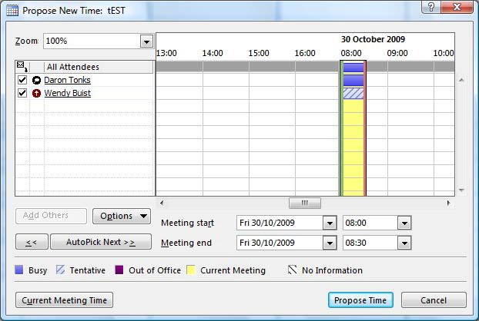

Select the date/time and click Propose Time. This will generate a message to the delegates with the new time.

How do I change the location of the meeting?

In the same way that the organiser of a meeting can change the date and time of the meeting, it is also possible to change the location. Remove the original meeting room and select a new room. Click Send Update to inform the delegates that the meeting has changed.

The original meeting will be removed from the calendar of the meeting room and a new meeting will appear in the calendar of the new room.

How do I add or remove an attendee from my meeting?

Only the organiser of the meeting can add new attendees or remove an attendee. Open the meeting and click on the To button to add more attendees. To remove attendees just delete them from the To field. Click Send Update to inform delegates of the changes.

How do I cancel my booking?

To cancel a meeting open the meeting and select the Cancel Meeting option. This will remove the meeting from your Calendar and give the option to send a cancellation message to the delegates. It will remove the meeting from the room’s Calendar as well.

Can I cancel/modify someone else’s meeting?

It is only possible to modify appointments you have made. Even if you are an attendee of the meeting only the organiser of the meeting can make amendments to the meeting.

Useful contacts

Issue | Name of contact | Contact details
Cleanliness or recycling | Facilities Management | 569 3939
Click and Collect Resource Room | Business Support | Please contact your Business Support Team
Health and Safety issues | Health and Safety Unit | 569 3807
HR issues | HR Helpline | 569 3300
Induction (guidance for managers) | HR Helpline | HR Services Managers Induction Toolkit
IT and IT equipment problems | IT helpdesk | Log a call via Landesk or 569 3399
Lost passes | Facilities Management | 569 3939
Post room (Oldbury Council House) | Postal Services | 569 3086
Printing Services | Printing Services | 569 3251
Repairs and maintenance, including kitchen appliances | Facilities Management | 569 3939
Security | Facilities Management | 569 3939
Stationery supplies | Business Support | Please speak to a member of your Business Support team
Other issues, including office furniture: | Facilities Management | 569 3939

28

