[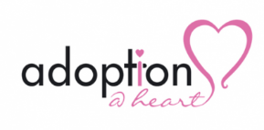](https://www.google.com/url?sa=i&rct=j&q=&esrc=s&source=images&cd=&cad=rja&uact=8&ved=2ahUKEwi35qqzj53iAhVIz4UKHdLzAyoQjRx6BAgBEAU&url=https://www.wolverhampton.gov.uk/news/new-agency-puts-adoptionheart-black-country&psig=AOvVaw1a-1syAWycWnxw4eirIxue&ust=1557995429044068).

|  |
| --- |
| **STEP PARENT ADOPTION Flow Chart** |
|

LA receive enquiry from

Step Parent (resident in LA area)

LA to undertake initial screening to include provision of alternatives to an A.O.

Enquirer has considered alternatives and is clear of their intention to apply for a A.O.

Enquirer sent written information and given advice (no further action at this stage)

LA to undertake an

Initial Assessment

(this may take place in the office or home)

LA not supporting

an application

LA support application

Not referring to RAA

LA responsible for completion of the

Assessment and Court Report

Refer to RAA for assessment

(up to 4 a year)