Recording supervision LCS
Click on menu – on the top tab bar in LCS
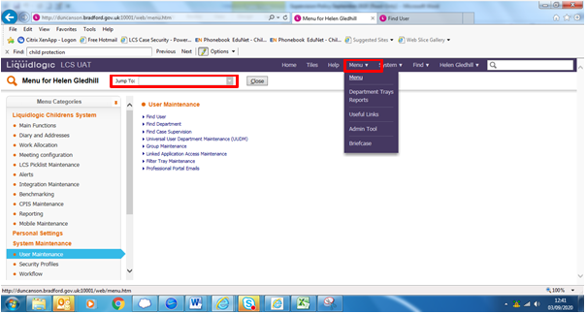
In the Jump to box type supervision
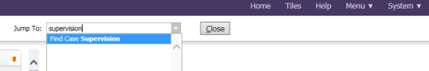
Click in ‘find case supervision’
At the next screen click on ‘create new’
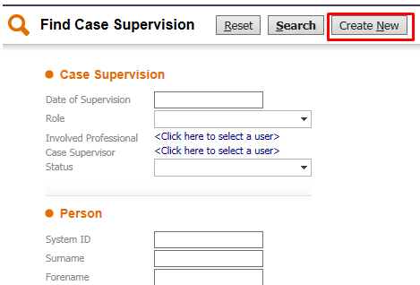
On the next screen, enter the date of supervision, the role is allocated case worker, enter name of Involved professional (social worker supervising) and name of case supervisor (Team manager)
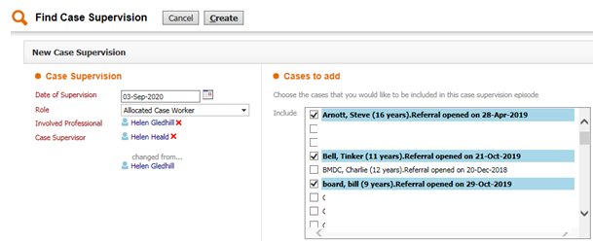
On the right hand side it displays all the cases that are allocated to the particular social worker – put ticks in the cases to be included in the supervision – this should only include sibling groups. Do not add other children that are not part of that referral
You will then see
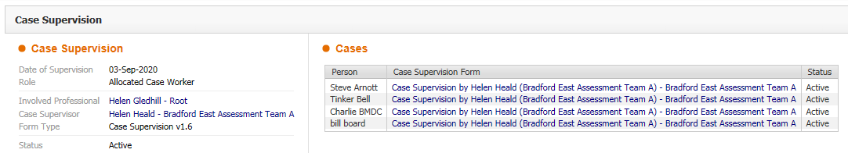
If you click on any of the case supervision form and the form will be displayed
There will also be a task in your work tray and can start from there as well
The first time you do the form for each supervision of the case you will need to start blank
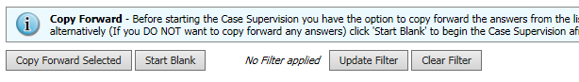
Subsequent supervisions you will need to select copy forward
First question need to select whether the supervision is for Child / Young Person or foster care. This will fetch up the relevant supervision template for that Service
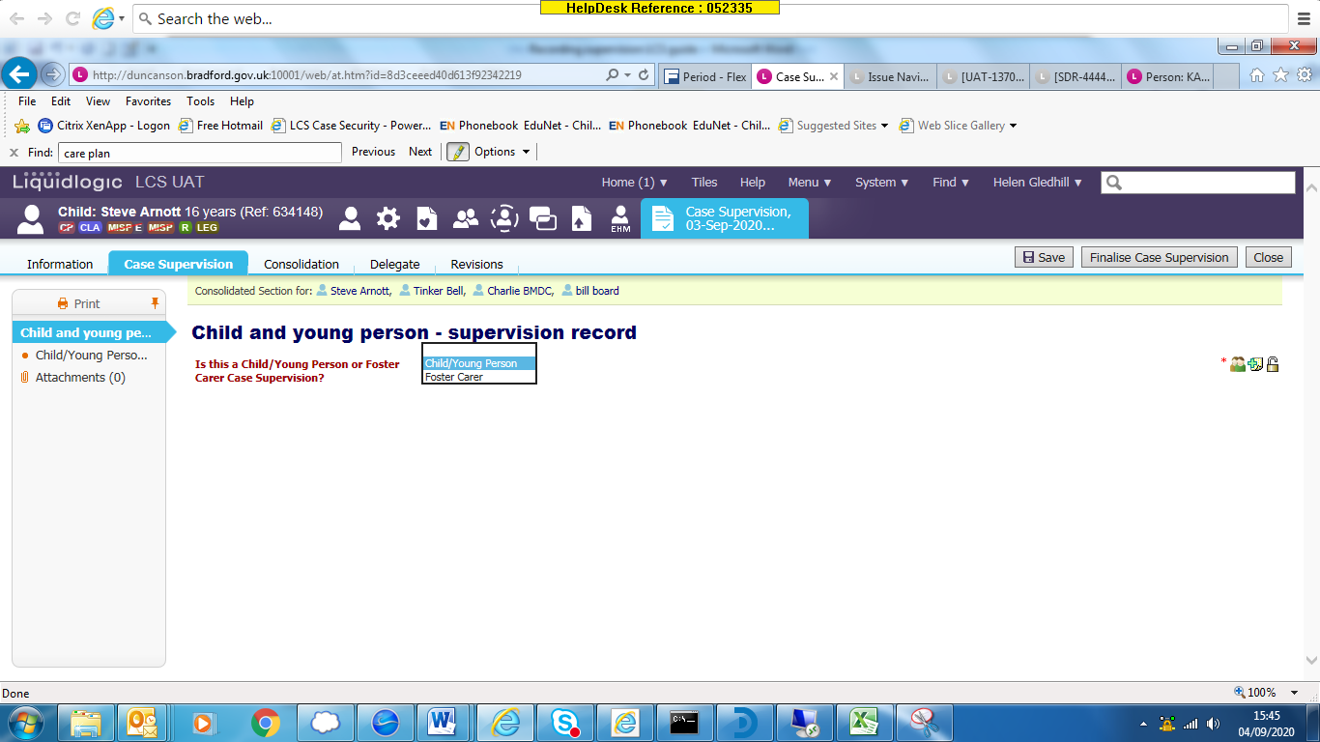
In this guide I am using Child / Young Person
Certain fields are populated within the form, to save time inputting
Under the section case note – add case note
The date of contact is the date of supervision, type is supervision, add the siblings as part of the supervision
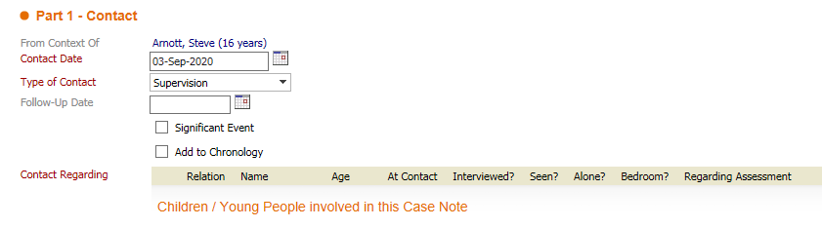
In the reason for contact and detailed notes enter something similar to
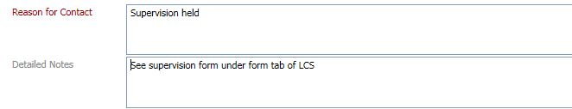
Please note case notes are not to be used to record the full supervision – this is completed within the form. The case note is for a chronological view of the Child’s journey as to when events take place.
Finalise the case note – you will be back within the case supervision form
The first table Actions agreed at last supervision will be blank and not editable.
You need to complete the table Actions required further down in the supervision form
Use the green + to add additional actions
Use the red x to delete any actions that may have entered in error
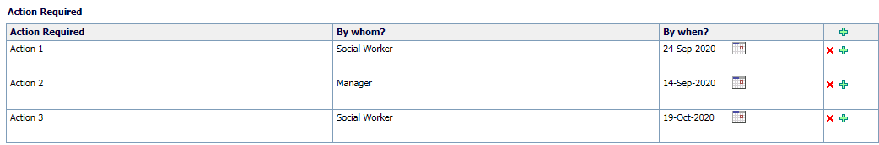
As you may be doing supervision on a sibling group, some actions may be specific to a particular child / young person. In this case you will need to toggle out the action table or any question that requires a different answer. Click on 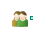 next to the question or action table
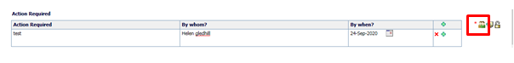
This will display the names of the children / young people included in the supervision form
Click on the name you need to add a different answer to. In this example I want separate actions boxes for each of the children. I have clicked on each of the names and now I have 3 action boxes, one for each child.
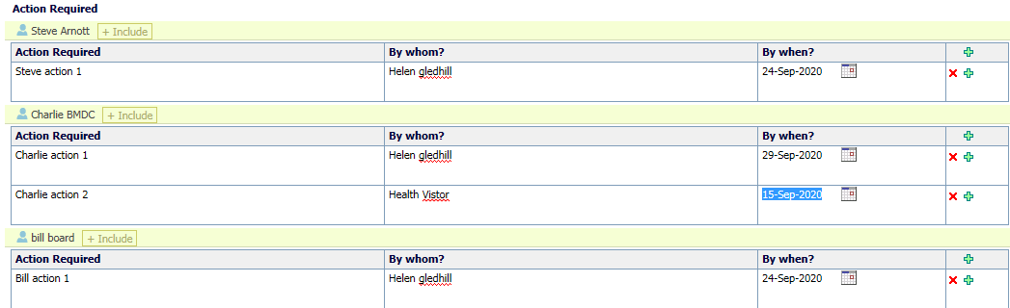
Enter the actions as relevant
Complete the rest of the supervision form and finalise – if need to complete the trest of the supervision form at a later date, click save. The supervision form can be found under the draft forms in the child’s records in the forms tab. You can also pick it up from your work tray.
At the next screen you will need to complete the supervision form 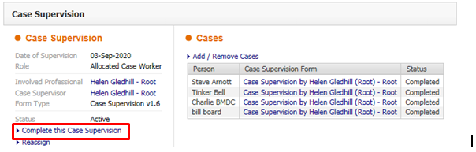
When you look at a child’s record who was included in the supervision
Within case notes, you will see the case note you entered as part fot he form
If look under the form tab for the child’s record, you will see the completed supervision. You can open and read – please note once the Supervision form is completed you will only see the details for the child / young person whose record you are in. So although may have started a supervision form on a sibling group, once it is completed it only displays the one child. You would need to go into each subsequent sibling’s record to read the supervision for them (although some answers may be relevant to all.)
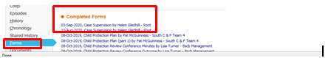
Subsequent Supervisions
Next time you do supervision and every time from here, you start the supervision form in the same way – menu, type supervision in the jump to box, enter date of supervision, role etc. Follow the process at the beginning of this guide.
When you get to start the form, you need to select the previous supervision form and copy forward selected
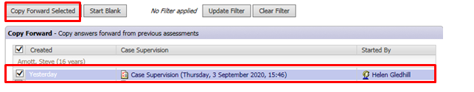
This copies forward the actions entered from the previous supervision into the new supervision
The actions agreed at the last supervision now has data copied in. This is read only apart from the Progress column where you record the progress of the action.
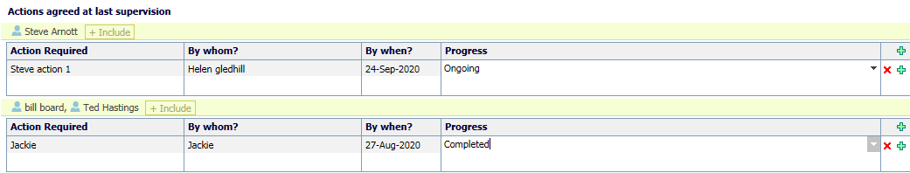
It has also copied into the actions required. This table you will need to update. 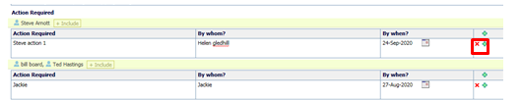
In this example I have shown that the progress for Steve Arnott is complete but for Jackie it is still ongoing. I need to delete the action for Steve using the red x and keep for Jackie. I have also added new actions.
My Action require table now looks like
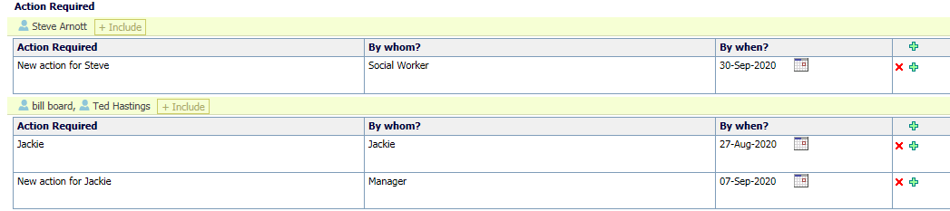
Complete the rest of the supervision form and finalise.
Remember it is only for the first supervision ever you start blank. For all subsequent supervisions you need to select the previous supervision form and copy forward

