Case Discussion and Escalation Procedure (Formally DRP)

Guidance for recording case discussion and resolving disputes between Independent Reviewing Officers and Children’s Social Care Practitioners and Managers.

Local Authorities are required under the Adoption and Children Act 2002 to have a ‘Dispute Resolution Process (DRP)’. Chapter 6 of the IRO Handbook, 2010, provides further guidance on dispute resolution and how it should be used by IROs in fulfilling their particular functions. In Newcastle, this process is called the Case Discussion and Escalation Procedure (CDEP).
CDEP is necessary because child care practice is shaped by a wide range of research, guidance and legislation. It is also the product of professional judgment and reflects individual experience, knowledge and skills. Given the breadth of the subject it is to be expected that at times professionals involved in the care planning and review process have different perspectives on how best to meet a child’s needs. This is not about simple right and wrong or good and bad approaches, but understanding why different professionals may have differing views on how best to proceed and how they work together to agree the best approach. CDEP may also be required when there is delay or drift in the implementation of the child’s plan.
Given the importance of timely and effective action in child care planning it is essential that the CDEP is accessible and able to function within a timescale that fits in with the child’s needs and best interests. It must not add unnecessary delay or complication. As such, it is important that the process is completed as quickly as possible and always within the child’s time frame.
Disputes are resolved through open and honest communication. The aim is to resolve them at the earliest possible point and in general this will be through discussions between the IRO and the social worker and / or team manager. If resolution is not achieved the matter must be escalated to the next tier of management within an agreed timescale. However, there will be circumstances when the CDEP will need to be raised with a senior manager in the first instance. This may be where the IRO and CSW/TM agree about the action required and the ‘disagreement’ rests with a senior manager. Similarly, some resolutions require senior management agreement. In such cases the CDEP should be raised with the appropriate manager so that the decision and resolution can be achieved without delay. Where this happens the views of the CSW/TM should, as far as possible be ascertained and included in the record.
The CDEP Process
It is important to remember that conversations between IROs and frontline social care staff should happen routinely and are an essential step in ensuring all parties understand the child’s needs and plan. These conversations are often referred to as ‘informal’ to distinguish them from more formal action (escalation) required when there is a significant disagreement about aspects of a child’s plan. But all discussions that have helped shape a child’s plan or address concerns about a plan must be recorded to evidence how the various professionals involved in the process have exercised their responsibilities.
Stage one of the process does not involve escalation. It is a means of recording case discussion between the IRO and the allocated social worker and team manager / CSW. Using stage one in this way means that there is one record demonstrating clearly questions raised by the IRO and responses from social care. This should speed up the process of resolution and allows the ‘informal discussions’ to be captured immediately in a form that means that should a dispute remain it can be escalated quickly to more senior managers.
It will not be necessary or appropriate to record all informal discussions as CDEPs. Other recording tools (IRO oversight records, Case Observations, Management Records) remain valid and should be the primary means of case recording. Stage one of the CDEP should be opened when it becomes clear from routine discussions and communications that there is a potential difference of opinion or concern. This is a matter of professional judgement on the part of the IRO that there is an issue which requires clarification that might, if it is not addressed or resolved swiftly, impact significantly upon the child. This will be discussed openly with the Team Manager / SW to ensure they are aware of the IRO’s rationale.
The decision to open a CDEP by the IRO must not come as a surprise to the social care manager. Stage one of the CDEP will usually involve face to face or telephone discussions. It would not be good practice to try to resolve differences of opinion / perspectives by means of email alone.
Stage one must be completed within 5 working days.
If the issue under consideration requires a senior management decision, or if the dispute rests with a senior manager the CDEP should be sent directly to the senior manager. Where this happens the views of the CSW/TM should, as far as possible be ascertained and included in the record.
Stage two of the process is initiated if, after 5 working days of a CDEP being raised, discussions between the IRO, social worker and team manager/CSW have not led to resolution. At that point, the issue must be escalated to the group manager (or next tier manager). The details of the issue, the action taken and the views of the parties must be reassigned to the relevant group manager.
Where possible issues will be resolved through the provision of guidance and direction by the group manager. But where this is not possible all parties must meet to explore the issue fully and achieve resolution.
Stage two must be completed within 5 working days from the point when the issue was raised with the group manager.
If the issue under consideration requires a higher management decision, or if the dispute rests with a more senior manager the CDEP should be sent directly to the relevant manager. Where this happens the views of the CSW/TM and GM should, as far as possible be ascertained and included in the record.
Stage three of the process is initiated if after stage two the issue remains unresolved. The issue and details of action taken need to be reassigned to the relevant service manager for social care via care first. The IRO must also inform the service manager for CSSU if they have not previously done so. The service managers will, wherever possible seek to resolve the dispute through the provision of guidance and direction. However, if this is not possible a meeting between the service managers and the IRO must take place within 5 working days.
If the issue remains unresolved Stage four will require information to be escalated to the Assistant Director of Children’s Services. The CDEP record will be reassigned on Care First to the Assistant Director. As with previous stages the Assistant Director may be able to resolve the dispute through the provision of guidance and direction but if this is not possible the Assistant Director must meet with the Service managers. This stage must be completed within 5 working days.
If the matter remains unresolved it will then be escalated to the Director for People. At this point the process will no longer be managed through Care First and information will be shared electronically or in hard copy as required. It is expected that this step of the process will be required infrequently and that almost all disputes will be resolved before this point and within 20 working days. Where possible the Director for People will resolve the dispute through the provision of direction and guidance. Where this is not possible the Director will meet with the Assistant Director and the relevant service managers. This stage must be completed within 5 working days.
If after escalation to the Director the matter remains unresolved discussions between all parties will take place and the Director will advise whether the dispute should be escalated to the Chief Executive. If this happens the process set out above will be followed. Where possible the Chief Executive will resolve the dispute through the provision of direction and guidance. If this is not possible the Chief Executive may wish to meet with the parties to explore the dispute and bring about resolution.
Should the dispute remain unresolved after escalation to the Chief Executive the IRO will refer the matter to Children and Family Court Advisory and Support Service (CAFCASS) to allow for independent oversight of the dispute.
All parties must be mindful of the time taken to resolve the dispute and the impact of this upon the child. The aim must be to resolve the dispute in a timely manner to meet the best interests of the child. As such CDEPs must be responded to as soon as possible. To avoid delay CDEPs should be directed to the most relevant manager. This should only happen when the IRO and CSW/TM agree about the action required or if the decision requires senior manager approval. Where this happens the views of the CSW/TM and GM should, as far as possible be ascertained and included in the record.
At any point in the process, where it is appropriate, the IRO may seek independent legal advice to inform their own view and the dispute resolution process.
There will be times when the IRO may be advised that obstacles preventing resolution are outside or beyond the Local Authority's control. For example, staffing, resource issues, court delays, independent commissioned assessments. However, if these are impacting on the ability of Children's Social Care to meet the needs of the child as identified in the Child Plan, the IRO should continue to escalate the issue.
The CDEP process should always be understood to be in the child's best interest and those involved need to remain child focussed. Dispute resolution can cause tensions within the agency, and this can be managed by good communication and good working relationships. It is important that the child remains the focus and the responsibility of corporate parenting is embedded with all professionals.
Recording and escalating concerns
The CDEP sits within Care First. As such records made under the process will be evident on the child’s file. Whilst this makes the process accessible and transparent, it is essential that information recorded on any child’s file is appropriate. Only the details of the dispute and action taken should be recorded. Views on the performance of individual staff, for example, must not be recorded.
The process sits within the Children’s Safeguarding Standards Unit and as such it will be initiated and closed off by the allocated IRO. The CDEP record will be ‘owned’ by the allocated IRO and s/he will be responsible for ensuring the process is completed.
The CDEP record is an assessment within Care First. After the relevant sections of the form have been completed the person completing must finish and save. They must not authorise the form. The IRO will trigger the initial report to the social worker and consultant social worker / team manager. Thereafter, the document will be escalated by mean of reassigning the activity to the appropriate person. The form should only be authorised by the IRO at the point that the dispute is resolved or when the dispute has escalated to the Director WCL and the CDEP assessment is no longer being used to escalate / record the dispute. Once authorised the form will be closed off and cannot be changed.
The Process
At stage one the IRO will complete a CDEP Record within Care First. The IRO must identify what s/he believes is the issue, what should happen and any steps required to achieve this. The record will be sent to the allocated social worker and team manager / consultant social worker.
The team manager / consultant social worker must respond via Care First using the CDEP Record setting out his/her response and views on any action required. The response and all necessary action should be completed within 5 working days. The team manager must finish and save the record but must not authorise it. The record is then reassigned to the IRO.
Should stage two of the process be required the IRO will be responsible for reassigning the CDEP Record to the relevant social work group manager. The group manager will, where possible resolve the dispute through the provision of direction and guidance. If this is not possible the Group Manager must meet with the IRO, CSW/Team Manager and Social Worker. All action must be completed within 5 working days. The group manager will then update the CDEP record, select finish and save but must not authorise the assessment. The group manager will then reassign it back to the IRO.
If necessary the steps taken above are then replicated for stages three and four with the IRO maintaining responsibility for escalating the concerns to the Service Manager (stage 3) and Assistant Director for Children’s Social Care (stage 4) via reassigning the CDEP. On completion the Service Manager and Assistant Director will update the CDEP record, select finish and save and reassign it back to the IRO. They must not authorise the record.
In the event of escalation above Assistant Director the IRO will share the DRP report electronically or in hard copy as required.
Should escalation CAFCASS this will be done in writing and sent securely via the Egress email system.
The IRO will be responsible for informing the Service Manager for CSSU about the dispute. This must happen by the time the dispute has been escalated to the Service Manager (stage 3). However, where appropriate the IRO will inform the Service Manager for CSSU at an earlier stage.
The attached flowchart outlines the timescales and actions that need to progress in relation to the CDEP process.
As far as possible action taken under the CDEP will be recorded on a CDEP form within Care First. However, where necessary any subsequent communication relating to the dispute must be recorded on Care First via IRO oversight records and / or Observations. The minutes of any meetings held must be uploaded to Total View.
An outline agenda for meetings held under the DRP is available below as appendix 1.

Note
If, because of the CDEP process there is a significant change to the child’s plan a LAC Review must be held within 4 weeks.
Categorising CDEPs for reporting purposes
It is important that action taken under the CDEP process can be understood strategically as well as at case level. As such it is necessary for CSSU to report on CDEP usage and to help identify patterns and themes with in practice.
At the point of opening a CDEP the IRO will be required to categorise the CDEP in one of the following 7 categories
1. Assessment (Concern about quality / outcome / conclusions / rationale)
2. Care Planning (Disagreement about a specific action or the overall objective of the plan)
3. Drift / delay (Delay or concern about the implementation of an agreed plan or action)
4. Non-allocation of social worker / frequent changes of social worker
5. Meeting stood down because of CSC practice resulting in significant impact on the child / family
6. The absence of the Child's voice (Lack of consultation / response to identified views)
7. Not referring a child for Advocacy or Independent Visitor

Appendix 1

Agenda template for meetings held under CDEP

- Child’s details
- Meeting details
- Reason for meeting
- Views of parties involved
- Actions taken to date
- Discussion
- Outcome
  - Dispute resolved – provide detail
  - Dispute remains – provide detail
  - Next steps (Escalation / Legal Advice etc…)

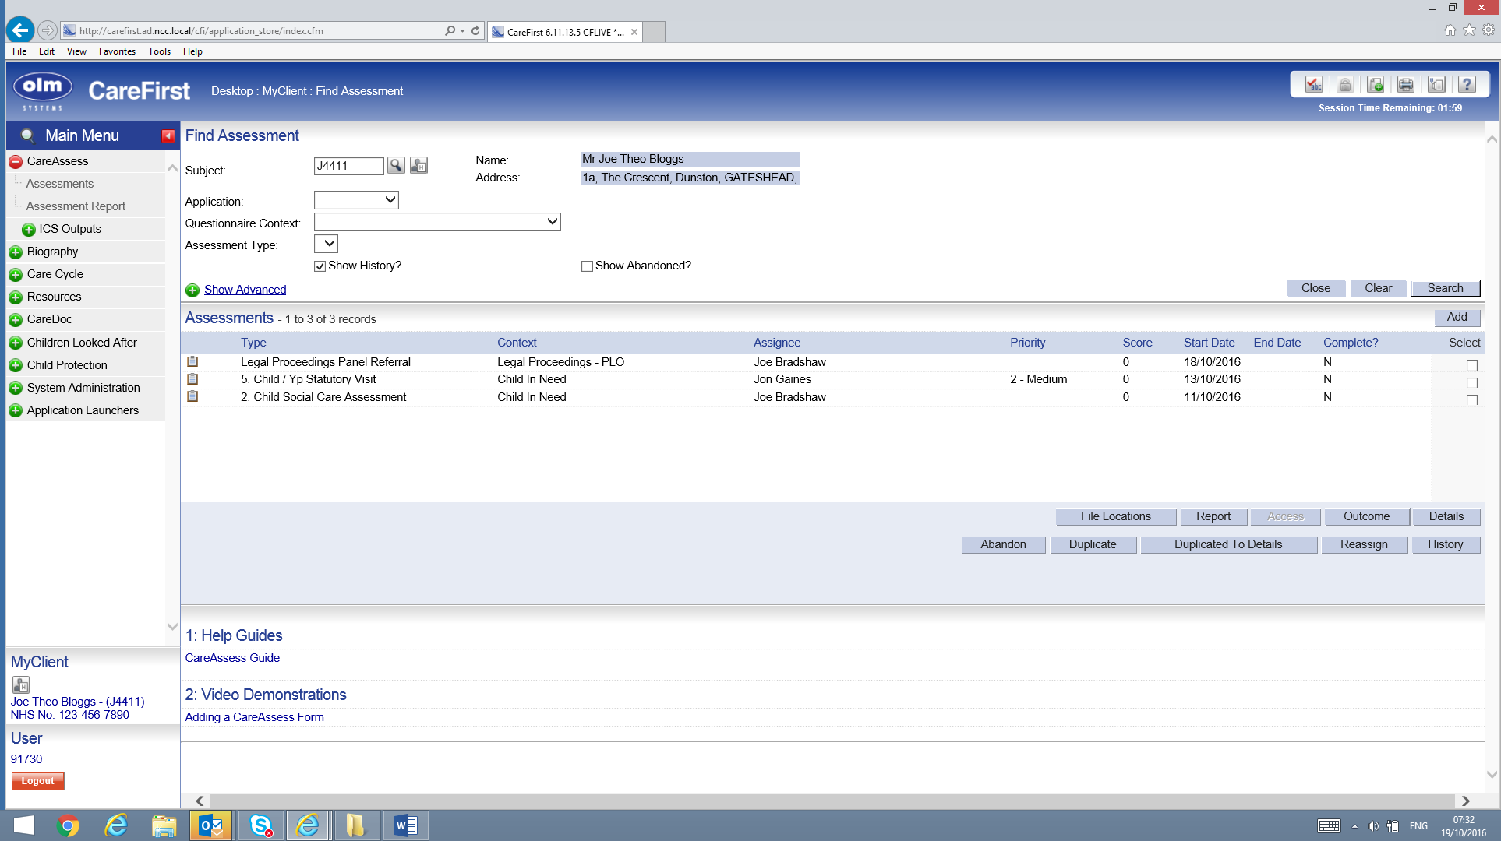
Enter client details and go to assessments – click add
IRO login
[Grab your reader’s attention with a great quote from the document or use this space to emphasize a key point. To place this text box anywhere on the page, just drag it.]
Select Child In Need for Questionnaire Context and Dispute Resolution for Assessment Type. Then press save.
IRO login
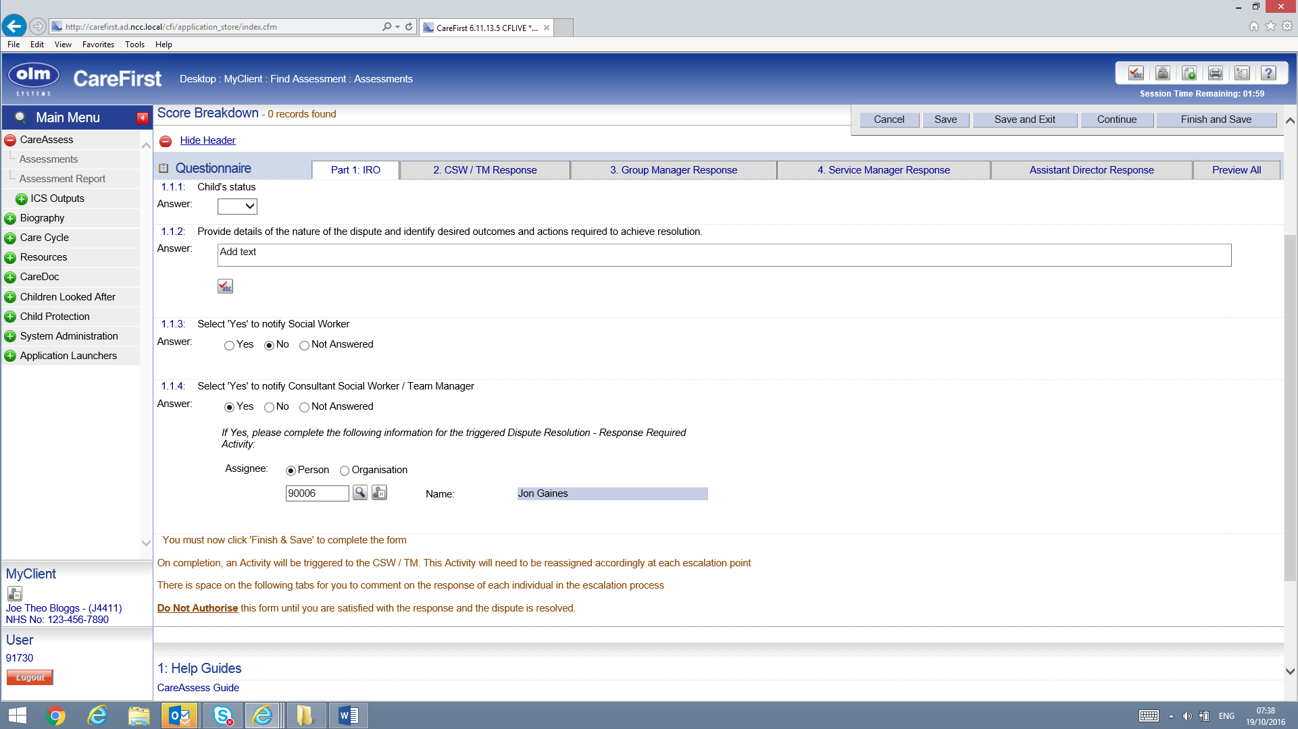
Fill in section 1.1.2
Select to trigger notification to TM/CSW & SW as required.
Select Finish & Save
IRO login
The TM/CSW will receive notification of DRP activity. Select the DRP.
CSW / TM Login
TM/CSW selects the DRP and presses details to access the document.
CSW / TM Login
TM/CSW completes 2.1.1 & 2.1.2 and the press save & exit
CSW / TM Login
TM/CSW goes back to clipboard and selects DRP
CSW / TM Login
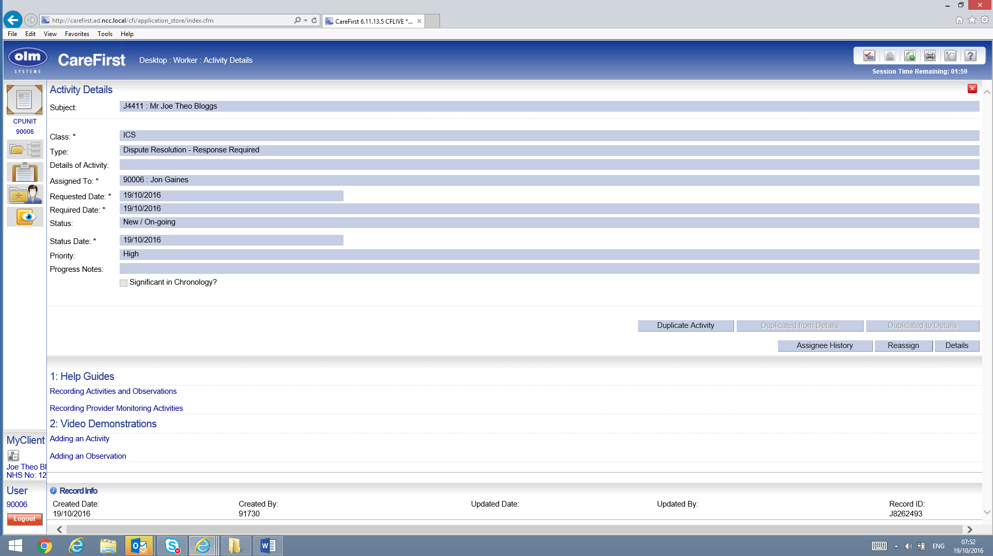
TM/CSW reassigns the activity back to IRO
CSW / TM Login
TM/CSW enters IRO details.
Press save.

CSW / TM Login
IRO receives DRP activity on clipboard
IRO login
Select DRP form and choose details.
IRO login
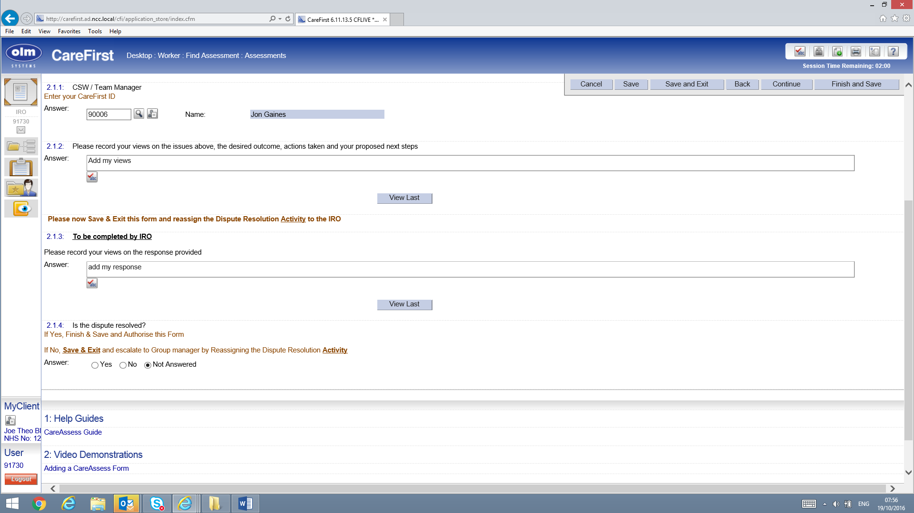
IRO completes 2.1.3.
Select yes or no as appropriate to say if dispute is resolved.
If yes finish and save & authorise form.
If no save and exit and escalate by reassigning the activity as shown below.
IRO login
IRO returns to clipboard and selects DRP and then details.
IRO login
IRO reassigns activity to group manager / service manager or other as appropriate.
Enter new manager details to escalate. Press save.
The process then repeated and escalated via reassigning the activity until it is resolved.
Once resolved the document can be authorised.

