**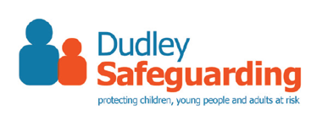**

**Dudley Early Help Assessment  
APPENDIX B - Consent Form**

|  |  |  |
| --- | --- | --- |
| My Name: | |  |
| My Date of Birth: | |  |
|  |  |  |
| I understand what an Early Help Assessment is and how this could help me and my family. | |  |
| I understand why information about me could be shared with other people who could help me and my family. | |  |
| I have been told about the different types of people who my information might be shared with. | |  |
| I understand that I can change my mind at any time and ask that information about me is not shared. | |  |
|  | | |
| I am happy for information about me to be shared with people who could help me and my family.  **Consent-Form-Yes_1024x1024.pngConsent-Form-No_1024x1024.png** | |  |