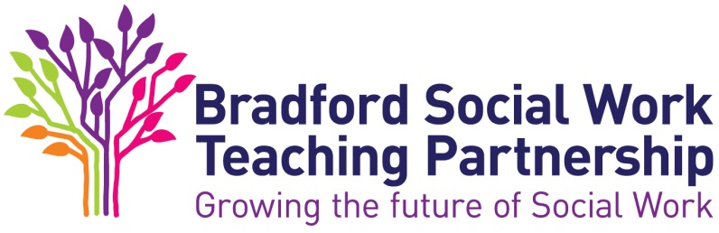

The ASYE in Children’s Services - Beginning the ASYE

This should be completed by the NQSW in preparation for the Support and Assessment Agreement meeting and presented to the Assessor in advance of the meeting.

Consider your learning needs for the next 3 months, and over the course of the year

Consider key legislation relevant to Children’s services generally, and your employment setting specifically

How do you plan to obtain the practice evidence you need?

