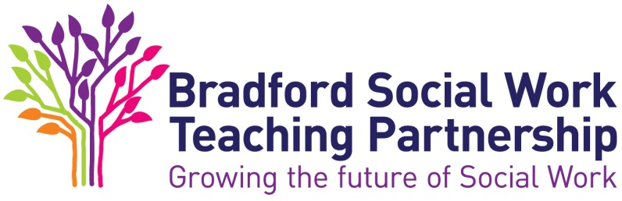

The ASYE in Children’s Services - Review of progress and interim assessment at nine months

- The NQSW should have submitted their third critical reflection for assessment prior to the review meeting
- This review should explore the progress being made towards developing the knowledge and skills outlined in the KSS. NB this statement lays out minimum expectations – whatever their starting point - all NQSWs should show progression across the course of the ASYE.
- The NQSW should incorporate areas for development in their PDP within their critical reflection

Date of review
Name of attendees
Assessor
NQSW
Line manager (if applicable)
Other e.g. HR, ASYE coordinator (if applicable)

Context
Since the last review have there been any changes that may have impacted on the NQSW’s progress?

Progressive assessment

Areas for development and focus for next PDP nine - twelve months

Additional comments to inform the nine month review from line manager and/or ASYE coordinator
(if applicable)
 | Yes | No | N/A
Is the NQSW’s progress satisfactory at this stage?
If no, have concerns been addressed in the next PDP and/or action plan?
Are there any issues that affect the probation of the NQSW? (i.e. conduct, attendance, ability to fulfill role?)
If yes, has HR been notified?

NQSW’s comments on six month review

Declarations and signatures

NQSW name
I have read and understood this review.
Signature
Date

Assessor Name
I confirm my assessment at this review.
Signature
Date

Line Manager (if applicable)
I have read this assessment and endorse it.
Signature
Date

