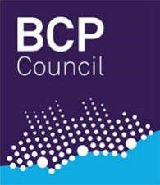

BCP Children’s Services.

Managing new referrals into BCP through the

First Response Hub.

|  |  |
| --- | --- |
| Document control | |
| Status |  |
| Effective from | September 2020 |
| Who Must Comply with this Guidance? | ALL STAFF |
| Who must be aware of this guidance? | ALL STAFF |
| Review Frequency | ANNUAL |
| Policy Lead and Approval Body |  |
| Produced By | Childrens Social Care |

Table of Contents

**1.** **Levels of Vulnerability and Need** 3

**2.** **BCP First Response Hub** 3

**3.** **The Children’s Social Care Out of Hour’s service** 3

**4.** **First Response Hub-How referrals are responded to Stage 1/Stage 2:** 4

**5.** **Stage 3 - MASH & Early Help – Risk Assessment** 5

# **Levels of Vulnerability and Need**

The pan Dorset Continuum of Need document is for use by all practitioners working with children and their families across Bournemouth, Christchurch, Poole and Dorset. This document is used to help identify a child’s degree of need and ensure that support is offered by the right agencies, at the right time and prevent their needs escalating to a higher level.

The Continuum of Need document can be found by visiting:

<https://www.earlyhelppartnership.org.uk/thresholds/Thresholds-docs/Draft-Continuum-of-Need.pdf>

# **BCP First Response Hub**

The First Response Hub for Children’s Services receives all new contacts and referrals into BCP Children’s Services from 8.30am to 5.15pm, Monday to Thursday and 8.30am-4.45pm on a Friday.

The Children’s Service First Response Hub provides the public and professionals with advice, information and support for children who are vulnerable and at risk and is made up of the Multi-Agency Safeguarding Hub (MASH) and Early Help Team

Referrers shouldContact the Children’s Services First Response Hub:

* if they are worried a child or young person is at risk of, or is being hurt or abused
* if they know of a child or young person who may be vulnerable without additional help and support
* if they want to know more about the services available to support children, young people and their families

There is a referral form that should be used to refer all non-urgent matters regarding children and families into the Hub. However, if the matter is more urgent and needs a swift response because a child is at risk of harm, the referral can be rung through in the first instance (if the referral is an emergency, then the referrer should dial 999 and speak to the police).

Information regarding First Response hub for referrers including Confidentiality

|  |
| --- |
| The contact details for the First Response Hub are:  Tel: 01202 735046  e-mail: [childrensfirstresponse@bcpcouncil.gov.uk](mailto:childrensfirstresponse@bcpcouncil.gov.uk) |

# **The Children’s Social Care Out of Hour’s service**

This is the emergency response service for any child who is in crisis, needs urgent help or is at serious risk of significant harm. Hours of operation are 5pm to 9am from Monday to Friday, all day Saturdays and Sundays and all bank holidays, including Christmas Day and New Year's Day.

|  |
| --- |
| The contact details for Out of Hours are:  Tel 01202 738256  e mail: [ChildrensOOHS@bcpcouncil.gov.uk](mailto:ChildrensOOHS@bcpcouncil.gov.uk) |

# **First Response Hub-How referrals are responded to Stage 1/Stage 2:**

**Stage 1**



**Front Door – Stage 2**

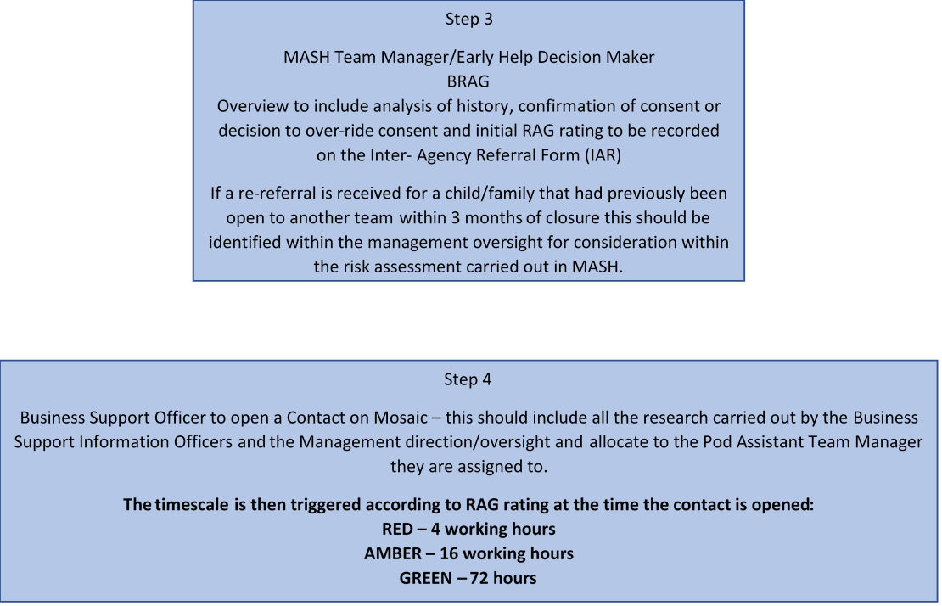

# **Stage 3 - MASH & Early Help – Risk Assessment**

