Parenting Assessment Plan
For Ms in Respect of Child.

The schedule below outlines the work that will be completed by the Local Authority with Ms to assess her ability to meet child’s physical, social and emotional needs. The parenting assessment is structured around the Framework for the Assessment of Children in Need (Department of Health).

There will be a particular focus on the home conditions and Ms capacity to change and sustain any changes.

Key to this assessment is Ms’s ability to reflect on her previous parenting as a way to understand what CYPS concerns have been and what changes the parent needs to make. In particular the assessment will focus on child’s needs as they have been the key areas of concern.

It is expected that Ms will work openly and honestly with the social worker and other professionals throughout the assessment period. The social worker and other professionals will work closely with each other to ensure that information is shared appropriately and support is provided consistently.

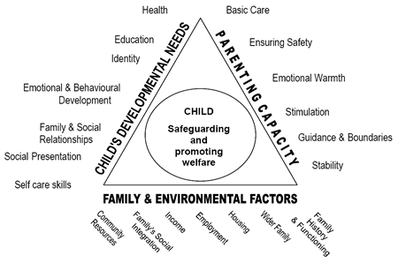

Ms is working with other Agencies and Professionals
It is expected that Jane will engage with the following support services agencies:
Social worker
Alliance Homes
Old Mixon Primary School
Family support worker.
School Nurse

Work with child
The social worker will carry out announced and unannounced visits to child at home. This will be a minimum of monthly and may include visits out of normal office hours. The social worker will visit child at school for a minimum of four sessions to direct work with the child to ensure the voice of the child is heard in the parenting assessment.

Other work prior to start of assessment
PNC checks will be requested, GPs to be contacted for health information for mother and child and older sibling. Historical social work files in relation to family will be reviewed by the social worker.

Possible Outcomes of the parenting assessment

a) The parenting capacity is good enough and there are no recommendations for further parenting work. There may be other issues that require assessment/attention.

b) The parenting capacity is not far short of being good enough and there are recommendations for further parenting work with a timescale.

c) The parenting capacity is not good enough and there is a detailed plan of recommendations that could reduce the risk to an acceptable level, with an opinion as to how far this programme is feasible given the motivation and capability of the parent within available resources, and the timescales of the child.

d) The parenting capacity is assessed as not good enough and the assessor recommends that legal action is taken.

Parenting Assessment Schedule

Week 1 – Week commencing: 26th October 2015
 | Monday | Tuesday | Wednesday | Thursday | Friday | Saturday | Sunday
a.m |  |  | 11am – Meet child
p.m
Area of focus: Introduce myself to child – Genogram/ecomap.

Week 2 – Week commencing: 2nd November 2015
 | Monday | Tuesday | Wednesday | Thursday | Friday | Saturday | Sunday
a.m
p.m |  | 3pm session with mother
Area of focus: Introducing parenting assessment / producing parenting support plan.

Week 3 – Week commencing: 9th November 2015
 | Monday | Tuesday | Wednesday | Thursday | Friday | Saturday | Sunday
a.m
p.m | 3 – 4 pm session with mother |  | 4pm Home visit | 3-4pm session with mother
Area of focus: mothers understanding of professionals concerns / assessment of motivation and intention to make changes using questionnaire / Goal setting.

Week 4 – Week commencing: 16th November 2015
 | Monday | Tuesday | Wednesday | Thursday | Friday | Saturday | Sunday
a.m |  |  | 9.30am child in school
p.m |  | 3 – 4 pm session with mother | 4.45 pm Home visit. | 3 – 4 pm session with mother
Area of focus: Mother’s childhood / family history.

Week 5 – Week commencing: 23rd November 2015
 | Monday | Tuesday | Wednesday | Thursday | Friday | Saturday | Sunday
a.m |  | 9.30am child in school
p.m |  | 3-4pm session with mother | 4.45 pm home visit.
Area of focus: Home conditions / Chronology and the impact on the children.

Week 6 – Week commencing: 30th November 2015
 | Monday | Tuesday | Wednesday | Thursday | Friday | Saturday | Sunday
a.m
p.m | 3-4pm session with mother |  |  | 3-4pm session with mother
Area of focus: child’s needs, child-parent relationship scale.

Week 7 – Week commencing: 7th December 2015
 | Monday | Tuesday | Wednesday | Thursday | Friday | Saturday | Sunday
a.m
p.m | 3-4pm session with mother |  | 4.45pm home visit.
Area of focus: Review goal setting

I understand and agree to take part in the Parenting Assessment detailed above

Name:

Signed:

Date:

