NB: The use of this guide and accompanying template is as a structure for your professional judgment. The methods of analysis used including the ability to change are a method of analysis, they are not the only method of analysis. If you wish to take a different approach please do so, however please ensure that the methodology is sufficiently explained to the reader (Parents / Children’s Guardian / Courts).

If you wish to depart from the structure of the template and believe this will assist the document, again, please do so as long as each of the areas are covered (e.g. you can move where you write about the ability to change – as long as you write about it!)

INTRODUCTION

This document is designed to be a short guide to the areas which should be considered in any parenting assessment. The assessments produced in pre-proceedings should be prepared as if for Court. It contains descriptions of methods of assessment and analysis, and specific areas which the report will need to cover.

The primary aim of this guidance is to attempt to bridge the gap between social work knowledge and evidence before the Court. It should be used alongside your existing social work skills and knowledge.

This document should not be treated as a standalone guide for the assessment of parents. The Court document is a formalised recording of the continuous process of assessment which has taken place over many months through the ongoing involvement with the family.

The following documents could be read in conjunction with this document:

- Framework for the Assessment of Children in Need and their Families (below)
- Assessing Children in Need and their Families – Practice Guidance
- Safeguarding Children Living with Trauma and Family Violence: Bentovim, Cox, Bingley-Miller and Pizzey (2009)
- The Child’s World, 2nd Edition. Jan Horwath (2009).
- Children’s Needs – Parenting Capacity, 2nd Edition. Cleaver Unell Aldgate
- Children Experiencing Domestic Violence – A research Review. Stanley / Research in Practice

As an appendix to the guide there is a template for writing up completed assessments. This format should be used in all pre-proceedings and Court assessments.

Department of Health Framework for Assessment Triangle:
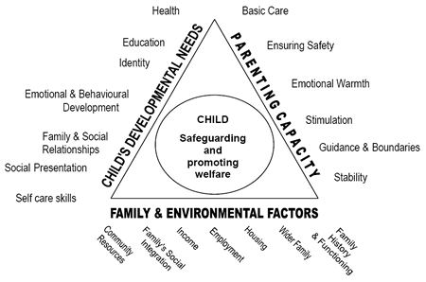

Glossary

‘Domain’ = The 3 main sides of the triangle.

‘Dimension’ = The 6 or 7 sub-divisions of the 3 domains.
PREPARATION

Principles of preparation

There are important principles in conducting parenting assessments. The planning and preparation is integral to ensuring a systemic and holistic approach. It is likely this will take two weeks. Careful consideration of the following is required:

- How will you engage with the parents in a meaningful assessment process using a relationship-based approach?

- What is already known about the family and how can the assessment be structured in a way that creates specific focus on particular issues? What further information is needed?

- Who will be key to the assessment in the family and professional networks, how will they be involved in the assessment process and how will roles be defined?

- What methodology and tools may be used to elicit the information required for the assessment? How will this support the parent(s) learning process, including their ability to reflect and demonstrate they can achieve change?

- What are the possible outcomes of the assessment? How will capacity to change be assessed and measured? How will this be conveyed to parents?

Preparation

Parents have to be ready to engage if the assessment process is going to be successful. This will rely heavily on a transparent relationship from the start which may require work to achieve this. Social workers have to be receptive to feedback from families about their practice. It is good practice to go through the social work chronology and genogram with parents at this point to check out differences in the family 'story' and potentially correct factual mistakes.

Before the assessment can begin any factors that could compromise the assessment must be identified. For example, if a parent has learning difficulties or are there issues of race, culture or religion that needs to be accounted for; are there any language barriers and is an interpreter required. Adjustments to how the assessment will be carried out should be made. It is imperative that any assessment is pitched at a level that the person being assessed is able to understand. You as the social worker should consider whether or not you think the person being assessed has capacity to understand the questions that you are asking of them. You should be mindful of the approach required to work with any such vulnerable adult including the benefits of representing information pictorially, repetition and session duration. You should consider whether an advocate would be beneficial.

It is important when preparing for your assessment to clearly consider the method of working, especially when considering session duration and frequency particularly if reflection is expected between sessions.

The purpose of the parenting assessment is to closer examine those key areas identified within the Core Assessment or Single Assessment and formalise that analysis. Care should be taken to avoid the start again syndrome and to focus on the areas assessed. If the assessment can be completed in 4 sessions then there is no need to use 10.

It may be that the assessment of parenting capacity should be undertaken using the PAMs toolkit. This is normally appropriate when the parent has an IQ of below 70. For more information please consult your line manager or principal social worker.

Planning

Information should be gathered in a number of ways to support the critical analysis process. There should be a mixture of interviews, observations, meetings, direct work etc to inform decision making.

Planning: Agreements

Agreements should be reached with other professionals who are being asked to contribute to the assessment. Agreement about expectations and joint working is essential. It may be necessary to consider joint working / interviewing with specialist professionals to support this process such as mental health workers, drugs and alcohol agencies. It may be necessary to reach agreement about the frequency of drug testing that is required. This can be agreed at a professionals' meeting in week one and it is advisable to complete a written agreement / contract about who will be responsible for particular elements of the assessment and how information will be shared to contribute and when. Any disagreements would need to be resolved immediately.

Parents value taking part in discussions about how and where the assessment will be carried out, as well as what they hope it will achieve. Similarly, according to the age and development of the child, listening to what children have to say and working openly and honestly is valued by them and produces more effective outcomes.

Agreement should be reached with family members who wish to play a role. This can be easily identified by exploring the genogram with parents; ecomaps can also be helpful. Some family members will play a more crucial role than others and this should be clear with agreement about what the expectations are for them to share information and contribute to the assessment. There should be a family meeting similar to the professionals' meeting and a written agreement also completed. This should take place within the first 2 weeks.

Planning: Schedules

Practically, it is advisable to produce a week to week calendar-type schedule which will incorporate all appointments, meetings, support work, supervised contact etc. There should be one planned session with the social worker per week which will have a specific focus. It is good practice to identify what will be discussed at each session in advance. This should be shared with parents and others' involved in the assessment.

To construct the schedule you will need to consider what you wish to address in each of the sessions. Through your work with the family and completion of the Single Assessment Form you will have formed a clear view of the areas in which the parent has specific strengths and weaknesses. You should be determining the assessment tools that you wish to use relevant to the domains and dimensions which you consider require the most focus.

Planning: Sessions

One of your early sessions should include completing a scaling exercise where the social worker and parent both have an opportunity to explore the understanding of each others’ concerns. This may have been addressed by Signs of Safety already and if so need not be repeated unnecessarily. A scaling exercise scoring between zero and ten should be conducted by the social worker to compare the parent’s perceptions to that of the department.

As part of the analysis you will need to consider how those strengths and weaknesses interact. You should be considering the topics that you want to cover in your semi-structured (one-to-one) interviews and determining the type of information to be ascertained to be able to resolve the positives and negatives around any areas of the child’s needs.

Assessments of parents may require consideration of the parents’ ability to care both together or separately, and the ability of the parents to separate. Some assessments will be carried out where children and parents are separated. There should be clear agreements about how parenting skills will be observed/tested out and any limitations to this within the 10 weeks. You will need to address this issue with the parents at the outset and consider how to incorporate separate sessions into the process.

You will need to have a clear understanding of the theories around a person’s ability to change [see below]. You will need to cover these within your semi-structured interviews to be able to determine what stage they are at in the change process. You will then be able to challenge the parent’s opinions and determine whether a reflective process is taking place and comment on their likely future ability to change.

Time should be built in for reflection as new issues will surface and need to be discussed and placed in to context with families. Social workers will need time for advice about managing new information and other agencies may need to intervene or be referred to for extra support.

You will need to consider the sources of information including direct work with the child (seeing, observing, and engaging with, talking to, and undertaking activities with the child), observations, semi-structured interviews with the parents and family members, external agencies, Local Authority records and files including previous assessments, and any other source considered relevant such as external professionals.

Planning: Contact

Observation of contact is key. It is good practice to review contact monthly to six weekly. It is important to view contact not just as time for children and parents to spend together but rather an opportunity to help parents' learning process. Supervisors and social workers must have clear agreements around the role of the supervisor, whether it is an interactive role or more of an observational role. The parents should be aware of the supervisor’s role. It may be helpful to role model for parents and comment on their ability to learn new skills throughout the contact sessions. Time will need to be built in to debrief parents after contact and give them feedback in order to build on their strengths, as well as highlight any concerns. Parents can be given reflective tools/tasks to complete in between contacts to help this process. Additional paperwork can be attached to the parenting assessment as well as review meeting minutes to evidence the analysis of contact.

Planning: Reviews

The assessment plan should be reviewed at least once, usually the half-way point, to measure progress and make any adjustments necessary. It is advisable to book this at the professional meeting and include family members if appropriate. This can be incorporated in to the schedule at the beginning.

To assist in planning included in the attached resource pack are the following:

Set Up Checklist
Parenting Assessment Plan Template
Partnership Agreement (Parents)
Partnership Agreement (Professionals)
Contact Agreement

ASSESSMENT

The process of assessment involves organising the information gathered according to the dimensions of the Assessment Framework as a necessary beginning to the next phase of analysis.

Categorization

The aim of the assessment process is to gather the available information together and categorize that knowledge to within the dimensions and domains (see glossary p1) of the framework. You will gather information from your knowledge of the family, the chronology, other professionals, your 1:1 sessions, observations and any other source that you identified during the planning stage.

To categorize the information available simply make a note in the margin of the dimensions impacted by each relevant piece of information. Taking the chronology, for example, consider each entry and alongside note which dimension(s) of the triangle the incident/entry impacts upon. If it doesn’t impact upon any of them then it may not be a relevant piece of information! Repeat the process with your 1:1 session notes, contact notes etc.

EXAMPLE: Next to a chronology entry that reads “20/10/2013: DV incident between parents reported by police. Children distressed when witnessing the violence.” which dimensions might be negatively impacted upon? You might feel that you should note a deficiency for the dimensions ‘Ensuring Safety’ and ‘Guidance & Boundaries’ under the ‘Parenting Capacity’ domain; and a deficiency for the dimension ‘Emotional and Behavioural Development’ under the ‘Child’s Developmental Needs’ domain.

When you come to draw things together you will do this for your contact notes, 1:1 parenting sessions and relevant chronology plus any other relevant documents. This will then give you an idea of which areas of the triangle overall the predominant strengths and difficulties lie. You are likely find strengths as well as deficiencies in many of the entries/reports/session notes.

You should be gathering together the information about all three domains. So you may also note that there are significant pieces of evidence that have been categorised on the ‘Child’s Needs’ domain as well as the ‘Family & Environmental Factors’ domain, not just the ‘Parenting Capacity’ domain.

The DoH Guidance to the Framework for Assessment contains the description of each of the sub-dimensions within each domain. You should read and understand these descriptions whilst undertaking parenting assessments.

Needs of the Child

Assessing the needs of the child remains at the heart of the assessment process. You will already have a clear understanding of the typical needs of a child their age and should be able to set out concisely what additional needs this particular child has. You will have determined in your assessment plan the methods of engaging with the child that you believe are necessary for completing the assessment.

A significant amount of this information should be contained within the Single Assessment completed throughout the Child Protection process. You can use information from the single assessment (if relevant / up to date) but be sure to state where the information has come from.

Parenting Capacity

When gathering information as to how caring tasks are carried out consider:

- their response to a child and his or her behaviour or circumstances;
- the manner in which they are responding to the child’s needs and the areas where they are experiencing difficulties in meeting needs or failing to do so;
- the effect this child has on them;
- the quality of the parent – child relationship;
- the child's attachment style;
- the parent's history of attachment (i.e. to their parents);
- their understanding of the child’s needs and development;
- their comprehension of parenting tasks and the relevance of these to the child’s
- the impact of any difficulties they may be experiencing themselves on their ability to carry out parental tasks and responsibilities (distinguishing realisation from aspiration);
- the impact of past experiences on their current parenting capacity;
- their ability to face and accept their difficulties;
- their ability to use support and accept help;
- their capacity for adaptation and change in their parenting response;
- What other professionals report in terms of capacity to change.

Observation of interactions are as critically important as the way they are described by the adults involved. Throughout the assessment process it is important that over reliance is not placed on any individual source.

When a child has suffered significant harm it is particularly important to distinguish between the capabilities of the abusing parent and the potentially protective parent.

Environmental Factors

The care and upbringing of children does not take place in a vacuum. Any assessment must consider the impact of the family’s wider circle and family history & functioning. This includes comment on the resources available locally to the family.

Particular attention should be paid to the family history and functioning. It may be that the root cause of the parent’s difficulty arises from their family history and functioning. The parent’s ability to change will necessarily be linked to this.

Parental Challenge

Throughout the parenting assessment process you will be challenging the parents, allowing them time to reflect, and then following up in subsequent sessions. This will assist in determining the parent’s ability to demonstrate insight and how / if this translates into any behavioural change.

You may choose to implement this in different ways within the sessions depending upon the area of concern. You may wish for example, to discuss practical areas of childcare within a parenting assessment session, then observe a contact to see whether the areas discussed are acted upon by the parent either with or without prompting.

Within the sessions you may find the techniques of Motivational Interviewing or the principles of Kolb's learning theory of assistance. How to approach this is a matter of social work practice and beyond the scope of this guide.

Assessment Tools

For each of the areas noted above there are a range of tools available to assist. Tools provide a method for organising professional judgement and are not a replacement for it.

For each assessment it is anticipated that a chronology, genogram, ecomap, and a concerns sheet (scaling exercise) will be required.

In addition there are a number of tools produced which the worker may find of assistance:

- The Family Pack of Questionnaires and Scales
- The HOME Inventory
- PAMs
- Attachment Style Interview

ANALYSIS & DESCRIPTION OF IMPACT

‘Analysis’, when using the assessment triangle, is to consider the way in which the three domains and multiple dimensions interact: for this child.

Analysis

The social worker’s ability to translate a deficiency or strength in “parenting capacity” across the triangle to “child’s need” is a critical part of the process and must be (i) carefully performed and (ii) clearly explained.

The following method of analysis is a structured use of the framework. It is not designed to be used exclusively of other methods of analysis and is an implementation of the method set out by Bentovim, Cox, Bingley-Miller and Pizzey ‘Safeguarding Children Living With Trauma and Family Violence’.

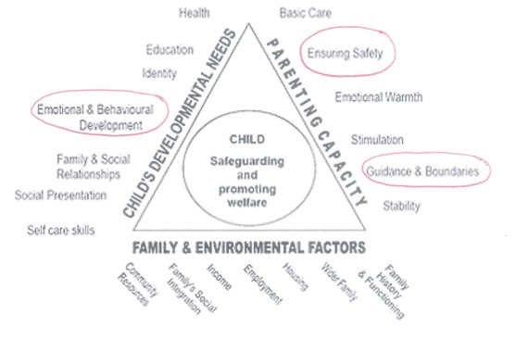
Having completed the assessment of the three ‘domains’, you will have listed the strengths and weaknesses against each area (dimension) of the triangle, i.e. you have categorised all the ‘evidence’ that you have collected during your assessment:

However, this is not yet enough. It is essential that you now consider how the various dimensions on the triangle interact with each other.

This will allow a complete picture of a child’s unmet needs to be seen and help identify the best response to them. It is important that the different sides (domains) of the ‘assessment triangle’ are not seen as discrete areas for investigation and that systemic thinking is used to explore the interconnections and interactions between different pieces of information.

PROCESS
In working with the family you will probably have formed views about the way that the family interacts and operates. You will have ideas about how the parents and wider environment might interact with the children at different times and how the children’s various behaviours influence the parents and wider environment. These are what we are calling ‘processes’.

EXAMPLE of a process: You think that a mother’s mental health difficulties mean that she isn’t always emotionally available to her children, whose behaviour is challenging and attention-seeking. Mum doesn’t always respond to the children with consistent boundaries because the children are hard work, which creates more family stress, arguments with the Dad/grandparents, and makes Mum more likely to deteriorate in her mental health.

EXAMPLE of a process: You think that domestic violence in the relationship between parents is scary for the children, which leads the children to act out aggressively.

The analysis model in this guidance allows you to test such hypotheses by mapping a number of the ‘processes’ onto the triangle itself to see whether it matches your evidence, and to test whether your belief about the (positive or negative) impact on the children is accurate.

Firstly, identify the key facts (already identified through your assessment, above) that are relevant to the process you are considering and note them onto the framework triangle, placing each fact against their corresponding dimensions as per your earlier ‘categorization’. You may wish to circle the dimensions for which you have evidence of positive or negative issues (red circles for negative issues and green for positive, for example), using all three sides of the triangle, depending on which dimensions you have evidence for.

The next step is to draw across the triangle (literally drawing lines on the triangle) where you believe one of your ‘circled’ dimensions impacts upon another, to create a linked process flow. Drawing lines between the three sides of the triangle is a pictorial representation of your hypothesis about what is happening in the family. Both positive and negative impacts should be drawn on (red for negative, green for positive). This shows cause and effect, and highlights which dimensions of the triangle represent areas of need or areas of strength, and therefore require comment on as part of the analysis.

EXAMPLE: you have evidence from contact sessions of the parent failing to provide emotional warmth to a child and have put a circle in red around the dimension ‘Emotional Warmth’. You might anticipate that this will have an adverse impact on a child’s emotions and behaviours.
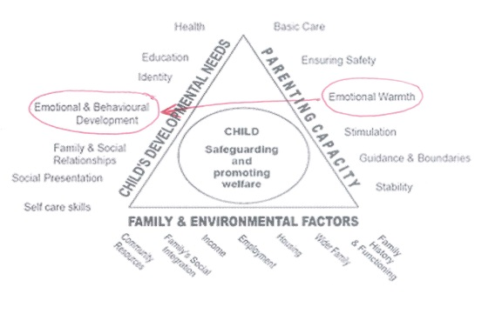
- Is this happening in this case? If so, you may wish to circle ‘Em/Beh Development’ and then draw a line from ‘Emotional Warmth’ on the right hand side of the triangle to ‘Em/Beh Development’ on the left hand side.
- Is it likely to happen in this case but you have seen no evidence of it yet? You may wish to draw a similar line, but you are not yet able to put a circle round ‘Em/Beh Development’ as you have no evidence of harm.

By drawing the lines which cross between the three domains on the framework you will be going through the processes that are impacting upon the family. Drawing the next line in the sequence arises from asking yourself the question ‘So What?’. Drawing an earlier line in the sequence comes from answering the question ‘Why is this happening?’

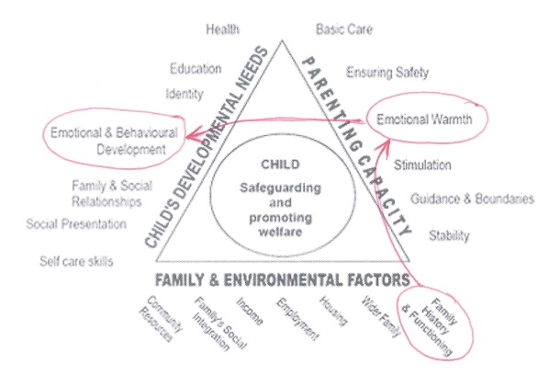
EXAMPLE: As in the above case, if a parent is not providing emotional warmth to a child, you need to ask yourself “why is this happening?” Your answer will explain which red line you should draw towards ‘Emotional Warmth’. You might believe that it is because of a parents’ experience of being parented [‘Family History’] or you may believe it is because of substance misuse issues [‘Family Functioning’]. If so, you should draw a red line from ‘Family History and Functioning’ to ‘Emotional Warmth’. The question ‘So What?’ has already been established above, and you may have drawn a line already from ‘Emotional Warmth’ to ‘Em/Beh Development’. You will see that there is a linear process that has been established here.

Processes may be linear or circular:

- LINEAR processes are where A leads to B which leads to C.
- CIRCULAR processes are either where A leads to B which leads to C which then leads back to A or where A leads to B which leads directly back to A.

By following this method you will be able to test whether there is evidence to support your hypothesis. It will also help develop new hypotheses. If there is no evidence of a negative impact on the children you will need to ask whether you have insufficient evidence or whether the child is not actually being harmed.

You may find that you draw a number of diagrams to represent the key processes which affect the family. Each of these processes can be described within your write up of your analysis.

Although it may not be immediately apparent, each of the lines that you are able to draw on the triangle represents either knowledge from research or is opinion based upon observation. E.g. drawing a line from parental deficiencies of ‘Emotional Warmth’ to children displaying problems with ‘Emotional & Behavioural Development’, is likely down to your expertise asserting that this is the case, or due to your knowledge of research.

Indirect (Secondary) Impact

Any direct impact on a dimension in the Child’s Needs domain is likely to have further indirect negative or positive impacts on other dimensions. When you have established that a child’s need is being directly impacted by the care they are receiving, you need to consider whether there are any further consequences of this in other dimensions of the ‘child’s need’ domain. You also need to be conscious of whether the child is ‘internalising’ or ‘externalising’ their behaviours.

EXAMPLE: The child’s emotional and behavioural development is being impaired because of lack of emotional warmth. Consider what the consequence of that impact is. Is the child demonstrating internalising or externalising behaviour? If externalising, is the challenging behaviour having an impact on the child’s ‘Education’ ‘Family and Social Relationships’, and possibly ‘Social Presentation’. What about if the impact is internalised? The parents’ lack of emotional warmth is not having a direct impact, but the secondary consequence can be impacting on a number of other dimensions

You may find that you are able to draw further red lines within the Child’s Need’s domain, between dimensions. Be careful, however, about whether you are able to evidence any of these secondary deficiencies in your assessment. If not, then it is likely either that there is a problem with your hypothesis, that the harm the child is suffering is not yet being seen, or that you have insufficient evidence.

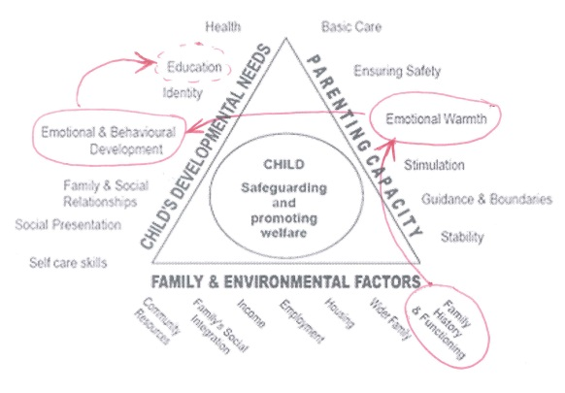
EXAMPLE: You may believe that the secondary impact of a child’s Emotional and Behavioural Development will be problems with focusing and doing well at school [‘Education’], but your evidence from teachers suggest the child is thriving. If this is so, you may wish to re-examine your hypothesis or obtain further clarification from school. Equally, upon further analysis of processes you may find that there are positive processes at play which have counterbalanced the harm through a significant positive impact on the child’s ‘Education’, such as a very supportive grandparent [‘Wider Family’]. These ideas will be discussed in the section below – Impact.

By examining these processes and identifying positive and negative impacts you will have formed a complete picture as to what is going on within the family. A discussion on the magnitude of the impact on each area is below. You may find that some preconceived ideas were challenged when drawing the lines.

You are likely to find it difficult to draw the lines at first. Reference materials will assist in clarifying the likely processes and impacts. Once familiar with using the triangle in this way it will hopefully become a natural and powerful tool which will assist your Court reports.

IMPACT
Positive vs Negative Impacts

You will by now have determined which dimensions are impacted and will be considering to what extent each of these areas are impacted. You are likely to find that there are some dimensions, especially under ‘Child’s Needs’, which are being both positively and negatively impacted on by the care provided. How much weight do you give to the positive and how much negative? You will need to think about the degree of concern you should have about these.

In order to help unpick this dilemma when considering the positive and negative impacts on a dimension you should have the following factors in mind:

- Intrusiveness – how deep (severe) is the impact on the dimension?
- Pervasiveness – how many situations does this arise in or affect?
- Modifiability – the extent to which other factors impact on the concern?
- Frequency – how often does it happen? (likelihood)
- Duration – how long has it happened / will it happen?
- Unusualness – Exceptional factors should be seen as a major factor in their own right regardless of the above as they may indicate a severe need, e.g. suicide attempt.

Once the above analysis has been completed it should be clear which areas of need (and which dimensions of the triangle) are most likely to be affected. By addressing the impact on the child you are ensuring that the assessment remains child centred and remains rooted in child development.

It is important that positives are recognised as well as negatives. A balancing act will necessarily need to take place to be able to comment upon whether the impact of the deficits outweighs the impact of the positives.

For each of the domains impacted, the social worker will have formed a view of the significance of the impact. The concerns will be ranked in the social workers mind in order of importance, the importance being set by the severity of the impact upon the child’s needs and the implications for the child for life. In addition to this, a view of the whole should also be taken. Comment should be made on the cumulative nature of multiple impact across many dimensions of need.

It is likely to be the interaction between a number of factors rather than any specific characteristic that leads to parenting difficulties. Thus most families are able to overcome adversities and provide their children with a sufficiently nurturing environment, although they may fall down in one or two areas. Only a very small proportion are unable to provide a sufficiently consistent standard of care across all seven (child development) dimensions, but it is they who form the group whose children are most likely to be admitted to care or accommodation.
Ward, 1995, p85

You may wish to have further sessions after conducting the analysis to inform your considerations of ability to change and support.

ABILITY TO CHANGE & SUPPORT

Ability to Change

To affect change a parent needs to be able to demonstrate the motivation and capacity to change. This is discussed in The Child’s World, by Jan Horwath.

Prochaska & DiClemente’s comprehensive model of change contains 5 steps. It is beyond the scope of this guide to include a tutorial on the change process and the social worker is expected to have a thorough understanding of the relevant concepts. The social worker needs to be clear with the parent about the areas of concern which need to change.

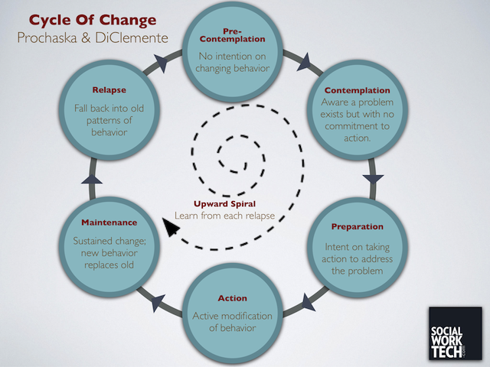

The model contains 5 stages:

Contemplation – Weighing up pros and cons. Start of change process (may exit)
Determination – Informed decision to change
Action – Rehearsing new thinking, behaviour and relationships
Maintenance – Sustaining / internalising new behaviour
Lapse – Return to some or all old behaviours (may start again or exit)

There are also 2 blocks to change:

Pre-contemplation – Defensive / denial / projecting blame / depressed / unaware of problem
Relapse – see lapse above

It is important that throughout the assessment process a thorough understanding of where the parent is within the change cycle can be established. In addition the social worker will be continuing to encourage insight by the parents into the problems of the family to enable change to take place.

The contemplation stage in the above cycle is of particular importance. Tony Morrison describes the 7 steps of contemplation as follows:

- I accept there is a problem
- I accept that I have some responsibility for the problem
- I have some discomfort about the problem
- I believe that things must change
- I can see that I can be part of the solution
- I can make a choice
- I can see the next steps towards change

The incremental development of the level of understanding of the problem, acceptance of their role, and then move towards a solution are each identifiable steps. Tracking each of these realisations by the parents within the parenting assessment sessions will provide the social worker with insights into the rate of reflection and progress. These must then turn into the next steps within the earlier described change cycle of Determination, Action and Maintenance.

The social worker will always be aware of the possibility for disguised compliance. A useful tool when considering the true motivation of the parent is to consider the dual continuum’s of commitment to change & effort, or alternatively what-I-say and what-I-do. Given the pre-requisites for change are motivation and capacity this continuum encapsulates a description of the necessary behaviours.

 | High Commitment | Low Commitment
High Effort | Genuine Commitment | - Tokenism  - Disguised Compliance
Low Effort | - Compliance  - Imitation  - Approval seeking | - Dissent  - Avoidance  - Sabotage  - Barriers

High Commitment and High Effort = Genuine commitment
High Commitment but Low Effort = Tokenism / Disguised Compliance
Low Commitment but High Effort = Compliance / Imitation / Approval Seeking
Low Commitment and Low Effort = Dissent / Avoidance / Sabotage / Barriers

Compliance behaviour where the behaviour is motivated by instruction may indicate that the parent is stuck within the contemplative phase, not moving beyond the 3rd step of contemplation.

Change will only occur if the perceived benefits of change outweigh the perceived fears and costs.

Of critical importance when considering the parent’s ability to change is the likely duration for the parents to move through the change process and the likelihood of change being maintained long term. The ability of the parent to change must be considered in the context of the child and the assessment’s timescales. A conclusion is required to be drawn by the worker around the parent’s ability to change.

The social worker will no doubt also have in mind the difficulties involved in alteration of behaviour by the parents. The longer ingrained a behaviour is the more difficult it will be for the parent to change the behaviour and move through the change cycle.

Techniques of Motivational Interviewing should be considered.

Support

As part of your analysis you will have identified the parent’s behaviours which impact upon the child.

The Local Authority are under an obligation to provide such support which is practicable (i.e. can be reasonably provided) to parents in order to support the child to remain safely within the family network. This is the effect of the article 8 ECHR right to respect for private and family life and the article 7, 8, and 9 UNCRC rights which encompass the child being brought up by and knowing their parents.

Following the above, linear or circular processes will have been examined and the root cause pinpointed. It may be that the root cause requires change of behaviour or pattern rather than simply provision of resources within the home. I.e. a parent may need to spend therapeutic time examining the root of their inability to provide emotional warmth with their child consistently, rather than spending time with a family support worker modelling emotional warmth to them.

Any support provided previously or interventions previously attempted can be considered to determine whether they were directed appropriately, and whether there are any other interventions which may be more suitable.

By identifying the areas of need clearly you will be able to comment upon whether a specific support will address the harm resulting from an inability to meet a particular need. You should discuss the supports which have been tried and comment upon their success. If they were not successful then you should set out the reason for this.

Similarly you should comment on any support which may be sufficient to meet a particular need. In the event that a support would be available to meet some but not all of the needs then you should explain whether, on balance, that support would reduce the harm the child faced to a level that is acceptable, and what the resulting level of harm might be. It may be easier to address this in each section when commenting upon the description of harm, and this is a matter of personal style for the author. Supports which may be sufficient to allow the children to remain within the family network should be identified.

CONCLUSION & WRITE UP

Recording the analysis into a document is the process of describing which lines you drew and why.

The reader needs to be taken through your train of thought, and to know what the likely outcome would be for the child if the child is parented by the person assessed.

You should by now have a clear description of the processes that are at play in the family, the reasons for the family behaving as it does, the impact on the child of those behaviours, and specifically the effect of the parenting being given.

For each of the areas identified as relevant you should set out the relevant process and the impact this has had and will have on the child. The analysis will be stronger if it is linked to examples exhibited by the child. You will have formed a view as to why each of the dimensions of need for the child will be impacted and have considered the interplay of the positive and negative factors.

To explain a multi-causal process like neglect you may need to explain a number of processes and demonstrate the cumulative impact across the dimensions of need. You are reminded that the purpose of the document is to explain to the Court the impact of the parenting provided by the person assessed and so it is important to distinguish the impact on the child’s needs short-term and long-term, from the other two sides of the triangle.

You will have identified where within the change cycle you believe the parent to be, and how capable they are of moving through the cycle. You will also have identified the areas where support could be focussed, and whether provision of practicable support will allow the child’s needs to be met.

The conclusion will by now be clear. The benefits and detriments of being cared for by the person assessed should be set out.

© January 2014 – David Barker, Amanda Bryan, Elliot Davis

Social work assessment of children in need: what do we know? Messages from research.

