Parenting Assessment Plan
For Ms and Mr in Respect of Child

The schedule below outlines the work that will be completed by the Local Authority with Ms to assess their ability to meet child’s' physical, social and emotional needs. The parenting assessment is structured around the Framework for the Assessment of Children in Need (Department of Health).

It is expected that Mst will work closely and openly and honestly with the social worker and other professionals throughout the assessment period. The social worker and other professionals will work closely with each other to ensure that information is shared appropriately and support is provided consistently.

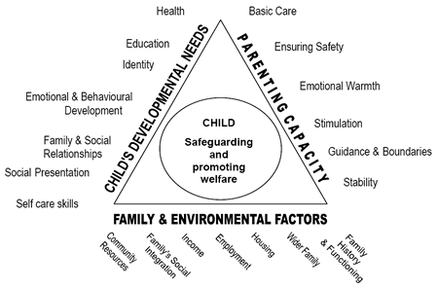

Ms working with other Agencies and Professionals
It is expected that Ms will engage with their Family Support Worker, CONSULT, and any other services identified as relevant during the Court proceedings.

Work with Child
The social worker will continue to carry out announced and unannounced statutory visits to his foster placement and in his school.

Other work prior to start of assessment
Police disclosure will be requested, health information will be reviewed, historical and any current social work files in relation to relevant adults/children will be reviewed.

Parents contact with
A referral will be made to CONSULT within the next seven days to consider the best way to re-introduce contact between Ms and child, and to introduce contact between Mr and child, and also between other possible careers if pertinent. Consult would aim to respond to the referral within seven days to advise of whether they feel a consultation is appropriate and to give a proposed date for any such consultation. Once this information is available, it will be shared with all parties, so that timescales and next steps can be agreed. If there is concern at this point about the likely timescales, a review meeting can be arranged to discuss the situation. Once there is a plan for re-introducing contact this will be formalised into a Written Agreement. Once contact is in place, contact sessions will be observed by the social worker for the purpose of assessing Mr’s or Ms’ Parenting.

Possible Outcomes of the parenting assessment

a) The parenting capacity is good enough and there are no recommendations for further parenting work. There may be other issues that require assessment/attention.

b) The parenting capacity is not far short of being good enough and there are recommendations for further parenting work with a timescale.

c) The parenting capacity is not good enough and there is a detailed plan of recommendations that could reduce the risk to an acceptable level, with an opinion as to how far this programme is feasible given the motivation and capability of the parent within available resources, and the timescales of the child.

d) The parenting capacity is not good enough and the assessor recommends that child is not placed with Mst during, or at the end of, the current Court proceedings.

Parenting Assessment Schedule
All sessions will take place at the home address of Ms, or at a suitable contact venue once contact is in place.

Session 1: Friday 22nd April 2016 – 6:00 p.m.
Introduction to parenting assessment – why are we here?

Session 2: Tuesday 26th April 2016 – 6:00 p.m.
Childhood and family history, including education.

Session 3: Tuesday 3rd May 2016 – 6:00 p.m.
Health, drugs, alcohol, violence, criminal history.

Session 4: Tuesday 10th May 2016 – 6:00 p.m.
Previous relationships and current relationship.

Session 5: Tuesday 17th May 2016 – 6:00 p.m.
Parenting skills and abilities (past and current).

Session 6: Friday 20th May 2016 – 6:00 p.m.
Parenting skills and abilities (past and current) continued.

Session 7: Wednesday 1st June 2016 – 6:00 p.m.
Child’s needs and balancing the needs of other children in household

Session 8: Friday 3rd June 2016 – 6:00 p.m.
Finances, home conditions, family and professional support networks, managing contact arrangements and ability and willingness to work with professionals.

Formal observation session dates will be added once there is a contact plan in place.

Additional sessions may be added if more time is needed on a specific area or if further information or concerns arise during the course of the Court proceedings that require further investigation or discussion.

I understand and agree to take part in the Parenting Assessment detailed above

Name:

Signed:

Date:

Name:

Signed:

Date:

