Recording Supervision in LCS
The Liquidlogic application has a built in core functionality to enable managers to record Case Supervision on LCS.
Managers can be given permission to use the Menu button within LCS to initiate the recording of supervisions. The search screens are dynamic, and will display search results depending on the manager’s role and staff allocated within the workflow model. The search results will display cases that the manager can select to record supervision on.
The recording is completed via a Liquidlogic form, when initiated this is shown within the Child’s record. There is also another view of this same date against the worker.
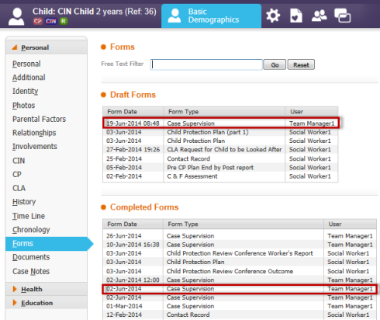
The form uses all the standard features of Liquidlogic, and can be modified to look the same as that promoted through GCC. It can be used with a single child, or, as part of family working with some questions having specific answers per child.
In order to automate the follow up process, the forms can be copied forward from the previous month, as shown in the screen shot below
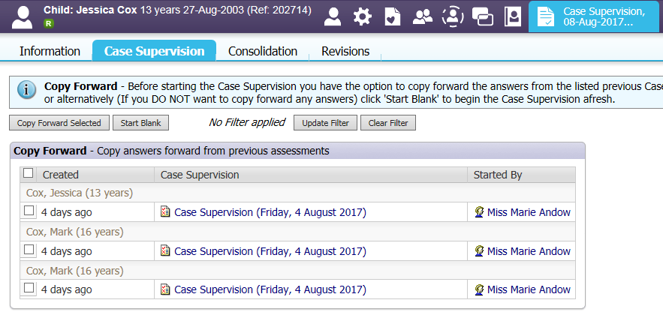
The data generated on completed and pending supervisions is automatically added to the Liquidlogic data warehouse so can be reported on. We can also set a number of alerts within the system to remind users of supervision forms that have not been completed.
The next steps
- ICT Applications team to add the current GCC supervision form to the test environment
- Demonstrate the application, so see if it meets GCCs requirements
- If agreed
  - Work with John James to produce a set of management reports
  - Write a how to guide (3 sides of A4 max)
  - Train the trainer approach to get teams understanding how the system works
- Promotion of the process through data and management oversight

