**[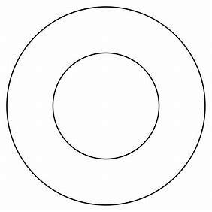](https://www.bing.com/images/search?view=detailV2&ccid=cIxZxH/8&id=57C027A4014255234EB068AA3A899A45F0C97363&thid=OIP.cIxZxH_8A8ttZpuq7OzrugHaHa&mediaurl=http://www.naergilien.info/tutorials/tricorn/hatpattern1.jpg&exph=1181&expw=1181&q=circle+inside+circle&simid=608043492106045239&selectedIndex=1&cbir=sbi)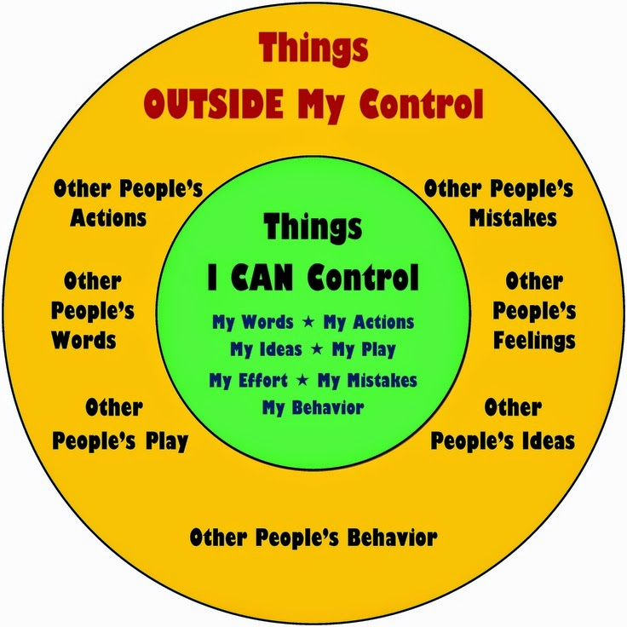Things I can control Worksheet.**