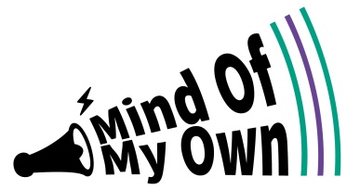
Dear Foster Carer
Please help get your foster child started with the Mind of My Own OneApp!
The Mind of My Own OneApp (www.mindofmyown.org.uk) makes it easier for children and young people to structure their thoughts and say what they want to say. It also helps young people talk to their workers by allowing them to send their views on to them any time they want, 24/7.
Your child can use OneApp on their own, but often doing it with you will help them talk about how they are feeling and what they’d like to change.
The Mind of My Own OneApp can be downloaded onto an Android or Apple device, or you can access it online through any web browser at app.mindofmyown.org.uk. Your child can sign up for an account on one device but can then log in on any device they want.
The Mind of My Own team have made a demo version of the app for foster carers to check out. Please try it out by clicking on ‘Sign up’ at appdemo.mindofmyown.org.uk.

What we would like you to do…
- Have a go on the demo
- Help your child sign up with their own account
- Use it with them to help them think about what they want to say through the OneApp, or encourage them to use it on their own

Children’s email addresses
The OneApp requires an email address for sign up to an account. If your child has a personal or school email address, then they are ready to sign up.
However, if they don’t, or if there is a reason why their use of internet is restricted then they can use it with their worker through a ‘Worker Account’.
www.mindofmyown.org.uk

Best wishes
The Ambassadors for Vulnerable Children Young People / Participation Team
cypvoice@gloucestershire.gov.uk

