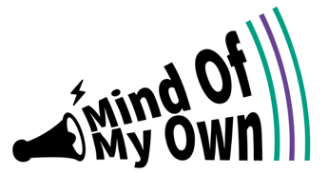

**A GUIDE FOR PARENT/CARERS TO SUPPORT CHILDREN AND YOUNG PEOPLE TO REGISTER FOR A MIND OF MY OWN ACCOUNT.**

Children and Young People who can use Mind of My Own to communicate with their workers.

It enables children and young people to create a structured statement of their views in relation to events and situations they encounter when receiving support from services.

Events and situations may include:

* Children looked after reviews
* Early Help Meetings
* Personal Education Plan
* Children in Need Reviews
* Child Protection Conferences
* Pathway Planning
* Sorting a Problem
* Sharing Good News
* Requesting a change
* Assessment Planning
* Family Group Conferencing

The app is available to use online, on android devices and on iPad and iPhones.

**YOUNG PERSONS ACCOUNT**

Children and Young People can register for their own account and it can be use by young people 24/7

* Young people can download the app from;
* Or access via the web: **one.mindofmyown.org.uk**
* Young people must have an email address to sign up for an account. If your child or young person does not have their own account you can support them to register for one if appropriate.

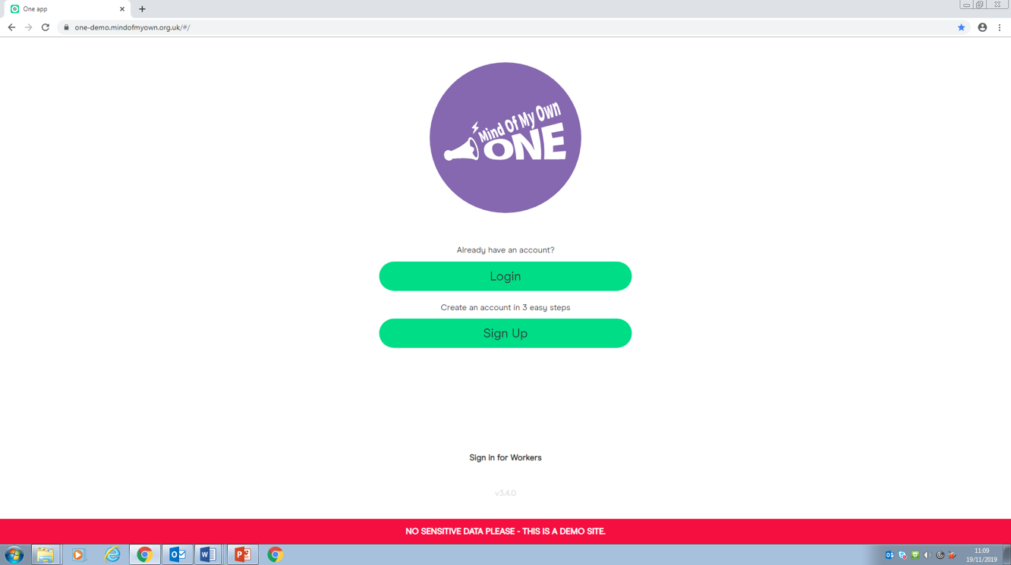

Young people can sign up in three easy steps. If you are supporting your child or young person to sign up to an account please can you ensure that they enter their correct name and date of birth. Statements are matched against our case management system and allocated to the appropriate worker identified on the system.

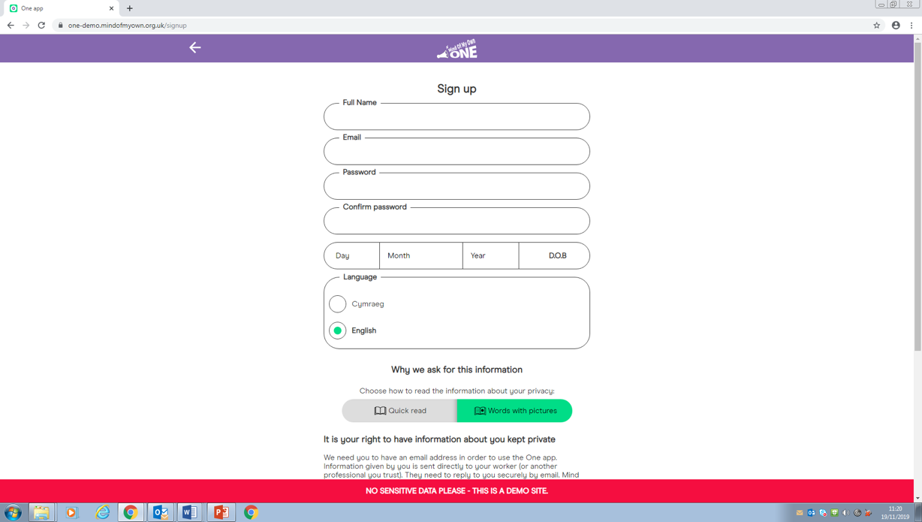

When signing up for an account young people will be asked to read and accept their privacy rights. They can either do this as a quick read or words in pictures. They must accept before they can move on.

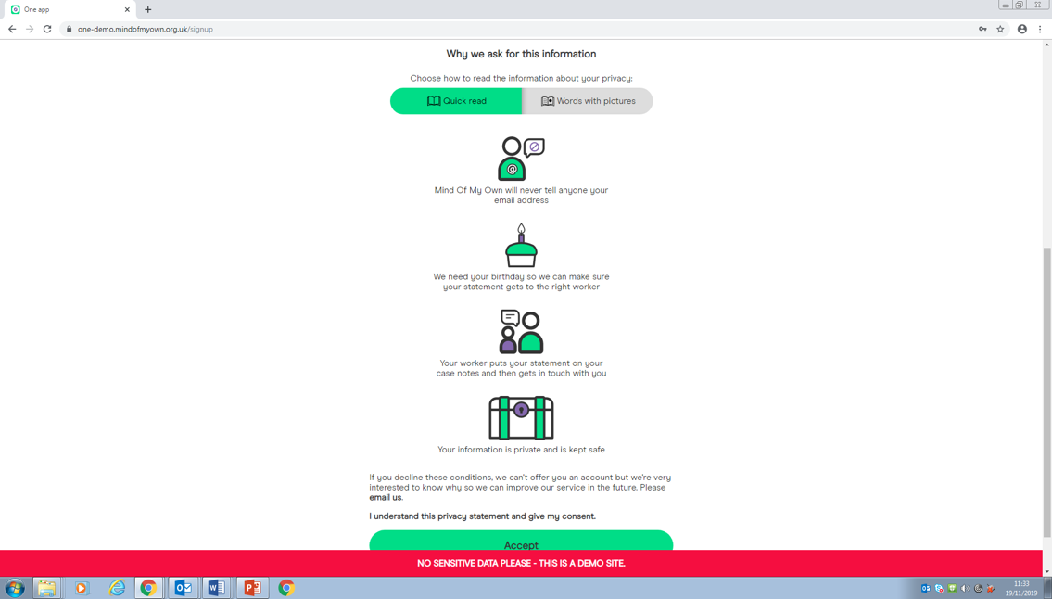

Young People will be asked to choose where they live. If a young person lives out of area, they will still need to choose the services location**.**

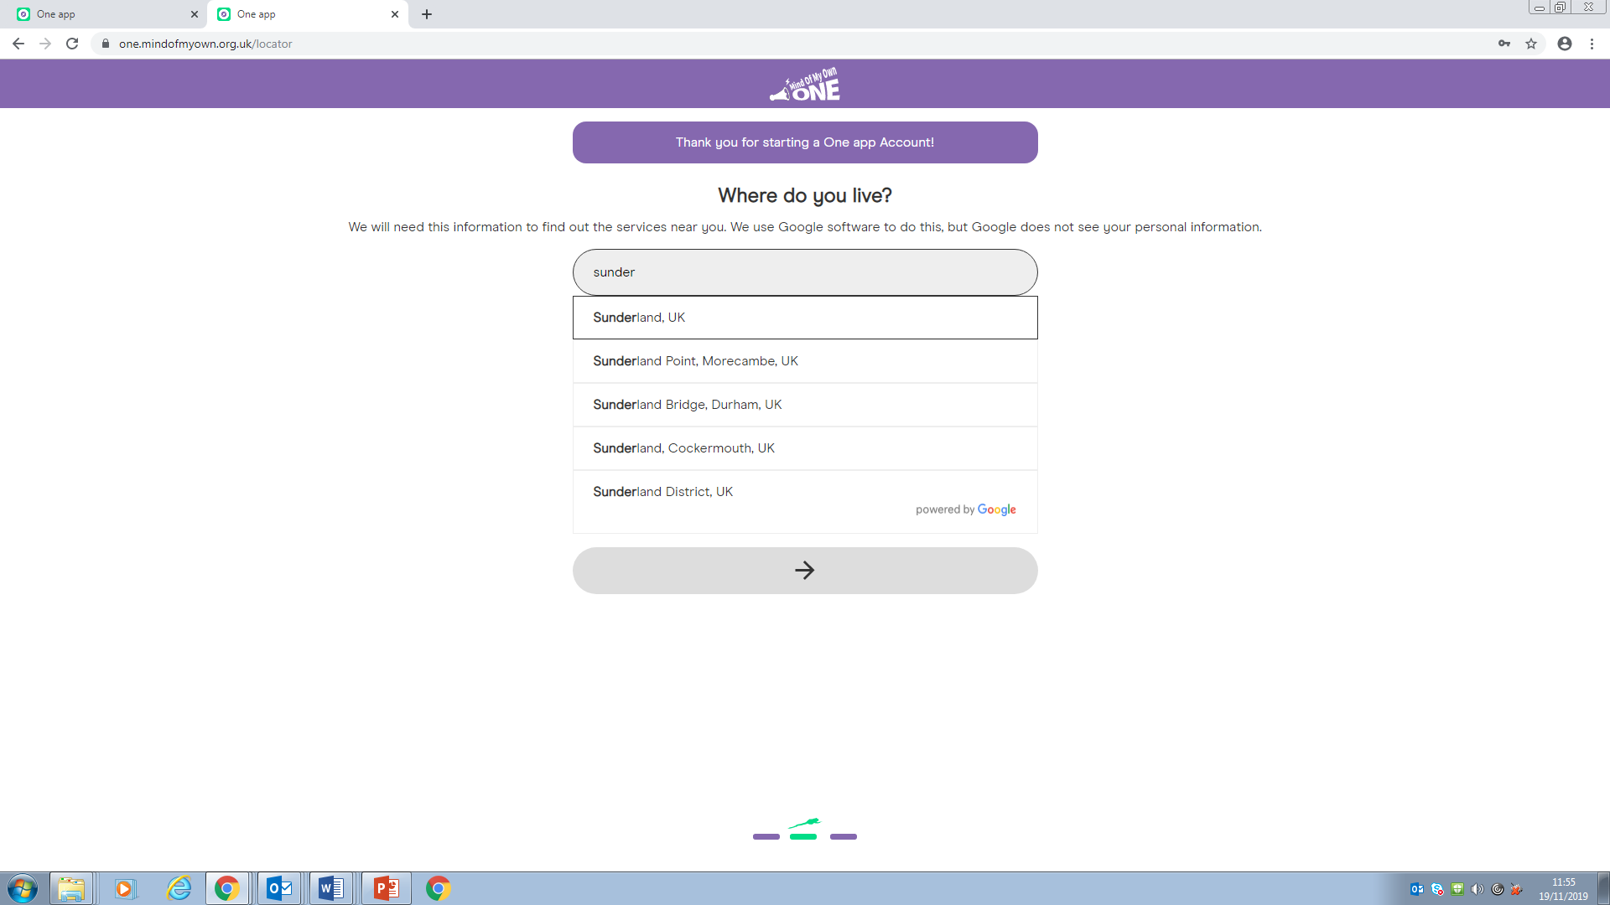

Young people will then be asked what services they use. When a young person sends a statement to the one service, others will not see this statement.

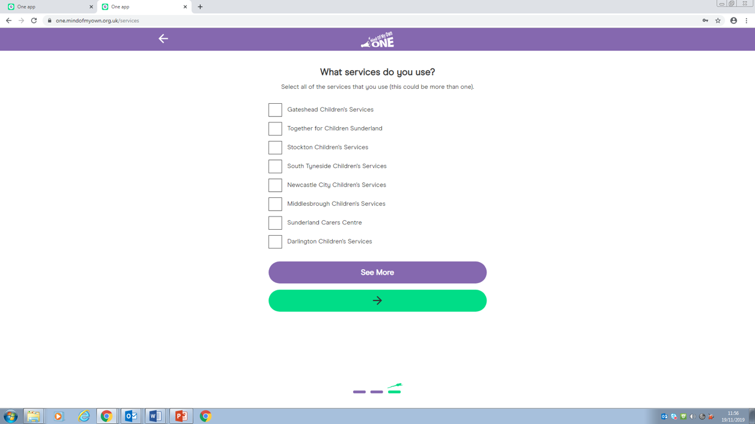

Once the services have been selected, the young person is ready to go.

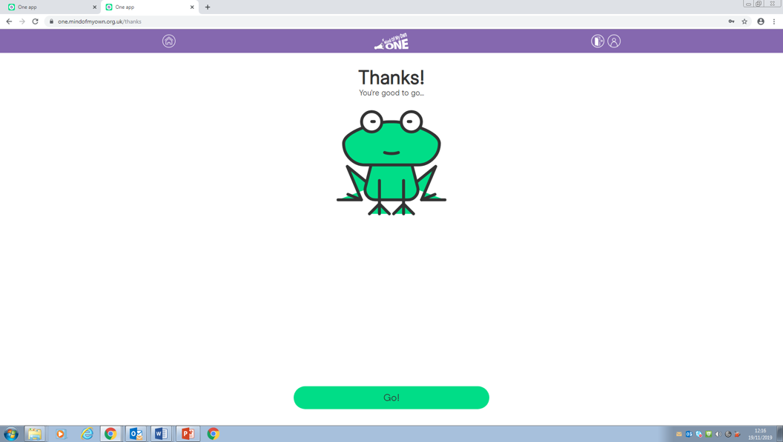

Please remind the young person that it’s ‘one login’ any device.

**MIND OF MY OWN ONE**

Mind of My Own one allows children and young people to choose any of the following statements to complete and send to the person of their choice.

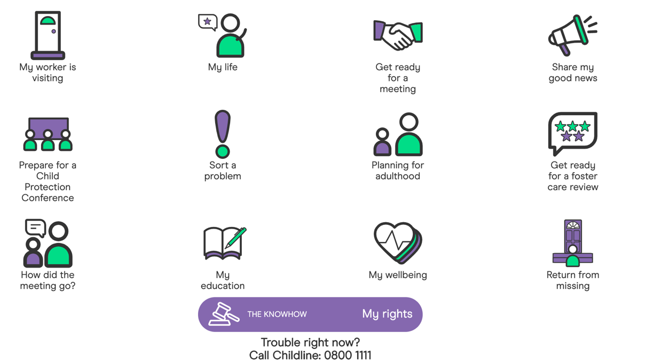

Once a young person has decided which scenario to complete, they will be given a series of questions to answer. For the purpose of this guide we are going to select the ‘My Worker is Visiting scenario’.

1. Select Scenario

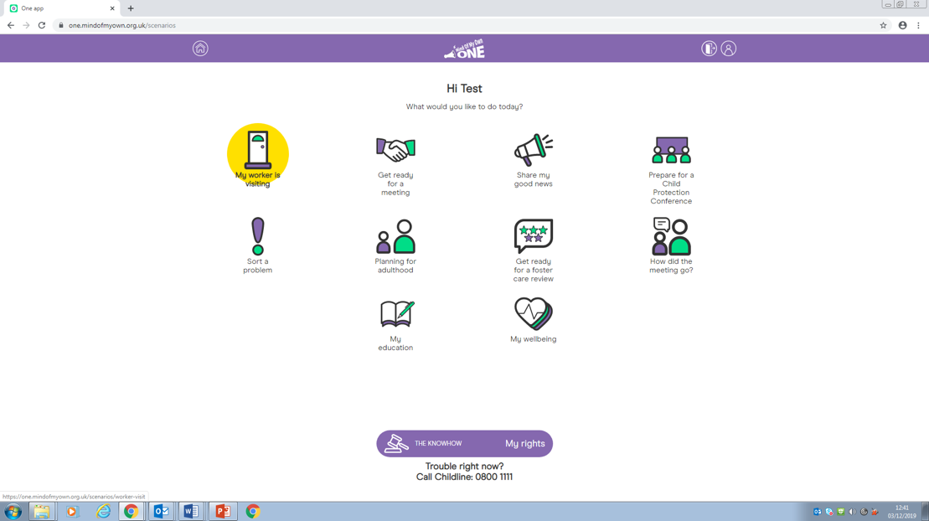

1. The first question is on a slider and will ask the young person how things are going, when the statement arrives it will be shown as a number from 1(not good) to 9 (feeling great).

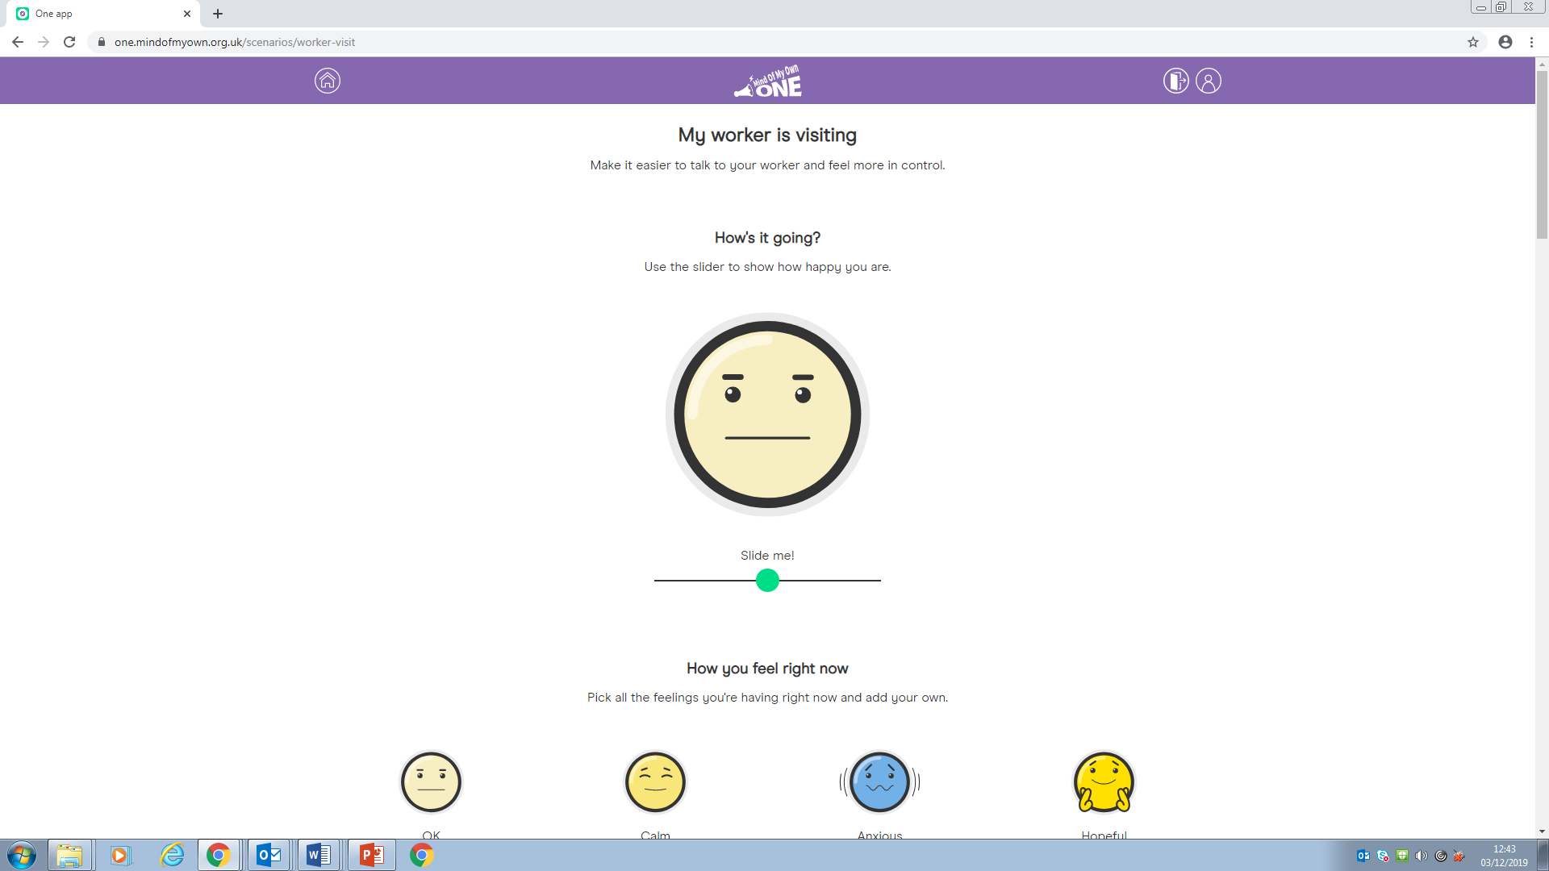

1. Young people will then be asked how they feel right now. They can tick as many emojis as they would like or alternatively add their own feelings into the box below.

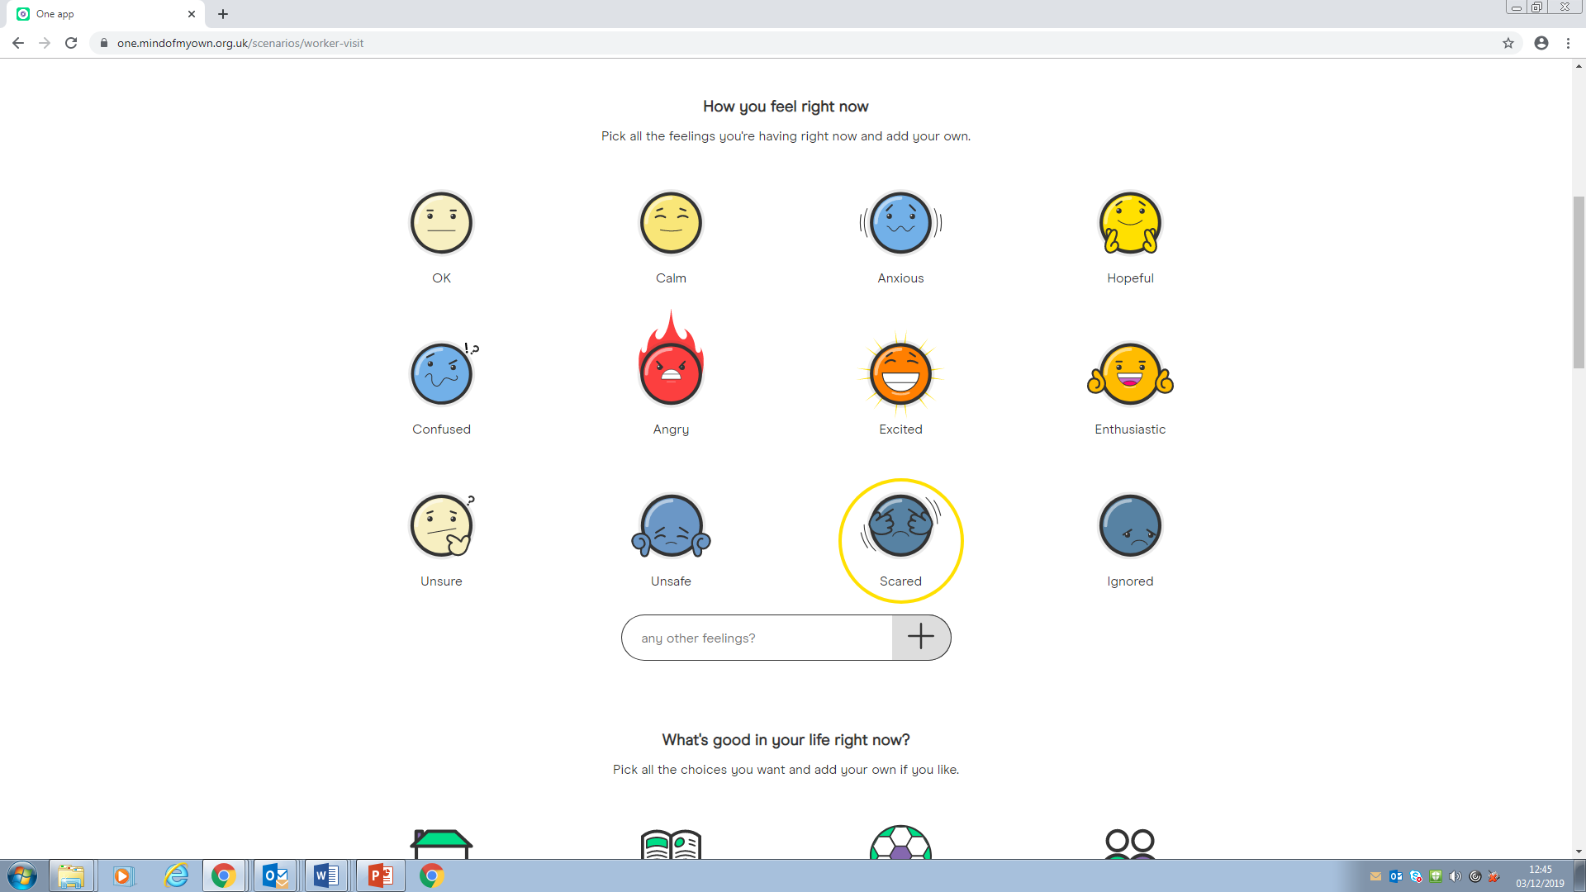

1. In the worker visit section the young people will be asked what is good in their life right now. Again, they can choose as many icons as they would like. When selecting they will get a pop-up box to encourage young people to add commentary to why they are choosing that icon. However, young people do not need to add any commentary if they don’t wish to and the box will still show as ticked.

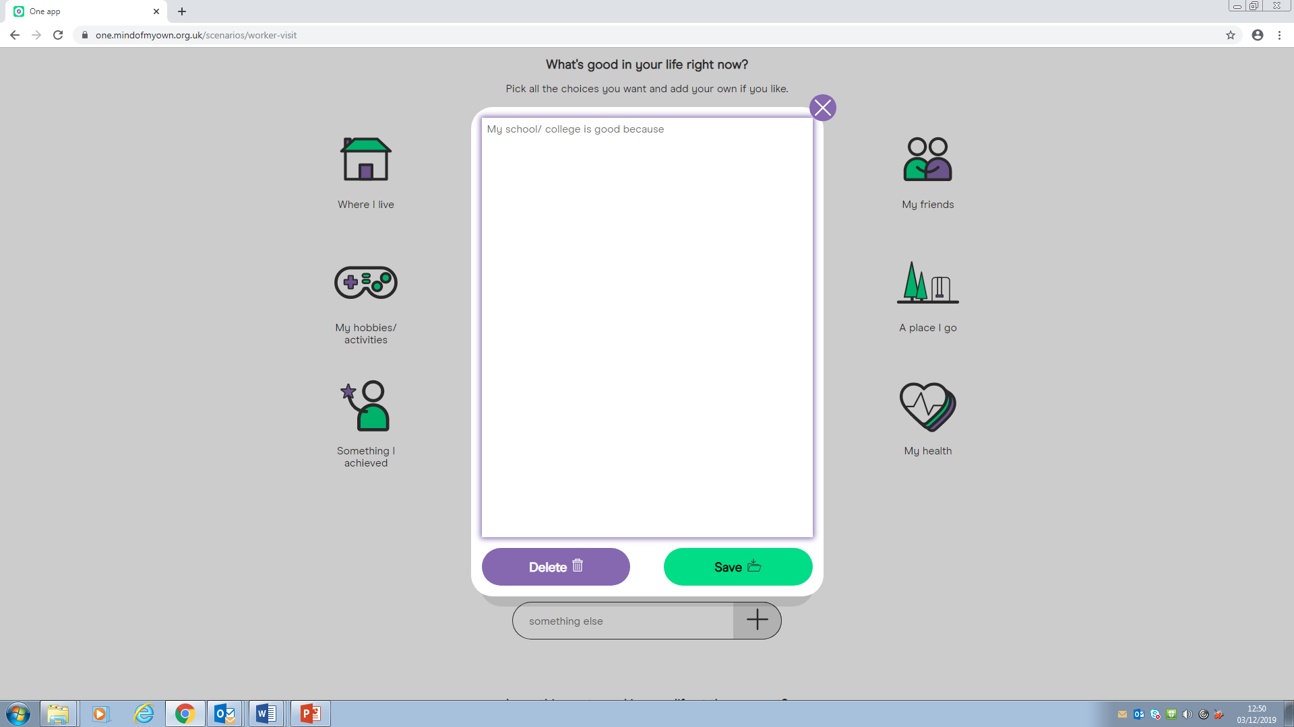

1. In this scenario young people will be asked what’s not so good in their life. Again, they can choose as many icons as they would like. When selecting they will get a pop-up box to encourage young people to add commentary to why they are choosing that icon. However, young people do not need to add any commentary if they don’t wish to and the box will still show as ticked.

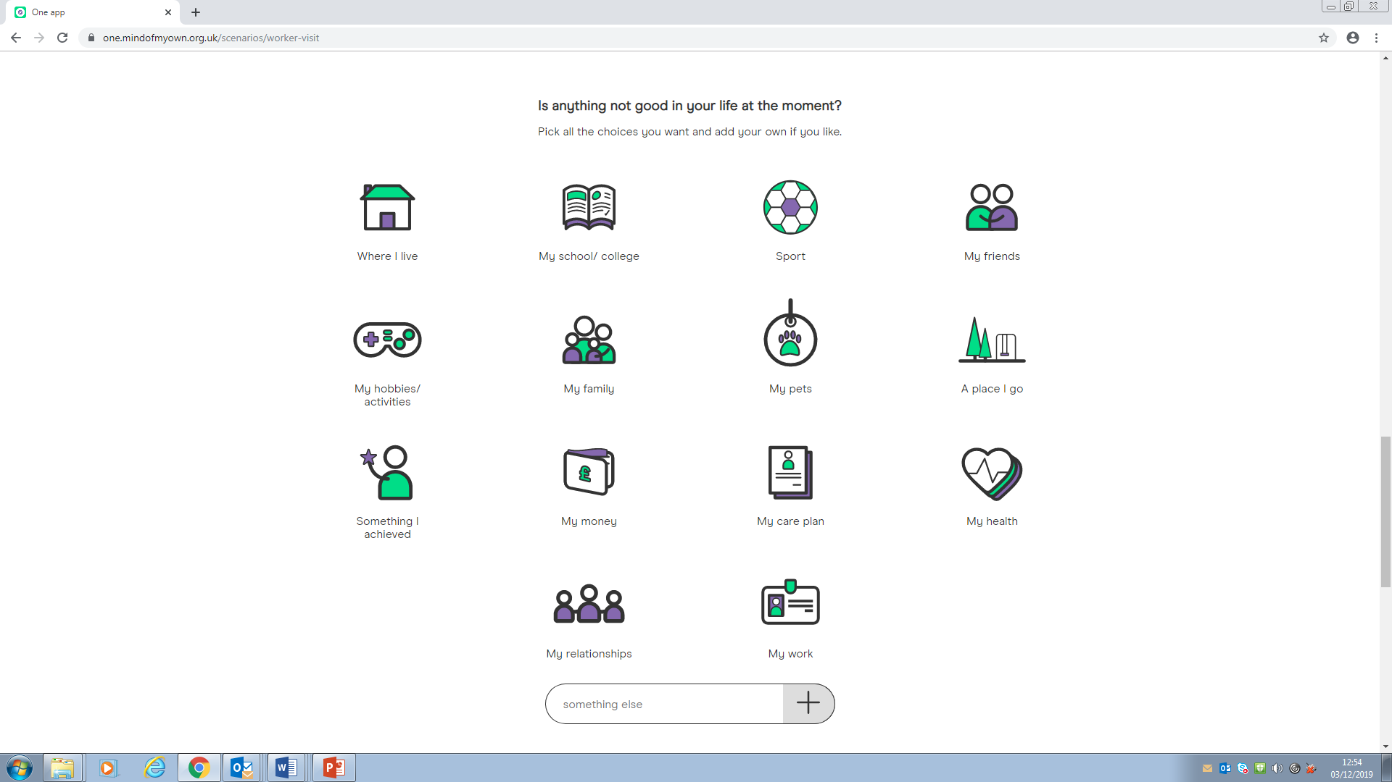

1. In the scenario for my worker is visiting the last two questions ask about how they feel about where they live and what they would like to be different. Young people do not have to answer all the questions in a scenarios, but do have to at least answer one.

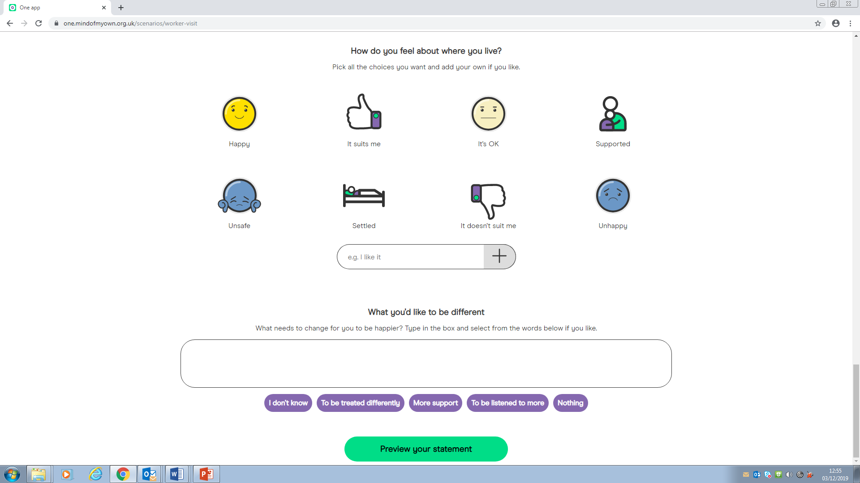

1. After completing the scenario young people will get the chance to preview their statement before sending it onto the worker of their choice.

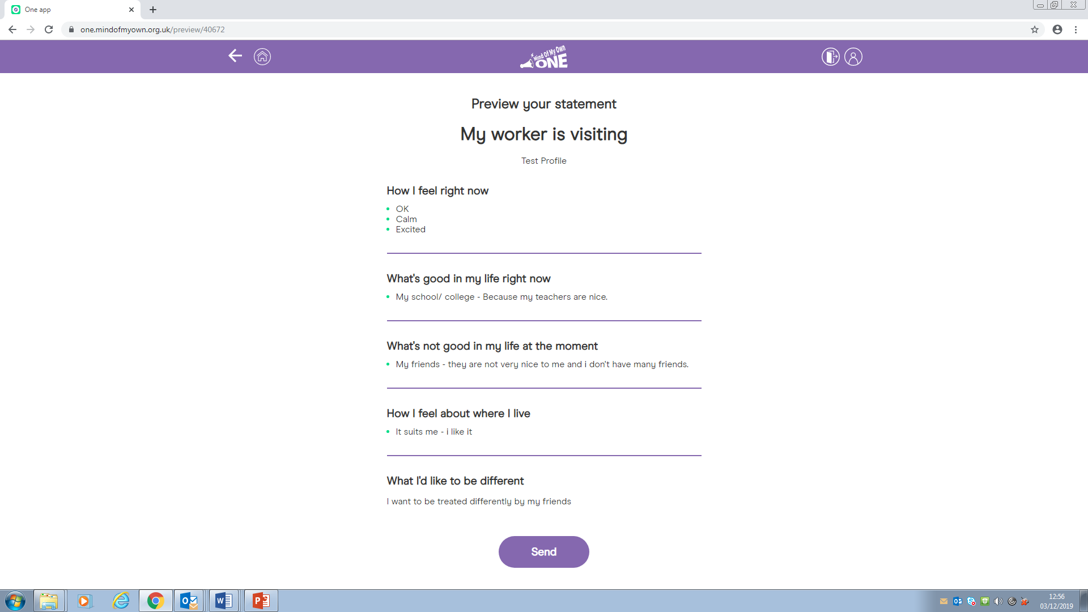

1. Once the young person completes a statement they will get a drop down to choose from as below.

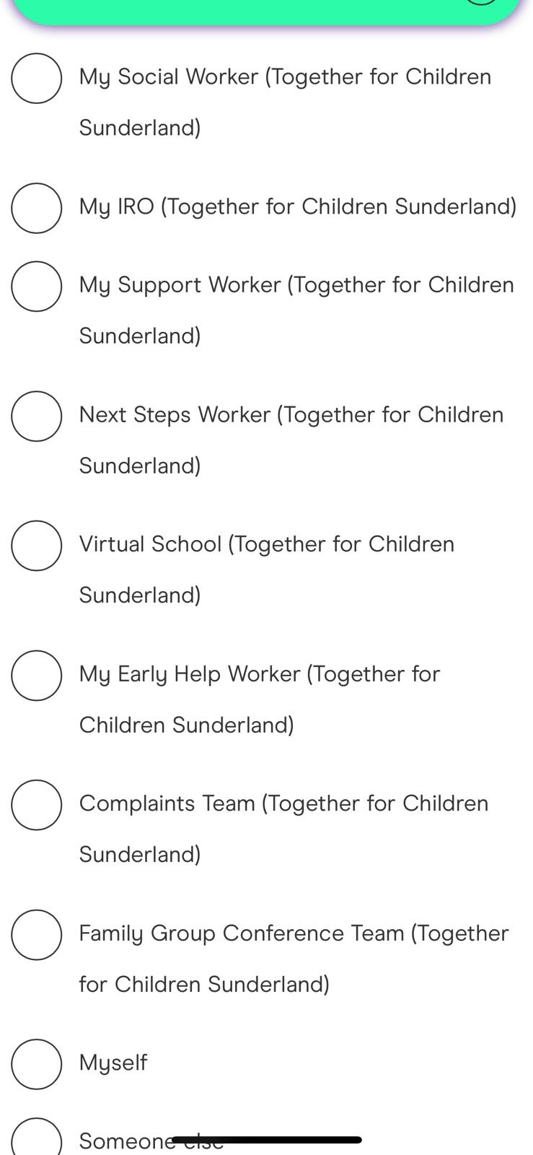

1. The young person will then choose who they wish to send it to, select the icon and press send. The statement will be filtered through service Mind of My Own to ensure it gets to the most appropriate person.

**FREQUENTLY ASKED QUESTIONS**

**Who will see the young person’s statement?**

The young person chooses who their statement will be sent too, however it does also stay on the Mind of My Own Dashboard and will be saved to the Case Management system.

**Will the young person’s worker reply via Mind of My Own?**

No, it is a one-way system, once their worker receives the statement, they will contact the young person via phone or visit.

**How quick will my worker receive my statement?**

Statements are allocated every working day, statements won’t be picked up over a weekend or on an evening.

**My child or young person doesn’t have an email account can I use mine?**

Sadly not the tool is there to ensure the child’s voice is heard and they are in control of what they say and to who too. There are lots of safe email providers out there and you my find they already have one with their school or college.