My Journey









My one Page Profile

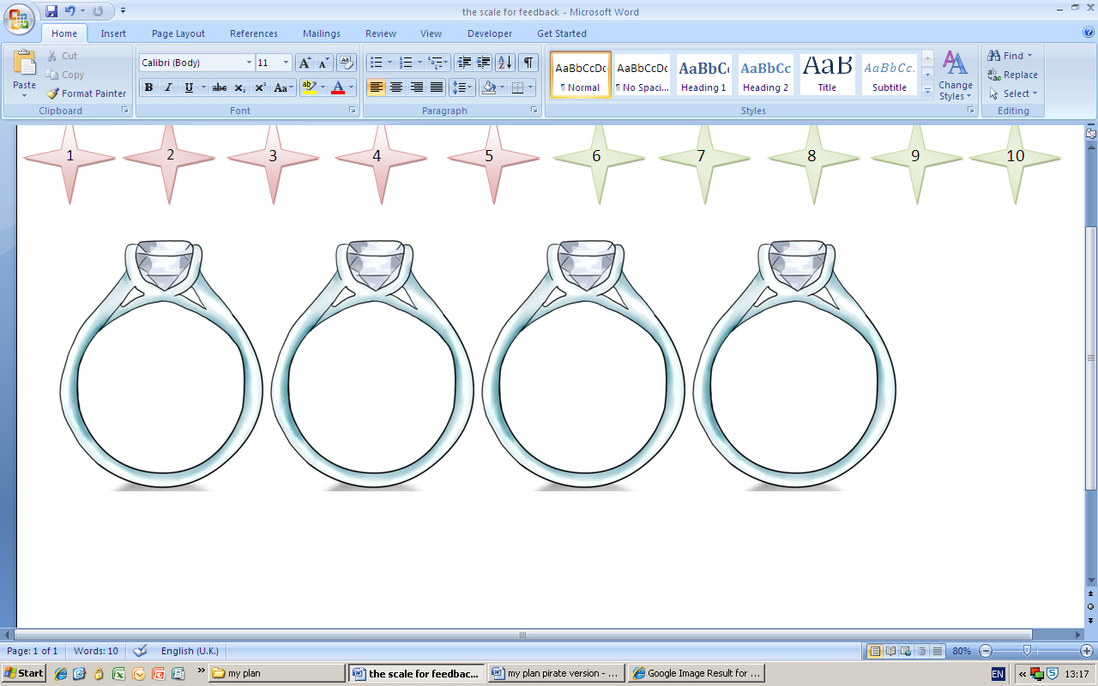









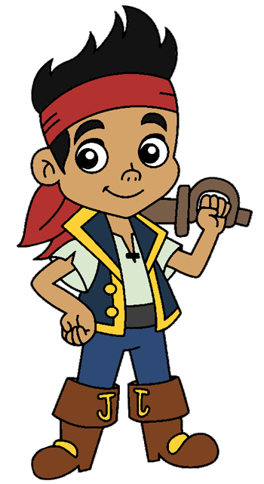

What makes me sad or worried?

If I had one wish, it would be:

Things that are important to me?

What I like about my life.

What do people like about me?



People that are important to me



My Journey

**What needs to change? What needs to happen? Who is going to help and how?**

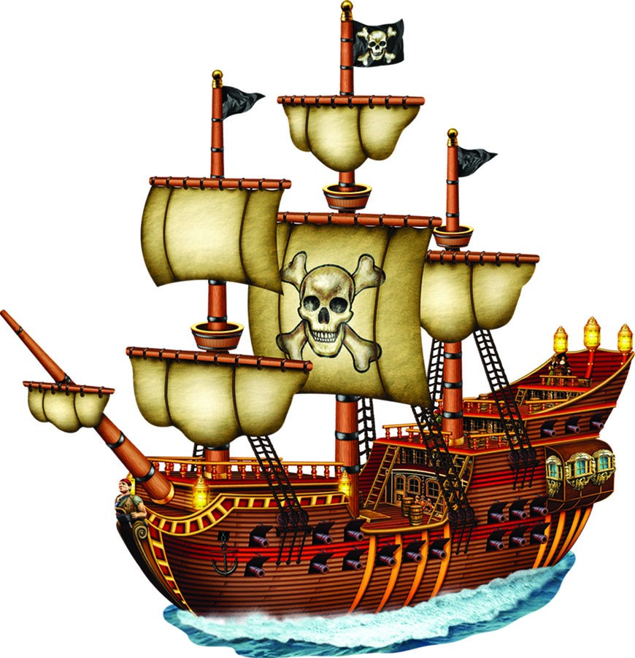

[](http://dewpac.org/event/student-performance-story-pirates/sp-logo_flag_wh/)

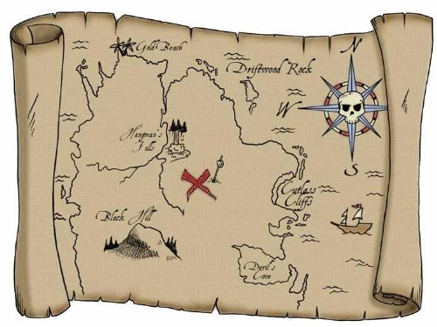



[](http://dewpac.org/event/student-performance-story-pirates/sp-logo_flag_wh/)

[](http://dewpac.org/event/student-performance-story-pirates/sp-logo_flag_wh/)

People helping me





my Road – What Has Changed?

What Helped?

What didn’t help?





