





My Journey







GCC Logo

My one page profile

Things that are important to me?

What makes me sad or worried?

If I had one wish, it would be:

What do people like about me?

What I like about my life.

[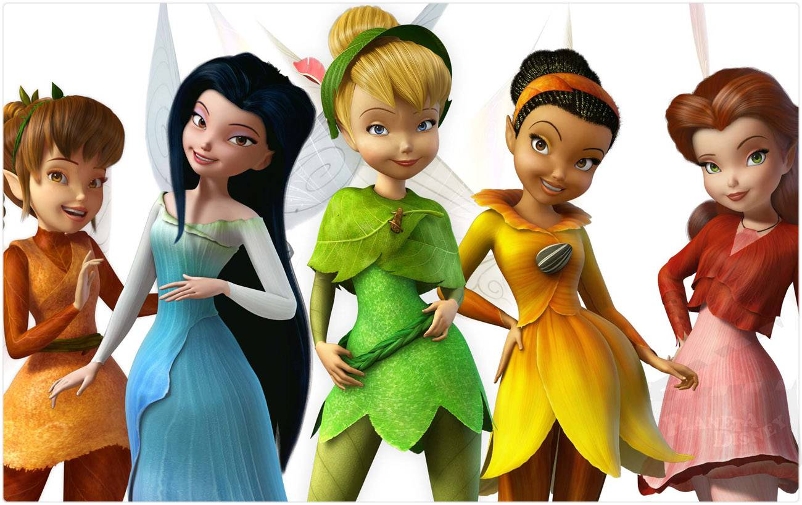](http://stuffpoint.com/pixie-hollow/image/6151-pixie-hollow-tink-and-friends.jpg)





People Helping Me

[](http://stuffpoint.com/pixie-hollow/image/6151-pixie-hollow-tink-and-friends.jpg)

My Journey

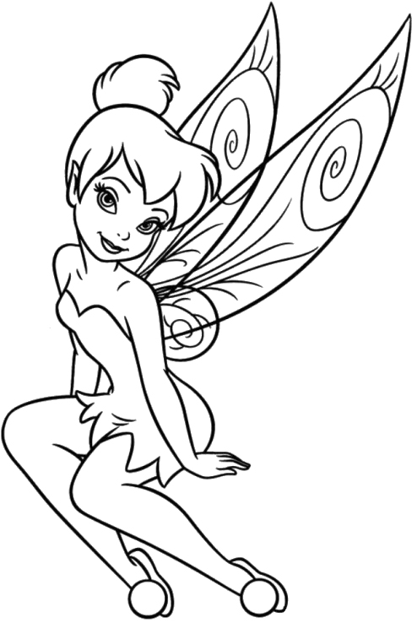

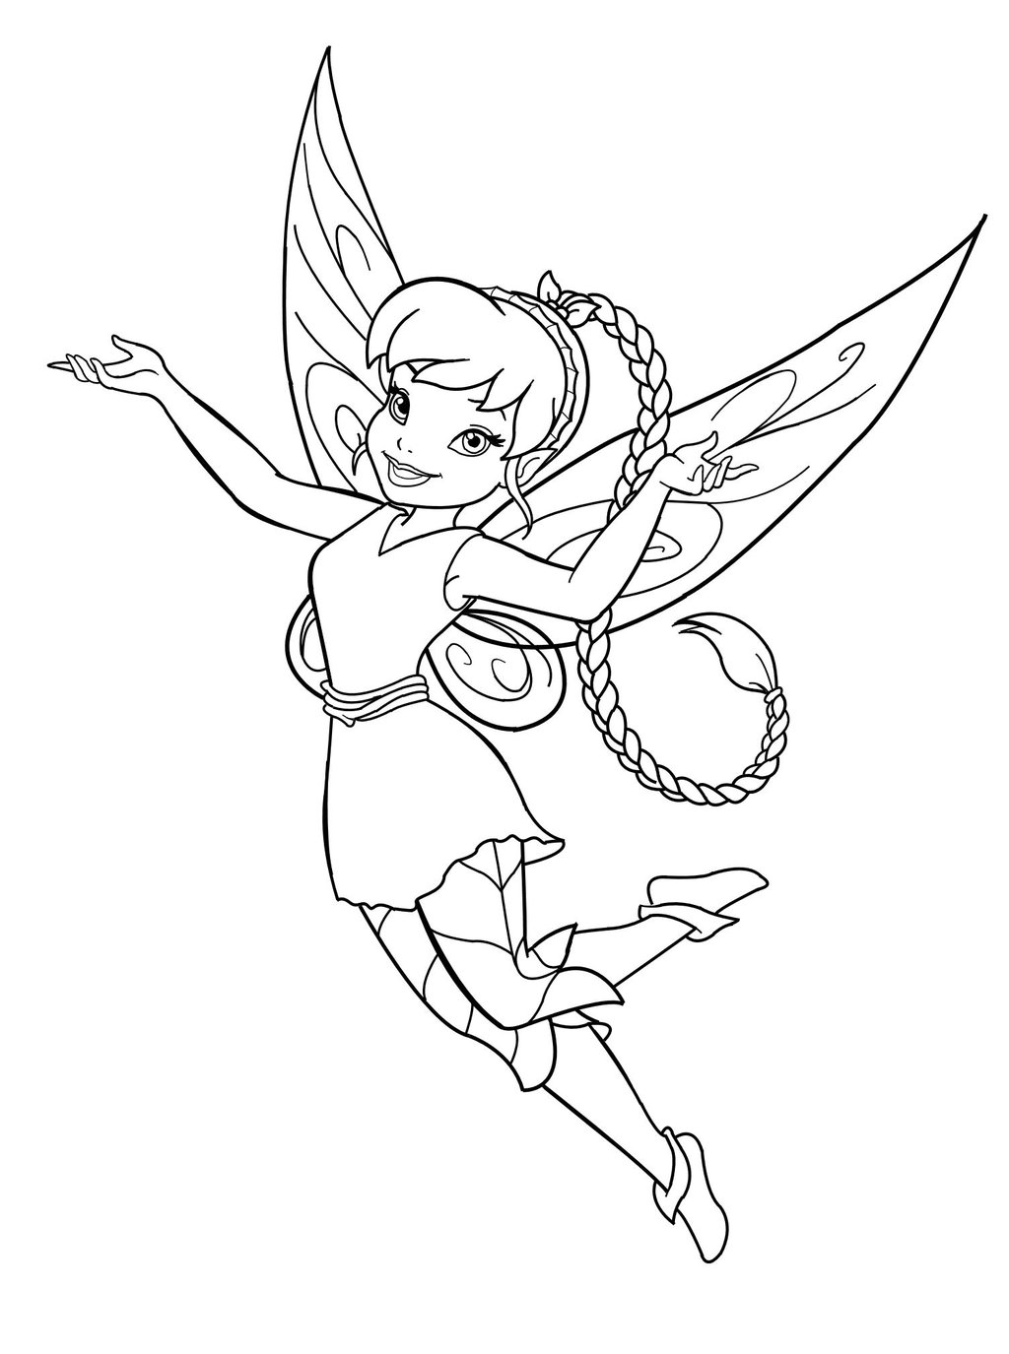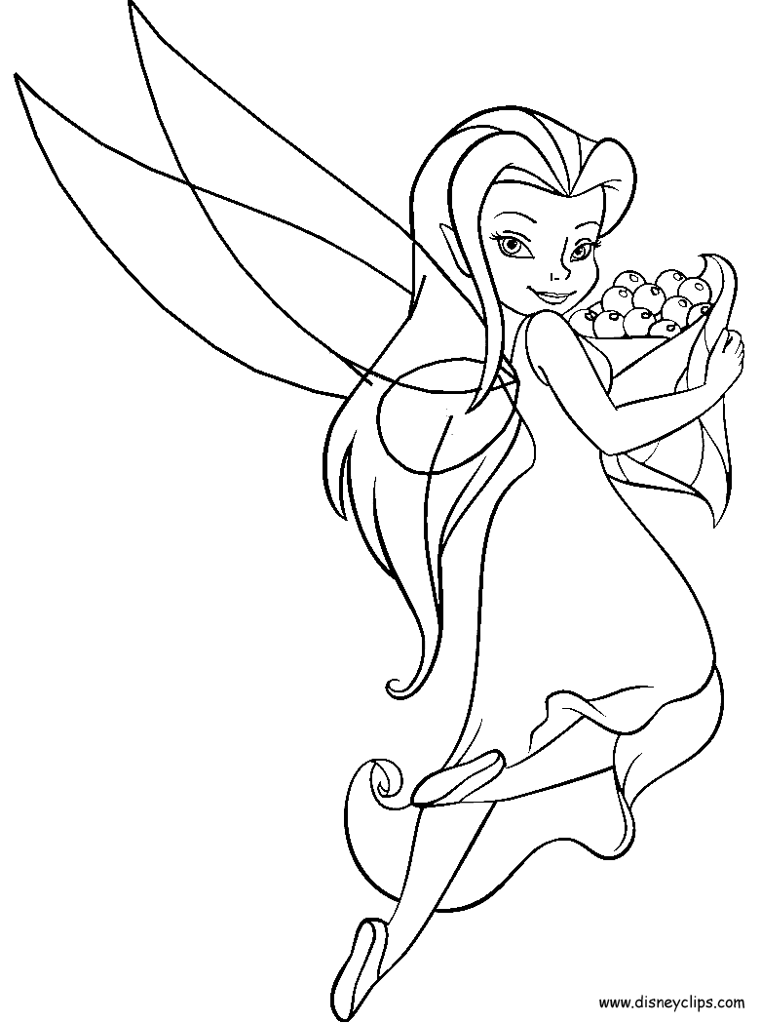

**What needs to change? How is it going to happen? Who is going to help and how?**

[](http://stuffpoint.com/pixie-hollow/image/6151-pixie-hollow-tink-and-friends.jpg)





People that are important to me

[](http://stuffpoint.com/pixie-hollow/image/6151-pixie-hollow-tink-and-friends.jpg)

My Road – What Has Changed?



[](http://stuffpoint.com/pixie-hollow/image/6151-pixie-hollow-tink-and-friends.jpg)

What helped?

What didn’t help?



[](http://stuffpoint.com/pixie-hollow/image/6151-pixie-hollow-tink-and-friends.jpg)