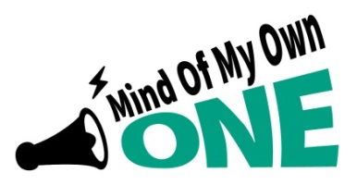

Signing up children and young people

It is so important to support children and young people to sign up for the One App now!

The ‘Mind of My Own One App’ is a great way for children and young people to let you know how they are, if they’ve got any problems, what is going on for them at home and if they don’t feel safe.
How do I support children / young people to sign up?
Ask them to visit the App Store or Google Play Store today to download Mind of My Own One App or go to www.mindofmyown.org.uk, click on the ‘Sign in’ bar and sign up as a young person.
All information on how to sign up is on the poster or watch this short video on how to sign up https://vimeo.com/400294861

What can the One App be used for?
The ‘scenarios’ on Mind of My Own One App are:
- Get ready for a meeting (child in care review, child in need or any meeting)
- Prepare for a Child Protection Conference (they can give their views about their life and how they feel)
- My worker is visiting (they can tell you what they want to discuss)
- Sort a problem (they can let you know if they have a problem or they don’t feel safe)
- Planning for adulthood (helping with pathway plan and the future )
- Share my good news (celebrating something they have done or achieved)
- How did the meeting go? (they can let you know whether they felt listened to or what could be done better)
- My wellbeing (they can tell you how they are feeling about lots of areas of their life which will help you get a picture of their life. This is really important right now!)
- Return from missing (which can be used after a young person has been missing to find out what is going on for them)
….and a new Scenario from 20th April 2020…
- My Education (for Personal Education Plan meetings or where a child/ young person can say what they think about various areas of their education )
For more info please contact the Participation Team cypvoice@gloucestershire.gov.uk

