Guidance for Managers to Approve a Mosaic ACS Request
Mosaic ACS requests will need to be approved by the Mosaic user’s line manager or a Manager nominated to do so on their behalf via Service Desk Online as follows.
Managers will receive an email from IT Services requesting approval
Open WSCC Intranet The Point http://theintranet.westsussex.gov.uk/
Click on Report IT faults and requests

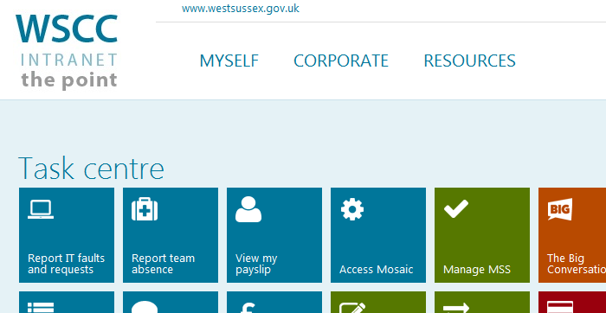
This will take you to Service Desk Online https://servicedeskonline.westsussex.gov.uk/
Access requests waiting to be approved by you as manager will show in My Approvals >
Click on My Approvals
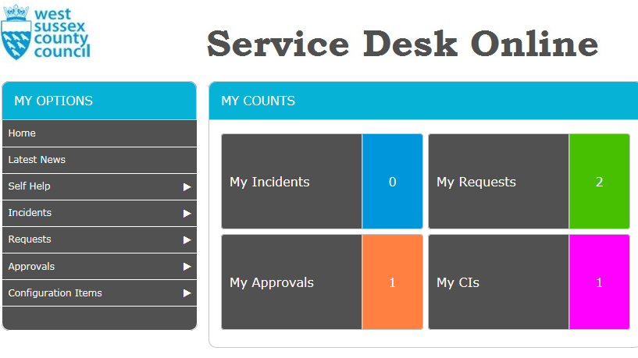
You will see access requests that are waiting for your approval
Click on the request
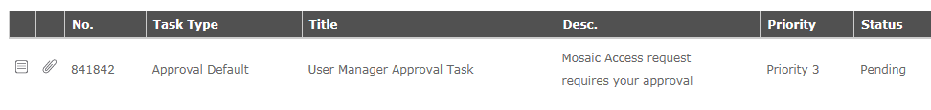
The request form opens as follows. Please check the request for accuracy making sure the correct access level / Organisation Name / Organisation ID / Adults/Childrens role are appropriate for the worker the request is for.
Example: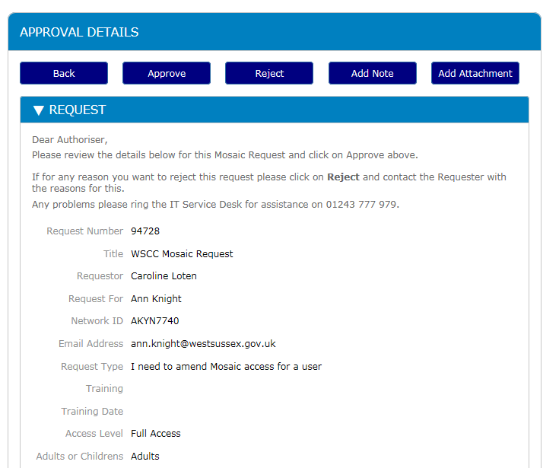

When all checks have been completed click on Approve.
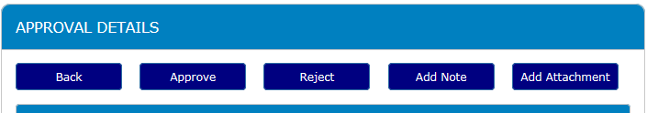
If you are not happy to approve the request please click on Reject.
If you are rejecting this request please write your reasons for this rejection in the comments box after clicking on Reject.
When the Manager has approved the request it will come to Systems User Support via Service Desk Online for the Mosaic access to be processed.
If you are having problems with any of the above please contact the system Support Team on 03302228777, who will be happy to assist you with this or any other enquiries.

