Guidance to request Mosaic ACS Access
Mosaic ACS requests are completed via Service Desk Online as follows.
Open WSCC Intranet The Point http://theintranet.westsussex.gov.uk/
Click on Report IT faults and requests

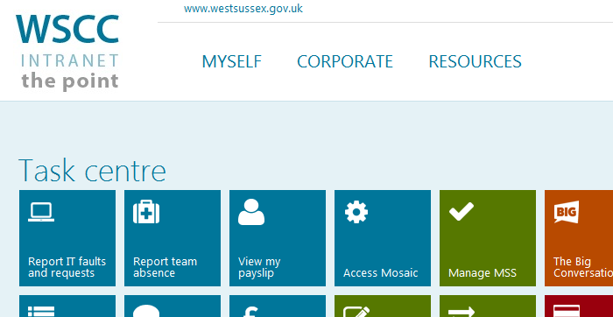
This will take you to Service Desk Online https://servicedeskonline.westsussex.gov.uk/
Click on Requests > Log a Request
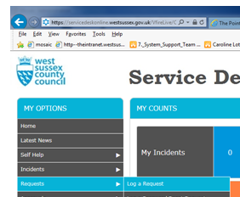
Click on Mosaic Request
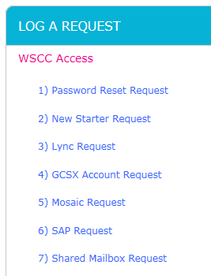

The form has been designed with embedded guidance
Step 1 – Please Read Guidance for completing form for new, amended or removed access to Mosaic
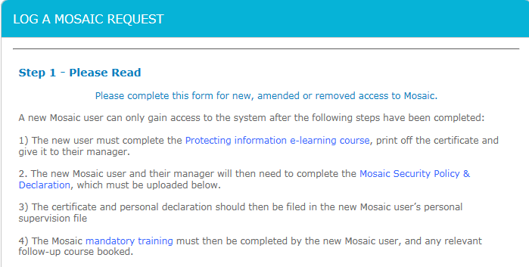
Step 2 – Confirmation
This is a mandatory question 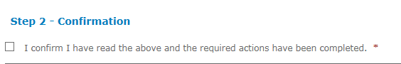
Step 3 – Request Type & Required for
Request for – enter the worker name the Mosaic Access is for, you can type in the full name or just the last name, this will give you a list of workers from the active directory, please check that you are selecting the correct person. The worker’s Network Users ID and Email address will pull through from the active directory.
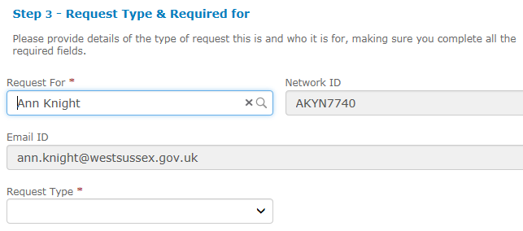
Then select the Request Type
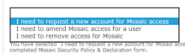

Step 4 Authorisation
The workers Line Manager will pull through from the directory,
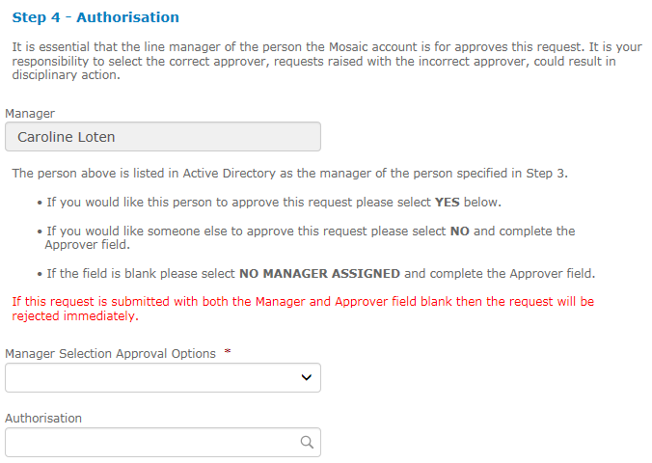
- If you would like the manager named in the Manager field to approve this request please select YES in the ‘Manager Selection Approval Options’
- If you would like someone else to approve this request i.e. not the manager named in the Manager field please select NO in the ‘Manager Selection Approval Options’ and enter the approvers name in the Authorisation field
- If the Manager field is blank please select NO MANAGER ASSIGNED and enter the approvers name in the Authorisation field
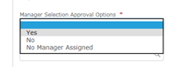
The rest of the form has not changed, and has embedded guidance to support completion.
If the request is for new access complete sections 1 to 9
If the request is for amended access section 5 of the form becomes hidden as this is not required for amended access, however you will need to complete the rest of the form, sections 1 to 4 and 6 to 9
If the request is for a leaver you will only need to complete sections 1 to 4.
The selected Manager will then need to approve the request via ‘My Approvals’ in Service Desk Online, the request will then be submitted to SST to complete the Mosaic Access as requested.

