CYP603 Gateway Referral Mosaic Guidance
A legal gateway form needs to be completed when agreement has been given by a practice manager that a case should be heard at legal gateway meeting, due to increased concerns for a child and legal advice is required. In addition, the trigger points for considering legal gateway are:
- Consideration of removal from a parents or family members care.
- Subject to child protection planning for more than 12 months
- Subject to child protection planning for two or more occasions within the last 3 years or for similar concerns.
- Where there are significant concerns in respect of an unborn child by week 28
- When children have previously been removed from a parent’s care.
- A child has been subject to S20 for three months or over, where permanence has not been secured.

To start a new Gateway Referral step go to
- Start> New> Gateway Referral
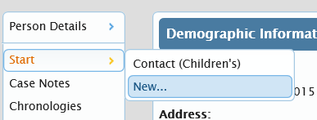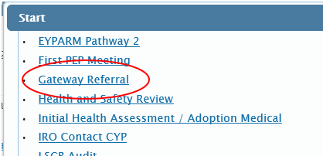
Section 1:
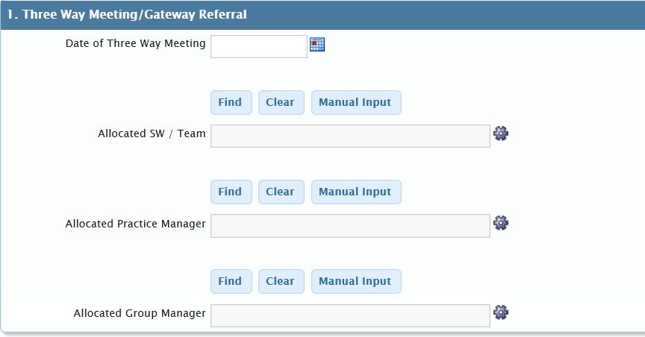
Please Note: if there is a CFIS Worker involved or there has been involvement within the last 3 months they need to be added to this section.
Section 2:
Section 2 of the legal gateway form needs to be completed in as much detail as possible, guidance notes have been added to help.
Child/ren’s details – this should include all children that are subject to the legal gateway meeting so siblings will need to be included.
Parents/Holders of Parental responsibility – self-explanatory, added by using the add button as normal.
Absent parents – self-explanatory the question next to the box explains this.
Current or previous child protection planning – this will pull through from the information on the child’s file. If the form is being completed on the oldest child’s file it is important to check that if there are younger siblings, all the information pulls through as we may have a younger child that has not been subject to the same periods of Child Protection Planning.
Previous Proceedings – self-explanatory, added by using the add button.
Children not in parents care – self-explanatory, added by using the add button.
Previous Assessment and Interventions – this is a table where details are used adding the add button. This should detail any assessments, including specialist/expert and interventions that have been put in place for the family – what the outcome of this was and when the work/assessment was undertaken. There is guidance within the form for this.
Family Network Meeting – all families that come to Legal Gateway meeting should have had a Family Network Meeting held. Details of the family plan in place need to be added to the comment box which opens once Yes is selected. If No is selected then a rationale is needed as to why the FNM has not been held and when it will be held.
Potential Carers – this is self-explanatory, added by using the add button. There is guidance on the form that any viability assessments completed need to be submitted with the Legal Gateway paperwork.
Background Family History/Current Concerns – this is the really important section as it acts as the social workers evidence as to why they feel the case needs to enter in to a legal framework - to include a full summary of the family history and any involvement with children’s services, when and why the family have been known. It needs to detail significant events that have occurred, what we have done to support the family and what the outcome of this was. It needs to include what the current situation and concerns are and any support in place to address this. Summary of parenting capacity, any complicating factors (e.g. mental health issues, substance misuse). Information about the child, their development, what their daily life is like and what impact this is having on them.
What’s working well & What are we worried about – self-explanatory, only needs to be bullet points.
Child’s voice – what is the child telling us, what do they think needs to happen or what do they want to happen. How their views have influenced our planning and if we cannot support their views, why not.
Social Worker Analysis & Plan – this is about pulling all the information together – what is all of this telling us, what needs to happen next and any identified gaps. Is there any further assessments required or further intervention and why this is needed, what else do we need to know. Why is the family being brought to legal gateway, what are you wanting to happen – request to enter pre-proceedings or care proceedings.

- Social Worker would then send the gateway form to their Practice Manager.
Practice Manger oversight/analysis – why they are supporting the request for LGW, any additional assessments identified or further intervention and why this is needed. How has the legal threshold been met, what is the early permanence plan for the child.
- Practice Manager would then send the gateway form to the General Manager
Group Manger agreement to proceed to LGW – General Manager agreement to authorise and any additional oversight required any agreement or disagreement with what is being requested.

Section 3:
There will be 2 mandatory requests that are sent to managers. The form will not be able to be completed until the requests have been sent. The requests are sent at different stages of the form filling process.
The embedded co-ordinator for PLO will complete this section following the LGW meeting – once they have received the rationale from the Service Lead and Legal Advisor. Once that has been received the embedded co-ordinator will input into the form and send to the Service Lead for their authorisation. The form will then be finished.
Section 4: Next Actions
- Click Add> Please Select
This will be completed by the embedded co-ordinator prior to sending to SL to finish the form.
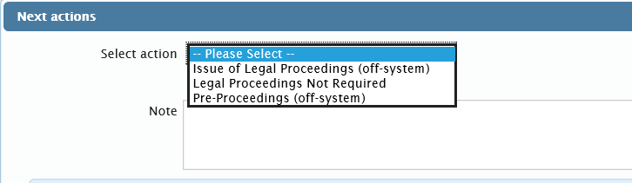
- Click on the request icon
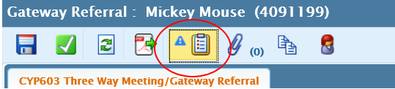
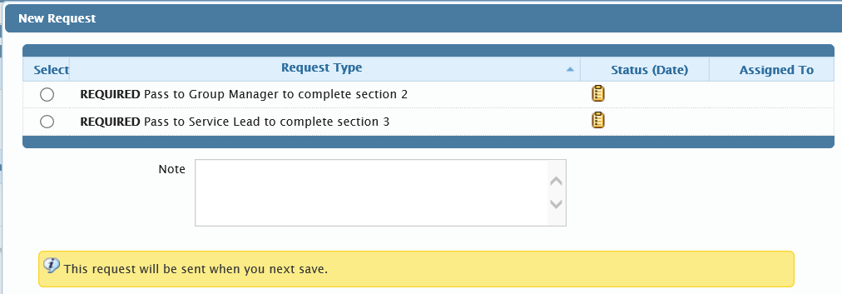
You will need to send the request to BOTH your Group Manager and your Service Lead. Add their names when prompted.
Please refer to the Legal Gateway form flowchart for additional information about when to open the step and who to send it to when completed.

