Mosaic Guidance for CYP589 Life Story Work Tracker Form

Background:
This form was created to provide a place for workers to create and store information about a child’s life story. Our hope is that information that may have otherwise been lost or forgotten will be captured here and enable the life story narratives and later life letters that we write for children to be far richer, more meaningful and helpful to them.
It is intended that anyone who works with the child can add content to the life story tracker and particularly hope that when workers, IROs and carers move on, that important information, messages and memories are stored here for the child’s narrative. There is space to add ‘soft’ information which is not easily captured elsewhere. It also provides a place to store all relevant photos together and there is a tracker to log what the photos are, who took them, when they were taken.
The step should be opened as soon as a placement search begins or in certain situations, pre-birth. The step can remain open throughout the time the child spends in care and/or is adopted.
This is a guide on to how to use the tracker but you can also see how it works in action by watching this brief video https://web.microsoftstream.com/video/ed15e2e4-6db6-4fdd-89b1-cf67ec07eaaf
Opening the Life Story Work Tracker
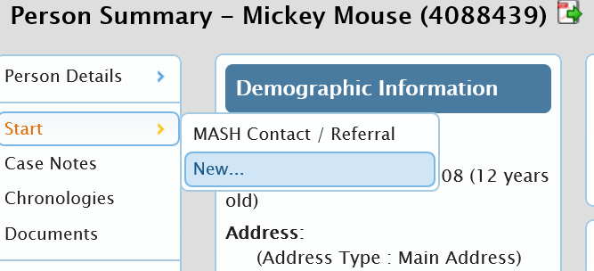
To open the step,
Go to the child’s Summary Page
Click on Start> New

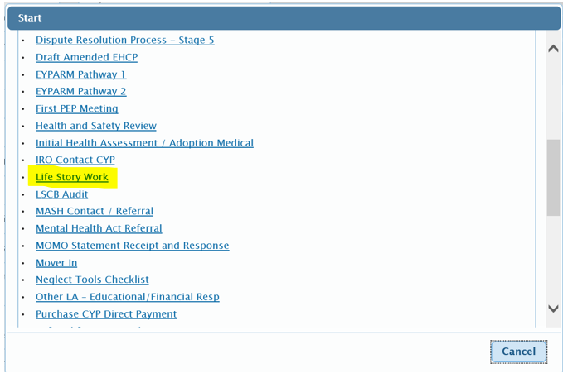
Scroll down the list of forms
Click on Life Story Work
The form will open in a new window.
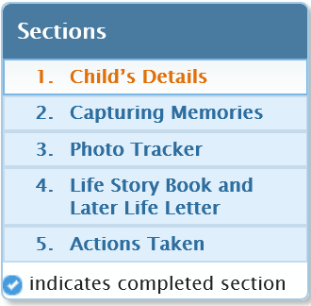
The form has four sections.
Section 1 pulls through the child’s name, Mosaic ID and date of birth.
Section 2: Capturing Memories
The first part of this section contains a list of tables where you can record as much detail about the child’s family and early experiences as possible; these are split into different categories.
The idea is that if you receive information about mum, dad or someone important, there is space here to capture it. For example, if a contact supervisor has a chat with mum about her pregnancy it would be great if this could be added into the relevant box. This ensures that this precious information is safely stored to enhance the child’s knowledge and understanding of their background. If you are the child’s social worker and are leaving or the child is being reallocated, please ensure you write something to the child in the relevant box. This will help to build a rich story for the child to help them understand who was involved at the vital time in their lives when important decisions were being made about their future. Don’t be afraid of adding seemingly trivial information about what you remember or what you will carry with you as a fond memory of your work with that child. Please encourage other professionals involved to provide information to be added.
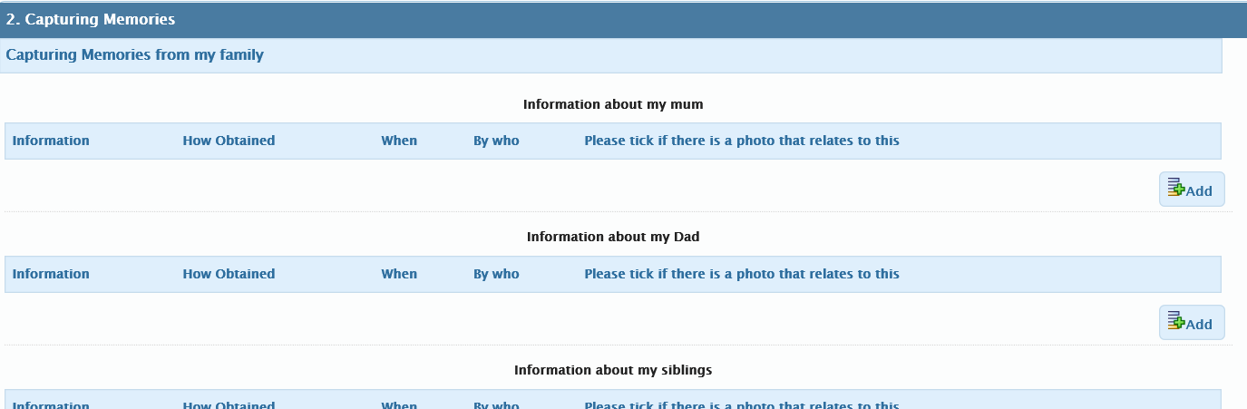
- To enter a new memory/piece of information:
Click >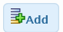 in your selected category.
A new window will appear:
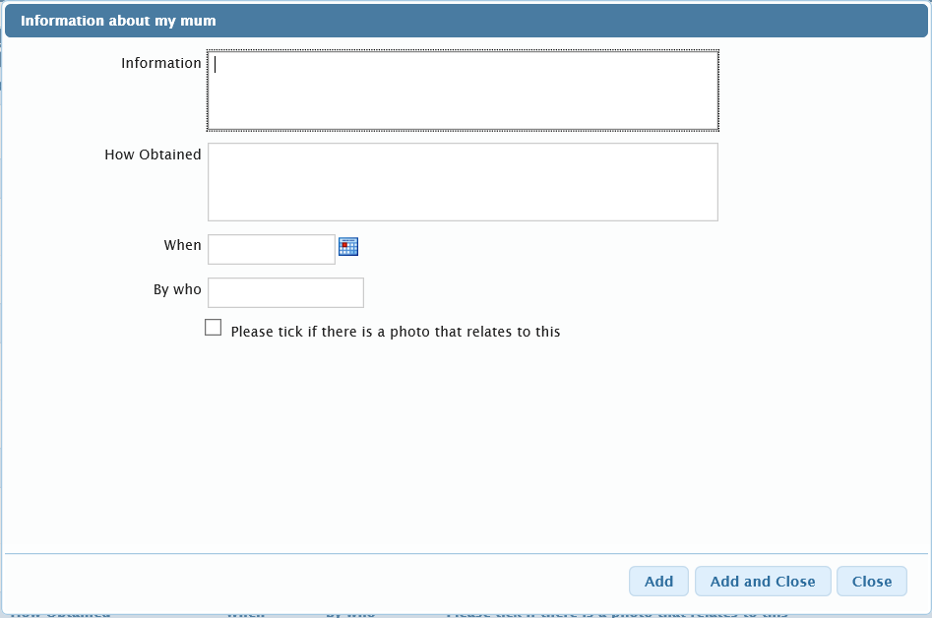
If you wish to enter additional pieces of information, Click> Add and repeat the steps until you have finished.
When you have finished entering the information, Click>Add and Close

Section 3: Photo Tracker
You are encouraged to upload photos to the Life Story Tracker, so the child has access to as many important memories as possible.
Photos can be added throughout the child’s time of being looked after. It is vital that if you receive a photo from someone that we capture information about when it was, who took it and what was happening in the picture.
Photos are so important to children and it is a challenging and sad task to write a child’s life story book when there are few photos of a child’s early life. Please do all you can to collect, save and track photos using this format.
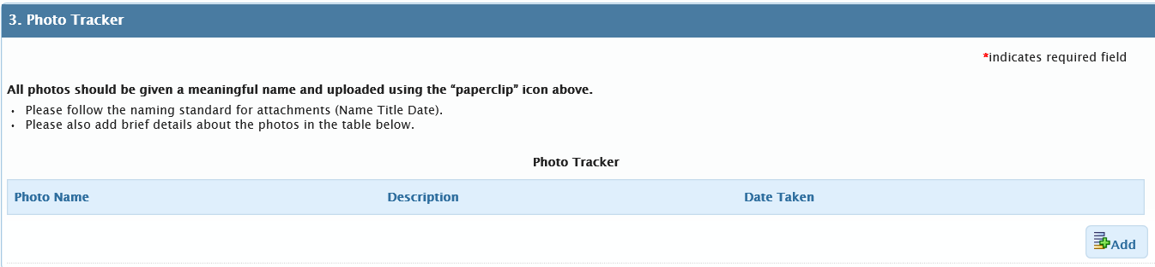
Important: Please follow the WSCC naming standards for all uploaded documents as this will help workers and children identify these documents in later years. For more information about the naming standards please go to Tri.X.

Section 4: Life Story Book and Later Life Letter
This contains a mandatory field. Clicking Yes to the question: Is the child’s plan Adoption? Reveals the following hidden fields:

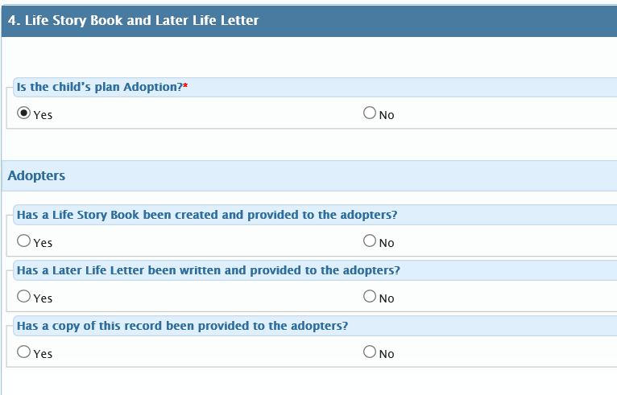
If you click No, these hidden fields will appear:
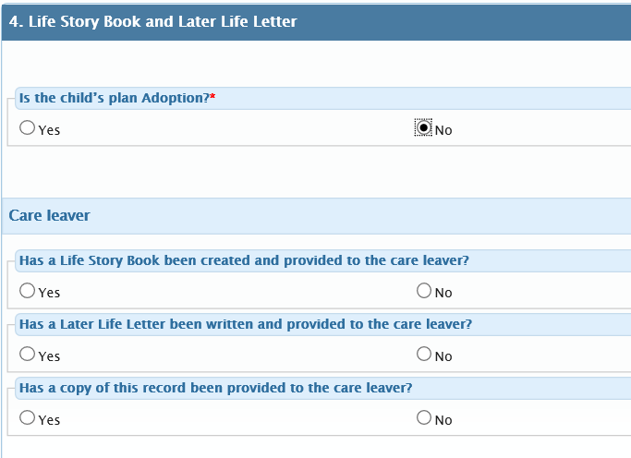
Section 5
Important: The step must only be finished when a child is adopted or leaves care.
If the child moves to a new team/worker then the step must be reallocated (see Tri.x > Mosaic Guidance for Childrens Services for more information on how to do this)
To finish the step, chose a next action by clicking on the Add icon and selecting either
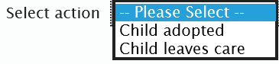
Click Add and Close.
A request will need to be sent to your manager to review the step. To do this click on the 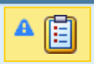 icon which is located in the top menu bar.

