Using Groups on Mosaic
Practice Guidance

IROs are qualified social workers with at least five years’ experience, and who have acquired the right skills to carry out this role.

Background
Working in a ‘Group’ is a way of supporting work with sibling groups in how we record information about them. It should enable more efficient recording and reduce time spent copying information to siblings’ records. It is important however, that with the introduction of this function that we continue to consider whether information should be recorded on each child’s file or whether it should be on just one child’s file.

What is a Group?
In Mosaic, a Group is a link created between different individual records. When we work within this Group on Mosaic this 'link' allows information to be recorded at the same time for each member of the Group (or members that you select within the Group).

In West Sussex we will create family groups comprising of children and/or care leavers (if relevant).

What can I do with a Group?
With a Group you can do the following:
- Record a Group case note
- Record a Group professional involvement for example GP
- Attach a Group document

The case note / involvement / attached document will show on the child’s individual record as well as in the Group page.

Who is included in the group?
A group is a set of siblings within a family. This could be full, half or step siblings who have the same or similar assessment/intervention/plan. Siblings that live at separate addresses can be included in the family group IF the same concerns have been raised about them and they share a similar plan. We do not include parents in a Group; parents and other relationships will continue to be recorded on the individual child’s record.

Children will only be a part of one Group.
Top Tip: The benefit of using Groups is to support with recording the same information about all the children in the Group, so think about this when creating a Group. For example, if you are working with one child who is Looked After and is going to be adopted, then a new referral is received about their unborn sibling, this is unlikely to be a situation where a group is helpful.

IROs are qualified social workers with at least five years’ experience, and who have acquired the right skills to carry out this role.

Top Tip: As children’s circumstances and plans change the group can change to reflect this. It is important that children are only a part of one Group and that the Group remains up to date.

IROs are qualified social workers with at least five years’ experience, and who have acquired the right skills to carry out this role.

Naming the Group
The family surname + the postcode of the primary residence is to be used to create the group name. For example, Jennifer, Michael, and Mabel Woodgett live in Worthing and their postcode is BN13 2PQ so the group will be named Woodgett BN13 2PQ.

Where the children in the group have different surnames, include these in the title. For example, a family consists of two half siblings Brian Jones and Belinda Jones-Smith and their postcode is BN13 2PQ. The name of this group will be Jones, Jones-Smith BN13 2PQ. The surname of the oldest child should go first.

Where there are two main addresses, both post codes can be used in the title. For example, Kwame Adebayo is the half sibling of Oba Wright-Adebayo. Kwame’s main address is his mother’s in Worthing and Oba’s is her father’s in Chichester; their group name would be Adebayo, Wright-Adebayo BN13 2PQ, PO19 1RQ.

Do not use a comma between the last surname and the first post code. Commas are only used to separate different surnames and different postcodes.

Please note you can use up to 64 characters in the group name.

If you are uncertain about how to name a group, please seek advice from your line manager.

When do I record as a Group rather than as an individual?
You should record as a Group when the information, whether contained in a case note, attachment or professional relationship is relevant for multiple children in the Group. If it is about one child only, you should record on just the one child’s record (for example most direct work completed). The Group allows you to select which children the information should be recorded on so for example if the information is only relevant for two children in the group out of four siblings you would select only the relevant two children.

If only part of the information is relevant to a sibling, only that part of the information should be recorded on a sibling’s record and therefore a Group record should not be made (as all the information will be shown on a sibling’s record).

When making these decisions about what to record on a sibling’s record you need to consider the risk to any siblings, and for example if a disclosure is made does all, some or none of the information have relevance for another child.

Top Tip: Please seek advice from your manager if you are unsure about whether information should be recorded on one child or their siblings record(s) too. It is important that we adhere to General Data Protection Regulations (GDPR) and Data Protection Act 2018 in how we record information about children.

IROs are qualified social workers with at least five years’ experience, and who have acquired the right skills to carry out this role.

Top Tip for Attachments: Please ensure you are using the correct naming standard;

Name of the child/family - Brief description of the document - Date it was completed

IROs are qualified social workers with at least five years’ experience, and who have acquired the right skills to carry out this role.

Step by Step Guide to Working with a Group

IROs are qualified social workers with at least five years’ experience, and who have acquired the right skills to carry out this role.

Creating a group
Go to the first child/young person’s summary page. At the bottom of the left menu is the ‘Groups’ function.
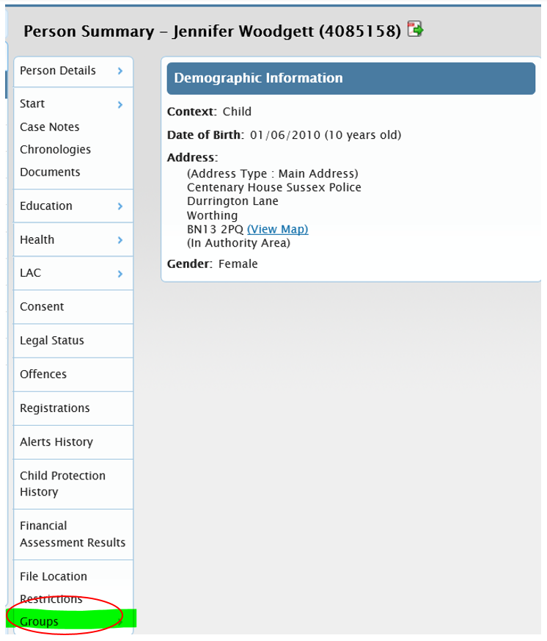

Hover on this and a new title will appear, ‘Create a group’
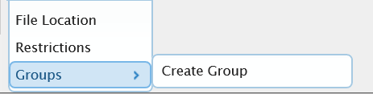
Click on ‘Create a Group’

A new box will appear
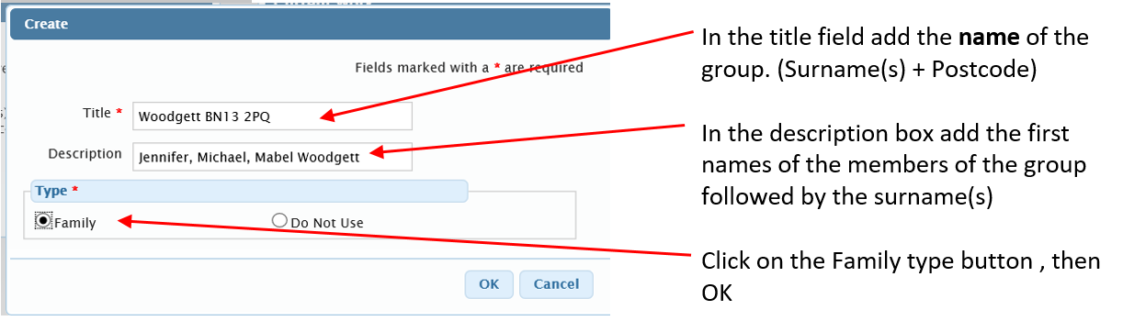

The group summary page will appear
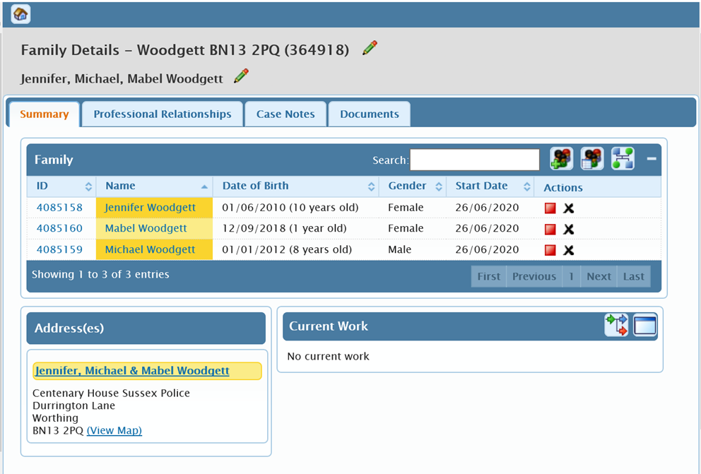

To add more family members to the group, click on this icon: located on the top menu bar.
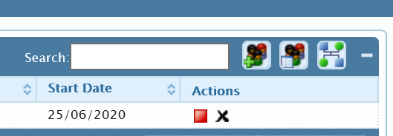

If a child or young person is a member of a group in Mosaic you will be able to see this on their Person Summary page in a separate work pane. In the example below Jennifer is a member of the Woodgett BN13 2PQ family group.
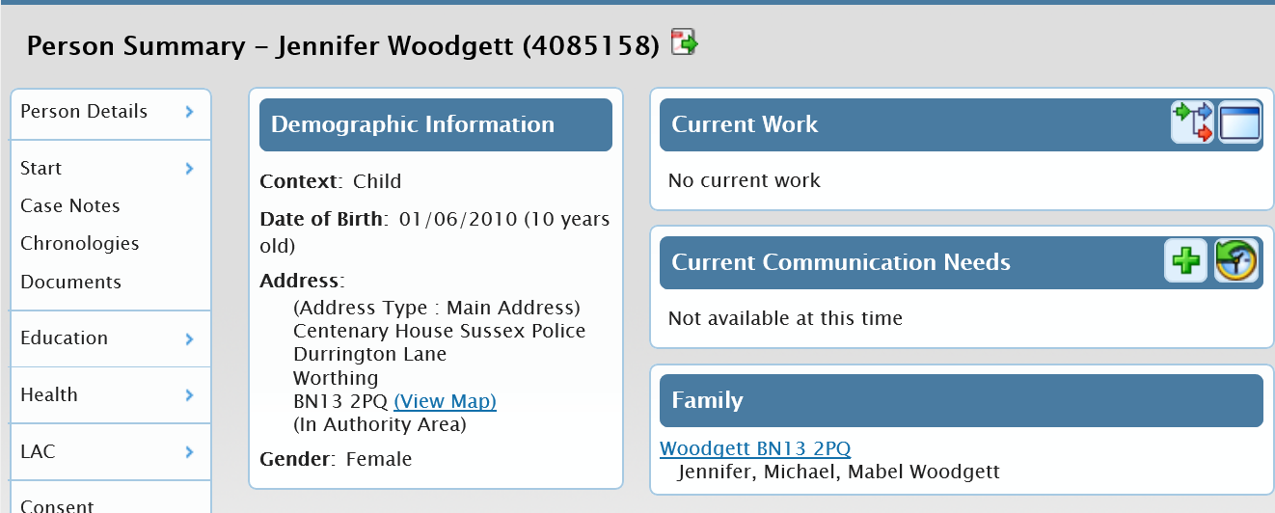

Clicking on this link will take you to the group summary page

Group Summary Tab layout

The group details page has four tabs: Summary, Professional Relationships, Case Notes and Documents

The Summary tab has work panes to list the members of the group, their address and any related current work

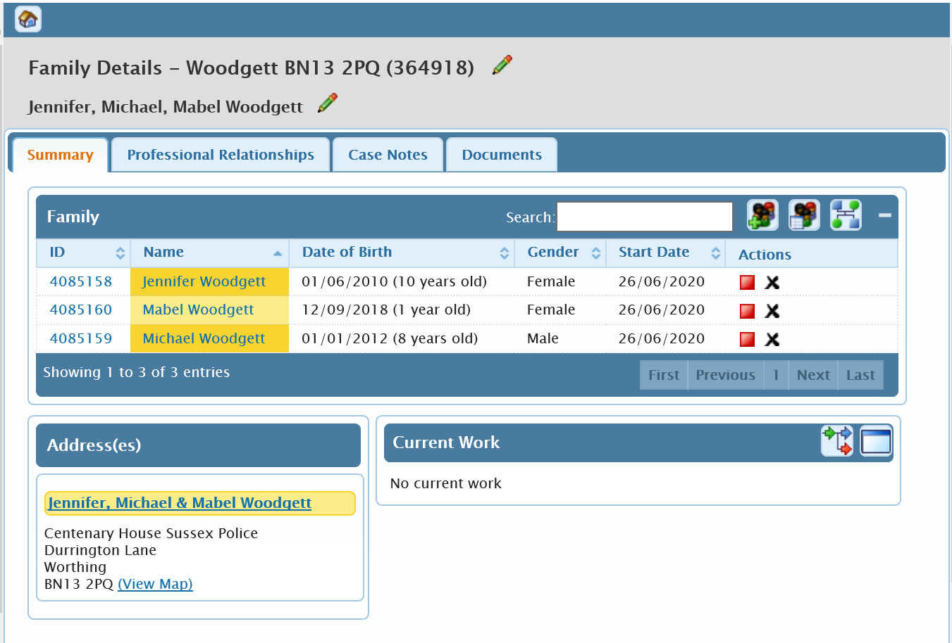

Family Pane:
The Family Pane lists the members of the group. The Actions icon allows you to remove a person from the group (providing they are not already involved in a piece of work or are included in an unfinished case note).
The header contains the following icons:
This allows you to add another person to the group, by finding the person and if necessary
creating a new person record.
Switches the display to show, or hide, people that are no longer members of the
group. Where someone is no longer a member of the group, the date their membership
ended is shown
This takes you to the genogram page.
Allows you collapse the pane to take up less space in the screen.

Addresses Pane:

The Addresses Pane shows a list of the addresses of members of the group. Where several people
share the same address, the address is listed once indicating who lives there.

Current Work Pane:

The Current Work Pane lists work that is in progress for this group.

Professional Relationships tab
The Professional Relationships tab lists the workers associated with members of the group. For
example:

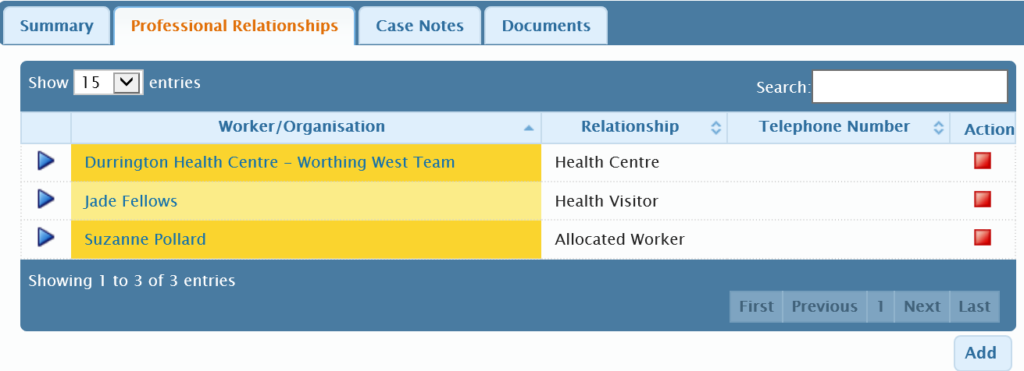
You can add professional relationships on this screen. When adding a new professional relationship, it is possible to select whether this relationship is with all or individual members.

You can end the relationship by clicking the icon

Case Note Tab
The Case Note Tab lists the case notes for the group or of selected members of the group.

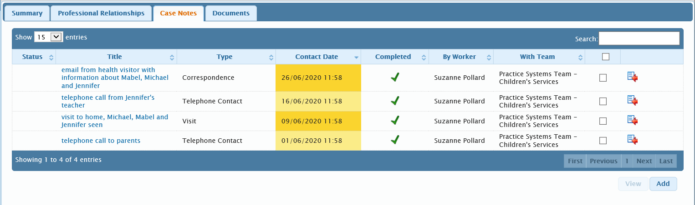

To add a group case note, Click the Add button.
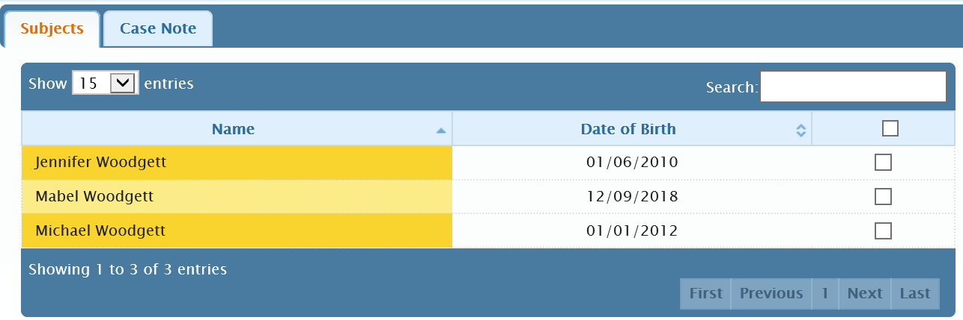
Select the members of the group that the note will apply to.

Click on the Case Note Tab and record as usual.
Group case notes are recorded in the group file AND the members’ individual files. Below are the case notes in Jennifer’s individual record,
Group case notes are identified by this icon to the left of the title:
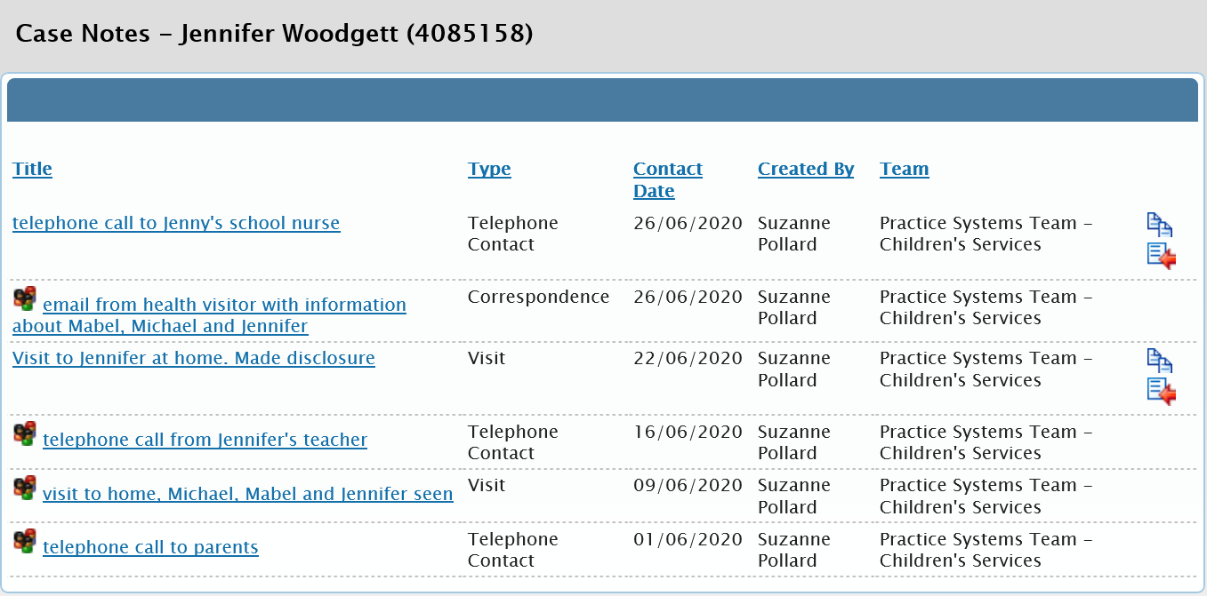

Documents tab
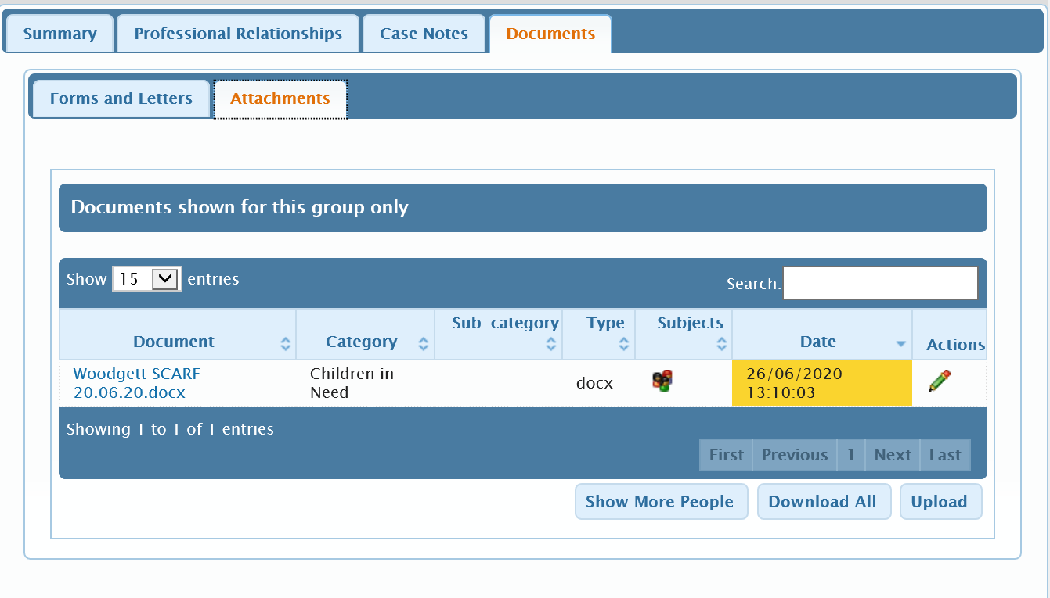

The Documents tab lists documents associated with the one or more members of the group. When on the Attachment tab, click Upload to attach documents in the usual way.

The uploaded attachments will also appear in the individual child/young person’s records.
Group documents are identifiable by the icon in the Subjects column.
N.B Please remember to adhere to the document naming standards to enable other workers to locate this information in the future.

Finding the group
You will be able to search Mosaic using the group name or by the individuals within it.
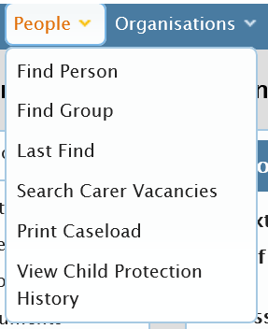

Review / Contacts / References
Document title:
Date approved:
Approving body: | Policy & Practice Steering Group
Last review date:
Next review date:
Related internal policies, procedures, guidance:
Document owner:
Lead contact / author:

