Gloucestershire
Children’s Services
Direct Work Library

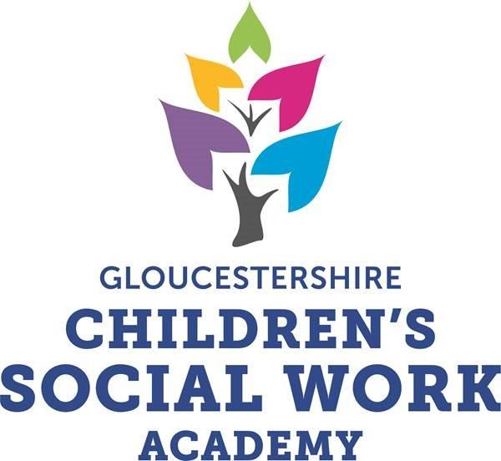

Direct Work Library
Purpose:
This library of tools and materials to support direct work with children and their families is a developing central resource for all practitioners in children’s services.
It is informed by a recent review of direct work practice and materials in use across the service by the Principal Social Worker and supported by examples and observations by Advanced Practitioners.
The resources can be used to support development and promotion of effective and purposeful contacts with children and will be expanded and reviewed by Participation Champions in each team, Ambassadors, the Social Work Academy and the Principal Social Worker.
Whilst currently on Tri-X, The Library will be accessible on the SWA website (or agreed GCC use only location on staff net)
Direct work tools identified will be reviewed by Participation Champions at regular forums with the Participation Team Ambassadors and PSW.
The Library will develop to include key headings and resources relevant to age, needs, culture, ethnicity etc – the resources will develop to identify direct work tools for assessment – view / wishes / feelings etc and direct work tools for intervention – specific activities resources to promote and measure change.
Good practice examples and stories will be linked to direct work examples via PSW contacts with practitioners, AP Forum and Comms Team.
The Library will also inform continuing Social Work Academy curriculum development and connect to NAAS, PQS and SW England Continuing Professional Development evidence gathering.

Next Steps:
This is a fluid collection of resources which is developing over time and will support social work evidence of the fundamental principles and sustained good and outcome focussed social work practice.
Current actions to achieve this are (as of August 2020):
Invitation sent to teams to identify Participation Champions to attend forum in September 2020with Participation Team, SW Academy and PSW and review current materials, timescales and expectations for new approach.
Request sent to APs to identify links and materials to support use of identified direct work tools.
Comms about revised resource library and expectations to be devised by PSW and shared across service.
Progress and evidence base to be reviewed by SWA board / Ambassadors.

Rob Tyrrell
Principal Social Worker
20/8/20

Resource | Use | Link | Links to Fundamentals, PQS and good practice examples
Social workers Toolbox | Free social work tools and resources for direct work with children. | http://www.socialworkerstoolbox.com/
Cafcass  Needs Wishes & Feelings Pack | Tool for allowing children to share their views directly with the Family Court | https://www.cafcass.gov.uk/grown-ups/professionals/resources-for-professionals/
Cafcass  How It Looks To Me | Resource for children in families who are involved in the family court. This resource can be disclosed to the court | https://www.cafcass.gov.uk/grown-ups/professionals/resources-for-professionals/
NSPCC Pants Rule | Resource for parents to use to talk to their children about staying safe | https://www.nspcc.org.uk/keeping-children-safe/support-for-parents/pants-underwear-rule/
8 Top Tips for Professionals when working with Children and Young People | Written by Ambassadors for Vulnerable Children and Young People.Blank Poster for use with Children | Top Tips Poster for Teams  Top Tips Poster
My Feelings Worksheet | Template for recording discussions with young people.  Needs further info | My Feelings Worksheet
My Journey | My Journey is a tool to aid direct work with children and young people to hear their voice in assessment and planning. The templates, designed by Ambassadors, are for children and young people who have a care plan, a child protection plan or a child in need plan. | My Journey - how to Guide  My Journey A4 Poster  My Journey  My Journey - Space Final Copy  My Journey - Jelly Beans  My Journey - Harry Potter  My Journey - Minions  My Journey - Paw Patrol  My Journey - My Little Pony  My Journey - Resource Toolbox  My Journey - Secondary Age Workbook
Who’s job is it to..? | Resource for conversations with children & families about parenting roles | Who's Job is it to?
What children should be able to expect from their worker | A tool to support effective social work practice and understanding about roles. Written and designed by Ambassadors for Vulnerable Children and Young People | What to Expect from My Worker
Worry Monster | A tool to encourage conversations with younger children. | Worry Monster Poem
Tools listed below provided by APs across the service – links to resources in use to be added to library
- Safety planning workbook in relation to parental substance misuse, mental health or domestic abuse.

- Domestic abuse workbook which is built on by each social worker.

- Say it Your Own Way Pack

- Flash cards around the Neglect Toolkit.

- Cultural genograms.

- Jelly baby tree.

- Ecomaps.

- The Rose and the Thorn Tool (DP, SW Student).

- Head, Heart and Hands Tool.

- Family tree/genograms

- Drawing around self and labelling feelings

- All About Me – Various worksheets

- ICPC – My Views

- Emotions Emoji

- Feelings Stones
- Feelings Map

- Worksheets - this is me, my family

- Story boards,

- Interactive feeling games

- Understanding my foster placement

- Do I fight or flight work sheet

- Parents are people to

- Rainbow statement

- Self esteem mirror

- Story dice

- Games – pie face, snakes and ladders

- Statement card eg I am….

- Emotion cards

- Routine traffic lights

- Various scales – How are you feeling today (0-10) etc.

- My Body is Mine’ (Keep Safe)

