Genogram Procedure

It has been agreed that Business Support colleagues will assist Children’s Services operational staff with the completion of professionally presented genograms. The process for this is as identified below.

The worker drafts the family genogram using the genogram guidance as attached at Appendix 1.

NB Appendix 1 also includes information regarding the completion of ecomaps and life maps which are not specifically covered within this procedure.
The genogram is then passed to Business Support colleagues for completion.

When the genogram is completed it has to be approved by the allocated worker prior to adding to the child’s file. The section below provides guidance for Business Support Colleagues to ensure a consistent approach to the completion of genograms

Genograms Guidance for Business Support
Last updated: 06.07.17

Genograms are family trees and are used in court documents and other assessment processes. There is a template available:

The worker drafts the family genogram and passes to Business Support colleagues.
Business Support will then complete the family genogram on a Word document.
When unsure of a relationship between people, Business Support can look for information on ICS, however this also needs to be checked with the worker. Once finalised and approved by the worker, the genogram is saved in the child’s Basic Information folder on the O-drive.

Often there will be ages or dates of birth in the genogram, add these in the boxes along with the name of the person, and make sure to use the same formatting for all persons.

Some basic shapes used:
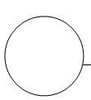 Female male

Deceased male 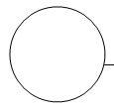deceased female

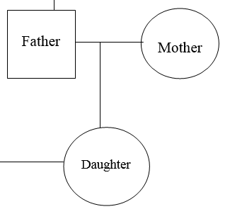
A simple line means a connection.

This is a family with one child, a daughter.

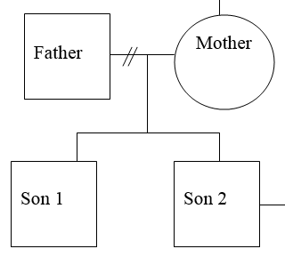

This is a family with 2 sons, but the parents have split up, and the mother has the care of the sons.

How to insert a genogram into a document
Last updated: 06.07.17

The genogram is in landscape, and needs to be inserted into word documents that are portrait orientated. This can be done by inserting section breaks. This guide is quite helpful: http://www.online-tech-tips.com/ms-office-tips/make-one-page-landscape-in-word/

APPENDIX 1

GENOGRAM, ECO MAP AND LIFE MAP GUIDANCE

1. Genograms
Genograms provide a quick visual picture of the complexity of a family. They are important in ensuring that all family members are identified and that it is clear who is biologically important to the child. For evidencing wider support networks Eco-maps can be a more appropriate way to record such information, see Eco-maps section for more information.
Genograms are particularly good for working with families to clarify complex relationships, to indicate gaps in knowledge and to make visible intergenerational and life cycle issues. They can be used to gather information and to work therapeutically.
As they can be powerful in raising painful and suppressed memories, it is important to explain what a genogram is and what it is likely to raise before undertaking this task. Some of the symbols used can have a considerable but unintentional impact. For example the use of X to symbolise the death of a family member may be very hurtful. Family members should be asked what symbols they would wish to use.
Workers sometimes avoid genograms because they feel the result often looks a mess, or the family structure is so large that they have difficulty drawing it on one sheet of paper. But this misses the main point of the exercise which is to help the family provide information which they think is important and assist them to see patterns and gain insights. Once the process is completed a neat version can be produced.
It is recommended that before using genograms workers should draw and discuss their own genogram not only to learn how to structure them but to experience the feelings which they can raise.
Genogram Symbols

In a genogram, the male is represented by a square on the left and the female by a circle on the Right
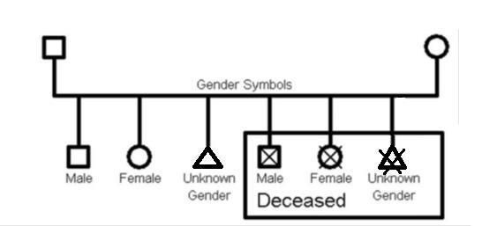

Standard gender symbols for a genogram

In a standard genogram a triangle is used to represent an unknown gender. In the case of a miscarriage or abortion, a diagonal cross to indicate the death of the foetus is drawn on top of the triangle.

If a biological father has not been linked with the child, the genogram will produce a standard square shape, although this will have a broken line, and rather than stating the name, it will say ‘unknown’
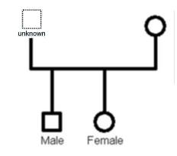

Symbols for unknown biological father

Rules to build Genograms

Although there is general agreement on the basic genogram structure and symbols, there are some variations from one author to another. If you understand the following rules, you will be able create the most complex genogram without any problem, and others will be able to understand your work. It can be useful to create genograms in assessment sessions with family members, and the following rules will support you to do so before recording them.

In summary, here are the four rules to build a genogram

The male is always at the left of the family and the female is always at the right of the family.

- In the case of ambiguity, assume a male-female relationship, rather than male-male or female-female relationship.

- A spouse must always be closer to his/her first partner, then the second partner (if any), third partner, and so on...

- The oldest child is always at the left his family, the youngest child is always at the right of the family.

2. Ecomaps

Valuable information about the child and their interactions with the people around them can be gained from carrying out an ecomap exercise. Some families or children may prefer this to the more formal structure of a genogram. It takes a relatively short period of time to complete with the child or family and can be used as supporting evidence in the assessment or care planning process.
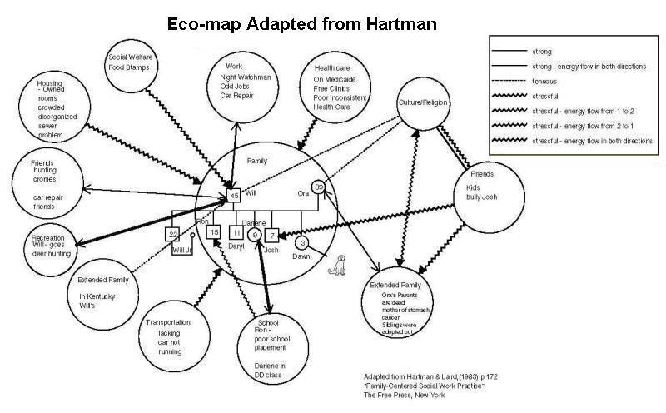

Ecomaps show the network of people around the child or family diagrammatically. The child is placed at the centre of the diagram; each person and organisation that forms a part of the child or young person’s network is named and placed within a circle
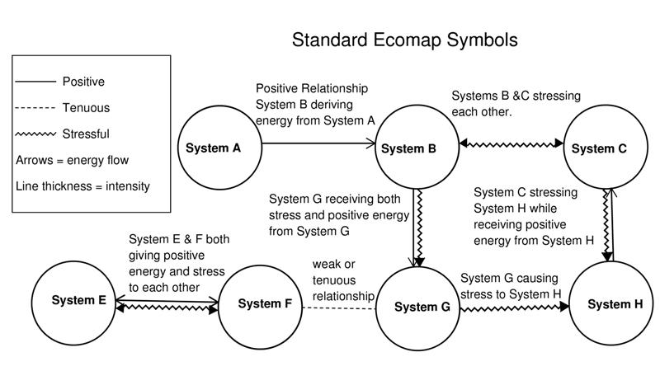

Ecomaps are not a static record as family relationships change, therefore they should be undertaken on a number of occasions to map the changes during assessment and care planning processes.
When working with children it is preferable to use moveable objects to represent their ecosystem. The child can then move them around to indicate what their feelings are and how they may change. This is similar to sculpting exercises.
Getting Started
The child is placed at the centre of the diagram. Each person and organisations that forms a part of the child or young person’s network is named and placed within a circle.
In the Middle
Where there is a connection between the child or young person and an individual and organisation the nature of the relationship is illustrated by a line drawn between them. During the exercise it is important to establish who is part of the child or young person’s life; this may involve asking about family members, friends and professionals.
Endings
Depending upon the age of the child it may take two sessions to complete the Ecomap. At the end of the exercise make sure the child or young person is able to have a copy of their Ecomap.

Where there is a connection between the child or young person and an individual and organisation the nature of the relationship is illustrated by a line drawn between them.

Why are Ecomaps effective?

- It focuses on the relationships children and family members have not only with their relatives but with significant others like friends and pets, with organisations such as schools and family centres and with pastimes and activities

- Information can be gained on who and what are important to each family member, whether relationships are supportive or stressful and the extent of their support systems

- Ecomaps are empowering as they give the children and families greater control over the information giving process that a structured question and answer session may not elicit

- Helps families to gain insights and to assess their own situation

4. Life Maps

Building a timeline of events from birth to the present can be a useful way of gaining an understanding of a family’s journey and the important events from their perspective. It involves the use of art, talking and charting to develop a visual map of the child’s life so far. It can often be the first time that a family, or a parent or child has thought about their life in its entirety. It can therefore be both illuminating and challenging. Practitioners using this method should ensure that they have the time required to support the people involved emotionally as well practically during and after the process.

Getting Started

Think about the space – you will need somewhere that enables all the people involved to have access to the timeline. They will need to feel comfortable and have a sense of privacy.

Time – do not do this when your time, or your participant/s, is limited. You may need to complete it over more than one session and ensure that you leave enough time in each session. It is important not to set anyone up to open themselves to difficult issues and then have to close them down too quickly. Equally if the participant closes things down and makes it a very quick and factual exercise, do not labour the point. Remember that time is also containing so you need to plan for the session to have a definite end so that people are not left struggling for closure. Think about what kind of time period you are trying to cover prior to arranging the meeting. If you are seeking a parent’s story, you might have 40 or more years to cover; a grandparent’s story is likely to take longer.

Equipment – at a minimum you will need pen and paper. The more creative the tools you supply, the more chance you will have of evoking a sense of permission to explore difficult subjects without speaking. Pens, paint, coloured paper, things to cut out, stickers, different textures such as feathers and cloth can all be useful.

Photographs – asking family members to bring photos that could be used to either date events, talk about them, or even to form part of the life snake can be useful. Remember to check how they are happy for them to be used.

Clear brief – ensure that all people participating in the life snake understand the process, what they will be expected to think and communicate about, and for what purpose the information will be used.

What happens to the life map at the end – it is important to talk about this before you start. Are you taking it away, or photographing it, or copying information from it? Is one of the family or the child keeping it? Or are you dismantling it at the end and packing all the private information back away? Although people may change their mind by the end of the process it is important to discuss this before it begins.

Confidentiality – what happens with all the information that has been shared? Is it discussed outside the room? If so by whom and for what reason? This does not just include professional disclosure but disclosure by different family members.

In the middle

The role of the social worker is to facilitate the process by asking open questions, encouraging sharing and participation, and keeping the focus by reminding participants of the task and drawing attention to the passage of time that needs to be explored. As well as this, the worker should be monitoring the quality of the communication, the emotions that are being brought up by doing the piece of work, and adjusting the task and the expectations accordingly. This might include frequent breaks, directing people to different tasks, or spending time listening to or supporting people as they remember difficult things.

Comfort – think about drink, food, toilets and anything else a person might need to keep them feeling relaxed and safe. Interruptions such as telephones or people coming in and out, or loud noises that make it hard to concentrate should be avoided.

Time – ensure that the life map is progressing and that you are about half way through the timeframe at the half way point. If you know that some of the more critical events happen near the end you might want to think about how to ensure enough time is left to explore those events well.

Endings

When the life map is complete make sure there is time to look at it as a whole. It is sometimes good to be able to place it on the wall or floor and get people to stand on chairs to look at the picture of their life. Allow people the space to look at it without making any comments. After five minutes or so you may want to ask an open question like “what are you thinking right now?”

Interpretations – if you have had any insights or developed a hypothesis during the process you need to check them out. Ask the participants what strikes them most about their life? Ask them what surprised them? What did they already know? Once you have listened to all they have to say if they have not raised some of the things that you are thinking, you need to ask their permission to share some of your observations. These are some of the things that I have been thinking about… what do you think?

What to do next – check in with the participants – what do they want to do with what they have explored? Do you need to follow anything up? How do they feel about ending the session? What would they like to do with the work? Finally it is good to ask what they are going to do with the rest of their day – talk a little bit about the small tasks that make up life to bring them back into the present.
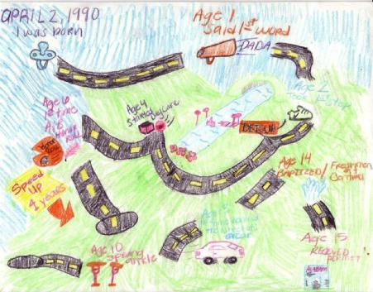

This is an example of a child’s life map covering the age from when he was born up to the age of 15, although the map suggests that the road continues into the future.

