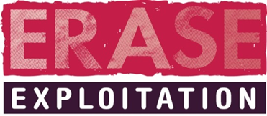

Multi-Agency Child Exploitation (MACE) Meeting
Referral |  | Review |  | Final
Child’s full name | I.D. Reference Number | Current risk status | Risk status agreed at MEG Meeting | NRM status

Social Worker / Lead Professional - information and views on the risk level

Durham Constabulary - information and views on the risk level

Health - information and views on the risk level

Education - information and views on the risk level

Exploitation Worker - information and views on the risk level

Missing Worker - information and views on the risk level
Including missing reports in the last 12 months (referral) / missing reports since the last MEG meeting

Any other professional - information and views on the risk level

Chair - information and views on the risk level

Agreed risk level and rationale

Safety Plan
Risk identified | How is the risk being managed | By whom | When | Review / update

*To include disruption of any named perpetrators / locations
Risk level | Time scale | Review MACE Meeting date | Review/Final risk assessment due
Low | 6-8 weeks
Moderate | 4-6 weeks
Significant | 4 weeks

Actions
To consider at each review:

Has a safety plan been undertaken: yes / no
Intelligence to be submitted to ERASE: yes /no
Does an NRM need to be submitted: yes /no
Has the family been offered an FGC: yes/no
Does a referral to Barnardo’s need to be made (if risk level is Medium/High): yes / no
Signposting consideration: (The Box, SWITCH, PACE Website, CEOP, “Being “Me programme, Kooth/ “Listening Post”/MIND/CAMHS, Harbour)

