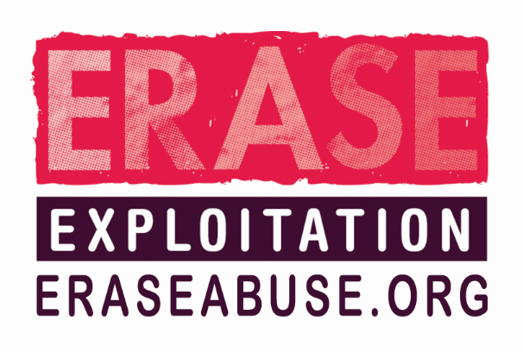
CSE Intelligence / Information Submission Form 2017

If you have concerns about a child / young person you should make a referral to your local children’s services. DO NOT USE THIS FORM IN PLACE OF A REFERRAL.

Please complete this form to share any information you have about:
- Suspected offenders
- Suspected vehicles
- Locations of interest

THIS INFORMATION WILL NOT BE RECORDED ON POLICE SYSTEMS
NAME:
POST / POSITION:
EMAIL:
TELEPHONE NO.:

THIS INFORMATION IS RECORDED ON POLICE SYSTEMS
AGENCY:

INFORMATION
Please supply all known information in as much detail as possible, including:
Date(s), Time(s), Person(s), Vehicle(s), Location(s)

If you only have partial details such as a colour and model of the vehicle please include this information as it helps us build a picture.
Please enter your information here: (this box will expand as you type)

THIS SECTION MUST BE COMPLETED

INFORMATION EVALUATION
SOURCE OF INFORMATION:  If the information was supplied by someone else, how reliable are they? | 1 RELIABLE – Person known to me and known to tell the truth  2 UNTESTED – Person known but cannot test how reliable they are i.e. never given information before or person unknown/heard indirectly and cannot be judged.  3 UNRELIABLE – Person known to me but known not to be truthful. |  |  |  | ENTERED YOUR RATING HERE:
INFORMATION ACCURACY: | A - KNOWN TO BE TRUE TO SOURCE  B - INFORMATION WHICH HAS BEEN OVERHEARD OR TOLD TO YOU BY SOMEONE ELSE  D - NOT KNOWN  E - SUSPECTED TO BE FALSE |  |  |  | ENTERED YOUR RATING HERE:
DATE OF SUBMISSION: |  |  | TIME OF SUBMISSION:

PLEASE RETURN YOUR COMPLETED FORM TO: ERASE@durham.pnn.police.uk

