**Resources  
Voice of the Child   
Early Help**



**List of Resources**(List of main resources used – not all resources can be included).   
 **What resources we use and how we use them:**  
1. Voice of Child Booklet 2-15  
2. Three Houses tool 16-18  
3. Stepping Stones 19  
4. Suitcase of Valuables 20   
5. Service User (Child) Feedback form 21  
6. Bag of worries 22  
7. Life path 23   
8. My First Aid Bag 24   
9. My solution Maze 25   
10. Worry Monster 26   
  
**Guidance on using resources:**   
6. Voice of Child Guidance 28-29  
  
**Who do we use the resources with:**11.Which children we use the resources with?31-34



**About the Team Around the Family Meeting**

**What is a Team Around a Family Meeting?**

A Team Around a Family Meeting is a meeting of people who want to support your family making things better. The people who come to the meeting are there because they know your family and they want to help you make things better.

The people in the meeting will talk about all of the good things about your family and what people could change to make things better. At the end of the meeting a plan will be agreed. Everybody will meet again in a few weeks to talk about the plan to see if things are getting better for you and your family.

**Who goes to my Team Around the Family Meeting?**

Your parents or the person who looks after you may be there and those working with you and your family, such as your teacher, family support worker or school nurse. Other people you have not met before could also be there, the person in charge of the meeting will tell you who is coming.

**How will I know what happens at the meeting?**

The person in charge of the meeting will tell you more about it, if you want to you can come. In the booklet you can write who you would like to tell you about what happens in the meeting.

**Who can see the information I write in this booklet?**

You decide who can see the information in your booklet as it is all about you and your family. There is a page in the booklet where you can add the names of the people you want to see it and who you would like to talk to you about the meetings. The information you write in your booklet is helpful to let your parents and people supporting your family know what you would like. Sometimes the information you write in this booklet might be shared with other people to keep you safe.

**The date of the your families next meeting is:**

**The person in charge of your families meeting is:**

**The person who you would like to tell you what happens at the meeting is:**

**Who can read this booklet?**

**All About Me!**

I Live At:

My Date of Birth Is:

My Name Is:

Here is a picture/drawing of me:

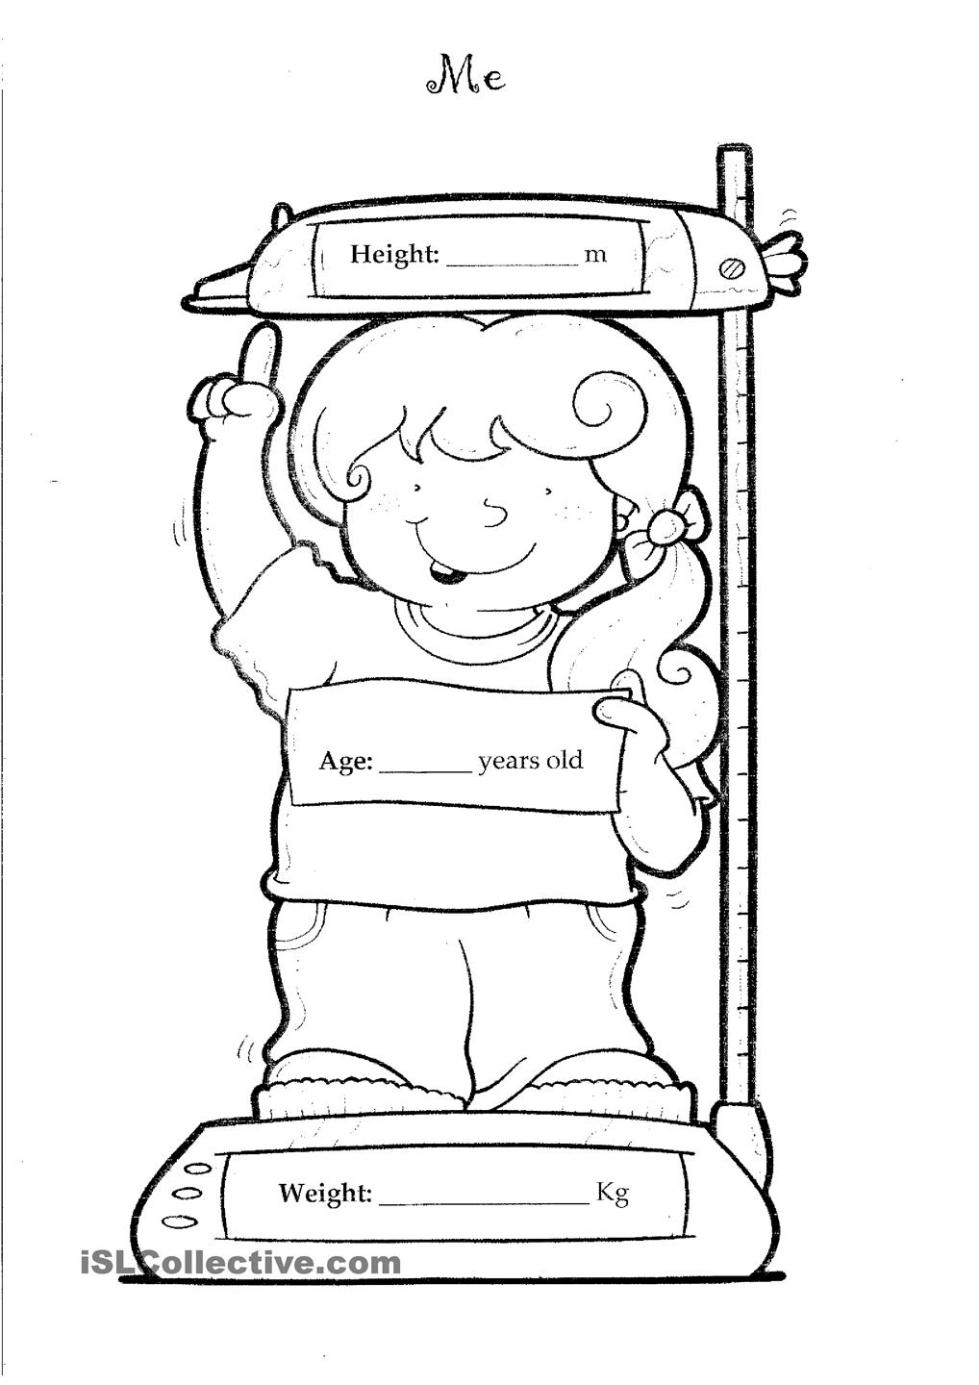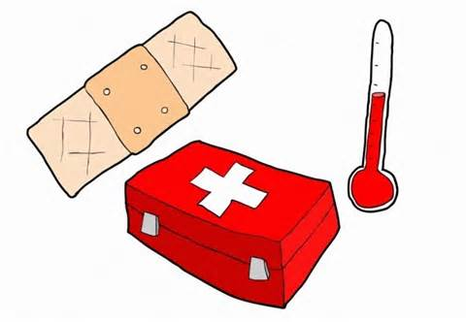

**My Health & Wellbeing**

To keep myself healthy I need:

Other comments:

When I feel unwell I would tell:

I brush my teeth _____ times a day.

My Doctor’s name is:

My Dentist’s name is:

My Opticians name is:



After school clubs I attend are:

My teachers could help me more by:

My friends at school are:

My teachers names are:

Things I would change about my school are:

Things I like about school are:

At school I eat:

My School’s name is:

My class’s name is:

**My Learning & Development**

[](https://www.bing.com/images/search?q=blank+house&view=detailv2&&id=81573918FF48227D5E0C175C4D1E27E469BBAF26&selectedIndex=0&ccid=I11S/Nv5&simid=607992289891123665&thid=OIP.M235d52fcdbf96391c799fc51bd8f8197H0)

Things I would change at home are:

who can help change these?

Things I like about my home are:

People who live with me are:

My hobbies and interests are:

I live at:

My favourite food:

**My Family & Environment**

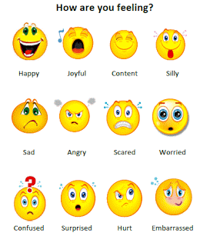

**What makes me feel**



**What I like**

**What I don’t like**

**Who lives with me?**

[](https://www.bing.com/images/search?q=blank+house&view=detailv2&&id=81573918FF48227D5E0C175C4D1E27E469BBAF26&selectedIndex=0&ccid=I11S/Nv5&simid=607992289891123665&thid=OIP.M235d52fcdbf96391c799fc51bd8f8197H0)

Write the names/draw pictures of the people who live in your house.

**My Helping Hand**



Write down the names of people who keep you safe & who you could go to for help if you needed it.



This is what I would change by waving my magic wand!

**My Magic Wand**



Write the names of the people who are in your family and who they are then draw a line to connect them to your family tree.

My Name:

**My Family**



**People who are special to me**



**My Health & Wellbeing**

My Doctor’s name is:

My Dentist’s name is:

My Opticians name is:

I brush my teeth _____ times a day.

When I feel unwell I would tell:

To keep myself healthy I need:

Other comments:

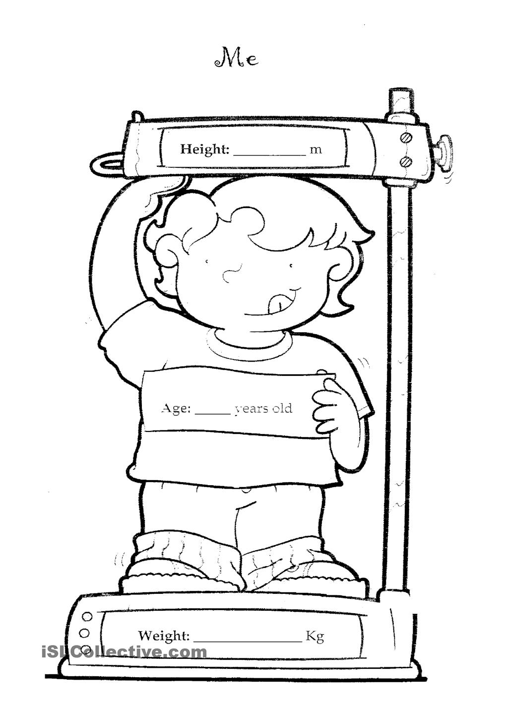

**House of Dreams**

**House of Worries**



**House of Good Things**



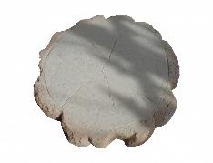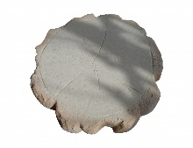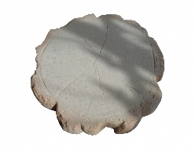

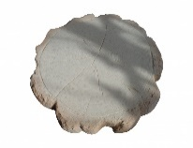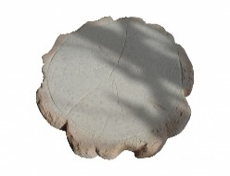

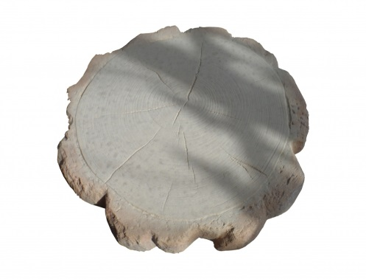 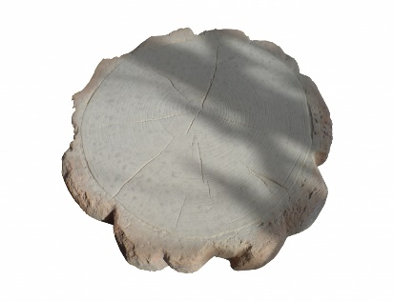



**Service User Feedback – Child**

We want to find out how things have been for you.

You don’t need to give your name or address so please tell us the truth – good or bad.

**About you:**

How old are you?

1 2 3 4 5 6 7 8 9 10 11 12

*Circle your answer*

Are you a:



Girl? Boy?

*Circle your answer*

**About your worker:**

Your worker is the person who helps you and your family. They help you and talk to you about the things you need. Your worker has given you this form.

What is your worker’s name?

_______________________________________________

**About the help that you got:**

Were you able to talk to your worker about what you needed?

YES NO

*Circle your answer*

Did you have a say in what help you wanted?

*Circle your answer*

YES NO

Since you first met your worker are things:

Better Worse The same

*Circle your answer*

**Bag of Worries**

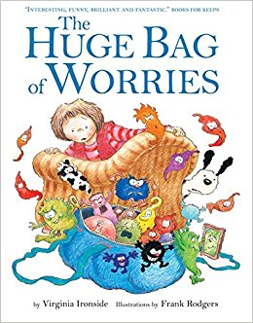

**The Huge Bag of Worries is a fabulous book to use when working with children who have lots of worries. It tells the story of a little girl who carries around a huge bag filled with worries (metaphor is little monsters). We use this book alongside the worry monster.**

**My Life Path**

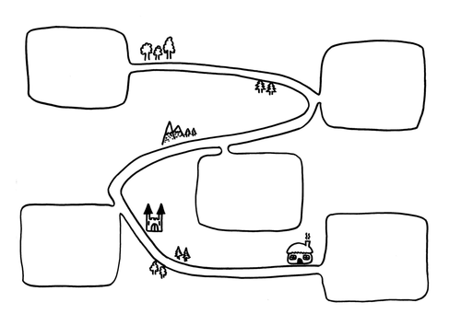

**My First Aid Bag**

**My Solution Maze**

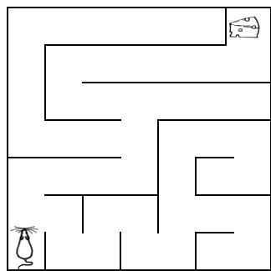

**Worry Monster**

# Guidance on using the resources



**Voice of the Child**

Take time to get to know the young person you are working with, what they enjoy, what are their concerns and what are their ambitions and aspirations?

* Document the child or young person’s journey from needing help, to receiving help
* Record the child or young person’s wishes and feelings
* Observe and record their behaviour and experiences
* Ask other professionals for their knowledge of the child or young person as they may have significantly more contact with the child
* Evidence the Child’s Voice throughout the Assessment
* Thread the Child’s Voice through all recording;
* Creative activities used to listen to children and young people can be held on Documentation

**The voice of children must be recorded and taken into account no matter what their age or ability to communicate directly**.

This can be done by:

* Direct engagement;
* Observation;
* Discussion with parents, family members, carers or agencies;
* Analysis of information held to consider what the impact might be on the child.

A good start is to explain your own role, to listen openly and to seek the voice of the child without advising or judging.

Remember to consider explaining to parents and carers in advance and seek consent where necessary.

Make the child or young person central to the story being told.

Ensure they feel important.

The child or young person should “jump off the page”.

Child centred thinking.

No child is too young to have a voice. Involve the child regardless of age.

Use creative methods to involve the child or young person, meeting their learning and development needs, and their preferences.

Co-production of plans, assessment and reviews; children and young people can participate in producing essential documents about their lives.

Involving the child or young person is a continual process that needs reviewing as the child changes and develops.

The child or young person shouldn’t have to tell their story over and over again.

Practitioners need to read what has already been written.

Other agencies will spend more time with the child and they need to be involved in recording the Child’s Voice.

Not rushing contact with the child; even if you only have limited time, focus on them.

Children and young people should not know how busy you are, or how many other meetings you need to attend.

Manage how you leave a child or young person after a hard moment.

Possible methods:

* Drawing a picture of the child or young person’s day to capture what their day is like.
* 1 Page Profile format including what the child looks like, their likes and dislikes, their personality, their fears and what makes their day good. This format is more than a form to fill in.
* Sort cards
* Role play
* Having a real understanding of what makes a child or young person’s day good or not so good. What is a good start to their day? This links to their specific likes and dislikes.

Enable choice for the child or young person. Where do they want to meet their worker?

Feedback from the child or young person on the value of being included and involved is essential. This can also support professional and practice development.

Recording the journey travelled; achievement and attainment is more than standard (national) indicators.

Endings are important and need to be planned for.

With the Child’s Voice well evidenced, handover between social workers is improved

**Who do we use the resources with?**

**Resources  
Who uses them and why?**

**Voice of Child Booklet**

**Who uses this tool?**

* Children with a range of issues/needs use this tool. This tool is used with direct work with children by early help practitioners, social workers and by similar professions.

**Why use this tool?**

* Using this tool enables practitioners and social workers to gain information about who the child is; their worries; their concerns; their family and environment.

**Three Houses tool**

**Who uses this tool?**

* Children undergoing Early Help Assessments and direct work use this tool. This tool is used by social workers, early help practitioners and by similar professions.

**Why use this tool?**

* “Taking three diagrams of houses in a row, the practitioner explores the three key

Assessment questions of the Signs of Safety framework: 1) What are we worried about, 2) What’s working well and 3) What needs to happen/how would things look if they were as wanted” (NSPCC, 2013, 30).

**Stepping Stones**

**Who uses this tool?**

* Children with a range of issues/needs use this tool. This tool is used with direct work with children by early help practitioners, social workers and by similar professions.

**Why use this tool?**

* Using this tool enables children to form pathways of moving towards a goal (stepping stone). Example, “how do we get to the next stepping stone?”

**Suitcase of Valuables**

**Who uses this tool?**

* Children with a range of issues/needs use this tool. This tool is used with direct work with children by early help practitioners, social workers and by similar professions.

**Why use this tool?**

* Using this tool helps children to identity their own values. This can be used in conjunction with signs of safety tools – eg: The Three Houses.

**Service User (Child) Feedback form**

**Who uses this tool?**

* Children with a range of issues/needs use this tool. This tool is used tool evaluate their experience working with a professional, i.e.: social workers, early help practitioners.

**Why use this tool?**

* Using this tool helps children feel valued in having their own opinions and views. Feedback tools are essential for practitioners to reflect upon their work and to ensure their practice remains empowering and anti-oppressive to children and families.

**Bag of worries**

**Who uses this tool?**

* Children with a range of issues/needs use this tool. This tool is used with direct work with children by early help practitioners, social workers and by similar professions.

**Why use this tool?**

* This tool is used for therapeutic intervention by early help practitioners, social workers and other professions. It enables children to understand how children ‘carry’ around their worries.

**Life path**

**Who uses this tool?**

* Children with a range of issues/needs use this tool. This tool is used with direct work with children by early help practitioners, social workers and by similar professions.

**Why use this tool?**

* This tool enables children to view their life from a different perspective alongside helping professional’s pin-point needs and details. Creating a life path also has therapeutic benefits in aiding children to understand what they have overcome.

**My First Aid Bag**

**Who uses this tool?**

* Children with a range of issues/needs use this tool. This tool is used with direct work with children by early help practitioners, social workers and by similar professions.

**Why use this tool?**

* This enables children to understand what support/coping mechanisms they have in place during any given period within their life.

**My solution Maze**

**Who uses this tool?**

* Children with a range of issues/needs use this tool. This tool is used with direct work with children by early help practitioners, social workers and by similar professions.

**Why use this tool?**

* This tool helps children to understand their own issues and helps them to think about possible solutions.

**Worry Monster**

**Who uses this tool?**

* Children with a range of issues/needs use this tool. This tool is used with direct work with children by early help practitioners, social workers and by similar professions.

**Why use this tool?**

* This tool can be used therapeutically in correspondence to the ‘Bag of Worries’ in relieving children of their problems by “eating them.”