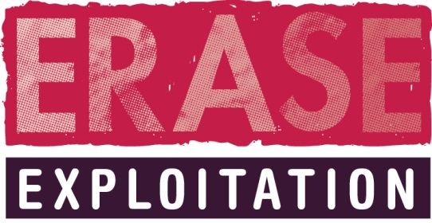

ERASE CSE Meeting Checklist for Social Workers

Prior to the CSE Meeting the Social Worker must ensure that the following is completed:

- All relevant Professionals involved or working with the CSE Victim and the family should be invited. This must include Health, School or College, Youth Offending Service, etc.
- All professionals involved or having relevant information around the CSE Suspect should be invited. This must include Youth Offending Service, Probation, Education, Health, etc.
- All relevant agencies involved with any identified location connected to CSE.
- ERASE research form to be forwarded to all professionals you have invited (Please do not forward the meeting schedule – which contains the details of all children being discussed – to external agencies due to data protection concerns).
- The ERASE Research form should be completed and forwarded to the ERASE Mail box ERASE@durham.pnn.police.uk 48hrs prior to the meeting.
- You must ask all professional’s to complete the ERASE Research form and send it to the ERASE Mail box ERASE@durham.pnn.police.uk 48hrs prior to the meeting.
- A copy of the CSE MATRIX should be emailed to the ERASE Mailbox ERASE@durham.pnn.police.uk
- The CSE MATRIX should be reviewed immediately before the meeting and that updated copy brought to the meeting.
- You must supply a list of all agencies invited to the meeting 48hrs prior to the meeting to ERASE@durham.pnn.police.uk

MAPS representatives will attend all meetings, so you will not need to issue an invite.

If you have any questions about the above please contact the ERASE Team on 01913752820.

