Starting an SGO Support Plan
Firstly, on the demographics page of the child’s record, click on the ‘start an SGO Support Plan Request’
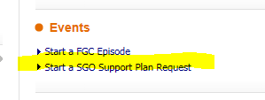
You will now be asked to assign this, assign it to yourself
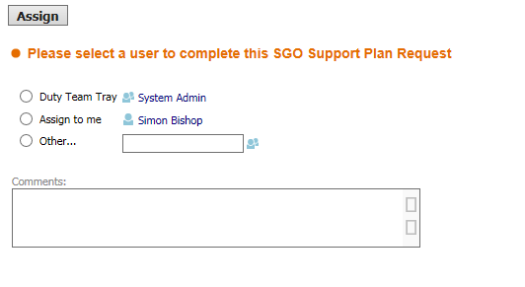
Now click on the Start SGO Support Plan Request button
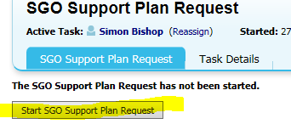
Complete the first form, including all the drop-down boxes. This will allow you commence within the pathway.
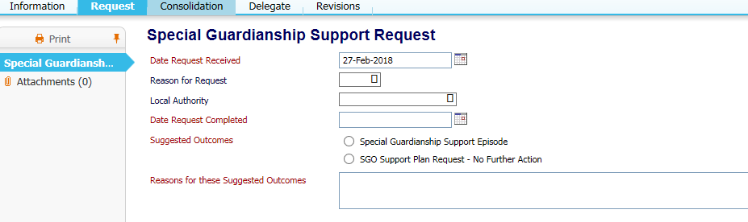
Ensure you click on the radio button ‘special guardianship support episode’ and this will start the process.
The process map below shows how the pathway can be followed:

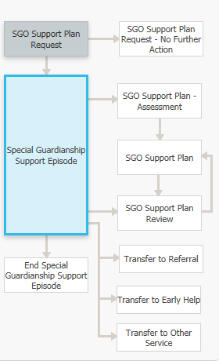
Click on the decisions tab, this will give you the options to start either an assessment or review:
