Parental Conflict and when to recognise the transition into Domestic Abuse and Violence
A continuum for identifying and implementing appropriate responses to Parental Conflict and the differentiation from Domestic Abuse and Violence
Version 1.1

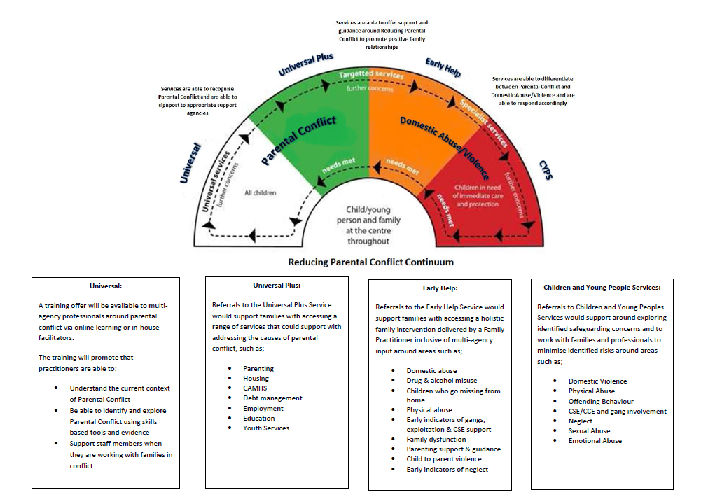

Contents
- What is Parental Conflict?
- How does Parental Conflict Impact on Children?
- What is Domestic Abuse and Violence?
- How does Domestic Abuse and Violence Impact on Children?
- What services seek to address the impact of Parental Conflict on Children?
- What services seek to address the impact of Domestic Abuse and Violence on Children and Families?
- Supporting Practitioners to identify the differences between Parental Conflict and Domestic Abuse and Violence
- Process Chart for SafeLives Dash Risk checklist and MARAC referrals
- References and Useful Websites and Contacts

What is Parental Conflict?
Conflict between parents is a normal part of relationships and family life. Not all conflict is damaging, but the way conflict manifests – its frequency, intensity, and how it is resolved – can negatively affect children.
Evidence has found that the quality of the relationship between parents, specifically how they communicate and relate to each other, has a significant influence on effective parenting and children’s long-term mental health and future life chances.
Where conflict between parents is frequent, intense and poorly resolved, it can harm children’s outcomes – regardless of whether parents are together or separated. This includes family contexts not usually regarded as ‘high-risk’, not just where parents have separated or divorced or where there is domestic violence.
Conflict can affect children in all types of parental relationships, which includes:

- Parents who are in a relationship with each other, whether married or not
- Parents who have separated or divorced
- Biological and ‘step’ parents
- Foster and adoptive parents

Conflict can range across a continuum of severity, from constructive to destructive conflict, to domestic violence and abuse in its most extreme form. Destructive conflict behaviours which put children’s mental health and long-term life chances at risk include aggression, non-verbal conflict or ‘the silent treatment’. By contrast, constructive conflict – where there continues to be respect and emotional control, and conflict is resolved or explained – is linked to lower risks of child distress. This suggests conflict resolution skills are an important focus for intervention to improve child outcomes.
Although destructive conflict can include domestic violence and abuse, the focus of the Reducing Parental Conflict Programme is on non-abusive conflict between parents.
There are a range of difficulties that can influence parental conflict and its impact on children. These are explored in more detail in the Reducing Parental Conflict Training but can include parents’ mental health, disability, substance misuse, family transitions and economic pressure.

How does Parental Conflict impact on Children?
There is a large body of evidence that shows that conflict between parents can have a negative impact on children’s long-term mental health and future life chances.
When conflict between parents is frequent, intense and poorly resolved, it puts children’s mental health and long-term outcomes at risk. Children of all ages can be affected by destructive parental conflict, from infancy to adulthood, but they may be affected in different ways. Children as young as six months show symptoms of distress when exposed to parental conflict, infants up to the age of five display symptoms such as crying or acting out, and children in middle childhood (six to twelve years) show emotional and behavioural distress. Children who witness or are aware of conflict between parents, or who blame themselves, are affected to a greater extent. This suggests that child perceptions of parental conflict could be an important focus for interventions.
Children who witness severe and ongoing parental conflict can display:
- Externalising problems (such as behavioural difficulties, antisocial behaviour, conduct disorder)
- Internalising problems (such as low self-esteem, depression and anxiety) academic problems
- Physical health problems
- Social and interpersonal relationship problems
In the long term, the above child outcomes are associated with:

- Mental health difficulties
- Poorer academic outcomes
- Negative peer relationships
- Substance misuse
- Poor future relationship chances
- Low employability
- Heightened interpersonal violence

The impact of parental conflict on children can therefore be varied and long-lasting, as well as the risk that relationship behaviours and problems are repeated across the generations, as evidence suggests these children can go on to experience destructive conflict in their own future relationships.
A key finding of the Early Intervention Foundations ‘What Works’ reviews is that parental conflict is a primary influence or central mechanism through which family stress (such as economic pressure) impacts both parenting and children’s long term outcomes.

The Family Stress Model shows how economic pressure impacts on parent’s mental health which can increase parental conflict. Parental conflict is then in turn a precursor to poor parenting practices (such as insensitivity, low quality and quantity of time spent together, harsh parenting or over-controlling behaviours) and also negative child outcomes. Parents who are in a conflicting and distressed relationship are typically less sensitive and emotionally responsive to their children’s needs towards their children. This then affects the parent-child relationship.

Family Stress Model

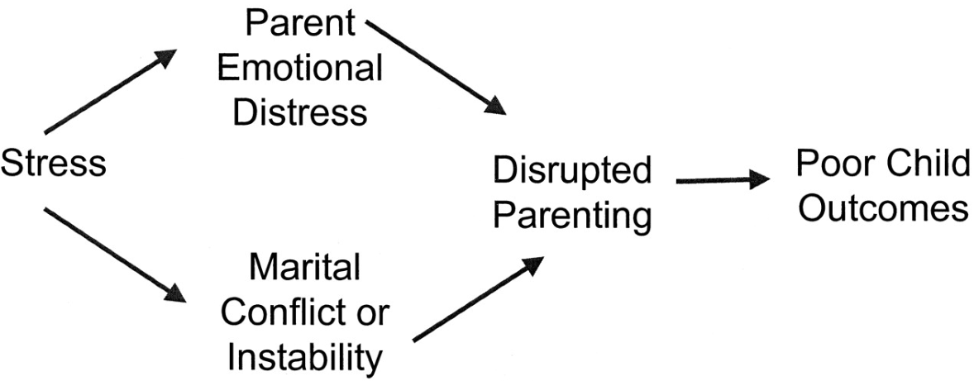

Evidence suggests that parental conflict may have more of a negative impact on the father–child relationship than the mother–child relationship. Fathers are more likely to respond to parental conflict by withdrawing from their children or becoming hostile towards them. In addition, parental separation can lead to reduced and inconsistent contact between children and non-resident parents, who are typically fathers, further disrupting the father–child relationship. For these reasons, including fathers in family-focused interventions is an important future direction for both practice and research.

What is Domestic Abuse and Violence?
Women’s Aid defines domestic abuse as an incident or patterns of incidents of controlling, coercive, threatening, degrading and violent behaviour, including sexual violence, in the majority of cases by a partner or ex-partner, but also by a family member or carer. It is very common. IN the vast majority of cases it is experienced by women and it is perpetrated by men.

Domestic Abuse can include, but is not limited to:
- Coercive control (a pattern of intimidation, degradation, isolation and control with the use or threat of physical or sexual violence)
- Psychological and/or emotional abuse
- Physical or sexual abuse
- Financial or economic abuse
- Harassment and stalking
- Online or digital abuse
Women are more likely than men to experience multiple incidents of abuse, different types of domestic abuse (intimate partner violence, sexual assault and stalking) and in particular sexual violence. But any person can experience domestic abuse regardless of race, ethnic or religious group, sexuality, class, or disability, but some people who experience other forms of oppression and discrimination may face further barriers to disclosing abuse and finding help.
Domestic abuse exists as part of violence against women and girls; which also includes different forms of family violence such as forced marriage, female genital mutilation and so called “honour crimes” that are perpetrated primarily by family members, often with multiple perpetrators.

How does Domestic Abuse and Violence impact on Children?

Domestic violence has a devastating impact on children and young people that can last into adulthood. Domestic abuse services offer specialist emotional and practical support for children and young people affected by domestic abuse.
Children can experience both short and long term cognitive, behavioural and emotional effects as a result of witnessing domestic abuse. Each child will respond differently to trauma and some may be resilient and not exhibit any negative effects.
Children’s responses to the trauma of witnessing domestic abuse may vary according to a multitude of factors including, but not limited to, age, race, sex and stage of development. It is equally important to remember that these responses may also be caused by something other than witnessing domestic abuse.
Children are individuals and may respond to witnessing abuse in different ways. These are some of the effects described in a briefing by the Royal College of Psychiatrists (2004):
- They may become anxious or depressed
- They may have difficulty sleeping
- They have nightmares or flashbacks
- They can be easily startled
- They may complain of physical symptoms such as tummy aches and may start to wet their bed
- They may have temper tantrums and problems with school
- They may behave as though they are much younger than they are
- They may become aggressive or they may internalise their distress and withdraw from other people
- They may have a lowered sense of self-worth
- Older children may begin to play truant, start to use alcohol or drugs, begin to self-harm by taking overdoses or cutting themselves or have an eating disorder
Children may also feel angry, guilty, insecure, alone, frightened, powerless or confused. They may have ambivalent feelings towards both the abuser and the non-abusing parent.

What services seek to address the impact of parental conflict on children?
Services that support parental relationships take many different forms. This includes interventions that are specifically designed to improve child and parent outcomes where there is parental conflict.
As highlighted in an Early Intervention Foundation mapping study of relationship support services in the UK, there are also wider services that are specifically designed to improve the quality of the relationship between parents. These services may have a focus on improving child outcomes in their design and/or they may focus on the parent/couple relationship:
- Relationship counselling and therapy
- Marriage and relationship education, including new parenthood programmes
- Family mediation and legal support, including in-court conciliation and Cafcass
- Online information and advice

There are also services that, while not explicitly defined as relationship support services, focus more broadly on supporting families and supporting the relationship between parents alongside other aspects of family life:
- Child and family support services, such as Early Help, Social Care, Children’s Centres and Troubled Families teams
- Parenting programmes, where they have a specific component that looks to improve child outcomes in the context of parental conflict
- Health services, including GPs and practice nurses, midwives or health visitors, and mental health services, including such as Improving Access to Psychological Therapies (IAPT)
- Schools, through sex and relationships education or school counselling

Some of this support involves practitioners working face-to-face with families, but other services are delivered over the phone or through video chat. There are also many online services that provide information and advice to parents with issues in their relationship, allowing them to ‘self-help’ without the involvement of a practitioner.

Some services are designed for parents at different stages in their relationship, including key transition points such as marriage, new parenthood, separation and divorce. These can be tailored to particular family demographics or child characteristics.

There are many services that aim to train practitioners to effectively spot and address relationship difficulties. This includes in-work training, such as on-line or face-to-face courses for practitioners, or formal education programmes to train people to become relationship support practitioners or counsellors.

While there is strong scientific evidence of the link between parental conflict and poor child outcomes, the UK evidence about the effectiveness of many of these services is currently at an early stage, which means we don’t yet know what impact they are having on family outcomes – and child outcomes in particular. There is often a lack of relationship support services at a local level, and a lack of research to map the specific nature and extent of relationship support provision. Much of the current provision is delivered by charities and voluntary sector organisations and so has been vulnerable to public service funding reductions.

What services seek to address the impact of Domestic Abuse and Violence on children and families?
Domestic abuse services provide a wide range of information and support including refuge accommodation, helplines, outreach support, floating support, resettlement support, specialist children and young people services, Domestic Abuse Prevention Advocates and drop-in support.
Support Services in Havering:
- Havering Women's Aid are an organisation based in Havering that can offer support in regards to domestic violence. They offer floating support, group support and 1-2-1 counselling is also available on 01708 728759.
- MENDAS are an organisation based in Havering that can offer support in regards to male victims of Domestic Violence. They offer floating support and 1-2-1 counselling is also available on 01708 397974
- If you are in need of emergency refuge please call the National Domestic Violence helpline; 0808 2000247
- If you are a victim of sexual violence contact the East London Rape Crisis Centre for free confidential advice and support on 020 7683 1210. Also visit the Rape Crisis website for help.
- LGBT victims of domestic violence can contact GALOP domestic abuse project for specialist support on 020 7704 2040.
- Deaf victims of domestic violence can receive advocacy and outreach support from Deaf Hope by telephoning 020 8772 3241 or email deafhope@signhealth.org.uk
- If you want to stop being violent and abusive to your partner contact Respect on 0808 802 4040.
- Women in Prison offers advice and support to women affected by the criminal justice system. Contact 0800 953 0125 for assistance.
- South Asian, Turkish, Iranian women experiencing domestic violence can contact Ashiana on 020 8539 0427 for support and advice.
- Victim Support can offer victims of crime advice and support, help with legal remedies, assistance with housing, and benefits advice. Contact 020 8550 2410.
- You can find local support to suit your circumstances through the Domestic Abuse Champions Network.
London Violence against Women and Girls (VAWG)
The London Violence Against Women and Girls (VAWG) Consortium is made up of 29 organisations working in partnership to deliver comprehensive, cost effective, high quality services to all communities across London. This innovative partnership strengthens referral pathways across organisations and identifies trends and emerging need.

Professional referrals
If you are a professional looking to make a referral for high risk domestic abuse please complete our Multi Agency Risk Assessment Conference (MARAC) referral form.
This will be screened by the MARAC coordinator to ensure the referral meets the threshold criteria.

Parental Conflict and Domestic Abuse/Violence as a continuum and what services are best placed to support families

Process for professionals in regards to potential/identified domestic abuse and violence
Individual/family known to services i.e. Early Help, CYPS is identified as at risk of or is currently experiencing domestic abuse or violence

SafeLives Dash Risk Checklist is completed with individual

If the risk assessment highlights 14 or more ‘Yes’ answers or professional judgement feels it meets the threshold a referral to MARAC (Multi Agency Risk Assessment Conference) is completed via an online referral
If the Risk assessment scores low (below 14 or according to professional judgement) professionals will ensure safety plans are completed and the individual has information in regards to support services i.e. women’s aid

Recommendations are followed as per the outcome of MARAC meeting and the individual/family are supported via this process alongside current intervention
Intervention is continued, the individual/family supported and the action plan is updated via regular progress meetings. Safety Plan is re-visited as required and further CAADA-RIC assessments completed as required

References
The information provided within this document can be found through the below links
https://www.eif.org.uk/files/pdf/commissioner-guide-reducing-parental-conflict-print.pdf
https://reducingparentalconflict.eif.org.uk/
https://www.gov.uk/government/publications/reducing-parental-conflict-programme-information-for-stakeholders/information-about-the-reducing-parental-conflict-programme
https://assets.publishing.service.gov.uk/government/uploads/system/uploads/attachment_data/file/621364/improving-lives-helping-workless-families-web-version.pdf

For further information on Domestic Abuse and Violence please visit
https://www.havering.gov.uk/info/20096/community/550/domestic_violence
https://www.womensaid.org.uk/information-support/what-is-domestic-abuse/
MARAC REFERRAL - https://my.havering.gov.uk/Pages/OnlineForms/MARACreferral.aspx#Referrer-details
SafeLives Dash Risk Checklist and Guidance –
https://www.havering.gov.uk/download/downloads/id/3404/guidance_note_for_how_to_complete_the_dash_risk_assessment.pdf
Domestic Abuse Champions Network for Havering –
https://www.reducingtherisk.org.uk/cms/content/havering?area=havering
Domestic Violence Disclosure Scheme (DVDS – Clare’s Law) –
https://www.met.police.uk/advice/advice-and-information/daa/domestic-abuse/alpha/request-information-under-clares-law/

