CHILDREN’S SOCIAL CARE QUALITY

ASSURANCE FRAMEWORK

April 2019

What is a Quality Assurance Framework and why do we need one?
Quality Assurance is an umbrella term, which embraces all activity that contributes to service improvement. Quality Assurance activities monitor compliance with policies and procedures; evidence strengths and good practice; identify gaps and areas for development; drive learning and service improvement. Critically, they enable us to see what difference we made for the child/ young person and how can we improve and strengthen outcomes.
A Quality Assurance Framework allows those with leadership, senior management, case management or scrutiny responsibility for children, to understand how effectively Merton Children’s Social Care is delivering services to keep children safe, promote positive outcomes and identify where improvements should be focused.
At service and individual practitioner level the critical judgement is whether we are making a difference to the children and families we come into contact with. Whether and in what way their lives are better and safer as a result of the services they have received. For example - Are we improving outcomes, how do we know?

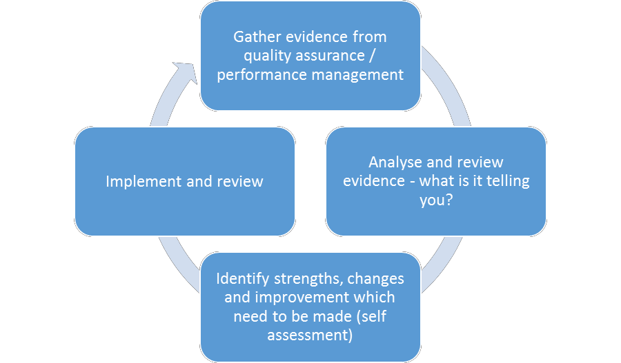

We need to ensure;
- we are providing services that are of a good standard
- The service we are providing is having a positive impact on the child and their family.
- The children’s voice and views are central to what we do
- Our intervention leads to strong and improved outcomes

Quality Assurance is more than just routine and meeting targets. Effective Quality Assurance is live, dynamic and evolving, where there is an embedded cycle of monitoring, continuous reflection and learning, based on the principle that there is always room for improvement.

Quality Assurance needs to be owned by everyone in the organisation and at all levels, we need to understand and routinely undertake these within our service areas. Learning organisations use a range of methods to gather both quantitative and qualitative information from a variety of sources, to measure and analyse the aggregated information against an agreed set of standards. Measuring practice is only purposeful if the loop is closed and the organisation uses the learning to plan and deliver service improvements.

The audit process should create dialogue between the auditor and the worker. Whilst the worker must be open to professional scrutiny and challenge as part of the process, it is important for this to be done in a way that is open, honest and transparent, so that everyone works together to improve the quality of service we deliver.

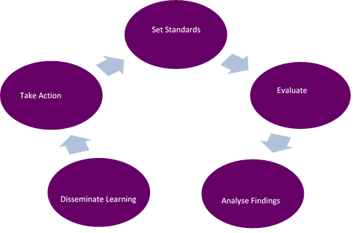

What are our methods of Quality Assurance?
Merton will utilise a combination of quantitative and qualitative information allows us to measure standards and outcomes. Quality Assurance is evidenced by the following sources:

- Audits - core & thematic  - Performance data  - National & local Inspections  - Peer reviews  - Serious Case Reviews & Internal Learning Reviews  - Appreciative Inquiries  - Practice and live learning Weeks  - Ofsted Readiness Week  - Annual Report of the Local Safeguarding Board  - Feedback from Independent Reviewing Officer/Child Protection chairs  - Internal Panel Processes such Care & Resource, Fostering & Adoption  - Private Fostering Annual Report | - Feedback from children, parents and carers.  - Complaints & compliments  - Children in Care Council - Positive Journey’s  - Employer Health Checks  - Staff feedback. For example, Exit interviews, Keep in Touch meetings. Practitioner Perspective Panel  - Supervision, Probation, Appraisal.  - CADCASS & Legal feedback from proceedings  - Multi agency partner feedback

Merton will embed the practice model and utilise Signs of Safety, systemic theory, motivational interviewing. The following documents and processes underpin our Quality Assurance framework. We will have a clear monthly schedule of audits being undertaken and focus on key areas where we need to a make a difference for young people.
What activities will be quality assured?
The annual schedule of auditing activity will routinely contribute to measuring core areas of practice:

- Assessments of need and risk to children and young people
- Plans and the effectiveness of intervention
- Direct working relationships with children, young people & their families
- Partnership working and effectiveness of multi-agency meetings & reviews
- Report writing and case recording
- Management oversight and decision making (includes supervision)

In addition to the above there will be specific areas that will periodically require a ‘deep dive’ in depth review. These areas might be identified as a result of analysis of patterns and themes emerging from the regular auditing activity, notable issues and/or changes raised through performance data, triggered by a complaint, a management review or changes in legislation and regulations.

Who will undertake QUALITY ASSURANCE, how and when?

Role | Activity | Frequency
Social workers, Team Managers, Heads of service and/or Independent Reviewers | Routine schedule of full case file auditing and/or direct observations. | Monthly
 | Thematic and ‘deep dive’ audits on specific areas of practice. | Periodic according to need
 | Moderating team manager case file audits. | Monthly
Team Managers | Checking and authorising a range of activities and reports on the Liquid Logic-ICS system | Daily
 | Monitoring and routinely reporting performance in performance meetings. | Weekly
 | Directly observing practitioners carrying out direct work with families or partner agencies – aligned to online case audits. | Every month
 | Routine schedule of core practice area and case file auditing for each social worker | Monthly
Practitioners | Self-assessment to inform monthly online case file audit. | Monthly
Director and Deputy Director of Children’s Services | A programme of activities observing different areas of practice and case audits during Practice Week and Inspection Readiness week. | Every 6 months

*Note. Independent Reviewers - Senior Managers includes: Independent Reviewing Officers, Child Protection Conference Chairs, Consultant Social Workers, Heads of Service, and Deputy Director of CSC.

Purpose of the Case Audit Process
All case file auditing is undertaken collaboratively with staff and family feedback is actively sought following each case file audit. The case file audit tool reflects both the Signs of Safety practice model and each section is graded according to Signs of Safety scaling i.e. from 0 to 10. The scaling has been aligned to the Ofsted Grades as follows:

Scaling | Ofsted Grade
0 – 2 | Inadequate
3 – 5 | Requires improvement
6 – 8 | Good
9 – 10 | Outstanding

The audit programme aims to:
- Provide assurances that practice positively influences outcomes for the most vulnerable children and young people;
- Take into account the requirements of inspection bodies;
- Involve all children’s social care staff in continuously seeking to improve their practice;
- Ensure consistency of practice across children’s social care and adherence to the practice model.
- Embed a culture of learning, confident practice and feedback.
- Identifying areas of practice improvement to inform the performance conversation and appraisal process.

How will the audit process work?
QAPD service will select cases that has been open for at least 6 months. Both the allocated social worker and Team manager will be notified of the child’s mosaic ID number and they are required to collaboratively audit using the agreed audit form.
- Social workers and Team Managers are required to audit one case file a month.
- This when completed will be shared with the Head of service for moderation (see fig 1)
- Unless otherwise specified, the period of the case file audit should cover is the last six months of a child’s journey.
- Child/ young person and Family feedback must be sought and recorded on the audit form.

Findings and accountability
- Team Managers are responsible for reviewing the audit findings and recommendations and outlining actions to be completed to bring the case up to expected practice standards. Audit actions should be regularly reviewed in supervision, cross referenced until Managers are satisfied the case meets expected practice standards.
- Any audit or moderation that is graded under 0-5 must have areas of improvement outlined to get to good. The auditor should recommend any actions they believe are necessary to bring the case up to a good standard of expected practice. The Head of service for both the relevant service and Safeguarding & Quality Assurance service must be informed of all audits or moderations graded inadequate.
- Head of service are responsible for reviewing the audit findings and recommendations of any audit graded inadequate and must be satisfied the actions outlined by the Team Manager are sufficient to bring the case up expected practice standards within a reasonable period.
- A quarterly quality assurance report will be provided by the QAPD service to the Senior Leadership Team and shared with Service and Team Managers in the process of the performance cycle. The highlights and overall themes will be shared with key stakeholders e.g. The Local Safeguarding Children Board, Councillors and the Chief Executive, Safeguarding Improvement Board.

Where will the information go and how will it be used?
- The Quality Assurance report will be shared with CSC senior management team to inform the Children Service’s Improvement Plan.
- This in turn will enable the senior management team will identify what needs to be implemented to improve practice, who will take the lead and the timescale for implementation.
- The QAPD service will also work closely with the Workforce Development team to contribute to the Learning & development strategy.

Appendix 1: Case Audit and moderation Process
QAPD identify case audit file for audit and moderation from mosaic
HOS (moderator) finalises the audit form and records case record/ management oversight under management record. This confirms the actions and timescales.
Audit is returned to QAPD
QAPD notify the SW, TM and HOS via email of the case ID and confirm the underline theme, timescale for return
HOS completes and confirms using the audit form
Social worker and Team Manager completes the case file audit tool. When completed, a meeting takes place to discuss and confirm findings and actions. When this document is completed, it is sent to the HOS for moderation

HOS (moderator) agrees with peer audit
HOS (moderator) does not agree with findings

HOS (moderator) and TM discuss the outcome and agreed changes, grade and actions
HOS (moderator) finalised the audit form and records a case note (saves audit on the child’s record) and records management case note with clear actions.
Audit is returned to QAPD

QAPD and HOS will collate all case file audits where there is a disparity between the moderator and TM.
QAPD will collate findings and share information

Merton’s practice model - General Principals and standards
Merton’s practice model is a strengths-based approach to working children and families. By using this model, we have a way of working across the service that everybody understands where we share a common language and a consistent application of risk and safety. This helps social workers and other professionals to better work together, reflect, think and talk about cases. The help provided to families is respectful, purposeful and based on strong professional judgements and decisions. The emphasis is on helping families rather than ‘intervening’. The focus is shifted from a way of working where professionals are considered to be the experts to a constructive, relationship-based model of helping parents to change. Whilst there is an emphasis on the strengths in the child’s network, the child’s safety is always the focus of any help provided.
Merton operates a whole system approach which is applied to all aspects of social work practice and social workers should reflect using the model in their direct work with families and their practice overall. Work with families is carried out from a stance of appreciative inquiry, being the curious and critical friend and continuously applying a questioning approach.
Social workers and managers should use the Signs of Safety questioning approach: Elicit Amplify, Reflect, and Start over (EARS). They should also use the case mapping to discuss and think about cases. All case recording therefore must be live, SMART and consistent with the practice model, addressing what is working well, what is not working well and what the next steps are.
Child focused work with children and young people has meaning for the child and their wishes and feelings are evidenced and inform our plans and intervention. Working in a child centred way is an essential part of good social work practice. Communicating and listening to children and young people helps social workers understand what life is like for them and what needs to change to increase their safety and promote their wellbeing and development.
Social workers need to understand and evidence what difference the help has made to the child or young person and what has improved for them. Therefore, the child or young person’s views and wishes are central to good social work practice and alongside the views of the parents, carers and other key professionals, are considered in all aspects of the help and support offered to the family. Feedback must and will be sought from parents and carers about their views of how helpful the support they are receiving is and this information will inform and influence how services are provided.
Using the practice model approach, there is a focus on direct work with children, not only to establish their wishes and feelings but also to fully involve the child in an age-appropriate way in the family safety planning. Social workers must therefore promote meaningful relationship-based practice with children and young people and this informs all aspects of their work with families.
Direct work should be carried out according to the age and level of understanding of the child, explaining what is happening and why. This will be evidenced and evident across the entirety of their journey. A variety of direct work tools and activities should be used to work with children and this should include direct observations of very young children. Direct work tools should be uploaded to the child’s file. Children and young people should be seen regularly and the work undertaken recorded on mosaic. Social workers should work with children alone wherever possible and in settings where they feel comfortable and that are child-friendly. Children and young people should be involved as much as possible in the decisions being made and the help being offered

Assessments (Includes genograms and chronologies)
The purpose of the assessment is the understand what is happening in the child’s life, exploring how they are cared for by the adults around them and how their health, education and wellbeing needs are being met. The practice model is used to identify what’s going well, the presence of dangers and what we may be worried about. The SW will analyse the information gathered and come to a professional judgement about whether or not the child/ren are presently safe and predict the likelihood of this remaining the same or changing in the future.
- The assessment will be undertaken in partnership with the child and families, with their full agreement and participation. If this is not possible, the reasons will be clearly recorded.
- The family history is critical to understanding and predicting the present and future, therefore every assessment will include a chronology which highlights key events in the child’s life. The chronology will be routinely updated whilst the case remains open.
- The child’s perspective, wishes and feelings are central to the assessment. Each of the children in the family will be seen and spoken to separately and on their own by the SW in the child’s first language, if this is not appropriate or possible, the reasons will be clearly recorded.
- The assessment will explore the child’s whole family, friend ship & community network to identify signs of safety and danger. Every assessment will include a genogram which highlights key people in the child’s life. The genogram will be routinely updated whilst the case remains open.
- The assessment is holistic and therefore requires information sharing from a number of sources, by all those involved in the child and family. Multi-agency checks will be undertaken to contribute to the assessment.
- The length of time it takes and depth of the assessment will be determined by the complexity of the child’s situation and the level of need. However, all assessments will be completed and the final report shared with family within 45 days of receipt of the referral.
- The assessment will identify what needs to happen next and what, if any, help or services the family need, which will inform the child’s plan. The family should not need to wait for the assessment to be completed in order to receive the help and services they require.

Plans for and visits to children, young people who are receiving support or direct intervention
- A child will have either a child in need, child protection, care or pathway plan. The plan will be written using signs of safety to provide all that are involved in that plan are clear of its purpose.
- The plan is a tool for helping the family and social worker measure progress, how the child’s circumstances are changing and should be written in plain English
- Plans will be regularly updated as the child’s circumstances changes and significant events occur and revisited regularly at review meetings, either Child in Need, Child Protection Conferences or Looked After Children reviews.
- Visits will be purposeful and will include some direct work with the child and will refer to progress being made against the child’s plan

Management oversight and Supervision recording
- Management oversight and supervision support a learning culture and provide a setting for case reflection, discussion and challenge. Supervision has three main elements - line management, professional development and casework oversight.
- Supervision has a direct impact on the outcomes for children and families and is key to improving practice with children and families.
- Therefore, managers will ensure that supervision takes place regularly and is prioritised and on time. Managers will plan supervision sessions based on an agreed agenda and bring together the learning form any case audits undertaken.
- Social workers will prepare for supervision and think about cases and issues they wish to discuss. They equally need to consider areas of development and training needs from any audits undertaken.
- Individual supervision is recorded for each member of staff and kept on their supervision file. Casework supervision is recorded on Mosaic for each child in a family.
- Managers should ensure key decisions about casework outside of formal supervision are recorded on case notes on Mosaic.
- Supervision sessions should be booked in advance for up to six months and be 90-120 minutes in duration.
- Supervision should take place at a minimum of every four weeks for experienced staff. Newly qualified staff should be supervised weekly for at least six months, then fortnightly for a further six months.
Additional resources
- supervision: http://www.londoncp.co.uk/chapters/supervision.html?zoom_highlight=supervision
http://www.londoncp.co.uk/chapters/supervision.html
- Quality assurance
http://www.londoncp.co.uk/chapters/quality_assurance.html?zoom_highlight=case+recording
- Child protection plans
http://www.londoncp.co.uk/chapters/imp_chi_prot.html
- child focused approach to safeguarding
http://www.londoncp.co.uk/chapters/child_focussed.html
- Best practice
http://www.londoncp.co.uk/chapters/best_prac_cpp.html
http://www.londoncp.co.uk/chapters/best_prac_cpc.html
- IRO handbook: https://www.gov.uk/government/publications/independent-reviewing-officers-handbook

