Info and tips around Private Fostering (PF)
What is Private Fostering?
- A privately fostered child is a child under 16 (or 18 if Disabled) who is cared for by an adult who is not a parent, grandparent, aunt, uncle, step parent (including civil partnerships), sister or brother where the child is to be cared for in that person's home for 28 days or more.
- A child who is Looked After or placed in any residential home, hospital or school is excluded from the definition. In a private fostering arrangement, the parent retains Parental Responsibility.
What are our Statutory responsibilities?
- Section 44 of the Children Act 2004 amends section 67(1) of the Children Act 1989 to extend the duty of local authorities to satisfy themselves that the welfare of children who are privately fostered within their area is being satisfactorily safeguarded and promoted to include children who are proposed to be, but not yet, privately fostered.

Further information can be found at:

https://assets.publishing.service.gov.uk/government/uploads/system/uploads/attachment_data/file/274414/Children_Act_1989_private_fostering.pdf

Other information relating to our policy and procedures around Private Fostering can be found on the internal Policy and Procedure pages.
Points to remember:
- If a child is in a Private Fostering arrangement, then this needs to be represented on Carefirst, this should be undertaken by MASH at point of opening case.
- Once PF Status completed this will automatically open the PF Arrangement Assessment
NOTE: do not open an assignment separately as this will result in the worker being unable to complete/close the assessment.
- If student is from abroad they tend to be supported through Gateway Education Guardianship Agency which is a private agency which sources and supports international students. This does not remove the local authority’s responsibilities to undertake a PF assessment.
- If they are supported by Gateway, then we need to request that Gateway Guardianship Agency ensures the ‘notification & consent form’ is signed by parents. This will then need to be uploaded to Carestore – Informal Carers.
- When Overseas students return home for summer break the LA involvement will need to be closed if this is going to be more than 6 weeks or the placement will change when they return. Not all students return to the UK or to their original placement.
- If undertaking an assessment for an overseas student who have been placed by Gateway, then Gateway will have already undertaken DBS checks and references. We do not need to repeat the DBS in these cases but we need to check no concerns are raised and gain the DBS number. We do need to repeat reference but we can contact the same people.
- Private Fostering assessments need to be completed and signed off by designated lead for all cases. Assessment can be found in the assessment screen of carefirst.

- When completing the visits on the system you need to ensure that when scheduling the Reg 8 visit that the status and requested date = date of visit and the required date is +42 which equates to 6 weekly requirements. This will then prompt you on system as when visit due.
- If young person is not an overseas student, parental consent will need to be obtained for assessment to proceed. If no consent for placement from parent(s) cannot continue.
- For overseas students you will need to request an interpreter for at least the first visit.
- CIN meetings are not always required. Good practice would be for a CIN meeting to be held to establish if a CIN plan is required. If the only reason for the case being opened is PF and there are no other concerns, then a CIN meeting/plan may not be required. If there are other concerns or work to be undertaken to enable the child to return home, then a CIN meeting and plan is required.
- As a local authority we do not have a statutory obligation to financially support placements.
- Placement is an agreement between families and therefore parents continue to hold PR.
- Email address of carer is required to enable an enhanced DBS to be completed. Admin should be informed who will request completion of the DBS.
- If a private fostering assessment concludes the placement is not appropriate then we need to inform the family and an alternative arrangement needs to be sought.

Templates can be found on Tri –x in the documents library under local resources – Prevention and Family support:
- Private Fostering leaflet to be given when completing Reg 4 visit, along with gaining information from carer for inclusion within the ‘notification & consent’ form;
- Translated letters;
- Leaflets for children;
- Letter template available for references.

Flowchart for Private Fostering can be found in documents library under flow charts.

For Managers
How to close a Private Fostering case in care first
- In the Main Menu on the left of the Carefirst Screen, navigate to Children Looked After, and then select Private Fostering Screen:

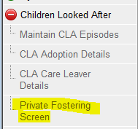

- In Find Private Fostering Placement, enter the child’s ID, and click Search. Then select the Placement and click Details:

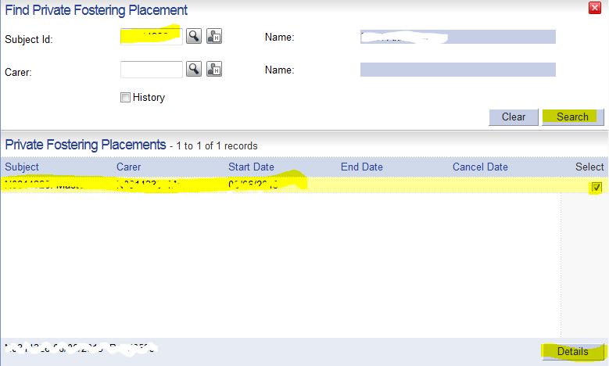

- In Private Fostering Placement screen, check that the dates and carer details were correctly recorded, then enter the Notification Date of PF End and the Arrangement End Date in the respective boxes.

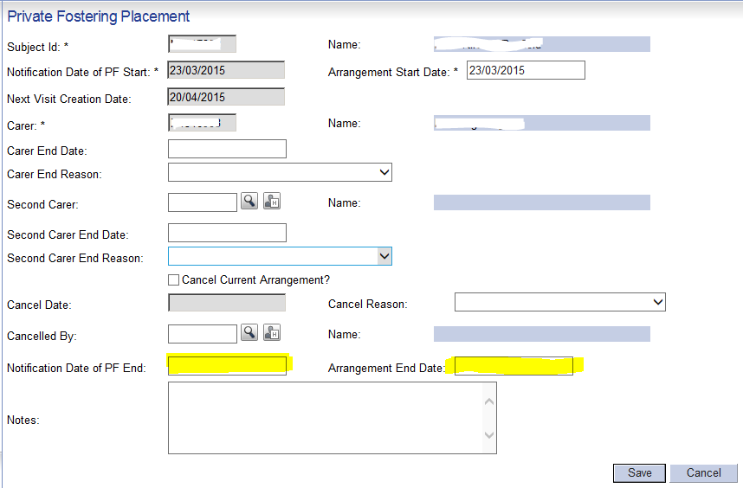

- When you attempt to click Save, the following message will pop up:
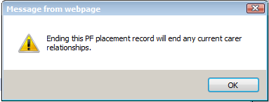
This is just an informational pop-up telling you that CareFirst will close the PF Carer relationships with the same dates you just entered.
You can click OK and then click on Save in the Private Fostering Placement Screen.
The Private Fostering Arrangement has now been closed.
Don’t forget to close any other outstanding PF Assessments etc.

